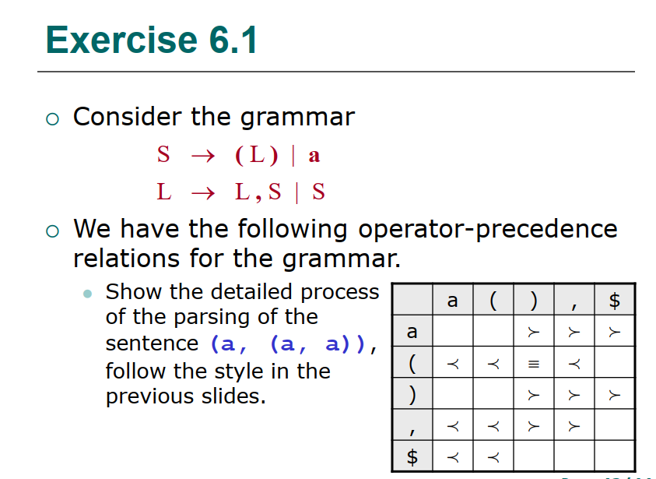

|  |  |  |  |  |
| --- | --- | --- | --- | --- |
| Step | Stack | Input | Action | Output |
| 1 | $ | (a,(a,a))$ | shift |  |
| 2 | $( | a,(a,a))$ | shift |  |
| 3 | $(a | ,(a,a))$ | reduce | S—>a |
| 4 | $(S | ,(a,a))$ | shift |  |
| 5 | $(S, | (a,a))$ | shift |  |
| 6 | $(S,( | a,a))$ | shift |  |
| 7 | $(S,(a | ,a))$ | reduce | S—>a |
| 8 | $(S,(S | ,a))$ | shift |  |
| 9 | $(S,(S, | a))$ | shift |  |
| 10 | $(S,(S,a | ))$ | reduce | S—>a |
| 11 | $(S,(S,S | ))$ | reduce | L—>S,S |
| 12 | $(S,(L | ))$ | shift |  |
| 13 | $(S,(L) | )$ | reduce | S—>(L) |
| 14 | $(S,S | )$ | reduce | L—>S,S |
| 15 | $(L | )$ | shift |  |
| 16 | $(L) | $ | reduce | S—>(L) |
| 17 | $S | $ | accept |  |