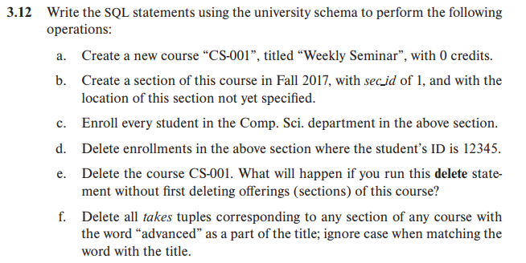

a.

insert into course(course_id,title,dept_name,credits)

    values('CS-001','Weekly Seminar',null,0)

b.

insert into section(course_id,sec_id,semester,year,building,room_number

,time_slot_id)

    values('CS-001',1,'Fall',2017,null,null,null)

c.

insert into takes(ID,course_id,sec_id,semester,year,grade)

    select ID,'CS-001',1,'Fall',2017,null

    from student

    where dept_name='Comp.Sci.'

d.

delete from takes

    where ID=12345 and course_id='CS-001' and sec_id=1 and semester='Fall' and year='2017'

e.

delete from course

    where course_id='CS-001'

如果没有先删除section中的这门课程，则会破坏外码的完整性约束。正确的删除方式应如下所示：

delete from teaches

    where course_id='CS-101'

delete from takes

    where course_id='CS-101'

delete from section

    where course_id='CS-101'

delete from prereq

    where course_id='CS-101'

delete from course

    where course_id='CS-101'

f.

delete from takes

    where course_id in

    (select course_id

    from course

    where title like '%advanced%')

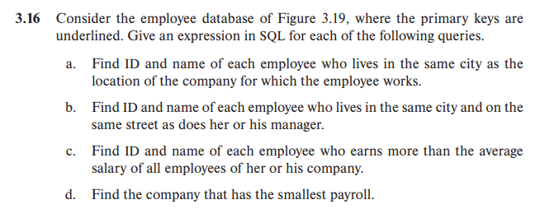

a.

select employee.ID,employee.person_name

from employee,works,company

where employee.ID=works.ID and works.company_name=company.company_name and employee.city=company.city

b.

select e1.ID,e2.person_name

from employee as e1,employee as e2,manages as m

where e1.ID=m.ID and m.manager_id=e2.ID and e1.street=e2.street and e1.city=e2.city

c.

select e.ID,e.name

from employee as e,works as w1

where e.ID=w1.ID and w1.salary>(select avg(w2.salary)

                                from works as w2

                                where w1.company_name=w2.company_name)

d.

select company_name

from works

group by company_name

having sum(salary)<=all(select sum(salary)

                        from works

                        group by company_name)