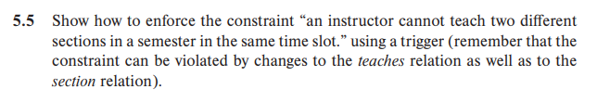

往section中插入后触发触发器section_insert_check：

create triggle section_insert_check after insert on section

    referencing new row as nrow

    for each row

        when exists(select ID as nid

                    from nrow natural join section

                    where nid in(select id

                                 from teaches natrual join section

                                 where nrow.semester = semester

                                 and nrow.year = year

                                 and nrow.time_slot_id = time_slot_id))

        begin atomic

            rollback

        end

往section中更新后触发触发器section_update_check：

create triggle section_update_check after update on section

    referencing new row as nrow

    for each row

        when exists(select ID as nid

                    from nrow natural join section

                    where nid in(select id

                                 from teaches natrual join section

                                 where nrow.semester = semester

                                 and nrow.year = year

                                 and nrow.time_slot_id = time_slot_id))

        begin atomic

            rollback

        end

往teaches中插入后触发触发器teaches_insert_check：

create triggle teaches_insert_check after insert on teaches

    referencing new row as nrow

    for each row

        when exists (select time_slot_id as n_time_id

                     from nrow natural join section

                     where n_time_id in (select time_slot_id

                                        from teaches natrual join section

                                        where ID = nrow.ID)

        begin atomic

            rollback

        end

往teaches中更新后触发触发器teaches_update_check：

create triggle teaches_update_check after update on teaches

    referencing new row as nrow

    for each row

        when exists (select time_slot_id as n_time_id

                     from nrow natural join section

                     where n_time_id in (select time_slot_id

                                        from teaches natrual join section

                                        where ID = nrow.ID)

        begin atomic

            rollback

        end