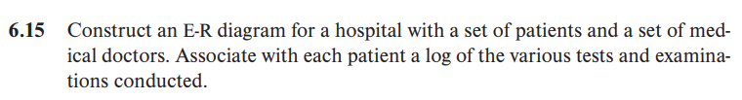

答：E-R图如下所示：

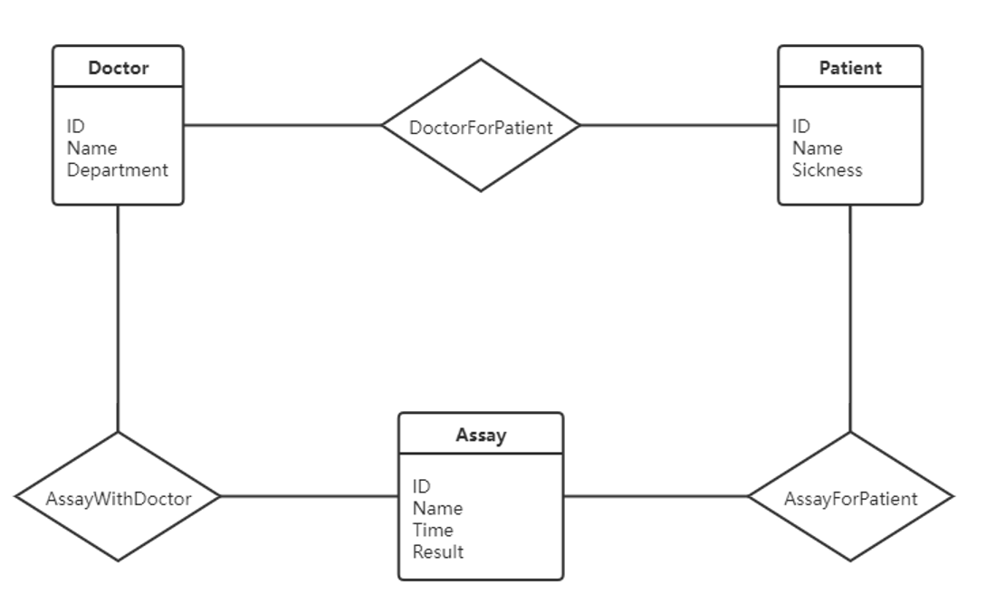

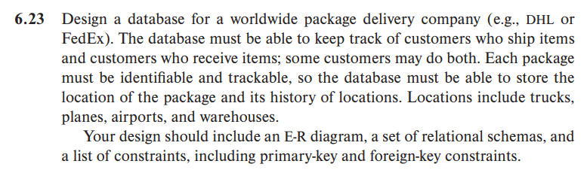

答：E-R图如下所示（见下页）：

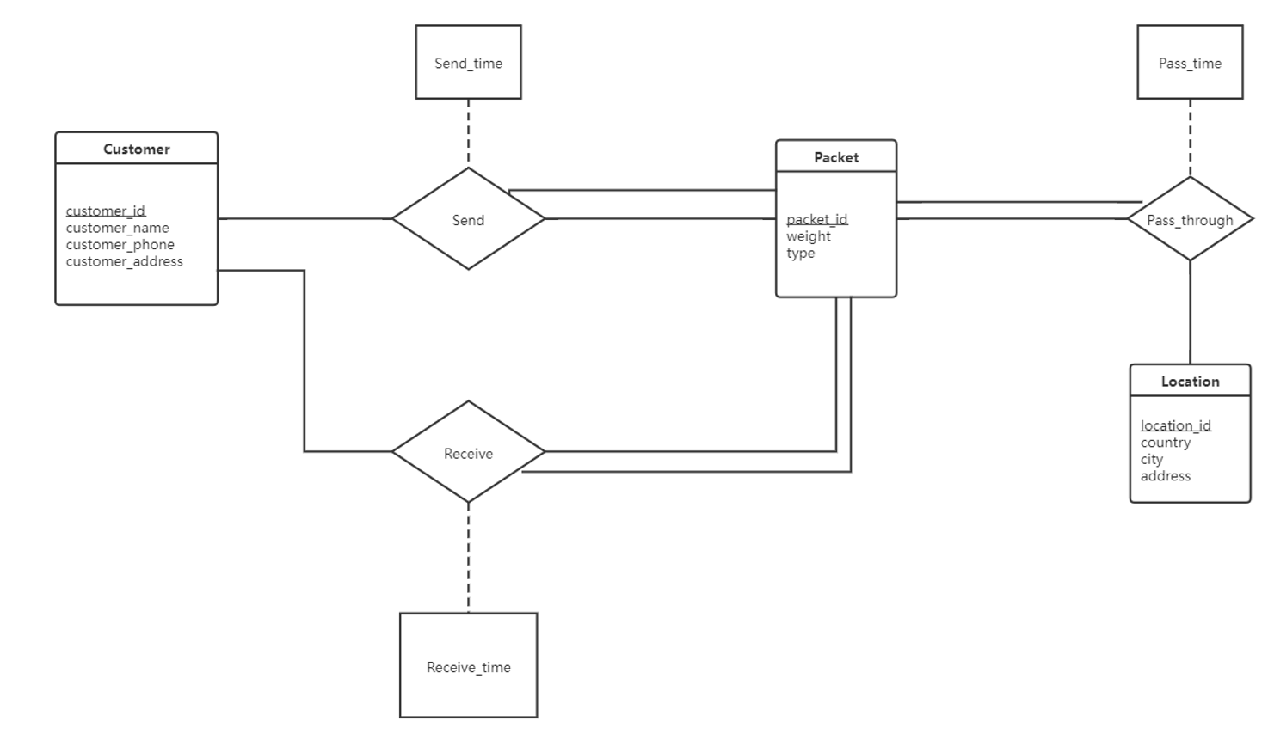

关系模式及约束如下所示：

Customer(

    customer_id,

    customer_name,

    customer_phone,

    customer_address,

    primary key(customer_id));

Send(

    packet_id,

    sender_id,

    Send_time,

    primary key(packet_id,sender_id),

    foreign key sender_id references customer,

    foreign key packet_id references packet);

Packet(

    packet_id,

    weight

    type,

    primary key(packet_id));

Location(

    location_id,

    country,

    city,

    address,

    primary key(location_id));

Recieve(

    receiver_id,

    packet_id,

    Receieve_time,

    primary key(receiver_id,packet_id),

    foreign key reciever_id references customer,

    foreign key packet_id references packet);

Pass_throuth(

    packet_id,

    location_id,

    Pass_time,

    primary key(packet_id,location_id),

    foreign key packet_id references packet,

    foreign key place_id references location);