堆
- 最小堆
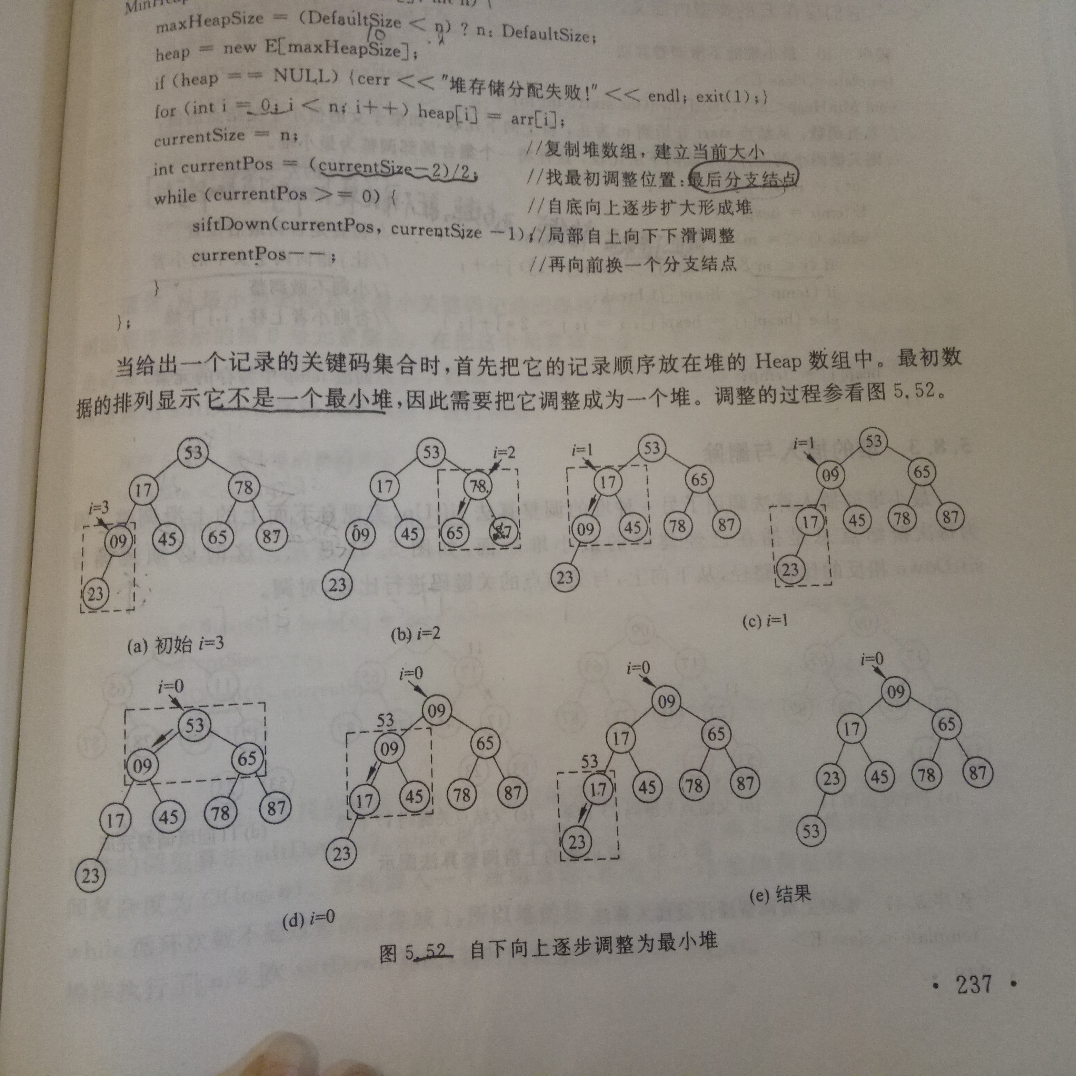
代码：
#include <iostream>
#include <assert.h>
using namespace std;

//最小堆 -建堆
#define DefaultSize 10

template<class E>
class MinHeap
{
public:
MinHeap(int sz=DefaultSize); //构造函数:建立空堆
MinHeap(E arr[],int n); //构造函数:通过一个数组建堆
~MinHeap(){delete []heap;}
bool Insert(const E& x);
bool Remove(E& x);
bool IsEmpty()const{return (currentSize == 0)?true:false;}
bool IsFull()const {return (currentSize ==maxHeapSize)? true:false;}
void makeEmpty(){currentSize =0;}

//template<class E>
friend ostream& operator<<(ostream& out,MinHeap<E>& H);
private:
E *heap;
int currentSize;
int maxHeapSize;
void siftDown(int start,int m);
void siftUp(int start);
};

template<class E>
MinHeap<E>::MinHeap(int sz)
{
maxHeapSize= (sz>DefaultSize)?sz:DefaultSize;
heap = new E[maxHeapSize];
assert(heap != NULL);
currentSize = 0;
}

template<class E>
MinHeap<E>::MinHeap(E arr[],int n) //n是数组的大小
{
maxHeapSize = (DefaultSize > n)? DefaultSize:n;
heap = new E[maxHeapSize];
assert(heap != NULL);
for(int i=0;i<n;i++) heap[i] = arr[i];
currentSize = n;
int currentPos = (currentSize -2)/2;
while(currentPos >= 0)
{
siftDown(currentPos,currentSize-1);
currentPos--;
}
}

template<class E>
void MinHeap<E>::siftDown(int start,int m)
{
int i=start;
int j=2*i+1;
E temp=heap[i];

while(j <= m)
{
if((j< m) && (heap[j] > heap[j+1])) j++;
if( temp <= heap[j]) break;
else{heap[i] = heap[j]; i=j;j=2*j+1;}
}
heap[i] = temp;
}

template<class E>
void MinHeap<E>::siftUp(int start)
{
int j=start;
int i=(j-1)/2;
E temp = heap[j];
while(j>0) //j不能是根节点
{
if(heap[i]<temp)break;
else
{
heap[j] = heap[i];
j = i;
i = (i-1)/2;
}
}
heap[j] = temp;
}

template<class E>
bool MinHeap<E>::Insert(const E& x)
{
if(IsFull() == true)return false;
heap[currentSize]=x;
siftUp(currentSize);
currentSize++;
return true;
}

template<class E>
bool MinHeap<E>::Remove(E& x)
{
if(IsEmpty() == true)return false;
x=heap[0];
heap[0]=heap[currentSize-1];
currentSize--;
siftDown(0,currentSize-1);
return true;
}

template<class E>
ostream& operator<<(ostream& out,MinHeap<E>& H)
{
out<<"当前堆的元素个数为："<<H.currentSize<<endl;
for(int i=0;i<H.currentSize;i++)
out<<i<<":"<<H.heap[i]<<endl;
return out;
}

- 最大堆
代码：
#include <iostream>
#include <assert.h>
using namespace std;

//最大堆
#define DefaultSize 10
template<class T>
class MaxHeap
{
public:
MaxHeap(int sz=DefaultSize);
MaxHeap(T arr[],int n);
~MaxHeap() {delete []heap;}
bool Insert(const T& x);
bool Remove(T& x);
bool IsEmpty()const{ return currentSize==0?true:false;}
bool IsFull() const{ return currentSize==maxHeapSize? true:false;}
void makeEmpty(){currentSize = 0;}

//template<class T>
friend ostream& operator<<(ostream& out,MaxHeap<T>& H);
private:
T* heap;
int currentSize;
int maxHeapSize;
void siftDown(int start,int m);
void siftUp(int start);

void Swap(const int i,const int j)
{ T tmp = heap[i]; heap[i] =heap[j]; heap[j] = temp;}
};

template<class T>
MaxHeap<T>::MaxHeap(int sz)
{
maxHeapSize = (sz > DefaultSize)? sz:DefaultSize;
heap = new T[maxHeapSize];
assert(heap != NULL);
currentSize=0;
}

template<class T>
MaxHeap<T>::MaxHeap(T arr[],int n)
{
maxHeapSize = (DefaultSize > n)? DefaultSize:n;
heap = new T[maxHeapSize];
assert(heap != NULL);
for(int i=0;i<n;i++)heap[i]=arr[i];
currentSize=n;
int currentPos=(currentSize -2)/2;
while(currentPos >= 0)
{
siftDown(currentPos,currentSize -1);
currentPos--;
}
}

template<class T>
void MaxHeap<T>::siftDown(const int start,const int m)
{
int i=start;
int j=2*i+1;
T temp= heap[i];
while(j<=m)
{
if(j<m && heap[j] < heap[j+1])j++;
if(temp >= heap[j])break;
else
{
heap[i] = heap[j];
i=j;
j=2*j+1;
}
}
heap[i] = temp;
}

template<class T>
void MaxHeap<T>::siftUp(int start)
{
int j=start,i =(j-1)/2;
T temp = heap[j];
while(j>0)
{
if(heap[i] >= temp)break;
else
{
heap[j] = heap[i];
j=i;
i=(i-1)/2;
}
}
heap[j]=temp;
}

template<class T>
bool MaxHeap<T>::Insert(const T& x)
{
if(IsFull() == true)return false;
heap[currentSize]=x;
siftUp(currentSize);
currentSize++;
return true;
}

template<class T>
bool MaxHeap<T>::Remove(T& x)
{
if(IsEmpty() == true)return false;
x=heap[0];
heap[0]=heap[currentSize-1];
currentSize--;
siftDown(0,currentSize-1);
return true;
}

template<class T>
ostream& operator<<(ostream& out,MaxHeap<T>& H)
{
out<<"当前堆的元素个数为："<<H.currentSize<<endl;
for(int i=0;i<H.currentSize;i++)
out<<i<<":"<<H.heap[i]<<endl;
return out;
}

