栈
栈通常被定义为只允许在表的末端进行插入或删除的线性表，允许插入的一端叫栈顶(top)，而不允许插入的一端叫栈底(bottom).
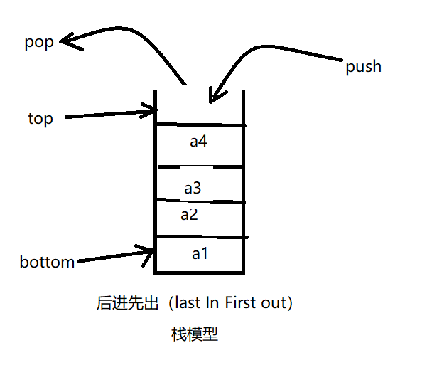
C++描述栈的抽象数据类型
const int maxSize=50;
//enum bool{false,true};

template <class T>
class Stack
{
public:
virtual void Push(const T& x) = 0;
virtual bool Pop(T& x) = 0;
virtual bool getTop(T& x)const = 0;
virtual bool IsEmpty()const = 0;
virtual bool IsFull()const = 0;
virtual int getSize()const = 0;
};

- 顺序栈
参考顺序表的成员：动态数组头指针elements,栈顶指针top（0-maxSize），最大容量maxSize;
源代码：
#include <iostream>
#include <assert.h>
using namespace std;

const int IncreamentStack=30;

template<class T>
class SeqStack
{
public:
SeqStack(int sz=20);
~SeqStack(){delete []elements;}
void Push(const T&ｘ);
bool Pop(T& x);
bool getTop(T& x);
bool IsEmpty(){ return top==-1? true: false;}
bool IsFull() { return top==(maxSize-1)? true:false; }
int getSize(){return top+1;}
void makeEmpty(){ top=-1;}

template<class T>
friend ostream& operator<<(ostream& out,SeqStack<T>& s);
private:
int top;
T* elements;
int maxSize;
void overflowProcess();
};

template<class T>
SeqStack<T>::SeqStack(int sz)
{
maxSize=sz;
top=-1;
elements=new T[maxSize];
assert(elements != NULL);
}

template<class T>
void SeqStack<T>::Push(const T& x)
{
if(IsFull() == true)overflowProcess();
elements[++top]=x;
}

template<class T>
bool SeqStack<T>::Pop(T& x)
{
if(IsEmpty() == true)return false;
x=elements[top--];
return true;
}

template<class T>
bool SeqStack<T>::getTop(T& x)
{
if(IsEmpty() == true)return false;
x=elements[top];
return true;
}

template<class T>
ostream& operator<<(ostream& out,SeqStack<T>& s)
{
out<<"top是："<<s.top<<endl;
out<<"栈大小是："<<s.getSize()<<endl;
for(int i=0;i<=s.top;i++)
out<<i<<":"<<s.elements[i]<<endl;
return out;
}

/*
template<class T>
void SeqStack<T>::overflowProcess() //溢出补救函数
{
T* newArray = new T[maxSize+IncreamentStack];
assert(newArray != NULL);
T* srcptr = elements;
T* destptr= newArray;
int n=top+1;
while(n--)
{
*destptr++=*srcptr++;
}
maxSize=maxSize+IncreamentStack;
delete[] elements;
elements=newArray;
}*/

template<class T>
void SeqStack<T>::overflowProcess()
{
T *newArray = new T[maxSize+stackIncreament];
if(newArray == NULL){cerr<<"存储分配失败"<<endl;exit(1);}
for(int i=0;i<=top;i++)
{
newArray[i]=elements[i];
}
maxSize=maxSize+stackIncreament;
delete []elements;
elements=newArray;
}

- 链栈
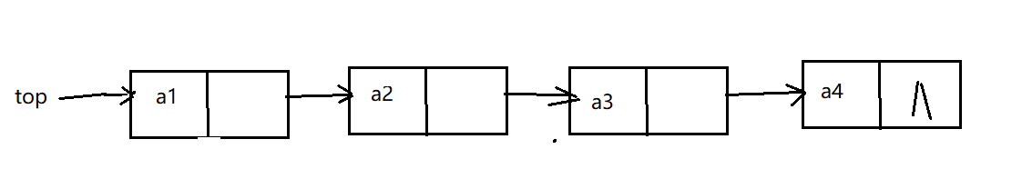
解读：不带头节点，只允许头插和头删的单链表

源代码：

#include "List.h" //引入链表的头文件，线性表的文件里

template<class T>
class LinkedStack
{
public:
LinkedStack():top(NULL){}
~LinkedStack(){makeEmpty();}
void Push(const T& x);
bool Pop(T& x);
bool getTop(T& x);
bool IsEmpty(){return (top == NULL)?true:false;}
bool IsFull() {return false;}
int getSize()const;
void makeEmpty();

template<class T>
friend ostream& operator<<(ostream& out,LinkedStack<T>& s);
private:
LinkNode<T>* top;
};

template<class T>
void LinkedStack<T>::Push(const T& x)
{
top=new LinkNode<T>(x,top);
assert(top != NULL);
}

template<class T>
bool LinkedStack<T>::Pop(T& x)
{
if(IsEmpty() == true)return false;
LinkNode<T> *p = top;
x=top->data;
top=top->link;
delete p;
return true;
}

template<class T>
void LinkedStack<T>::makeEmpty()
{
LinkNode<T>* p;
while(top != NULL)
{
p=top;
top=top->link;
delete p;
}
}

template<class T>
int LinkedStack<T>::getSize()const
{
int count=0;
LinkNode<T>* p=top;
while(p != NULL)
{
p=p->link;
count++;
}
return count;
}

template<class T>
bool LinkedStack<T>::getTop(T& x)
{
if(IsEmpty()==true)return false;
x=top->data;
return true;
}

template<class T>
ostream& operator<<(ostream& out,LinkedStack<T>& L)
{
out<<"栈中元素个数："<<L.getSize()<<endl;
LinkNode<T>* p=L.top;
while(p != NULL)
{
out<<p->data<<"->";
p=p->link;
}
out<<"nul"<<endl;
return out;
}

