排序
- 堆排
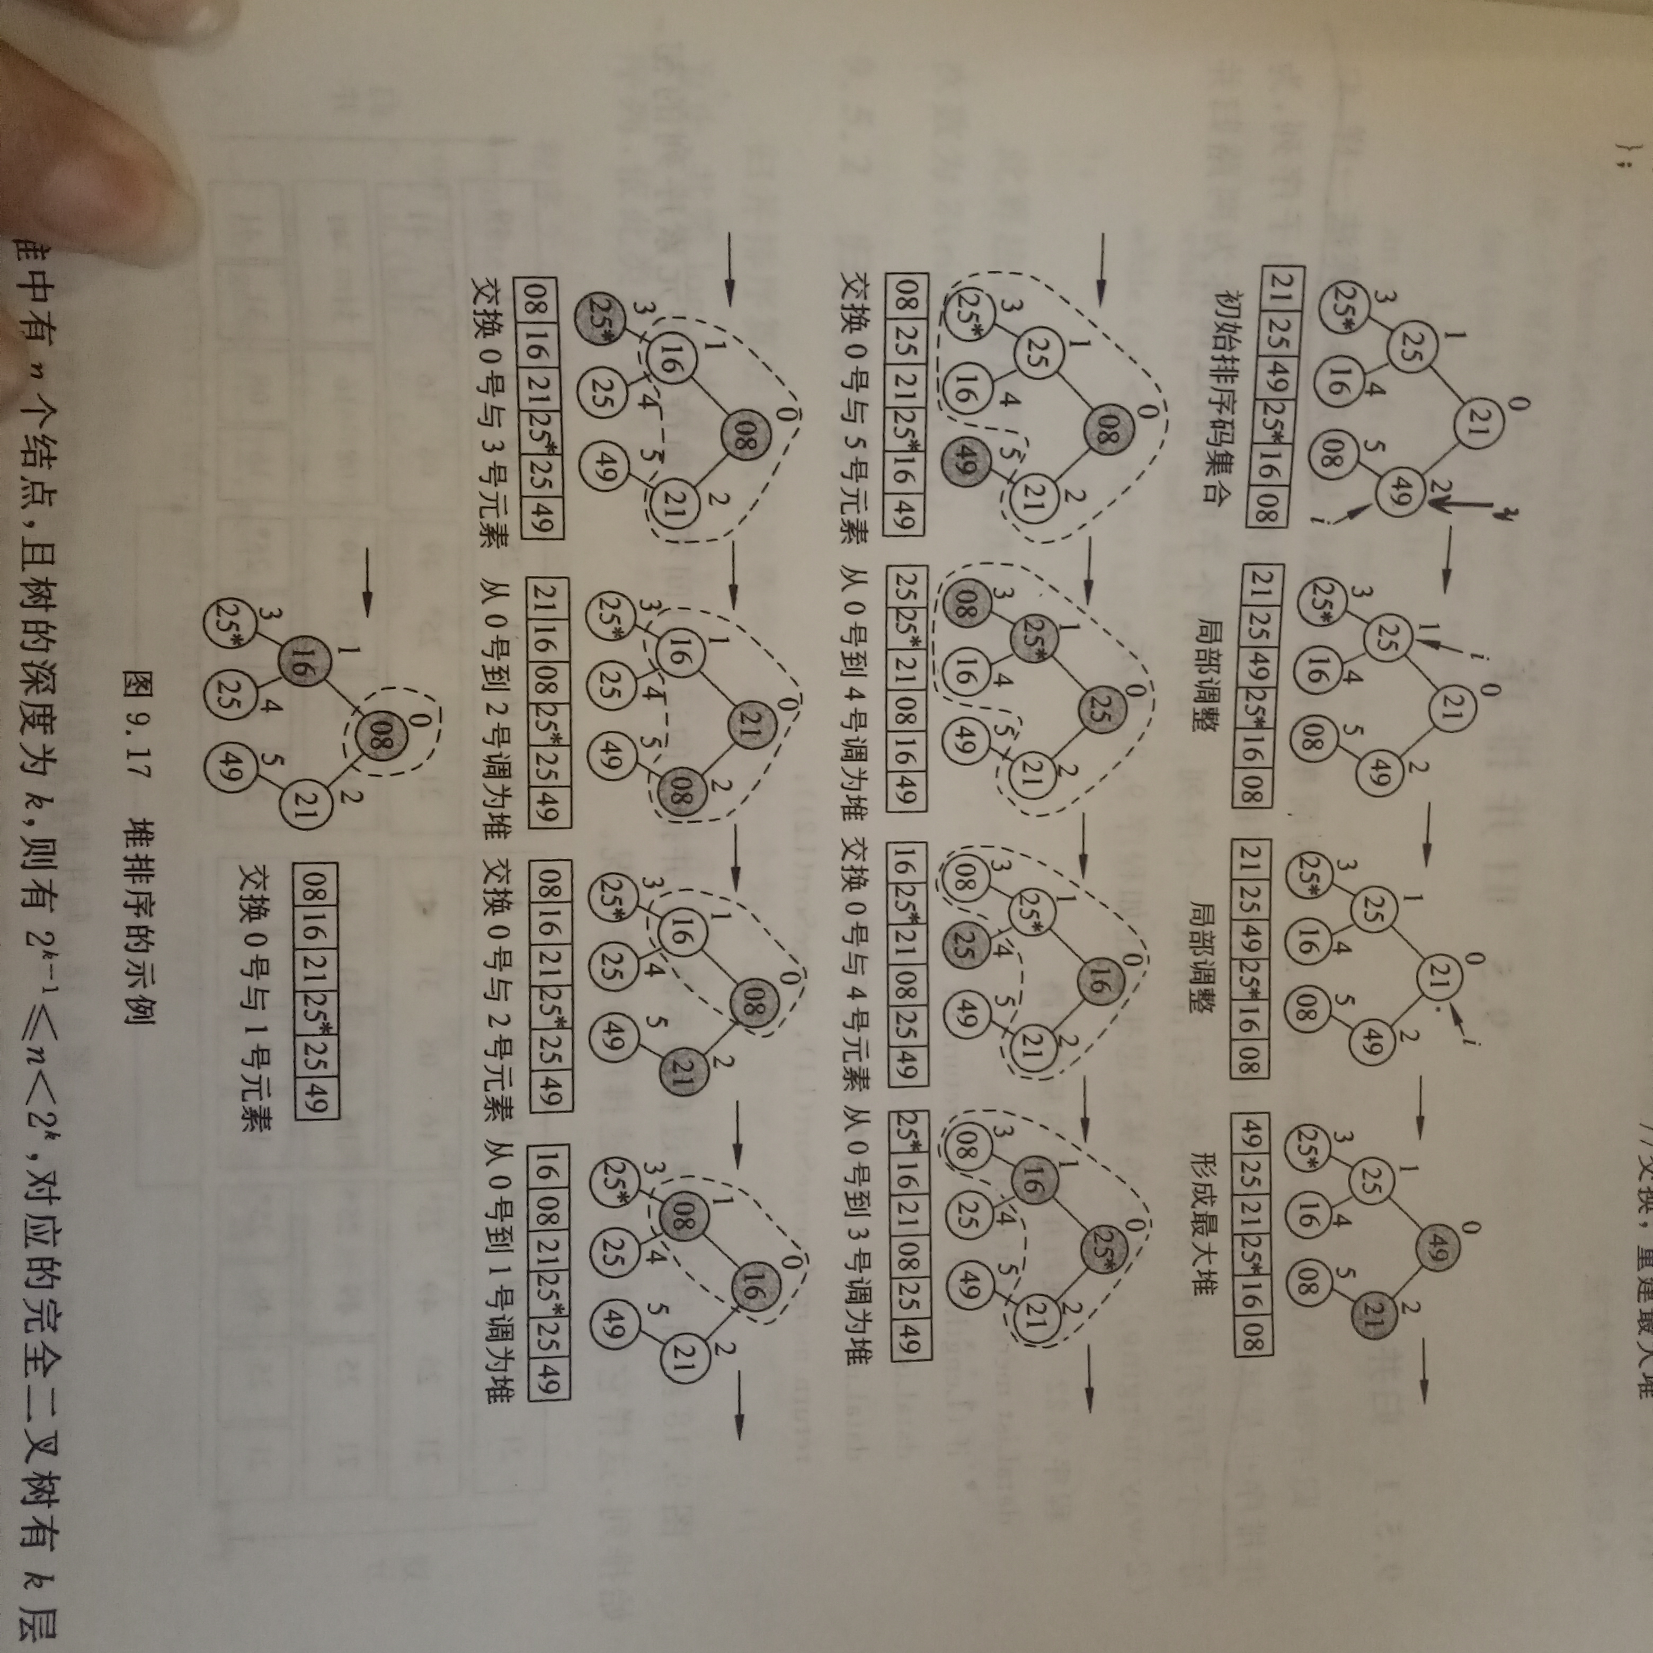
- //最大堆
- #define DefaultSize 10
- template<class T>
- class MaxHeap
- {
- public:
- MaxHeap(int sz=DefaultSize);
- MaxHeap(T arr[],int n);
- ~MaxHeap() {delete []heap;}
- bool Insert(const T& x);
- bool Remove(T& x);
- bool IsEmpty()const{ return currentSize==0?true:false;}
- bool IsFull() const{ return currentSize==maxHeapSize? true:false;}
- void makeEmpty(){currentSize = 0;}

- template<class T>
- friend void HeapSort(MaxHeap<T>& H); //堆排要借助最大堆的下滑//函数,所以必须弄成友元或者成员函数.
- template<class T>
- friend ostream& operator<<(ostream& out,MaxHeap<T>& H);
- private:
- T* heap;
- int currentSize;
- int maxHeapSize;
- void siftDown(int start,int m);
- void siftUp(int start);

- void Swap(const int i,const int j) //大写Swap：库里面也有交换函数，一定不能打错为swap()；
- { T temp = heap[i]; heap[i] =heap[j]; heap[j] = temp;}
- };

- template<class T>
- MaxHeap<T>::MaxHeap(int sz)
- {
- maxHeapSize = (sz > DefaultSize)? sz:DefaultSize;
- heap = new T[maxHeapSize];
- assert(heap != NULL);
- currentSize=0;
- }

- template<class T>
- MaxHeap<T>::MaxHeap(T arr[],int n)
- {
- maxHeapSize = (DefaultSize > n)? DefaultSize:n;
- heap = new T[maxHeapSize];
- assert(heap != NULL);
- for(int i=0;i<n;i++)heap[i]=arr[i];
- currentSize=n;
- int currentPos=(currentSize -2)/2;
- while(currentPos >= 0)
- {
- siftDown(currentPos,currentSize -1);
- currentPos--;
- }
- }

- template<class T>
- void MaxHeap<T>::siftDown(const int start,const int m)
- {
- int i=start;
- int j=2*i+1;
- T temp= heap[i];
- while(j<=m)
- {
- if(j<m && heap[j] < heap[j+1])j++;
- if(temp >= heap[j])break;
- else
- {
- heap[i] = heap[j];
- i=j;
- j=2*j+1;
- }
- }
- heap[i] = temp;
- }

- template<class T>
- void MaxHeap<T>::siftUp(int start)
- {
- int j=start,i =(j-1)/2;
- T temp = heap[j];
- while(j>0)
- {
- if(heap[i] >= temp)break;
- else
- {
- heap[j] = heap[i];
- j=i;
- i=(i-1)/2;
- }
- }
- heap[j]=temp;
- }

- template<class T>
- bool MaxHeap<T>::Insert(const T& x)
- {
- if(IsFull() == true)return false;
- heap[currentSize]=x;
- siftUp(currentSize);
- currentSize++;
- return true;
- }

- template<class T>
- bool MaxHeap<T>::Remove(T& x)
- {
- if(IsEmpty() == true)return false;
- x=heap[0];
- heap[0]=heap[currentSize-1];
- currentSize--;
- siftDown(0,currentSize-1);
- return true;
- }

- template<class T>
- ostream& operator<<(ostream& out,MaxHeap<T>& H)
- {
- out<<"当前堆的元素个数为："<<H.currentSize<<endl;
- for(int i=0;i<H.currentSize;i++)
- out<<i<<":"<<H.heap[i]<<endl;
- return out;
- }

- template<class T>
- void HeapSort(MaxHeap<T>& H)
- {
- int i;
- for( i=(H.currentSize-2)/2; i >= 0;i--)
- H.siftDown(i,H.currentSize-1);
//其实不要这两句也可，弄成友元函数后，传入的参数H必定已经是最大堆

- for(i=H.currentSize-1;i>=0;i--)
- {
- //int a=0;
- H.Swap(0,i);
- H.siftDown(0,i-1);
- }
- }

- //测试函数
- void main()
- {
- int arr[]={53,17,78,9,45,65,87,23};
- int n=sizeof(arr)/sizeof(int);
- MaxHeap<int> H(arr,n);
- cout<<H;
- HeapSort(H);
- cout<<H;
- }

2.快速排序
template<class T>
void QuickSort(T a[],const int left,const int right) //left =0;right=n
{
if(right > left)
{
int pivotpos=Partition(a,left,right);
QuickSort(a,left,pivotpos-1);
QuickSort(a,pivotpos+1,right);
}
}

template<class T>
int Partition(T v[],const int low,const int high)
{
int pivotpos=low;
T pivot=v[low];
for(int i=low+1;i<=high;i++)
if(v[i] < pivot)
{
pivotpos++;
if(pivotpos != i)Swap(v[pivotpos],v[i]);
}
v[low] = v[pivotpos];
v[pivotpos] = pivot;
return pivotpos;
}

template<class T>
void Swap(T& a,T& b)
{
T temp;
temp=a;
a=b;
b=temp;
}

3.冒泡排序
typedef int T;
void BubbleSort(T* v,int n)
{
for(int i=1;i<n;i++) //总体排序n个数，要比较n-1趟；
for(int j=n-1;j>=i;j--) //每一趟比较n-i次
if(v[j-1] > v[j])
{
T temp=v[j-1];
v[j-1] = v[j];
v[j] = temp;
}
}
4.希尔排序
//希尔排序
typedef int T;
void ShellSort(T v[],const int left,const int right)//left =0 ;right=n(数组长度)
{
int j,gap=right-left;
T temp;
do
{
gap= gap/3+1;
for(int i=left+gap;i<right;i++)
if(v[i] < v[i-gap])
{
temp=v[i];
j=i-gap;
do
{
v[j+gap]=v[j];
j=j-gap;
}while(j>= left && temp<v[j]);
v[j+gap] = temp;
}
}while(gap>1);
}

5.插入排序
1>直接插入排序
//直接插入排序
typedef int T;
void InsertSort(T L[],const int left,const int right)
{
T temp;
int i,j;
for(i=left+1;i<right;i++) //主程序要执行N-1次
if(L[i] < L[i-1] )
{
temp=L[i];
j=i-1;
do
{
L[j+1] = L[j];
j--;
}while(j >= left && temp<L[j]);
L[j+1] = temp;
}
}
2>二分法插入排序
//二分插入排序
typedef int T;
void BinaryInsertSort(T L[],const int left,const int right)
{
T temp;int i,low,high,middle,k;
for(int i=left+1;i<right;i++)
{
temp=L[i];
low = left;
high = i-1;
while(low <= high)
{
middle=(low+high)/2;
if(temp <L[middle])
high=middle-1;
else low=middle+1;
}
for(k=i-1;k>=low;k--)L[k+1]=L[k];
L[low]=temp;
}
}

6.选择排序
typedef int T;
void SelectSort(T v[],const int left,const int right) //left =0 ;right=n(数组长度)

{
for(int i=left;i< right-1;i++) //执行N-1次
{
int k=i;
for(int j=i+1;j<=right-1;j++)
if(v[j]<v[k])k=j; //k总是最小元素的下标
if(k != i){ T tmp; tmp=v[i];v[i]=v[k];v[k]=tmp;}
}
}

