Class Scores Report

# Scores Rank

|  |  |  |  |  |
| --- | --- | --- | --- | --- |
| Name | Id | Chinese | Math | English |
| 华奕轩 | 201921 | 97.5 | 77.0 | 100.0 |
| 蔡奕扬 | 201902 | 89.0 | 96.0 | 98.0 |
| 杨孟凡 | 201914 | 92.0 | 69.0 | 96.0 |
| 王承彦 | 201910 | 94.5 | 90.0 | 96.0 |
| 李文琪 | 201912 | 97.0 | 91.0 | 96.0 |
| 屠佳佳 | 201934 | 92.5 | 92.0 | 96.0 |
| 钱梓暄 | 201932 | 96.0 | 97.0 | 96.0 |
| 查宇航 | 201917 | 97.5 | 97.0 | 96.0 |
| 霍懿昕 | 201926 | 97.5 | 86.0 | 95.0 |
| 葛逸玮 | 201920 | 94.5 | 77.0 | 94.0 |
| 包静宜 | 201928 | 97.0 | 79.0 | 94.0 |
| 杨之文 | 201929 | 68.0 | 93.0 | 93.0 |
| 周智宸 | 201909 | 85.0 | 68.0 | 92.0 |
| 席庆 | 201908 | 83.0 | 77.0 | 92.0 |
| 戴逸辰 | 201922 | 65.0 | 93.0 | 91.0 |
| 毛瑜彤 | 201925 | 96.0 | 96.0 | 91.0 |
| 王慧茹 | 201923 | 98.0 | 99.0 | 91.0 |
| 金佳琪 | 201937 | 86.0 | 88.0 | 90.0 |
| 周越芊 | 201931 | 92.5 | 90.0 | 90.0 |
| 王斌臣 | 201903 | 93.5 | 94.0 | 90.0 |
| 陶永胜 | 201916 | 98.0 | 95.0 | 90.0 |
| 刘可馨 | 201927 | 95.0 | 100.0 | 90.0 |
| 施浩林 | 201918 | 90.0 | 95.0 | 89.0 |
| 潘音琪 | 201936 | 88.5 | 79.0 | 87.0 |
| 邹锐 | 201919 | 86.5 | 81.0 | 86.0 |
| 张宇凡 | 201933 | 89.5 | 87.0 | 86.0 |
| 朱国煜 | 201906 | 94.0 | 97.0 | 86.0 |
| 金熙晨 | 201915 | 89.0 | 76.0 | 84.0 |
| 颜宇晨 | 201904 | 78.5 | 79.0 | 84.0 |
| 罗倩霞 | 201924 | 91.0 | 87.0 | 83.0 |
| 毛骐耀 | 201905 | 88.0 | 97.0 | 79.0 |
| 张晨阳 | 201901 | 96.5 | 94.0 | 78.0 |
| 蒋梓昊 | 201907 | 94.5 | 97.0 | 72.0 |
| 沈一凡 | 201911 | 92.5 | 95.0 | 69.0 |
| 陈沫兰 | 201930 | 87.5 | 61.0 | 68.0 |
| 陆俊祺 | 201913 | 83.0 | 55.0 | 64.0 |
| 沈琪 | 201935 | -1.0 | -1.0 | -1.0 |
| 程梓涵 | 201938 | -1.0 | -1.0 | -1.0 |

# Scores District

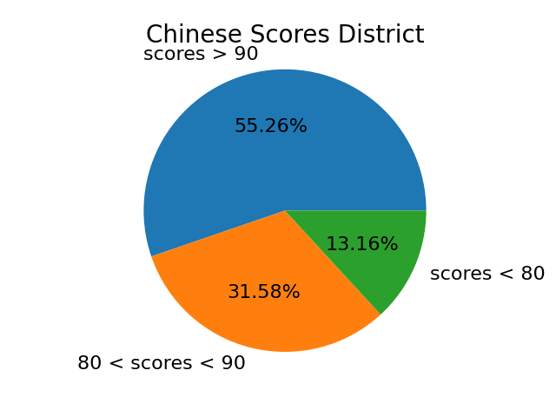

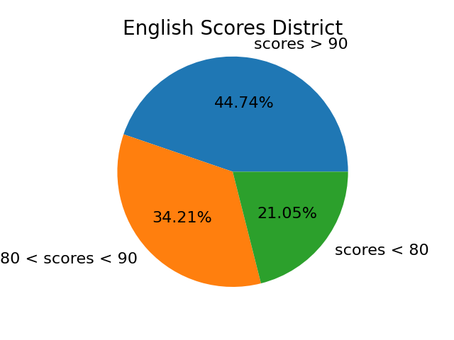

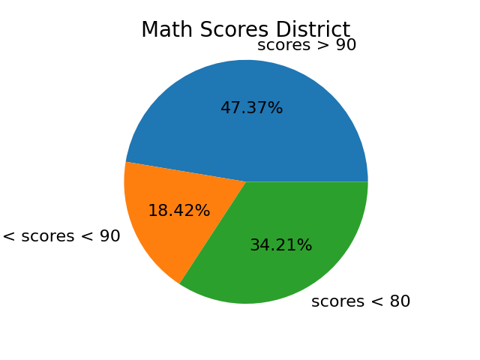

# Average and Median

|  |  |  |
| --- | --- | --- |
|  | Average | Median |
| Chinese | 85 | 92.5 |
| Math | 82 | 88.0 |
| English | 83 | 90.0 |