Pinocchio Design Specifications: Admin

1. Page Defaults
   1. Header bar
      1. Link to Index Page (2)
      2. Link to User Admin Page (3)
      3. Link to Round Admin Page (4)
      4. Link to Team Admin Page (5)
      5. Link to Question Admin Page (6)
      6. Link to Questionnaire Admin Page (7)
      7. Link to File Manager Page (8)
      8. Link to Server Manager Page (9)
   2. Footer Bar
      1. Copyright Information
      2. Log Out: returns the user to the log in page
2. Index Page
   1. Welcome
      1. Wizard Button: Starts the wizard.

i

* 1. Interesting Information
     1. Pinocchio Description
        1. Link to University of Pretoria
     2. Development team information
        1. Link to page about the development team

1. User Admin Page
   1. User Registration (Manual)

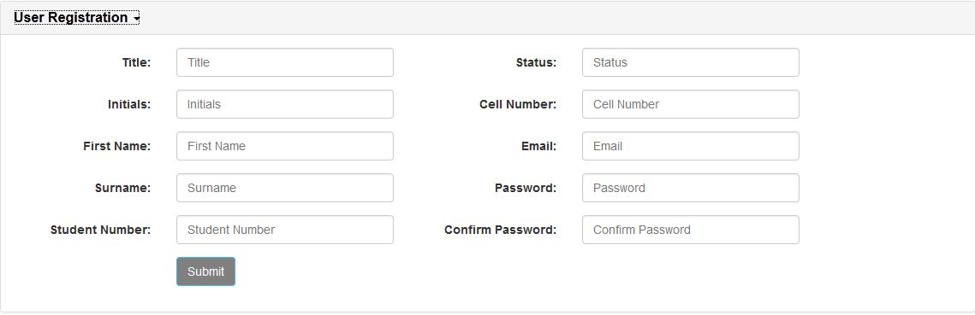

User details are input one by one.

* + 1. Submit: user details given are entered into the user database as a new entry.
  1. 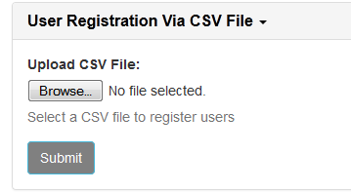
  2. User Registration (Via CSV File)
     1. Browse: Opens pop-up to select a CSV file to upload
     2. Submit: Uploads the CSV file and enters contained details into the user database as new entries
  3. 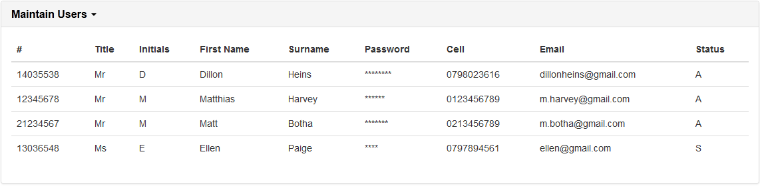Maintain Users

Current user information is retrieved from the user database and is displayed here. When “Submit” (3.a.i and 3.b.ii) is clicked, the new user information will automatically be displayed here.

1. Round Admin Page
   1. Create Round

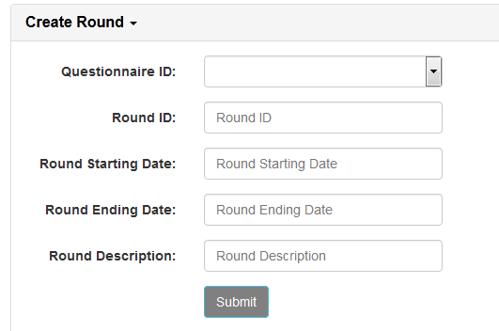Round information is entered in (a previously used Questionnaire ID can be used by using the drop down (i). When “Submit” (ii) is clicked, the information will be used to create a new entry in the questionnaire database

* 1. 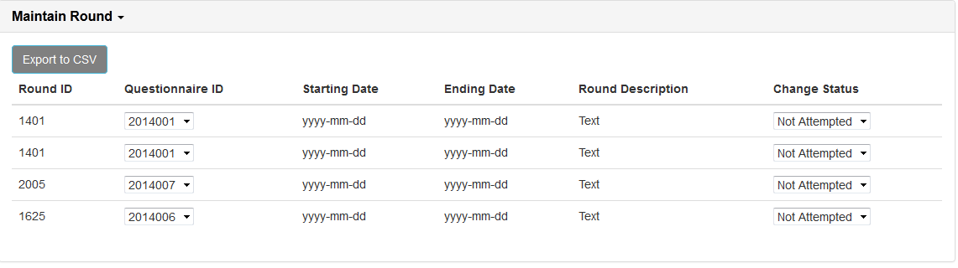Maintain Round

Displays Current questionnaire details

* + 1. Export to CSV: exports all details to a CSV file
    2. Questionnaire ID: allows for the manual changing of a questionnaire’s ID. Changes are reflected in the database.
    3. Change Status: Changes the status of a questionnaire. Changes are reflected in the database.

1. 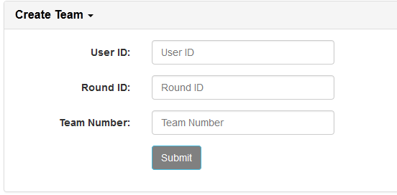Team Admin Page
   1. Create Team (manual)

Team details are manually entered in one by one.

* + 1. 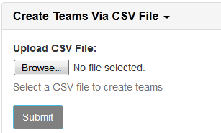Submit: Enters details into the team database as a new entry
  1. Create Team (Via CSV File)
     1. Browse: Opens pop-up to select a CSV file to upload
     2. Submit: Uploads selected CSV file and uses data therein to create new entries in the team database
  2. 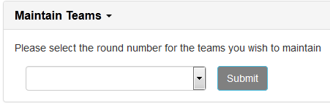Maintain Teams
     1. Dropdown selection: Select the round for which teams you wish to edit.
     2. Submit: Opens the team maintenance window.

1. Question Admin Page
   1. 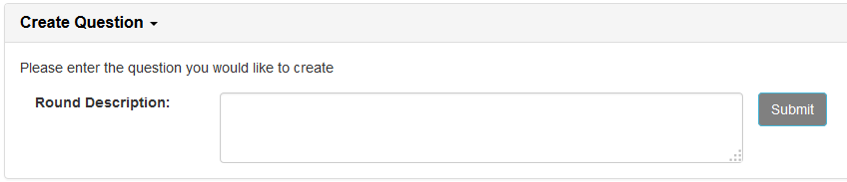Create Question
      1. Text Area: The question is typed in here. HTML tags are allowed to edit the text.
      2. Submit: takes the entered text and uses it to create a new entry in the question database.