Brochure, 2017-11-20

Contents

1 Save money! 1

2 Workshops and advisory tracks 4

2.1 Workshop: content strategy 6

2.2 Workshop: house style (styleguide) 6

2.3 Workshop: quality management 7

2.4 Workshop: terminology 7

2.5 Workshop: content creation and maintenance 7

2.5.1 Specification management 8

2.6 Advisory track: organizaton 8

2.7 Advisory track: technology and tools 8

3 Methode 8

3.1 Working with models 9

4 Appendix 10

4.1 The organization maturity model 10

4.2 Competences for development of information products model 12

4.3 Language proficiency 13

5 About Constant Gordon 19

5.1 Experience with processes for documentation and information 19

5.1.1 Getting ready 19

5.2 Experience 20

5.3 Presentations 20

5.4 Mission, vision & values 21

# 1 Save money!

Do your **engineers** spend too much time on documentation and specifications instead of developing?

* Or worse, are your **customers** complaining about missing information or inconsistencies?

Or even more worse, do they **not buy** because your information is difficult to comprehend?

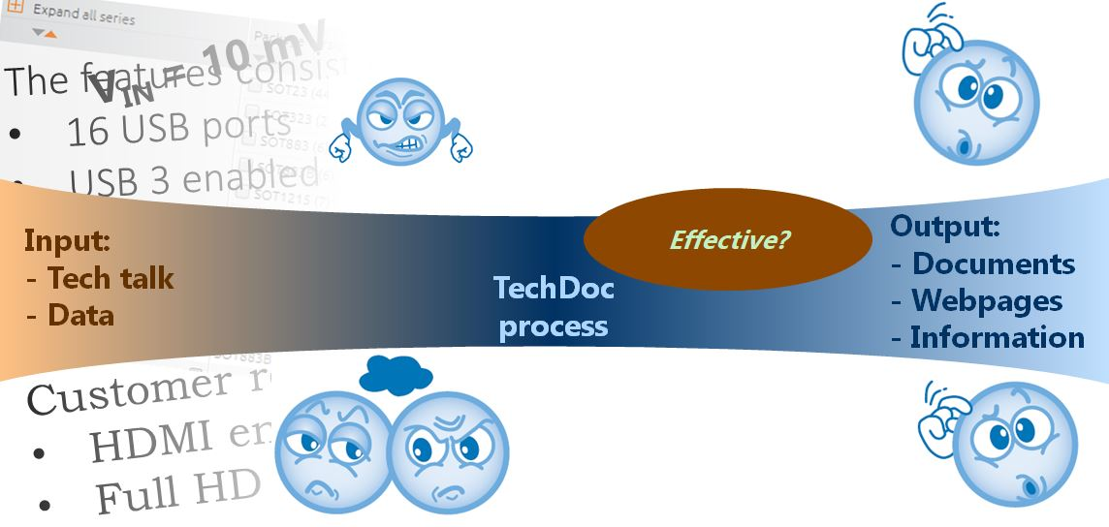

During my career I have been working to solve these issues by organizing teams, changing processes and technologies. Let me help you and your team find the opportunities to achieve the comfortable feeling that your process is working and future proof.

Common problems and solutions

Sales support often receives questions on subjects, that the technical documentation should explain. Answering questions takes much energy in the sales support activities which is better spent on more ***effective*** documentation.

* A well-defined content strategy ensures that all relevant information is captured in a structure that enables users to find answers to their questions as quickly as possible.

The documents seem to come from different companies, they lack charisma.

* A styleguide defines look & feel as well as writing style and aims to produce a consistent presentation throughout all information.
* Terminology management is invaluable to ensure a consistent user experience but is also very helpful for internal processes and information retrievability.

The information seems to come from multiple sources which lead to misunderstanding and questions at customer services.

* Quality management is needed to ensure that the information created adheres to the house style as defined.

The people who contribute to the documentation see the documentation work as a lowest priority task.

The documentation is never finished in time and it is never quite clear why it is delayed.

The product portfolio contains multiple, similar products which are updated regularly and it is difficult to find the right information when questions arise.

The document creation and maintenance process helps the content retrievability, to ensure timely information creation, to achieve the quality levels as defined and the information completeness as defined in the content strategy.

|  | |
| --- | --- |
|  |  |

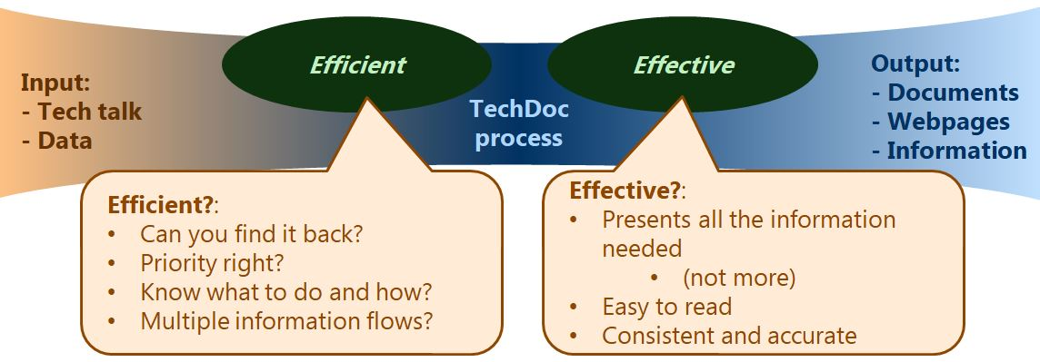

Technical documentation is a part of a product, not something that goes with it like the packaging.

* Often, the technical documentation is consulted before purchase.

Good, ***effective*** technical documentation helps to build confidence in the products or services to be delivered, while inconsistent and unclear information gives little confidence.

Documentation effectiveness impacts the total experience of the customer and as such influences the purchase.

* ***Effective*** documentation is:
  + Easy to read
  + Consistent and accurate
  + Presents the information needed

# 2 Workshops and advisory tracks

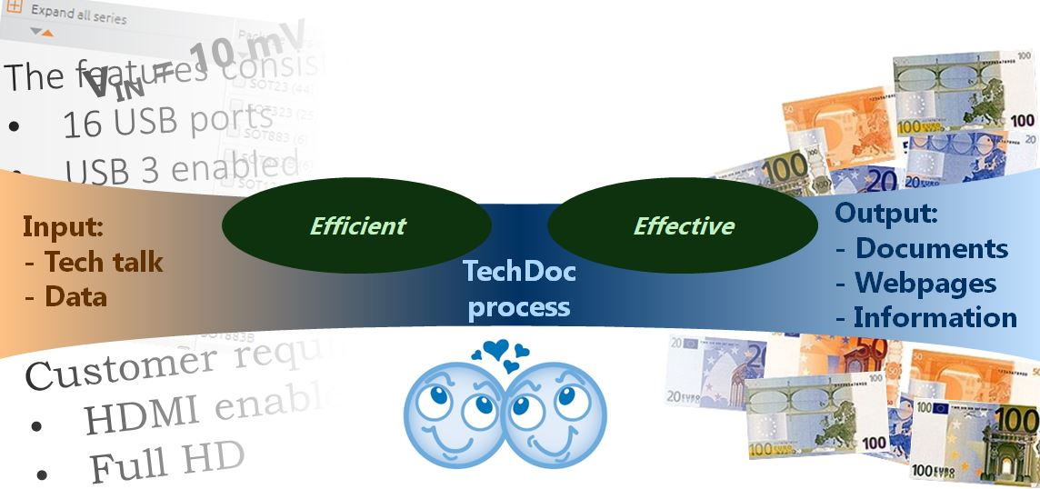

Creating ***effective*** documentation in an ***efficient*** manner requires the right skills and the right environment.

With a selection of workshops and advisory tracks, an optimum solution can be arranged to match skills, environment and requirements.

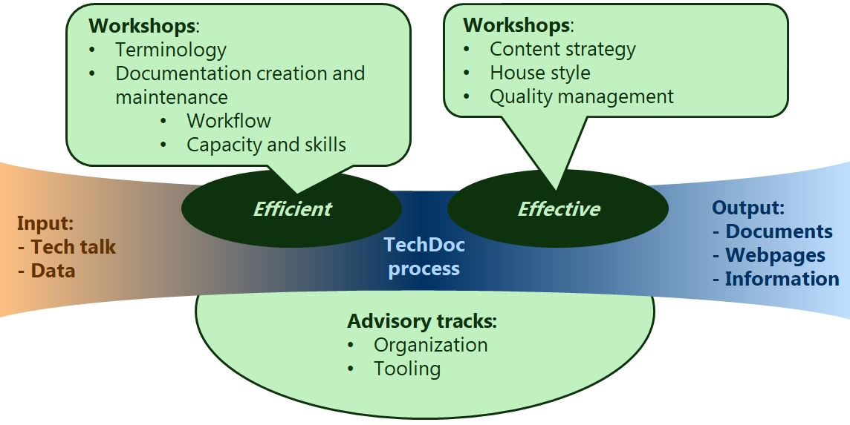

| Workshop | Content |
| --- | --- |
| Content strategy | Define content elements, content structure, distribution and document types needed for your customers. How the information is created, from which sources, the publication timing and means is part of a sustainable strategy. |
| House style | Establish the relevant elements of language, style, standardization of terminology next to the fonts and page design. The workshop hints on the processes to adhere to the house style. |
| Quality management | During the workshop the various aspects of quality such as correctness, readability and document management will be visited aiming to establish a quality management roadmap. |
| Terminology management | During the workshop we will investigate which elements of terminology apply to your domain and how you can manage your terminology. |
| Document creation and maintenance | The workflow for document creation, information gathering and assembly, revising and managing the documentation projects will be discussed aiming to establish (or simplify!) a workflow and the skillsets required in each part. |
| Advisory track | Content |
| Organization for documentation and product information | During an organization advisory track all elements of the technical documentation creation processes will be reviewed, including the needs for the specific workshops. |
| Technology and tooling | During a tooling advisory track all contributing content and source delivery systems will be reviewed and how the contribution is optimized. |

## 2.1 Workshop: content strategy

A well-defined content strategy ensures that all relevant information is captured in a structure that enables users to find answers to their questions as quickly as possible.

The content strategy defines document types and content elements needed for your customers and possibly internal processes. A sustainable strategy includes the process, how the information is created, from which sources and the publication timing and means.

In the workshop we will:

* Define content elements, content structure, distribution and document types needed for your customers. How the information is created, from which sources, the publication timing and means is part of a sustainable strategy.

In the workshop we will use a content strategy model to cover the most important aspects of the content strategy model.

Content strategy model

* Content topics (customers needs)
* Information grouping / navigation / document types
* Content creation processes / sources
* Publication / content delivery channels

## 2.2 Workshop: house style (styleguide)

A styleguide defines look & feel as well as writing style and aims to produce a consistent presentation throughout all information.

The most visible aspect of the styleguide is usually the look and feel of the documents and the website of a company.

Language, style, standardization of terminology are less visible parts of the house style but are equally important for a consistent user experience.

During the workshop we will:

* Establish the relevant elements of language, style, standardization of terminology next to the fonts and page design. The workshop hints on the processes to adhere to the house style.

During the workshop we will use a content impact model to ensure all aspects are covered.

Content impact model

* Writing style, including language proficiency
* Image style
* Page layout
* Terminology

## 2.3 Workshop: quality management

Quality management is needed to ensure that the information created adheres to the house style as defined.

More aspects of quality include timely availability, correctness, readability and information retrievability but are less visible for the user.

During the workshop the various aspects of quality such as correctness, readability and document management will be visited aiming to establish a quality management roadmap.

Quality control model

* Quality standard
* Measurement
* Feedback
* Reporting

## 2.4 Workshop: terminology

Terminology management is invaluable to ensure a consistent user experience but is also very helpful for internal processes and information retrievability.

Terminology is an element of house style as it has effect on the customer perception of your information. But as important is its effect on internal processes. Consistent terminology supports content management and information findability.

During the workshop we will investigate which elements of terminology apply to your domain and how you can manage your terminology.

## 2.5 Workshop: content creation and maintenance

The document creation and maintenance process helps the content retrievability, to ensure timely information creation, to achieve the quality levels as defined and the information completeness as defined in the content strategy.

The workflow for document creation, information gathering and assembly, revising and managing the documentation projects will be discussed aiming to establish (or simplify!) a workflow and the skillsets required in each part.

During the workshop we will use the organization maturity model

Organization maturity model

* Marketing, know what you need to do.
* Production / delivery, make sure the work is done.
* Development, know how to do it.
* Maintenance, make sure it works.

### 2.5.1 Specification management

Specification management is a special case within content creation as it involves multiple disciplines within the company and the information is both internal and external usable.

Specifications are originated in the product development, Specifications are maintained and validated by quality engineers. The specification targets are set by marketing and sales and have constraints coming from external standardization. This makes specifications organizational the most complex part of documentation.

Specifications will be compared with competing products, both internal as well as external products. Sometimes you want comparison to be easy (so standardize) and sometimes it is better if this is difficult depending on the market situation.

## 2.6 Advisory track: organizaton

During an organization advisory track all elements of the technical documentation creation processes will be reviewed, including the needs for the specific workshops.

Interim management is an option during such an advisory track.

## 2.7 Advisory track: technology and tools

During a tooling advisory track all contributing content and source delivery systems will be reviewed.

An advice, how the delivery systems and the receiving systems can be optimized and how to handle the changes in the organization will be provided.

# 3 Methode

Each workshop and advisory track will be mapped to the specific requirements to deliver an optimal solution.

| Phase | Workshop | Advisory track |
| --- | --- | --- |
| Analysis | Identify current working practices, goals, ambitions and limitations.  Identify best in class examples. | |
| Planning | Align goals, ambitions and limitations. | Align goals, ambitions and limitations and define improvement tracks and alternatives. |
| Execution | Conduct the workshop | Implementation of these improvement tracks supported with workshops and coaching.  Depending on the specific situation, interim management is a option. |

## 3.1 Working with models

Working with models helps to analyse the way of working.

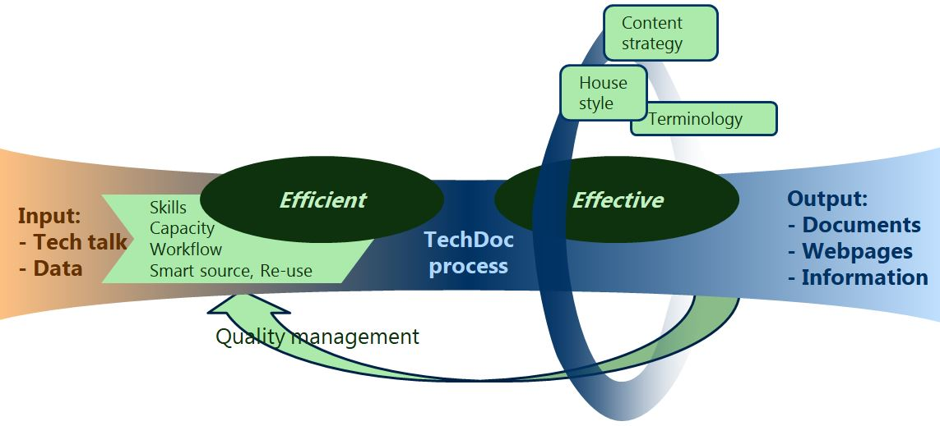

In the ideal ***efficient*** organization delivering ***effective*** content to the users you will recognize these models:

| Organization | Process | Content |
| --- | --- | --- |
| *Know how to do what you need to do.*  Organization maturity model   * Marketing, know what you need to do. * Production / delivery, make sure the work is done. * Development, know how to do it. * Maintenance, make sure it works. | *Ensure you deliver as planned.*  Quality control model   * Quality standard * Measurement * Feedback * Reporting | *Know what you have to do.*  Content strategy model   * Content topics (customers needs) * Information grouping / navigation / document types * Content creation processes / sources * Publication / content delivery channels |
| *Have the right approach.*  User centric maturity model (Dutch government: Gebruiker centraal volwassenheidsmodel)   * Management * Knowledge / skills * UX Methodes * Means * User impact | *Know what your product is.*  Content impact model   * Writing style, including language proficiency * Image style * Page layout * Terminology |

# 

# 4 Appendix

## 4.1 The organization maturity model

The technical documentation organization, a company within a company.

Documentation creation and maintenance can be seen as a mini production company within your company and has all elements of a regular production company. Next to the product flow from input material to sales ready product there is an information stream that makes sure the end result is according to specifications.

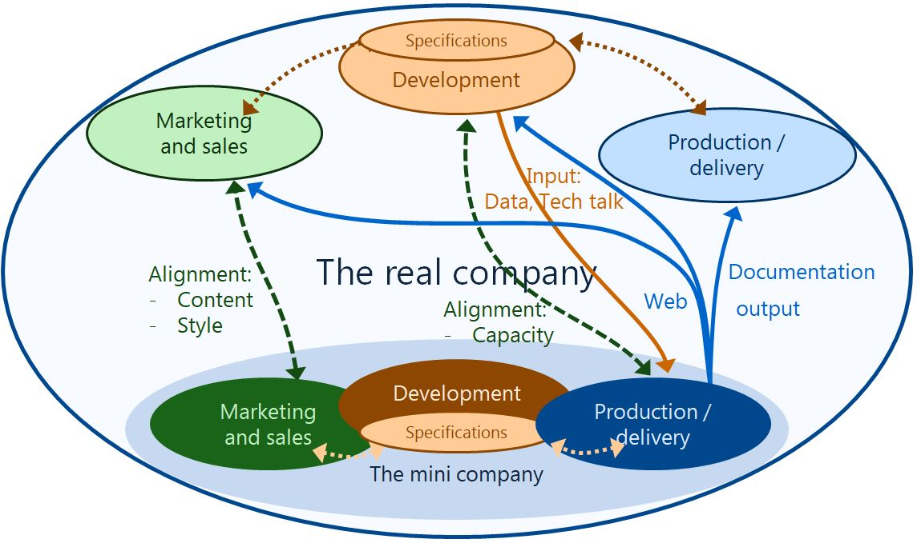

Table 1: The technical documentation company

| Marketing and sales | Development / maintenance | Production |
| --- | --- | --- |
| * Contact with the "real" sales and **marketing** to align requirements for   + Presentation   + Information objects   + Quality and standardisation requirements * Contact with the **lawyers** to meet the appropriate legal requirements * Contact with the **development** projects within the company, capacity alignment | * **Technology**   A balanced choice between tools and processes with the required means and guidelines.   * **Craftsmanship**   How to maintain the craftsmanship during illness, replacements, transfers of staff. | * **Shop floor control** or project management. Possibly translation management * **Specification management** may require specific attention as it connects product development, product and process quality control and marketing. * **Text creation**   Converting tech talk to information   * **Illustrations**   A picture is worth 1000 words   * **Quality** control and terminology managements |

For each element of this documentation production "company" multiple solutions are possible. The marketing and development area’s are the most important sources for the goal of effective and efficient documentation.

## 4.2 Competences for development of information products model

Tekom competence framework, Stuttgart November 9 2016.

| Context analysis | Planning | Concept development | Information creation | Media production | Publication and distribution | Observation |
| --- | --- | --- | --- | --- | --- | --- |
| Legal requirements | Product life cycle support | Information products | Information source | Print media | Printing | User feedback |
| Normative requirements | Information creation planning | Information architecture | Acquisition and selection of information | Electronic media | Delivery of electronic media | Evaluation |
| Target groups | Project management | Access | Content creation | Automation and programming | Screen design | Web monitoring |
| Country specific requirements |  | Content presentation | Tools for creating content |  | Quality control for delivery |  |
| Products and terminologies |  | Methods | Integration of content |  | Archiving |  |
| Media |  | Information flow | Quality assurance for content |  |  |  |
| Result of observation |  | Localization | Arranging localization and translation |  |  |  |

## 4.3 Language proficiency

In general, proficiency level B1 is the best proficiency target for technical documentation.

* Some of the intended readers may have a different mother tongue in which case B1 is the most likely proficience level.
* Readers with proficiency levels up to C2 indicate that the readability is better which results in faster reading.

Table 2: Language proficiency grouping

| Level group | Level group name | Level | Level name | Description |
| --- | --- | --- | --- | --- |
| A | Basic user | A1 | Breakthrough or beginner | * Can understand and use familiar everyday expressions and very basic phrases aimed at the satisfaction of needs of a concrete type. * Can introduce themselves and others and can ask and answer questions about personal details such as where he/she lives, people they know and things they have. * Can interact in a simple way provided the other person talks slowly and clearly and is prepared to help. |
| A2 | Waystage or elementary | * Can understand sentences and frequently used expressions related to areas of most immediate relevance (e.g. very basic personal and family information, shopping, local geography, employment). * Can communicate in simple and routine tasks requiring a simple and direct exchange of information on familiar and routine matters. * Can describe in simple terms aspects of their background, immediate environment and matters in areas of immediate need. |
| B | Independent user | B1 | Threshold or intermediate | * Can understand the main points of clear standard input on familiar matters regularly encountered in work, school, leisure, etc. * Can deal with most situations likely to arise while travelling in an area where the language is spoken. * Can produce simple connected text on topics that are familiar or of personal interest. * Can describe experiences and events, dreams, hopes and ambitions and briefly give reasons and explanations for opinions and plans. |
| B2 | Vantage or upper intermediate | * Can understand the main ideas of complex text on both concrete and abstract topics, including technical discussions in their field of specialization. * Can interact with a degree of fluency and spontaneity that makes regular interaction with native speakers quite possible without strain for either party. * Can produce clear, detailed text on a wide range of subjects and explain a viewpoint on a topical issue giving the advantages and disadvantages of various options. |
| C | Proficient user | C1 | Effective operational proficiency or advanced | * Can understand a wide range of demanding, longer clauses, and recognize implicit meaning. * Can express ideas fluently and spontaneously without much obvious searching for expressions. * Can use language flexibly and effectively for social, academic and professional purposes. * Can produce clear, well-structured, detailed text on complex subjects, showing controlled use of organizational patterns, connectors and cohesive devices. |
| C2 | Mastery or proficiency | * Can understand with ease virtually everything heard or read. * Can summarize information from different spoken and written sources, reconstructing arguments and accounts in a coherent presentation. * Can express themselves spontaneously, very fluently and precisely, differentiating finer shades of meaning even in the most complex situations. |

# 5 About Constant Gordon

## 5.1 Experience with processes for documentation and information

The last 17 years Constant has been active changing NXP technical authoring from a central team to a distributed team with central guidance, the technology and the working processes and procedures.

* From a central team of authors and illustrators we moved to decentral authors and illustrators with central support. The guidelines were adapted from an author and illustrator handbook (and informal group knowledge) to a support website with all the rules and guidelines, hints and tips with the user in mind.
* The document management systems were changed from homegrown to open source document management systems with a perspective to continued growth of the databases.
* The applied methodologies have been adapted from documentation as last part of product development to parallel development of documentation with the product to enhance time to market.
* The technologies used have changed from document building in a homegrown XML into a topic based approach using standard XML and well as generating documentation from parametric based information storage in another open source format.
* Content marketing has always been very important but has been simplified strongly by creating single source information that can be converted to documentation as well as web based information.

All these changes resulted in a highly standardized information while the contributors were flexible to optimize the procedures to their local conditions.

### 5.1.1 Getting ready

Constant started with a broad interest in technology as a Master of Physics at the Technical University Eindhoven. His first job was as a marketing reseacher for integrated circuits (ICs), applying the logical thinking in making macro economic models for the IC markets, the IC inventory in the market and the IC production capacity worldwide.

Industrial engineering became his second job where much was learned about logisitics, cost price calculation and development project planning.

The understanding of market movement combined with detailed knowledge of production processes lead to his next job as sales support manager, becoming responsible for technology guidance to customers as well as the specification for products to be built. It is in this job that Constant started learning about managing product designers and the path for people to change their ways of working from technology driven development to customer requirement driven development and optimizing the technologies already in use.

From being responsible for specifications with the help of technical authors and illustrators, Constant later became responsible for setting up a new way of working for NXP semiconductors.

## 5.2 Experience

Team management

* Application engineers team
* Technical author support team
* Documentation team including development, implementation, support, authors and illustrators.

Documentation and information technologies used

* Documentation and information formats
  + DITA (topic based text)
  + OntoML (parameter based data)
  + FrameMaker (document template)
  + RDF/OWL (open linked data)
* Illustration formats
  + EPS
  + SVG
* Document/content management systems
  + Multiple home grown document management
  + Alfresco (open source content management)
  + Componize (DITA based component content management)

What we see is that there are many tools, systems and technologies. But technology is developing fast so you do not want to be held up by your vendor. You do not want to be in a position where your vendor decides on you progress. On the other hand, vendors do help you to move forward faster, they do help you learn the next steps. There is always this balance to partner with a vendor but allow for future growth. Open standards help you to prevent lock-in and many vendors understand and help you optimize to take advantage of the technologies.

Key is that the technology is only there to support your process for creating, managing and distributing your information.

## 5.3 Presentations

* 2011:
  + DITA Europe (CIDM), explaining how NXP created an internal support website using the DITA concept without DITA technology.
    - Together with John Walker.
* 2014:
  + TCworld, explaining how NXP moved from a central technical documentation department to a decentralized team with a central core.
* 2015:
  + Acrolinx WebConference, explaining why NXP choose for Acrolinx, how Acrolinx is benefitial to the authoring community and how much work it is to maintain the functionality.
    - Together with Jolanda Rouwendal.
  + TCWorld, explaining how NXP uses DITA as a content transport vehicle and as an authoring technology in a decentralized department.
    - Together with Frank Ralf.
* 2016:
  + CIDM USA, explaining the benefit of using DITA when 2 companies merge.
    - Together with Seth Park.

## 5.4 Mission, vision & values

* **Vision**:

Every employee needs guidance and tools to do what is needed. Listening to them helps to make the most of their talents.

The proper support of staff makes them more effective, the processes more efficient, and lets the company as a whole become more effective

* **Mission**:

It is the Constants mission to optimize the documentation processes using the qualities of the employees whilst giving employees the tools and guidance to enable optimum process usage.

* **Value**: Honesty is the best policy.