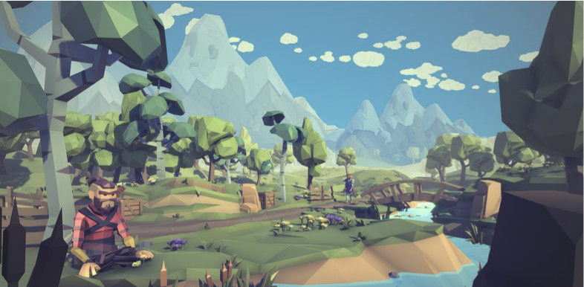

***Fenrir’s Revenge***

***A Low-Poly SwordMen’s Game***

Constantin Balan

Jonathan Cardasis

Jerry Lee

Selaiwa Mona

**Project Description**

The town of Selfoss has been invaded by the Knights of the Sleria Empire. Fenrir, the town’s best warrior, was out on a hunt when the invasion happened. He must retake his town back from the foreign invaders and restore stability to the local region.

The game will use low polygon Viking themed assets. This means the environment and characters will be in a low polygon style. The camera will be in third person, so the player can see their character.

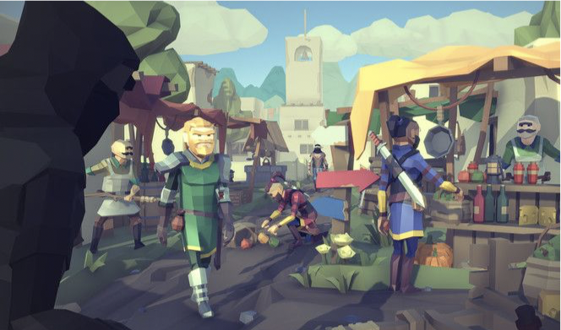

**Version History**

|  |  |  |  |  |  |
| --- | --- | --- | --- | --- | --- |
| **Version #** | **Implemented**  **By** | **Revision**  **Date** | **Approved**  **By** | **Approval**  **Date** | **Reason** |
| 1.0 | *Jon* | *12/18/2018* | *Fenrir Team* | *12/18/2018* | *Initial version* |
|  |  |  |  |  |  |
|  |  |  |  |  |  |
|  |  |  |  |  |  |

1. ***Characters***
2. ***Story***
   1. ***Theme***
3. ***Story Progression***
4. ***Gameplay***
   1. ***Goal***
   2. ***User Skills***
   3. ***Game Mechanics***
   4. ***Items & powerups***
   5. ***Progression & Challenge***
   6. ***Losing***
5. ***Art style***
6. ***Music & Sounds***
7. ***Technical description***
8. ***Marketing & Funding***
   1. ***Demographics***
   2. ***Platforms & Monetization***
   3. ***Localization***

**1. Characters**

*The reason we start with characters is because you need to introduce them before the Story. If your game doesn’t have Characters and/or Story, you can just jump to the Gameplay section and remove Sections 1 to 3 (or leave them empty).*

*An example of character descriptions:*

***“Gnumies*** *are the main characters in this game. These creatures are happy and wealthy, but not greedy. They are wealthy because their ancestry is related to money, or Numismatic, thus their name: Gnumies. They’re hairy and come in a variety of colors.*

***Red Gnumies*** *are passionate and break stuff.* ***Yellow Gnumies*** *are electric and jump up and down.* ***Green Gnumies*** *are tranquil, relaxed and easy going.* ***Blue Gnumies*** *are a little sad and grumpy.*

*Gnumies also have a lot of arms, anywhere from 1 up to 4, and their arms have hands. They have a firm handshake and can combine when holding hands. Gnumies like rough play and leave everything messy…”*

*You can also add some character artwork here.*

**2. Story**

*The town of Selfoss has been invaded by the Knights of the Sleria Empire. Fenrir, the town’s best warrior, was out on a hunt when the invasion happened. He must retake his town back from the foreign invaders and restore stability to the local region.*

**2.1. Theme**

*The game will use low polygon Viking themed assets. This means the environment and characters will be in a low polygon style. The camera will be in third person, so the player can see their character.*

**3. Story Progression**

The player will be able to explore the map, pick up items that will improve their stats/add different cosmetics to the character. The player will also be able to fight enemies with either their hands or weapons. Aside from the main quest, the player can rach the town to defeat additional enemies in a short side quest.

**4. Gameplay**

The gameplay is a 3rd-party-view sword game where you must fight off enemies to beat the game and save your town.

* The first level will be the path up to the entrance to the town, where the player will be able to fight some enemies and pick up their first tier of equipment. The second level will be in the actual town where the number of enemies increase, and better equipment can be found.

**4.1. Goals**

The goal is to collect an item to fight with, destroy the enemies, and beat the boss.

**4.2. User Skills**

* WASD for controls.
* Space for jump.
* Left click to attack.
* Navigate around the map and avoid the AI attacking you.
* The main weapon is a proximity based weapon, a sword. You must be within a certain range to do damage to the enemies.

**4.3. Game Mechanics**

The player will able to: modify their stats, pick up items, browse their inventory, heal, and fight enemies.

**Player Use Cases**

* ●  Player can take damage from enemy attacks.
* ●  Player can click to collect items to store in inventory.
* ●  If inventory is full, player can not pick up more items.
* ●  If player has weapon (i.e. Sword) equipped, they can attack.
* ●  Player health bar displays above their head.
* ●  Player has standard WASD movement controls to look around and  move through the world.
* **Game Use Cases**
* ●  Level should restart when player dies. Player loses all collected items when killed. Health is reset to 100%.
* ●  Enemies will path follow to the main player.
* ●  Enemies will attack players according to a hit-per-second allowed  ratio (varies depending on difficulty).
* ●  Main camera follows player from a 3D person perspective. Wide  enough to show surroundings and enemies.

**4.4. Items and power-ups**

There are swords through the map which you can pick up in your inventory system and use. There is a hidden sword on the map which does double damage to your enemies.

Your skill tree can be customized when you either begin or restart the game, giving you different buffs which can help through your quest.

**4.5. Progression and challenge**

**Character Creation:** The game starts. The player is greeted with a screen displaying multiple playable characters to choose from. The player has a max of 50 points to spend on attributes to customize their character. The points can be spend on attributes such as Strength, Speed, Wisdom, etc. Once the player has spent thier points they can continue to spawn into the game.

**Main Map:** The main map has mountains surrounding the playable area of the game. Surrounded by enemies you must defeat all the enemies to continue onto the boss fight, defeating the overloads, to win the game.

**4.6. Losing**

The game will display a lose message when you run out of HP, meaning your health bar has run out due to attacks from enemies.

1. **Art style**

The game is in a low-poly art style set on an Icelandic island in summer time. The user’s health, armor, and damage will be displayed in the top left portion of the screen. The stats will be layered on top of a template that will fit the theme of the game, and will allow the player to easily read them without confusion.

1. **Music and Sounds**

Sound effects play on scheduled events such as attacked, damage dealt, new game start, and other events. Music autoplays in the background of the game.

1. **Technical description**

The game is targetted for Windows 64bit platforms.

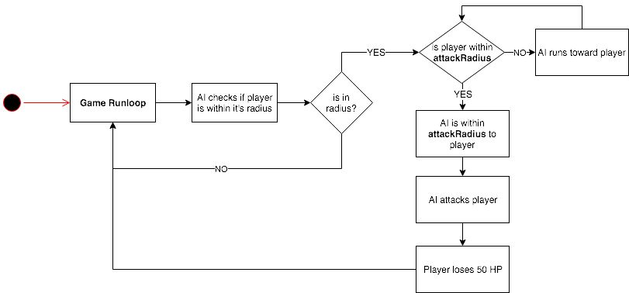

1. **Marketing & Funding**

No monetization plan has been applied to the game as this current time.

**8.1. Demographics**

This game’s target demographic is the casual young adult PC gamer. The game is designed to suit the expected playtype of a $10 downloadable PC game — a game in which the player expects to beat within a short amount of time, have a simple, yet developed story, and fun gameplay mechanics.

**8.2. Platforms & Monetization**

Free Windows 64bit game. No monetization plan has been applied to the game as this current time.

**8.3. Localization**

Only English localization is supported.