Level Concept – Fenrir’s Revenge

1 Notes
Add notes and concept edits here, if this is to be a “living document” on a server. Make sure each edit has the name and time marked, for instance:

12/17/18 – Updated Assets Catalog per Additions

12/16/18 – Created Document

2 Location
Use this section to outline where the level will take place, for example:

  - Geographic Location
The game takes place in Iceland in a remote sector of the island called Selfoss.

  - Time of Day
The sun is possitioned midday for the duration of the game.

  - Current Weather
The weather is always sunny as plays no effect on the playable character.

  - Architecture or Terrain Style
Mostly flat with scattered mounds and mountains encasing the user into the playable area.

  - Visual Reference
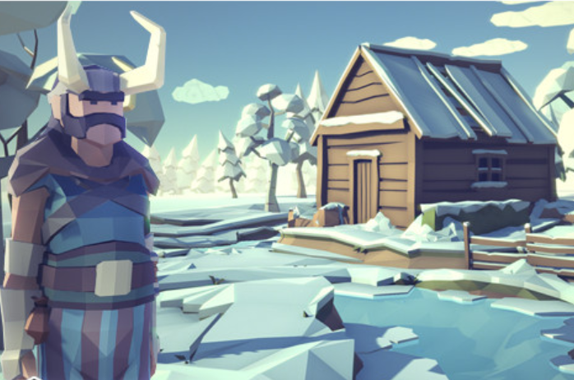

3 Player
This section describes information about the player in the level:

  - Player Start Location
The player starts in the character creation screen, allowing them to customize their character and spend a limitted number of points on attributes such as defense, offense, and mana.

Upon character creation, the player will spawn near the middle of the map, surrounded by enemies who the main character must defeat.

  - Player Inventory
Starting Inventory is empty. The player can pick up weapons such as a sword. The weapon can then be used to kill opossing enemies.

  - Briefing/Starting Information
The knights of Sleria have made their attack onto the Icelandic town of Selfoss. The town’s best warrior, Fenrir, was out on a week long hunt when the knights invaded. On his return back, he noticed the knight invasion and approached from a minimally guarded angle. It is solely up to him now to retake the city of Selfoss back from the Slerian invaders.

  - Reasons For Being There
The player must defeat the knights of Sleria in order to restore peace to the Icelandic town of Selfoss.

4 Objectives
This section contains the vital information about that the player needs to do to win the mission or finish the level successfully.

  - Main/Primary Objectives
The player must first find an item to use to defeat the number of AI enemies they are surrounded by. Upon killing these enemies and saving the surrounding town, the player enters the boss stage to defeat the overlords of the land.

  - Secondary Objectives
Aside from the main quest, the player can rach the town to defeat additional enemies in a short side quest.

  - Bonus Objectives
N/A.

  - Hidden Objectives
An additional sword is hidden on the map which does double damage.

5 Challenge Highlights
What are the key challenges and encounters that will happen in the level?

  - Combat Encounters
Immediate encounter with enemy knight AIs. Once entering their field of view, they will target and attack you.

  - Stealth Encounters
The AI will only attack once you are within thier field of view (radius), you can sneak around some enemies (such as in the side quest).

  - Puzzles
N/A for this game.

  - Conversations
The only text in the game is on the character creation screen.

  - Boss Battles
The boss is a multitude of strong enemy overlords which watch over the island, wreaking havic. The player must fight all boss enemies to beat the game.

6 Wow Factor
What are the memorable moments (not represented in the section above) that will stick with the player?

  - Character Creation Screen
The game starts on this screen, allowing the player to choose their hero and spend points on stats to customize their hero’s abilities. This gives the player personalization over their character.

  - Selfoss
The player spawns in Selfoss surrounded by enemies they need to defeat.

  - Hidden Village
There is a small hidden village with a short side quest where the player can defeat more enemies and save the small village.

  - Final Battle Area
In the final area, the player must battle a number of boss enemies in order to beat the game.

7 Map Description
This section allows you to verbally describe key areas of the level, explain complicated sections and generally provide other team members with an vision of the environment.

7.1 Character Creation: The game starts. The player is greeted with a screen displaying multiple playable characters to choose from. The player has a max of 50 points to spend on attributes to customize their character. The points can be spend on attributes such as Strength, Speed, Wisdom, etc. Once the player has spent thier points they can continue to spawn into the game.

  - Main Map: The main map has mountains surrounding the playable area of the game. Surrounded by enemies you must defeat all the enemies to continue onto the boss fight, defeating the overloads, to win the game.

8 Assets and Requirements
List here anything that you know the level will require in terms of external assets

8.1 Polygon Fantasy Rivals Pack
Used for textures, models, and effects.
https://assetstore.unity.com/packages/3d/characters/humanoids/polygon-fantasy-rivals-118399

Sketches and Additional Reference

Early Development Screenshots :
