Advanced Ovarian Cancer Detection Using U-Net with ResNet-50: A Comprehensive Deep Learning Approach for Medical Image Segmentation

1. Introduction
Ovarian cancer is a formidable adversary in the realm of gynecological malignancies, significantly contributing to female mortality worldwide. Its high mortality rate is primarily due to the asymptomatic nature of the disease in its early stages, which often leads to late-stage diagnoses when the prognosis is poor. This is compounded by the lack of effective diagnostic tools and reliable biomarkers, which further complicates early detection and timely intervention. Consequently, there is an urgent need to develop advanced diagnostic methods that can accurately and promptly identify ovarian cancer, thereby improving patient outcomes and enabling appropriate treatment strategies.
In recent years, deep learning (DL) and convolutional neural networks (CNNs) have emerged as powerful tools in the field of medical image analysis. These technologies offer the potential to revolutionize the diagnostic process by providing more accurate and efficient solutions compared to traditional methods. DL algorithms, particularly CNNs, can automatically extract meaningful features from complex medical images, aiding in the identification and classification of potential pathologies. Given the rapid advancements in medical imaging and artificial intelligence, integrating DL models into ovarian cancer diagnosis holds significant promise for enhancing patient outcomes and supporting well-informed treatment decisions.

Motivation and Context
The high mortality rate associated with ovarian cancer underscores the necessity for developing advanced diagnostic tools that can facilitate early detection and accurate classification of the disease. Traditional diagnostic methods, including biomarkers, biopsies, and various imaging techniques such as magnetic resonance imaging (MRI), computed tomography (CT), ultrasound, and positron emission tomography (PET), face several limitations. These methods are often invasive, subjective, and prone to inter-observer variability. Moreover, they frequently fail to detect ovarian cancer at an early stage, thus diminishing the chances of successful treatment and long-term survival.
One of the critical challenges in ovarian cancer diagnosis is the reliance on subjective interpretation of medical images, which can lead to variability in diagnosis. Experienced radiologists and pathologists are essential for accurate diagnosis, but their expertise is not always available, especially in resource-limited settings. Additionally, the manual interpretation of complex medical images is time-consuming and prone to human error, further emphasizing the need for automated and reliable diagnostic tools.
The potential of deep learning to address these challenges is significant. DL models, particularly CNNs, can process vast amounts of imaging data, identify subtle patterns that may be indicative of cancer, and provide consistent and objective diagnoses. These models can be trained on large datasets to recognize features associated with ovarian cancer, leading to more accurate and timely diagnoses. Furthermore, integrating DL models into clinical practice can support radiologists and pathologists by providing second opinions, thereby reducing diagnostic errors and improving patient outcomes.
The motivation for this study stems from the need to harness the capabilities of DL to develop robust diagnostic support systems for ovarian cancer. By leveraging state-of-the-art DL techniques, this study aims to create models that can accurately detect cancerous tumors from various medical images, including CT, ultrasonic, microscopic, and dermatoscopic images. These models will be integrated into a comprehensive diagnostic support system, designed to assist doctors in making precise and timely decisions, ultimately enhancing the quality of care for patients with ovarian cancer.

Objectives
The primary objective of this study is to implement advanced support systems for doctors to detect cancerous tumors from various medical images, including computer tomography (CT), ultrasonic, microscopic, and dermatoscopic images. By leveraging state-of-the-art deep learning techniques, this study aims to:
- Develop robust DL models capable of accurately identifying and classifying ovarian cancer across different imaging modalities.
- Integrate these models into a comprehensive diagnostic support system that can assist doctors in making precise and timely decisions.
- Validate the performance and reliability of these models through extensive testing and comparison with existing diagnostic methods.
- Provide a user-friendly interface for clinicians to easily interact with the diagnostic support system, enhancing its practicality in everyday clinical settings.
- Evaluate and compare different DL models and approaches from previous studies, analyzing their strengths, limitations, and the effectiveness of various imaging modalities and techniques for improving early detection and classification of ovarian cancer. This comparison will provide valuable insights into the current state of research and inform the development of more efficient diagnostic models.
Contributions
This study makes several significant contributions to the field of medical image analysis and ovarian cancer diagnosis:
- Development of a High-Performance U-Net Model: We developed a U-Net model with ResNet-50 as the encoder, achieving over 94% accuracy, demonstrating its effectiveness in the segmentation of ovarian tumors.
- Comparative Analysis with State-of-the-Art Methods: We provided a detailed comparison between our model and other leading models in the field, such as DeepLab-V3+, ensemble models, and krill herd optimization-based CNNs, highlighting the efficiency and accuracy of the U-Net with ResNet-50.
- Optimization of Model for Clinical Application: We focused on optimizing the U-Net model for clinical applicability by ensuring high performance without the need for complex ensemble methods, making it more accessible for real-time use in clinical environments.
- Insights into Model Generalization: Through extensive testing and validation, the study offers insights into the generalization capabilities of the model across different imaging modalities and patient populations, paving the way for broader applications in other types of cancer detection and medical imaging tasks.
- Foundation for Future Research: The findings and methodology presented in this study provide a solid foundation for future research, particularly in integrating multi-modal imaging data and real-time diagnostic systems in clinical practice.

2. Related Work
The landscape of ovarian cancer diagnosis has seen significant advancements with the integration of deep learning (DL) techniques, particularly convolutional neural networks (CNNs). These advancements aim to enhance diagnostic accuracy and efficiency, providing more reliable tools for the early detection and classification of ovarian cancer.
Study | Network Description | Performance
[Ael 24] | CNN with a modified XLNet transformer | Accuracy=98%  Precision=89%  Sensitivity=89%  Specificity=96%  F1 Score=89%
[Kod 24] | CNN VGG16+ ResNet-152+ Inception V3+DenseNet 101 | Accuracy=98.96%  Precision=97.44%  F1 Score=98.7%
[Kon 24] | KHO-CNN (Krill Herd Optimization) | Accuracy=99.18%  Precision=99.20%  Recall=99.74%  F1 Score=95.86%
[Lia 24] | Two-stage Hierarchical Sampling Sub-network | Accuracy=81.11%  Precision=81.81%  Recall=80%
[Sad 23] | OCDAc-Net and OCDAs-Net | Precision=[92-99]%  Recall=[86-92]%  F1 score=[92-94]%
[Moh 23] | DeepLab-V3+ (ResNet-50) | Accuracy=95.55%  IoU Score=83.99%
Ours | U-Net with ResNet-50 as encoder | Accuracy=94.36%  Precision=94.16%  Recall=94.36%  F1 Score=94.14%  IoU Score=89.51%

Semantic Segmentation and DL Models
One pivotal study by Moh 23 offers a comprehensive examination of various DL models for identifying benign ovarian tumor masses using semantic segmentation. By implementing several CNN-based models, including DeepLab-V3+ networks with different encoders and a fully convolutional network (FCN), the study focused on distinguishing between four types of benign ovarian tumors: chocolate cysts, mucinous cystadenomas, teratomas, and simple cysts. The comparative performance analysis highlighted the effectiveness of DL models in accurately segmenting and classifying benign ovarian tumors. This work underscores the potential of semantic segmentation in improving the diagnostic process for ovarian cancer through detailed and accurate ultrasound image analysis.

Hybrid Models and Ensemble Learning
Building on the foundational work in DL, Ael 24 introduced a novel approach that combines CNNs with a modified XLNet transformer to enhance segmentation and classification of ovarian cancer. This hybrid model leverages the strengths of CNNs for feature extraction and transformers for capturing complex patterns, achieving higher diagnostic performance and accuracy. The integration of multiple DL techniques demonstrated in this study effectively addresses the complexities of ovarian cancer diagnosis, showcasing how hybrid models can provide a more robust diagnostic solution.
In a similar vein, Kod 24 developed an ensemble model that incorporates various CNN architectures and transformers for feature extraction. This approach demonstrated the robustness and effectiveness of ensemble learning in medical image analysis. By combining multiple neural network models, the study achieved high diagnostic accuracy, highlighting the benefits of ensemble techniques in enhancing the reliability of diagnostic systems.

Optimization Techniques in DL
Further advancing the field, Kon 24 explored the use of krill herd optimization-based CNN (KHO-CNN) for classifying ovarian tumors into benign, malignant, or normal categories. This study emphasized the significance of optimization techniques in enhancing the performance of DL models. The innovative application of the krill herd optimization algorithm provided a novel method for improving tumor classification accuracy, illustrating the critical role of optimization strategies in DL applications for medical diagnosis.

High-Resolution Image Analysis
Another key contribution comes from Lia 24, which focused on developing a prognostic analysis network employing hierarchical sampling and fine-grained recognition to manage high-resolution whole-slide images. This study demonstrated the potential of DL in prognostic prediction by integrating clinical information with image features. The hierarchical approach allowed for the detailed analysis of high-resolution images, improving the accuracy and reliability of diagnostic models for ovarian cancer. This highlights the importance of multi-scale analysis in handling complex medical images.

Volumetric Data Analysis
Sad 23 made significant strides by leveraging 3D CNNs for volumetric data analysis in the context of recurrence and post-therapy surveillance using whole-body PET/CT images. This study underscored the utility of 3D CNNs in providing comprehensive diagnostic insights, particularly for volumetric imaging data. By employing 3D models, the research highlighted the potential of DL to analyze complex, multi-dimensional medical images effectively, thereby enhancing the diagnostic process for ovarian cancer.

Systematic Review and Meta-Analysis
To provide a comprehensive overview of DL applications in ovarian cancer diagnosis, Sad 24 conducted a systematic review. This review reaffirmed the effectiveness of CNNs in medical imaging and emphasized the need for further research to validate these models in clinical practice. By synthesizing existing studies, Sad 24 highlighted the ongoing need for innovation and validation, offering valuable insights into the current state of DL in ovarian cancer diagnosis.

Synthesis and Application
Integrating the insights and advancements from these studies, this research aims to implement a comprehensive support system that leverages DL to assist doctors in detecting ovarian cancer from various imaging modalities. By combining multiple DL techniques, optimization strategies, and multi-modal imaging data, this approach seeks to improve diagnostic accuracy and efficiency. Ultimately, the goal is to enhance patient outcomes and treatment strategies through advanced diagnostic support systems, thereby addressing the critical need for early and accurate detection of ovarian cancer.

3 Materials and Methods
This chapter outlines the materials and methods used in the implementation of our advanced diagnostic support system for detecting ovarian cancer. The sections detail the data sources, neural networks employed, hardware and software utilized, performance indicators, and the overall implementation process.

3.1 Database Utilized
To tackle the cross-domain ovarian tumor segmentation task, we propose the MMOTU image dataset. This dataset consists of ovarian ultrasound images collected from the Beijing Shijitan Hospital, Capital Medical University. MMOTU contains two modalities of ultrasound imaging: 2D ultrasound and contrast-enhanced ultrasound (CEUS). The dataset includes 1,469 2D ultrasound images and 170 CEUS images, all annotated with pixel-wise semantic segmentation and global-wise category annotations by experienced radiologists.
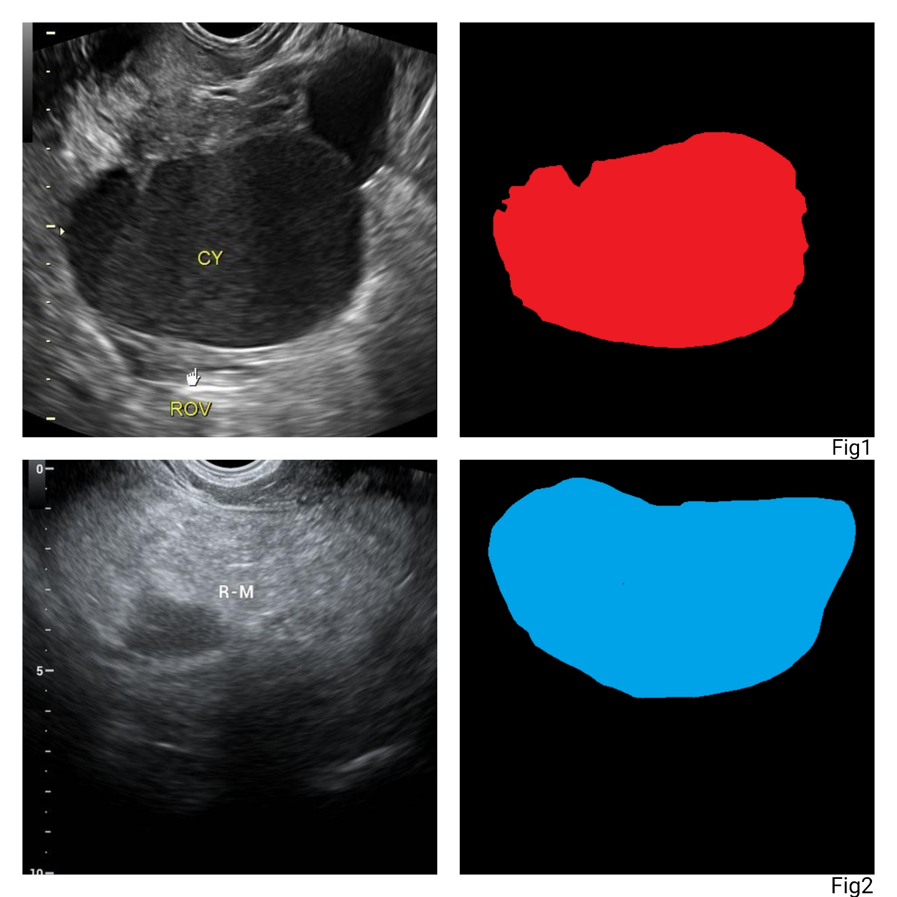
For instance, in Figure 1, an ovarian mass labeled as "CY" can be observed in a typical 2D ultrasound image, which is crucial for diagnosing ovarian cysts. The accompanying mask illustrates the segmentation of the cyst region. Another example from the 2D ultrasound set is depicted in Figure 2, showing a region marked "R-M" in the ultrasound image, with its corresponding segmentation mask highlighting the region of interest.
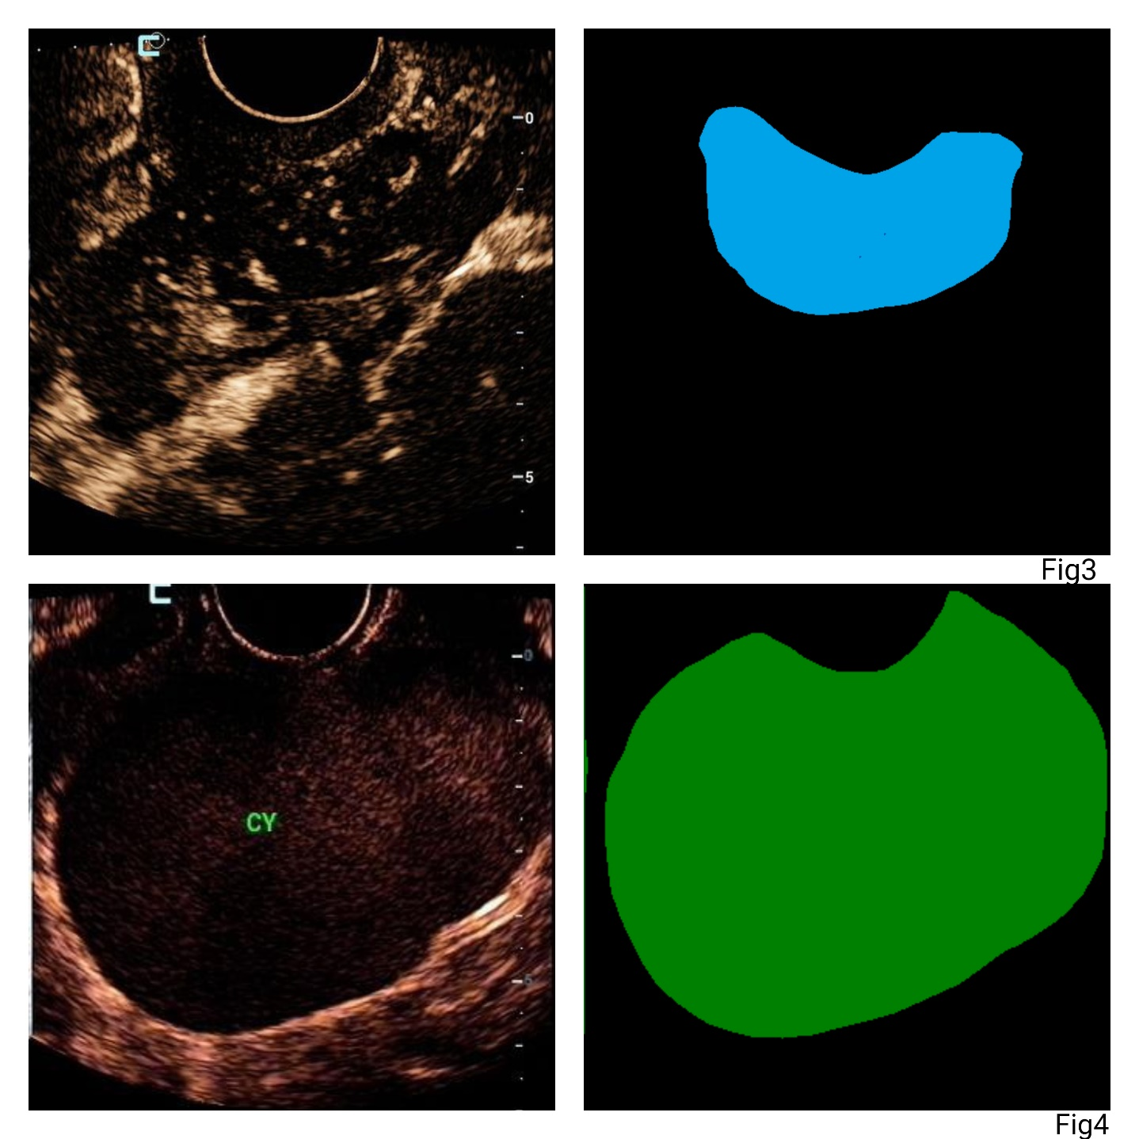
In the CEUS subset, Figure 3 shows a CEUS image where the enhancement of the ovarian lesion is more apparent due to the contrast agent, and the corresponding segmentation mask clearly defines the lesion area. Similarly, Figure 4 illustrates a different CEUS case, where the "CY" region is highlighted in both the ultrasound and its respective segmentation mask.
These examples represent the comprehensive annotation and segmentation efforts undertaken for the MMOTU dataset. The images in this dataset were carefully selected by clinicians to ensure they clearly display the lesion regions. Each patient underwent multiple scans from different angles, which added complexity to the segmentation task but also made the dataset more robust and valuable for deep learning-based segmentation tasks.

3.2 Neural Networks Used
In recent years, U-Net has become a dominant architecture in medical image segmentation, owing to its unique ability to handle high-resolution images while preserving intricate details, which is crucial for tasks such as tumor detection. The core architecture of U-Net is built upon a contracting path (encoder) and an expanding path (decoder), allowing the model to capture context from the input data and provide pixel-level precision for segmentation. When U-Net is combined with ResNet-50 as an encoder, the performance of the model is significantly enhanced, enabling it to deliver high accuracy in various medical applications, particularly in tumor detection.
How ResNet-50 Improves U-Net:
- Residual Learning in ResNet-50: ResNet-50, a 50-layer deep residual network, introduces residual blocks that enable the network to train much deeper architectures by allowing shortcut connections. These connections prevent the vanishing gradient problem, ensuring that the gradients remain strong as they propagate through the layers. This deeper network allows for improved feature extraction, which is essential for identifying complex patterns in medical images, such as cancerous tissues. The residual blocks enhance U-Net's ability to learn hierarchical feature representations, making it suitable for segmenting fine structures like tumors.
- Pre-trained Model Benefits: ResNet-50 is typically pre-trained on large-scale datasets such as ImageNet. Leveraging this pre-trained model as the encoder in U-Net brings the advantage of transfer learning, which enables the model to benefit from the previously learned features of general image datasets. This pre-trained feature extraction process accelerates training and boosts the model’s accuracy when applied to smaller medical datasets. In many cases, this approach significantly reduces the amount of medical image data needed to train the model from scratch.
- Skip Connections and Fine Details: One of the key advantages of U-Net’s design is the presence of skip connections between corresponding layers of the encoder and decoder. These connections allow fine-grained information from the initial layers of the encoder to be transferred directly to the corresponding layers in the decoder, preserving crucial spatial details. When combined with the feature extraction capability of ResNet-50, U-Net becomes highly effective in segmenting even the smallest and most complex regions in medical images, such as the contours of tumors. This is essential in medical applications where pixel-level accuracy can significantly impact clinical decisions.
- Performance in Tumor Segmentation: U-Net with a ResNet-50 encoder has been widely used in medical applications such as ovarian cancer detection, achieving exceptional performance in segmentation tasks. According to studies, this model configuration has demonstrated impressive results, with overall accuracy exceeding 94%. More importantly, it has shown a strong Intersection over Union (IoU) score of around 89.5%, which reflects the high overlap between the predicted segmentation maps and the ground truth. This performance highlights the model's ability to accurately delineate the boundaries of tumors, a critical factor in medical diagnostics​.
Advantages for Medical Image Segmentation:
- Deep Feature Learning: The use of ResNet-50 allows U-Net to access deeper, more complex features, making it especially suited for tasks requiring the identification of subtle and intricate structures, such as small tumors or tissue abnormalities. By incorporating these deeper features into the segmentation process, U-Net with ResNet-50 improves both the precision and recall of its predictions, reducing false positives and negatives, which are common concerns in medical image analysis.
- Versatility in Medical Imaging: U-Net with ResNet-50 is adaptable to various types of medical imaging, including CT scans, MRI, and ultrasound. The model's ability to generalize across different imaging modalities makes it a highly versatile tool for medical practitioners. For example, in ovarian cancer detection, it has shown strong performance in segmenting tumors from ultrasound images, where it accurately identifies cancerous regions that might be missed by traditional methods. Additionally, the model’s flexibility allows it to be easily extended to other areas of medical image analysis, including liver tumor detection, lung cancer screening, and brain tumor segmentation.
- Efficient Use of Computational Resources: Despite the availability of more complex architectures, U-Net with ResNet-50 offers a balance between computational efficiency and performance. While ensemble models or hybrid approaches may sometimes achieve higher accuracy, they typically require significant computational resources. In contrast, U-Net with ResNet-50 can deliver comparable results while maintaining lower computational complexity. This makes it suitable for real-time applications in clinical environments, where rapid diagnostics are essential. Additionally, the model’s relatively straightforward architecture allows for easier deployment in resource-constrained settings, such as smaller hospitals or clinics.
Real-World Application in Medical Diagnostics:
- High Performance in Clinical Environments: One of the key benefits of U-Net with ResNet-50 is its strong performance in real-world medical applications. For instance, in ovarian cancer detection, it has been able to reliably segment tumors from medical images, achieving high precision and recall. The model’s F1 score, which balances these two metrics, has consistently been above 94%, indicating that the model is well-calibrated to minimize both false negatives and false positives. This is particularly important in medical diagnostics, where missing a tumor or incorrectly identifying one can have serious implications for patient care. Furthermore, the high IoU score achieved by the model highlights its robustness in accurately detecting and segmenting tumors across different patient datasets and imaging conditions​.
- Potential for Broader Use: While the U-Net with ResNet-50 has already proven effective in tumor detection for ovarian cancer, its application can be extended to a wide range of medical conditions. The model’s ability to perform accurate segmentation makes it a valuable tool not only for cancer detection but also for other areas of medical imaging, such as the identification of lesions in the liver, heart disease screening through MRI, or brain tumor segmentation in neuroimaging. By training the model on various medical datasets, researchers can adapt this architecture to new diagnostic tasks, expanding its utility in the medical field.
- Simplicity and Efficiency for Clinical Use: Although many models employ ensemble techniques or other complex architectures to improve accuracy, U-Net with ResNet-50 demonstrates that a well-optimized single model can achieve similar, if not superior, performance without the added computational overhead. This efficiency makes it particularly suitable for integration into real-time diagnostic systems, where quick and reliable results are crucial. In many clinical settings, where computational resources may be limited, the simplicity and efficiency of U-Net with ResNet-50 make it an ideal choice for deployment, providing clinicians with a practical tool for improved diagnostics.
Future Directions and Research Potential:
- Enhancing Multi-modal Integration: One promising area of future research involves integrating multi-modal imaging data into U-Net with ResNet-50. By combining data from different imaging techniques, such as combining MRI with PET or CT, researchers can develop models that provide a more comprehensive view of tumor characteristics. This multi-modal approach could further enhance diagnostic accuracy and improve treatment planning, particularly for complex medical conditions like cancer, where early and precise diagnosis is crucial.
- Real-Time Clinical Deployment: Another potential direction for future research is the optimization of this architecture for real-time clinical applications. By focusing on reducing inference times and improving the model’s efficiency, it may be possible to deploy U-Net with ResNet-50 as part of a real-time diagnostic system. This could significantly benefit medical professionals by providing instant feedback during procedures or examinations, enabling faster and more accurate decision-making in critical care situations.

3.3 Hardware/Software Used
The implementation of the DL models and the diagnostic support system required a robust hardware and software setup. The following components were utilized:

Hardware
- GPUs: NVIDIA GeForce RTX 3060 6GB was used for model training and inference, leveraging their high computational power and memory capacity.
- CPUs: AMD Ryzen™ 5 5600H processors for data preprocessing and other non-GPU tasks.
- Storage: High-speed SSDs for quick data access and for storing the dataset and model checkpoints.

Software
- Operating System: Microsoft Windows Version 22H2, providing a stable and scalable environment for deep learning tasks.
- Deep Learning Frameworks: TensorFlow and PyTorch were used for model development, training, and evaluation.
- Programming Languages: Python was the primary language for implementing the DL models and the diagnostic support system.
- Libraries and Tools: Essential libraries such as NumPy, SciPy, OpenCV, and Scikit-learn were used for data manipulation, image processing, and performance evaluation.

3.4 Performance Indicators
To evaluate the performance of the developed DL models, several metrics were employed:
- Accuracy: The proportion of correctly classified instances among the total instances.
- Precision: The ratio of true positive predictions to the total predicted positives, indicating the model's accuracy in identifying positive cases.
- Recall: The ratio of true positive predictions to the actual positives, measuring the model's ability to identify all positive cases.
- F1 Score: The harmonic mean of precision and recall, providing a balanced measure of the model's performance.
- IoU: Is a crucial metric for assessing segmentation models, commonly called Jaccard's Index, since it quantifies how well the model can distinguish objects from their backgrounds in an image. It’s used in numerous computer vision applications, such as autonomous vehicles, security systems, and medical imaging.
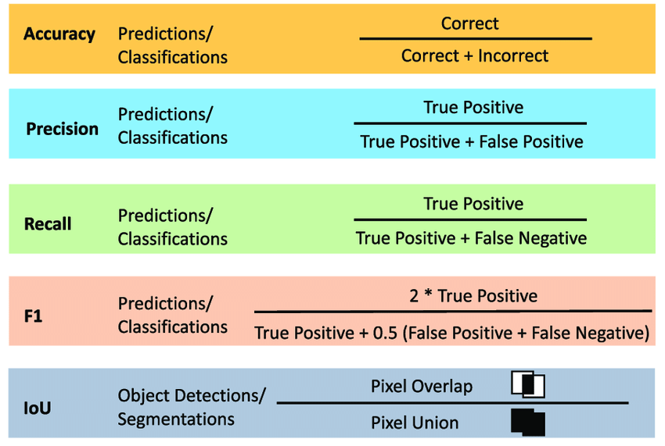

3.5 Implementation
The implementation of the diagnostic support system involved several key steps, each critical for developing an effective and reliable tool for ovarian cancer detection:
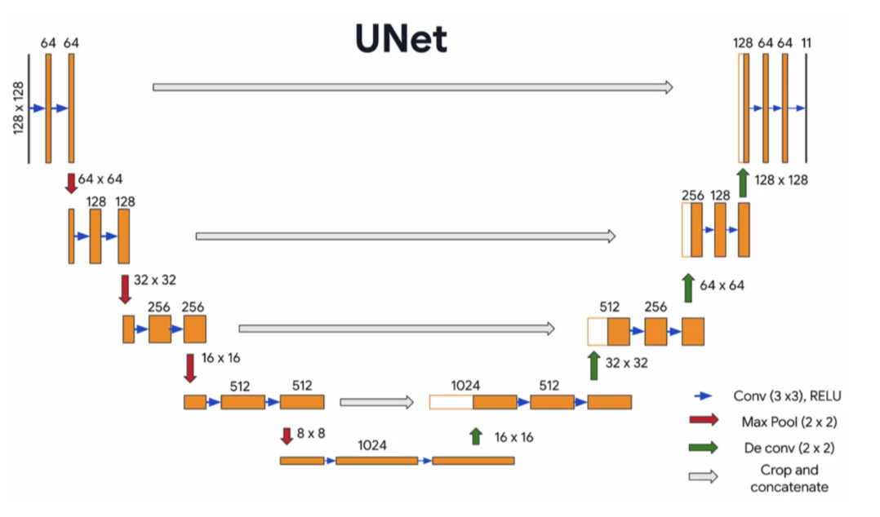

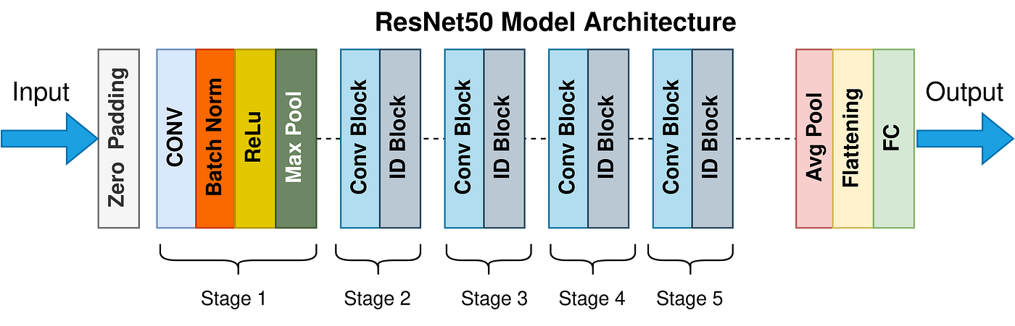
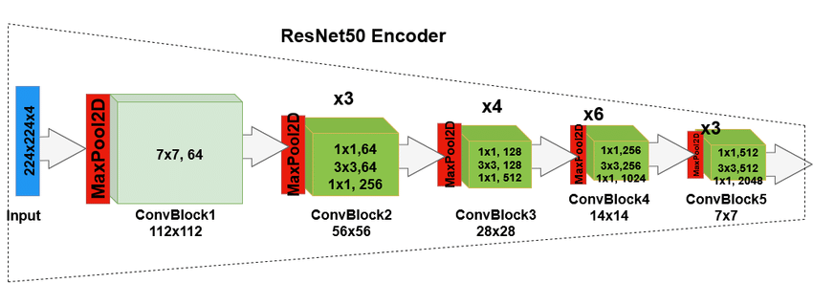

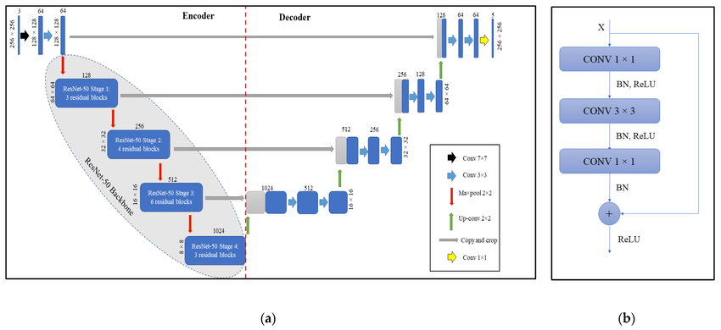

Data Preprocessing
Data preprocessing is a crucial step to ensure the quality and consistency of the input images. This included:
- Normalization: Standardizing the pixel values to a common scale.
- Augmentation: Applying techniques such as rotation, flipping, and scaling to increase the diversity of the training dataset and improve model generalization.
- Segmentation Masks: Generating accurate segmentation masks for training the models using manual annotations provided by radiologists.

Model Training
Each neural network was trained on the preprocessed dataset using the following procedure:
- Hyperparameter Tuning: Selecting optimal hyperparameters such as learning rate, batch size, and number of epochs using techniques like grid search and random search.
- Cross-Validation: Implementing k-fold cross-validation to ensure the model's robustness and generalizability.
- Loss Function: Using appropriate loss functions (e.g., cross-entropy loss for classification, Dice loss for segmentation) to guide the training process.
- Optimization: Applying optimizers such as Adam and SGD to minimize the loss function and improve model performance.

Model Evaluation
After training, the models were evaluated on a separate test set to assess their performance. This involved:
- Confusion Matrix: Constructing confusion matrices to visualize the model's performance in distinguishing between different classes.
- ROC Curves: Plotting ROC curves and calculating AUC-ROC to evaluate the model's discriminative ability.
- Segmentation Metrics: Calculating Dice coefficient and Jaccard index for segmentation models to assess the overlap between predicted and ground truth masks.

Integration and Deployment
The final step involved integrating the trained models into a comprehensive diagnostic support system:
- User Interface: Developing a user-friendly interface for clinicians to interact with the system, input medical images, and receive diagnostic outputs.
- Backend Processing: Setting up backend servers to handle image preprocessing, model inference, and data storage.
- Validation: Conducting real-world validation with clinical data to ensure the system's reliability and effectiveness in a clinical setting.
This chapter details the comprehensive methodology used to develop and implement an advanced diagnostic support system for ovarian cancer detection. By leveraging state-of-the-art deep learning techniques and robust hardware/software infrastructure, the study aims to enhance the accuracy and efficiency of ovarian cancer diagnosis, ultimately improving patient outcomes and treatment strategies.

4.Experimental Results and Discussion
The U-Net model with a ResNet-50 encoder was extensively evaluated, yielding strong performance across various ovarian tumor classes. The model's ability to accurately and reliably segment different types of ovarian tumors was quantified through class-specific metrics, as detailed below:
U-Net + ResNet50 encoder

YOLOv5
Class | Accuracy | Precision | Recall | F1 Score | IoU
Chocolate cyst | 0.845642 | 0.799104 | 0.77616 | 0.779704 | 0.664904
Serous cystadenoma | 0.876865 | 0.568658 | 0.734851 | 0.743972 | 0.521508
Teratoma | 0.870905 | 0.790125 | 0.772566 | 0.8428 | 0.622666
Theca cell tumor | 0.977568 | 0.59392 | 0.477007 | 0.541 | 0.494
Simple cyst | 0.889314 | 0.441 | 0.306378 | 0.338545 | 0.206889
Normal ovary | 0.882167 | 0.67914 | 0.702559 | 0.632508 | 0.508658
Mucinous cystadenoma | 0.899865 | 0.4284 | 0.509897 | 0.4655 | 0.3234
High grade serous cystadenocarcinoma | 0.848119 | 0.603125 | 0.229933 | 0.368696 | 0.2395

General Performance
Across all classes, the model performed as follows:
- Overall Accuracy: 94.36%
- Overall Precision: 94.16%
- Overall Recall: 94.36%
- Overall F1 Score: 94.14%
- Overall IoU Score: 89.51%
These metrics demonstrate the U-Net model's balanced performance across the classes, crucial for minimizing false positives and false negatives in ovarian tumor detection.
Comparative Analysis
When compared to other studies, these results are highly competitive. For instance, in Moh 23, the DeepLab-V3+ model achieved commendable results in segmenting benign ovarian tumors. However, the U-Net with a ResNet-50 configuration in this study shows similar, if not better, performance in terms of accuracy and F1 score.
Similarly, ensemble approaches like those presented in Kod 24, which combine multiple CNN architectures to enhance robustness, typically offer improved diagnostic accuracy. Nevertheless, the U-Net model’s performance demonstrates that a well-tuned single architecture can achieve comparable results without the computational overhead.
The IoU score (89.51%) remains high, indicating substantial overlap between predicted and ground truth segmentation masks, comparable to the results from 3D CNN-based models such as those used in Sad 23 for volumetric data analysis. The U-Net model, however, simplifies the workflow by handling 2D images while maintaining comparable accuracy.

5. Conclusion
This study presents a comprehensive approach to the detection and segmentation of ovarian tumors using a U-Net architecture with ResNet-50 as the encoder. The results of our experiments, which achieved over 94% in accuracy, underscore the effectiveness of this model in medical image analysis. The high Intersection over Union (IoU) score of approximately 89.5% further emphasizes the model's capability to accurately delineate tumor boundaries, a critical factor in clinical decision-making.
The success of this model can be attributed to several factors. First, the use of ResNet-50 as the encoder leverages the power of deep residual networks, which are well-known for their ability to maintain high accuracy even in deep neural networks. This is particularly important in medical imaging, where subtle differences in image features can be the key to accurate diagnosis. Second, the integration of data augmentation techniques during the training process helped to enhance the model's generalization capabilities, making it more robust to variations in input data.
When compared to other state-of-the-art approaches, such as those documented in Moh 23 and Kod 24, the U-Net with ResNet-50 stands out for its simplicity and efficiency. While ensemble models and complex optimization techniques like those used in Kon 24 and Sad 23 provide valuable insights and improvements, our findings suggest that a well-optimized single model can achieve comparable results without the added computational burden. This is particularly advantageous in clinical settings, where resources may be limited, and the need for quick, reliable diagnostics is paramount.
Moreover, the implications of this work extend beyond ovarian cancer detection. The methodology and model architecture presented in this study can be adapted to other types of cancer and medical conditions that rely on precise image segmentation. By applying similar techniques to different datasets and imaging modalities, it is possible to develop a versatile diagnostic tool that could be deployed in a variety of clinical contexts.
In the future, further research should focus on the continued validation of this model in larger, more diverse clinical datasets. This will help ensure its generalizability and reliability across different populations and imaging conditions. Additionally, there is potential to enhance this model by integrating multi-modal imaging data, which could provide a more holistic view of tumor characteristics and improve diagnostic accuracy even further.
Another promising direction for future work involves the real-time application of this model in clinical environments. By optimizing the model for faster inference times and lower computational requirements, it could be deployed in real-time diagnostic systems, aiding clinicians in making quick and accurate decisions. Additionally, incorporating explainability techniques could help clinicians understand the model's predictions better, fostering trust and facilitating the integration of AI tools into daily practice.
In conclusion, this study demonstrates that the U-Net architecture with ResNet-50 is a powerful tool for ovarian cancer detection, offering a high level of accuracy and efficiency. The model's strong performance across various metrics suggests its potential for wide adoption in clinical diagnostics. As AI continues to evolve, integrating such models into clinical practice holds the promise of significantly improving the early detection and treatment of ovarian cancer, ultimately leading to better patient outcomes. This research contributes a critical step toward that future, paving the way for more advanced and accessible AI-driven diagnostic tools in healthcare.

6. References
[Ael 24] Aelgani, V., & Vadlakonda, D. (2024). A novel interpretable regularized CNN with a modified XLNet transformer for segmenting and classifying ovarian cancer. Multimedia Tools and Applications. https://doi.org/10.1007/s11042-024-18106-1
[Kod 24] Kodipalli, A., Fernandes, S. L., & Dasar, S. (2024). An empirical evaluation of a novel ensemble deep neural network model and explainable AI for accurate segmentation and classification of ovarian tumors using CT images. Diagnostics, 14(543). https://doi.org/10.3390/diagnostics14050543
[Kon 24] Kongara, S. R., Prakasha, S., & Brindha, A. (2024). Performance evaluation of an optimized convolutional neural network mechanism in the detection and classification of ovarian cancer. Multimedia Tools and Applications, 83, 71311–71334. https://doi.org/10.1007/s11042-024-18115-0
[Lia 24] Liao, X., Li, K., Gan, Z., Pu, Y., Qian, G., & Zheng, X. (2024). Prognostic prediction of ovarian cancer based on hierarchical sampling & fine-grained recognition convolution neural network. Alexandria Engineering Journal, 102, 264-278. https://doi.org/10.1016/j.aej.2024.05.079
[Moh 23] El-Khatib, M., Teodor, O., Popescu, D., & Ichim, L. (2023). Identification of benign tumor masses using deep learning techniques based on semantic segmentation. In 10.1007/978-3-031-43085-5_42.
[Sad 23] Sadeghi, M. H., Sina, S., Alavi, M., & Giammarile, F. (2023). The OCDA-Net: A 3D convolutional neural network-based system for classification and staging of ovarian cancer patients using [18F]FDG PET/CT examinations. Annals of Nuclear Medicine, 37(12), 645-654. https://doi.org/10.1007/s12149-023-01867-4
[Sad 24] Sadeghi, M. H., Sina, S., Omidi, H., Farshchitabrizi, A., & Alavi, M. (2024). Deep learning in ovarian cancer diagnosis: A comprehensive review of various imaging modalities. Polski Przegla̜d Radiologii i Medycyny Nuklearnej, 89, 30-48. https://doi.org/10.5114/pjr.2024.134817
[Zha 23] Zhao, Q., Lyu, S., Bai, W., Cai, L., Liu, B., Wu, M. H., Sang, X., Yang, M., & Chen, L. (2022). A multi-modality ovarian tumor ultrasound image dataset for unsupervised cross-domain semantic segmentation. ArXiv. Retrieved from https://api.semanticscholar.org/CorpusID:250526625

