Moldova State University
Department of Mathematics and Computer Science

Exercise #5
on course “Cryptography and Information Security”
topic: RC4



Выполнил студент группы I1802:
Vigulear Constantin

Проверил преподаватель:
Olga Cerbu

Chisinau, 2021
Task

Realize RC4 algorithm.

n=3
2³ =8 – flux of bits
Creating vector S: 01234567
Choosing key: 61, K – key vector
Key code in ASCII: 6 → 54; 1 → 49;
Key vector is:
54 | 49 | 54 | 49 | 54 | 49 | 54 | 49

Depunem valorile codului ASCII al cheii:
P | 0 | 1 | 2 | 3 | 4 | 5 | 6 | 7
S | 0 | 1 | 2 | 3 | 4 | 5 | 6 | 7
K | 54 | 49 | 54 | 49 | 54 | 49 | 54 | 49

Permutating bits from vector S:

i=0, j=0.
j=(j+K[i]+S[j]) mod 8

1) i=0, j=(0+K[0]+S[0]) mod 8 = (0+54+0) mod 8 = 54 mod 8 = 6;
SWAP(S[i],S[j])=SWAP(S[0],S[6])=61234507 = 54 49 54 49 54 49 54 49

P | 0 | 1 | 2 | 3 | 4 | 5 | 6 | 7
S | 6 | 1 | 2 | 3 | 4 | 5 | 0 | 7
K | 54 | 49 | 54 | 49 | 54 | 49 | 54 | 49

2) i=1, j=(6+K[1]+S[6]) mod 8 = (6+49+0) mod 8 = 55 mod 8 = 7;
SWAP(S[i],S[j])=SWAP(S[1],S[7])= 67234501 = 54 49 54 49 54 49 54 49

P | 0 | 1 | 2 | 3 | 4 | 5 | 6 | 7
S | 6 | 7 | 2 | 3 | 4 | 5 | 0 | 1
K | 54 | 49 | 54 | 49 | 54 | 49 | 54 | 49

3) i=2, j=(7+K[2]+S[7]) mod 8 = (7+54+1) mod 8 = 62 mod 8 = 6;
SWAP(S[i],S[j])=SWAP(S[2],S[6])= 67034521 = 54 49 54 49 54 49 54 49

P | 0 | 1 | 2 | 3 | 4 | 5 | 6 | 7
S | 6 | 7 | 0 | 3 | 4 | 5 | 2 | 1
K | 54 | 49 | 54 | 49 | 54 | 49 | 54 | 49

4) i=3, j=(6+K[3]+S[6]) mod 8 = (6+49+2) mod 8 = 57 mod 8 = 1;
SWAP(S[i],S[j])=SWAP(S[3],S[1])= 63074521 = 54 49 54 49 54 49 54 49

P | 0 | 1 | 2 | 3 | 4 | 5 | 6 | 7
S | 6 | 3 | 0 | 7 | 4 | 5 | 2 | 1
K | 54 | 49 | 54 | 49 | 54 | 49 | 54 | 49

5) i=4, j=(1+K[4]+S[1]) mod 8 = (1+54+3) mod 8 = 58 mod 8 = 2;
SWAP(S[i],S[j])=SWAP(S[4],S[2])= 63470521 = 54 49 54 49 54 49 54 49

P | 0 | 1 | 2 | 3 | 4 | 5 | 6 | 7
S | 6 | 3 | 4 | 7 | 0 | 5 | 2 | 1
K | 54 | 49 | 54 | 49 | 54 | 49 | 54 | 49

6) i=5, j=(2+K[5]+S[2]) mod 8 = (2+49+4) mod 8 = 55 mod 8 = 7;
SWAP(S[i],S[j])=SWAP(S[5],S[7])= 63470125 = 54 49 54 49 54 49 54 49

P | 0 | 1 | 2 | 3 | 4 | 5 | 6 | 7
S | 6 | 3 | 4 | 7 | 0 | 1 | 2 | 5
K | 54 | 49 | 54 | 49 | 54 | 49 | 54 | 49

7) i=6, j=(7+K[6]+S[7]) mod 8 = (7 + 54 +5) mod 8 = 66 mod 8 = 2;
SWAP(S[i],S[j])=SWAP(S[6],S[2])= 63270145 = 54 49 54 49 54 49 54 49

P | 0 | 1 | 2 | 3 | 4 | 5 | 6 | 7
S | 6 | 3 | 2 | 7 | 0 | 1 | 4 | 5
K | 54 | 49 | 54 | 49 | 54 | 49 | 54 | 49

8) i=7, j=(2+K[7]+S[2]) mod 8 = (2+49+2) mod 8 = 53 mod 8 = 5;
SWAP(S[i],S[j])=SWAP(S[7],S[5])= 63270541 = 54 49 54 49 54 49 54 49

P | 0 | 1 | 2 | 3 | 4 | 5 | 6 | 7
S | 6 | 3 | 2 | 7 | 0 | 5 | 4 | 1
K | 54 | 49 | 54 | 49 | 54 | 49 | 54 | 49

Encryption

Define message to be encrypted m = Approval
Starting with i=0, j=0.
i=(i+1) mod 8 = 1 mod 8 = 1.
j=(j+S[i]) mod 8 = (j+S[1]) mod 8 = (0+3) mod 8 = 3

Calculating t:
t=(S[i]+S[j]) mod 8 = (S[1]+S[3]) mod 8 = (3+7) mod 8 = 2

Encryption r = chr(ord(m)) XOR K[t]

K[t] = K[5] = (54)₂ = (00110110)₂
m[0] = A → (65)₁₀ = (01000001)₂
m[1] = p→ (112)₁₀ = (01110000)₂
m[2] = p → (112)₁₀ = (01110000)₂
m[3] = r → (114)₁₀ = (1110010)₂
m[4] = o → (111)₁₀ = (01101111)₂
m[5] = v → (118)₁₀ = (01110110)₂
m[6] = a → (97)₁₀ = (1100001)₂
m[7] = l → (108)₁₀ = (01101100)₂

- r[0] = 01000001 XOR 00110110 = (1110111)₂ = (119)₁₀ → w
- r[1] = 01110000 XOR 00110110 = (1000110)₂ = (70)₁₀ → F
- r[2] = 01110000 XOR 00110110 = (1000110)₂ = (70)₁₀ → F
- r[3] = 1110010 XOR 00110110 = (1000100)₂ = (68)₁₀ → D
- r[4] = 01101111 XOR 00110110 = (1011001)₂ = (89)₁₀ → Y
- r[5] = 01110110 XOR 00110110 = (1000000)₂ = (64)₁₀ → @
- r[6] = 1100001 XOR 00110110 = (1010111)₂ = (87)₁₀ → W
- r[7] = 01101100 XOR 00110110 = (1011010)₂ = (90)₁₀ → Z

Hence, message m = „Approval” encrypted is „wFFDY@ WZ”

Decrypting
Cript r = wFFDY@z
K=61
S= 63270541

P | 0 | 1 | 2 | 3 | 4 | 5 | 6 | 7
S | 6 | 3 | 2 | 7 | 0 | 5 | 4 | 1
K | 54 | 49 | 54 | 49 | 54 | 49 | 54 | 49

Starting with i=0, j=0.
i = (i+1) mod 8 = 1 mod 8 = 1.
j = (j+S[i]) mod 8 = (j+S[1]) mod 8 = (0+2) mod 8 = 2
t=SWAP(S[i],S[j]) mod 8 = (3+2) mod 8 = 5
K[t] = K[5] = (54)₂ = (00110110)₂

Decryption d = chr(ord(r)) XOR K[t]
r[0] = w → (119)₁₀ = (1110111)₂
r[1] = F → (70)₁₀ = (1000110)₂
r[2] = F→ (70)₁₀ = (1000110)₂
r[3] = D → (68)₁₀ = (1000100)₂
r[4] = Y→ (89)₁₀ = (1011001)₂
r[5] = @→ (64)₁₀ = (1000000))₂
r[6] = W → (87)₁₀ = (1010111)₂
r[7] = Z→ (90)₁₀ = (1011010)₂

- m[0] = 1110111 XOR 00110110 = (1000001)₂ = (65)₁₀ → A
- m[1] = 1000110 XOR 00110110 = (1110000)₂ = (112)₁₀ → p
- m[2] = 1000110 XOR 00110110 = (1110000)₂ = (112)₁₀ → p
- m[3] = 1000100 XOR 00110110 = (1110010)₂ = (114)₁₀ → r
- m[4] = 1011001 XOR 00110110 = (1101111)₂ = (111)₁₀ → o
- m[5] = 1000000 XOR 00110110 = (1110110)₂ = (118)₁₀ → v
- m[6] = 1010111 XOR 00110110 = (1100001)₂ = (97)₁₀ → a
- m[7] = 1011010 XOR 00110110 = (1101100)₂ = (108)₁₀ → l

Encrypted message r = „wFFDY@WZ” decrypted will be: „Approval”.

Code listing:

import java.util.*;
public class RC4 {
public static void main(String[] args) {
String message;
int key, n, i, j, t;
Vector<Integer> S = new Vector<>();
Vector<Integer> digits = new Vector<>();
Vector<Integer> keyVector = new Vector<>();
Scanner input = new Scanner(System.in);
// Input Data
System.out.println("Enter message to be encrypted: ");
message = input.nextLine();
System.out.println("Message to be encrypted: " + message);
System.out.println("Enter n: ");
n = input.nextInt();
System.out.println("Entered n = " + n);
for (i = 0; i < Math.pow(2,n); i++) {
S.add(i);
}
System.out.println("Creating vector S: " + S.toString());
System.out.println("Enter the key: ");
key = input.nextInt();
System.out.println("Entered key = " + key);
// acquiring digits from key
while (key > 0) {
digits.add(key % 10);
key = key / 10;
}
Collections.reverse(digits);
// converting digits into ASCII
char character1 = Character.forDigit(digits.get(0), 10);
char character2 = Character.forDigit(digits.get(1), 10);
System.out.println("Key code in ASCII:" + digits.get(0) + " -> " + (int)character1 + ", " + digits.get(1) + " -> " + (int)character2);
for (i = 0; i < Math.pow(2,n) / 2; i++) {
keyVector.add((int)character1);
keyVector.add((int)character2);
}
System.out.println("Key vector is: " + keyVector.toString());
// Applying permutations
i = 0;
j = 0;
for (i = 0; i < Math.pow(2, n); i++) {
j = (int)((j + keyVector.get(i) + S.get(j)) % Math.pow(2, n));
Collections.swap(S, i, j);
System.out.println("Iteration " + (i+1));
System.out.println(S.toString());
System.out.println(keyVector.toString());
}
// Calculating t
i = 0;
j = 0;
i = (int)((i + 1) % Math.pow(2, n));
j = (int)((j + S.get(i)) % Math.pow(2, n));
t = (int)((S.get(i) + S.get(j)) % Math.pow(2, n));
System.out.println("t = " + t);
// Calculating K[t]
System.out.println("K[t] = K[" + t + "] = " + keyVector.get(t) + " = " + Integer.toBinaryString(keyVector.get(t)));
ArrayList<Character> m = new ArrayList<>();
i = 0;
for (char ch : message.toCharArray()) {
m.add(ch);
System.out.println("m[" + i + "] = " + m.get(i) + " -> (" + (int)m.get(i) + ") = (" + Integer.toBinaryString(m.get(i)) + ")");
i++;
}
// Encrypting
System.out.println("\n");
i = 0;
for (char ch : m) {
System.out.println("r[" + i + "] = " + Integer.toBinaryString(m.get(i)) + " XOR "
+ Integer.toBinaryString(keyVector.get(t)) + " = (" + Integer.toBinaryString(m.get(i) ^ keyVector.get(t)) + ") = "
+ " (" + Integer.toBinaryString(m.get(i) ^ keyVector.get(t)) + ") = "
+ ((int)m.get(i)^ keyVector.get(t)) + " -> " + (char)((int)m.get(i)^ keyVector.get(t)));
m.set(i, (char)((int)m.get(i)^ keyVector.get(t)));
i++;
}
String encryptedMessage = "";
for (char ch : m)
encryptedMessage = encryptedMessage.concat(Character.toString(ch));
System.out.println("\nYour encrypted word is : " + encryptedMessage);
}
}
Results:

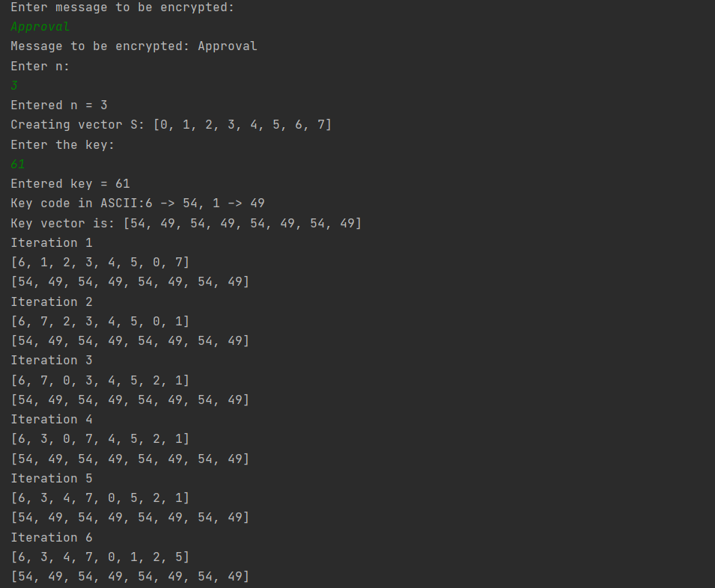
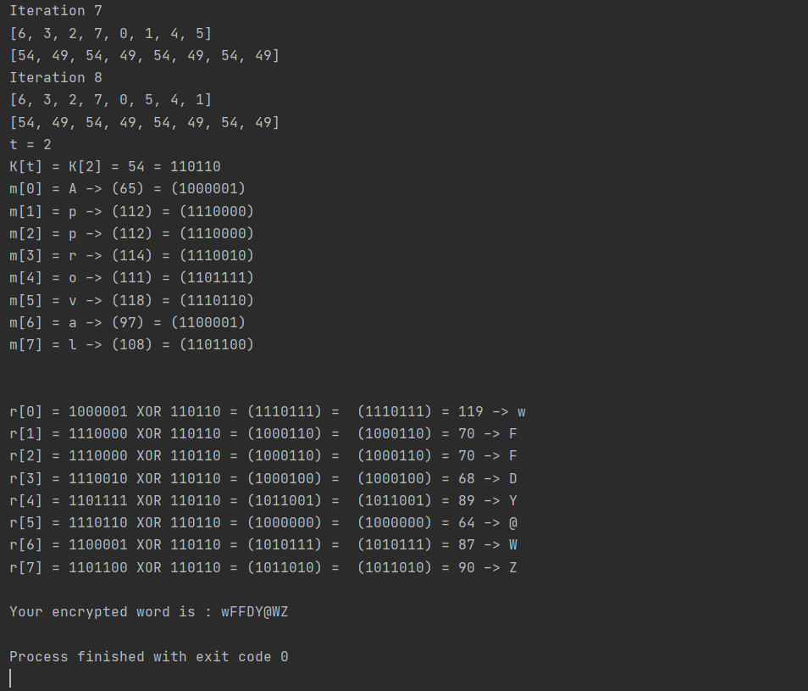

Conclusion:

Применив симметричный алгоритм шифрования RC4, мне удалось зашифровать сообщение “Approval” вручную. В результате ручной расшифровки результат совпал с начальным словом. Результаты ручного вычисления совпали с результатами запрограммированного алгоритма, что подтверждает правильность ответа.
Bibliography:

Code: The Hidden Language of Computer Hardware and Software, Book by Charlez Petzold, Microsoft Press, October 23, 1999

Serious Cryptography: A Practical Introduction to Modern Encryption, Book by Jean-Philippe Aumasson, 2017

Cryptography, Book by Rubinstein-Salzedo Simon, 2018

Information Security, 2Ed: Principles And Practices, book by Mark Stamp, 2018

Introduction to Cryptography, Book by Sahadeo Padhye, Rajeev A.Sahu, Vishal Saraswat, 2018

