Moldova State University
Department of Mathematics and Computer Science

Exercise #6
on course “Cryptography and Information Security”
topic: Merkle-Hellman Knapsack Cryptosystem



Выполнил студент группы I1802:
Vigulear Constantin

Проверил преподаватель:
Olga Cerbu

Chisinau, 2021
Task

Пусть имеются следующие элементы супервозрастающей последовательсности:
W = {3, 5, 9, 19, 39, 92, 174}
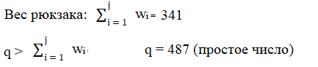
1 < r < q r = 313 (тоже простое)
Значения W, q, r обозначают секретные ключи.

Этап 1: Шифрование
β_{i} = (W_{i} * r) mod q – публичные ключи
β₁ = (3 * 313) mod 487 = 452
β₂ = (5 * 313) mod 487 = 104
β₃ = (9 * 313) mod 487 = 382
β₄ = (19 * 313) mod 487 = 103
β₅ = (39 * 313) mod 487 = 32
β₆ = (92 * 313) mod 487 = 63
β₇ = (174 * 313) mod 487 = 405
β_{i} = {452, 104, 382, 103, 32, 63, 405}

m = “Kosta”
m₁ = “K” → ASCHII → (75)₁₀ → (1001011)₂
m₂ = “o” → ASCHII → (111)₁₀ → (1101111)₂
m₃ = “s” → ASCHII → (115)₁₀ → (1110011)₂
m₄ = “t” → ASCHII → (116)₁₀ → (1110100)₂
m₅ = “a” → ASCHII → (97)₁₀ → (1100001)₂

m₁ | m₂ | m₃ | m₄ | m₅
1*452 | 1*452 | 1*452 | 1*452 | 1*452
0*104 | 1*104 | 1*104 | 1*104 | 1*104
0*382 | 0*382 | 1*382 | 1*382 | 0*382
1*103 | 1*103 | 0*103 | 0*103 | 0*103
0*32 | 1*32 | 0*32 | 1*32 | 0*32
1*63 | 1*63 | 1*63 | 0*63 | 0*63
1*405 | 1*405 | 1*405 | 0*405 | 1*405
c₁ = 1023 | c₂ = 1159 | c₃ = 1406 | c₄ = 970 | c₅ = 961
Зашифрованное сообщение c = {1023, 1159, 1406, 970, 961}

Этап 2: Дешифрование
r⁻¹ mod q = 313⁻¹ mod 487 = 473
(c * r⁻¹ mod q) mod q
W = {3, 5, 9, 19, 39, 92, 174}

  - (1023 * 473) mod 487 = 288
288 – 174 = 114
114 – 92 = 22
22 – 19 = 3
3 – 3 = 0

W = | 3 | 5 | 9 | 19 | 39 | 92 | 174
 | 1 | 0 | 0 | 1 | 0 | 1 | 1
(1001011)₂ → (75)₁₀ → ASCII → “K”

  - (1159 * 473) mod 487 = 332
332 – 174 = 158
158 – 92 = 66
66 – 39 = 27
27 – 19 = 8
8 – 5 = 3
3 - 3 = 0

W = | 3 | 5 | 9 | 19 | 39 | 92 | 174
 | 1 | 1 | 0 | 1 | 1 | 1 | 1
(1101111)₂ → (111)₁₀ → ASCII → “o”

  - (1406 * 473) mod 487 = 283
283 – 174 = 109
109 – 92 = 17
17 – 9 = 8
8 – 5 = 3
3 – 3 = 0

W = | 3 | 5 | 9 | 19 | 39 | 92 | 174
 | 1 | 1 | 1 | 0 | 0 | 1 | 1
(1110011)₂ → (115)₁₀ → ASCII → “s”

  - (970 * 473) mod 487 = 56
56 – 39 = 17
17 – 9 = 8
8 – 5 = 3
3 – 3 = 0

W = | 3 | 5 | 9 | 19 | 39 | 92 | 174
 | 1 | 1 | 1 | 0 | 1 | 0 | 0
(1110100)₂ → (116)₁₀ → ASCII → “t”

  - (961 * 473) mod 487 = 182
182 – 174 = 8
8 – 5 = 3
3 – 3 = 0

W = | 3 | 5 | 9 | 19 | 39 | 92 | 174
 | 1 | 1 | 0 | 0 | 0 | 0 | 1
(1100001)₂ → (97)₁₀ → ASCII → “a”

m = “Kosta”

Code listing:

import java.math.BigInteger;
import java.nio.charset.Charset;
import java.nio.charset.StandardCharsets;
import java.util.Random;
import java.util.Scanner;
/**
* <p>
* This implements Merkle-Hellman knapsack cryptosystem with arrays.
* </p>
* <p>
* Details of Merkle-Hellman knapsack cryptosystem can be seen here:
* <a href="https://en.wikipedia.org/wiki/Merkle-Hellman_knapsack_cryptosystem">
* https://en.wikipedia.org/wiki/Merkle-Hellman_knapsack_cryptosystem
* </a>
* </p>
*
* @author Stephen Xie &lt;[redacted]@cmu.edu&gt;
*/
public class MerkleHellmanKnapsack {
// w: the superincreasing sequence of integers that make up part of the private key
// and used for decryption
// b: the public key sequence used for encryption
private BigInteger[] w, b;
// q: a random integer that's larger than the sum of w
// r: a random integer that's coprime with q
private BigInteger q, r;
private final Random rand = new Random();
private static final int MAX_CHARS = 150; // maximum number of characters allowed in a message
private static final int BINARY_LENGTH = MAX_CHARS * 8; // length of the longest message allowed in binary (a char is 8-bit long)
private static final Charset UTF8 = StandardCharsets.UTF_8; // the program only processes UTF-8 encoded messages
/**
* Constructor
*/
public MerkleHellmanKnapsack() {
genKeys();
}
/**
* <pre>
* Generate public & private keys for encrypting / decrypting a message with a
* given length; the public key is the array b, and the private key is (w, q, r)
* combined.
*
* Pre-condition: the maximum characters allowed per message (MAX_CHARS) should be an integer greater than 0
* Post-condition: w, b, q, r of this object are modified
* </pre>
*/
private void genKeys() {
int maxBits = 50;
// maximum number of bits of a randomly generated big integer; this affects the number scale of the
// generated public / private keys below
// w will be a superincreasing big integer array
w = new BigInteger[BINARY_LENGTH];
// initialize a random big integer as the starting point; since the range of the random number includes 0,
// add 1 to it to be safe
w[0] = new BigInteger(maxBits, rand).add(BigInteger.ONE);
BigInteger sum = new BigInteger(w[0].toByteArray()); // sum of the w BigInteger array
for (int i = 1; i < w.length; i++) { // populate the array with superincreasing big integers
w[i] = sum.add(new BigInteger(maxBits, rand).add(BigInteger.ONE));
sum = sum.add(w[i]);
}
// q will be a random integer bigger than the sum of the array w
q = sum.add(new BigInteger(maxBits, rand).add(BigInteger.ONE));
// a simple selection for r: just pick q - 1 as it and q will always be coprime
r = q.subtract(BigInteger.ONE);
// generate the public key sequence
b = new BigInteger[BINARY_LENGTH];
for (int i = 0; i < b.length; i++)
b[i] = w[i].multiply(r).mod(q);
}
/**
* <pre>
* Encrypt the given message.
*
* Pre-conditions:
* 1. The length of the message (number of characters) must not exceed the maximum limit defined in this class.
* 2. The message must not be an empty string.
* 3. The message string is encoded in UTF-8.
* Post-condition: the encrypted message is returned
* </pre>
*
* @param message the message string to be encrypted
* @return the ciphertext converted to string
*/
public String encryptMsg(String message) {
if (message.length() > MAX_CHARS)
throw new IndexOutOfBoundsException("Maximum message length allowed is " + MAX_CHARS + ".");
if (message.length() <= 0)
throw new Error("Cannot encrypt an empty string.");
// convert message to binary string
String msgBinary = new BigInteger(message.getBytes(UTF8)).toString(2);
// pad 0 to the left if the converted binary is not as long as the key sequences w and b
if (msgBinary.length() < BINARY_LENGTH) {
msgBinary = String.format("%0" + (BINARY_LENGTH - msgBinary.length()) + "d", 0) + msgBinary;
}
// produce the final encrypted message
BigInteger result = BigInteger.ZERO;
for (int i = 0; i < msgBinary.length(); i++) {
result = result.add(b[i].multiply(new BigInteger(msgBinary.substring(i, i+1))));
}
return result.toString();
}
/**
* <pre>
* Decrypt the given message.
*
* Pre-conditions: the supplied ciphertext must be able to convert to BigInteger type.
* Post-condition: the decrypted message is returned
* </pre>
*
* @param ciphertext the ciphertext
* @return the decrypted message
*/
public String decryptMsg(String ciphertext) {
BigInteger tmp = new BigInteger(ciphertext).mod(q).multiply(r.modInverse(q)).mod(q);
byte[] decrypted_binary = new byte[w.length]; // the decrypted message in binary
for (int i = w.length - 1; i >= 0; i--) {
if (w[i].compareTo(tmp) <= 0) { // found the largest element in w which is less than or equal to tmp
tmp = tmp.subtract(w[i]);
decrypted_binary[i] = 1;
} else {
decrypted_binary[i] = 0;
}
}
// convert byte[] to string
StringBuilder sb = new StringBuilder();
for (int i = 0; i < decrypted_binary.length; i++) {
sb.append(decrypted_binary[i]);
}
return new String(new BigInteger(sb.toString(), 2).toByteArray());
}
/**
* Test driver
*/
public static void main(String[] args) {
MerkleHellmanKnapsack crypto = new MerkleHellmanKnapsack();
System.out.println("Public and private keys have been generated.\n");
Scanner input = new Scanner(System.in);
String message;
while (true) {
System.out.println("Enter a string and I will encrypt it as single large integer:");
message = input.nextLine();
if (message.length() > MAX_CHARS)
System.out.printf("\nYour message should have at most %d characters! Please try again.\n\n", MAX_CHARS);
else if (message.length() <= 0)
System.out.println("\nYou message should not be empty! Please try again.\n\n");
else break;
}
System.out.println("\nClear text:");
System.out.println(message);
System.out.println("\nNumber of clear text bytes = " + message.getBytes().length);
String encrypted = crypto.encryptMsg(message);
System.out.println("\n\"" + message + "\"" + " is encrypted as:");
System.out.println(encrypted);
System.out.println("Length of encrypted message = " + encrypted.length());
System.out.println("\nResult of decryption:");
System.out.println(crypto.decryptMsg(encrypted));
}
}
Results:

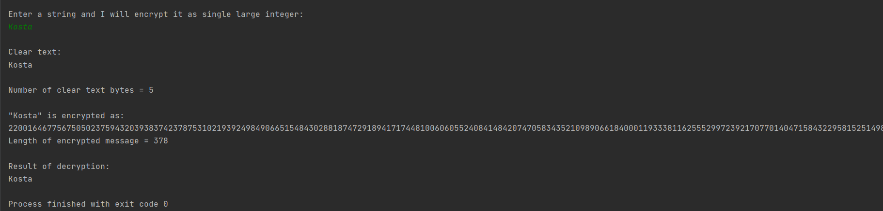

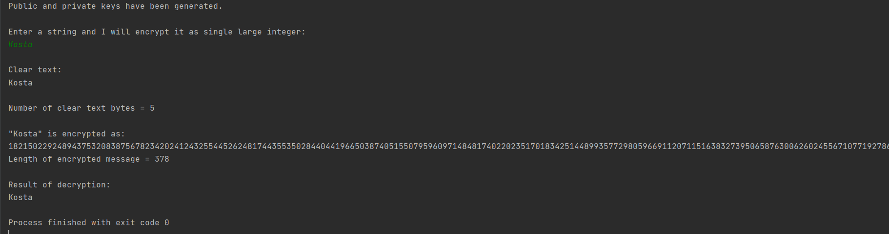

Зашифрованные сообщения получаются разные, но всегда одной длины для одного и того же изначального сообщения.

Conclusion:

Применив алгоритм ранцевой криптосистемы, Меркла - Хеллмана, мне удалось зашифровать сообщение “Kosta” вручную. В результате ручной расшифровки результат совпал с начальным сообщением. Запрограммированный алгоритм демонстрирует усложненную и приближенную к полевым условиям работу по шифровании сообщений согласно вышеуказанному алгоритму. Код позволяет каждый раз получать уникальную длинную комбинацию шифров.
Bibliography:

Code: The Hidden Language of Computer Hardware and Software, Book by Charlez Petzold, Microsoft Press, October 23, 1999

Serious Cryptography: A Practical Introduction to Modern Encryption, Book by Jean-Philippe Aumasson, 2017

Cryptography, Book by Rubinstein-Salzedo Simon, 2018

Information Security, 2Ed: Principles And Practices, book by Mark Stamp, 2018

Introduction to Cryptography, Book by Sahadeo Padhye, Rajeev A.Sahu, Vishal Saraswat, 2018

Great thanks to Stephen-X from GitHub who has originally posted this code
https://github.com/Stephen-X/Merkle-Hellman-Knapsack-Cryptosystem/blob/master/MHK_Crypto_w_Arrays.java

