Moldova State University
Department of Mathematics and Computer Science

Exercise #10
on course “Cryptography and Information Security”
topic: El Gamal Encryption Algorithm



Выполнил студент группы I1802:
Vigulear Constantin

Проверил преподаватель:
Olga Cerbu

Chisinau, 2021
Task

Realize El Gamal asymmetric algorithm.

First side generates a prime number P = 2909,
a number g which is between 1 and (p-1) = 72, G = 2134
a random number x which will be a private key, X = 62

Algorithm in action.

Calculations:

First side calculates Y:
Y = G^{X} mod p = 2134⁶² mod 2909 = 468
Public Key is now [P, G, Y] = [2909, 2134, 468]
This public key is sent to second side.

Encryption:

Let message that second side wants to send be M = “!” = 33 in ASCII.
The second side generates random value K = 137
and calculate two new values a = G^{K} mod P = 2134¹³⁷ mod 2909 = 1883
and b = Y^{K} M mod 2909 = 468¹³⁷ * 33 mod 2909 = 936
Now second sends encrypted message as a pair of a and b: (1883, 936)

Decryption:

First side receives the message and decrypts it:
M (clear original message) = b * (a^{X})⁻¹ mod P = 936 * (1883⁶²)⁻¹ mod 2909 = 33

Message has been securely sent!


Signature:

Signer makes the same steps to produce a secret key X and public key [P, G, Y].
To sign a message M, signer performs the following steps:

Choose a random K such that 0 < k < p-1 and gcd(k, p-1) = 1, let K = 137
Compute r = G^{K} mod P = 1883, r = 1883
Compute s = (H(M) – xr)k⁻¹mod(p-1).
Let H be the identity function, i.e. H(M) = M = “!” = 33 in ASCII
s = 2799

The sender sends message M to receiver with signature S = (r, s) = (1883, 2126)
Signature verification:

In order to verify the signature, receiver computes:

V1 = y^{r}r^{s} mod p = 468¹⁸⁸³ * 1883²⁷⁹⁹ mod 2909 = 1879
let H(M) = M = h = 33

V2 = g^{h} mod p = 2134³³ mod 2909 = 1879

V1 = V1 = 1879, hence signature is accepted.

Code listing:

package Vigulear;
import java.math.BigInteger;
public class ElGamal {
public static BigInteger stringToASCII (String string) {
StringBuilder sb = new StringBuilder();
char[] letters = string.toCharArray();
for (char ch : letters) {
sb.append((byte) ch);
}
return BigInteger.valueOf(Integer.parseInt(sb.toString()));
}
public static void main(String[] args) {
BigInteger P = BigInteger.valueOf(2909);
System.out.println("\tP = " + P);
BigInteger G = BigInteger.valueOf(2134);
System.out.println("\tG = " + G);
BigInteger X = BigInteger.valueOf(62);
System.out.println("\tX = " + X);
System.out.println("Calculating Y ...");
BigInteger Y = G.modPow(X, P);
System.out.println("\tY = " + Y);
String message = "!";
BigInteger M = stringToASCII(message);
System.out.println("Message M: \"" + message + "\" = " + M);
BigInteger K = BigInteger.valueOf(137);
System.out.println("\tK = " + K);
System.out.println("Calculating a ...");
BigInteger a = G.modPow(K, P);
System.out.println("\ta = " + a);
System.out.println("Calculating b ...");
BigInteger b = Y.pow(K.intValue()).multiply(M).mod(P);
System.out.println("\tb = " + b);
System.out.println("\nEncrypting...\nEncrypted message: (" + a + ", " + b + ")");
System.out.println("Decrypting...");
BigInteger decM = a.pow(X.intValue()).modPow(BigInteger.valueOf(-1), P).multiply(b).mod(P);
System.out.println("Decrypted message: " + decM + " = \"" + (char) decM.intValue() + "\"\n");
System.out.println("Signing the message M ...");
System.out.println("Calculating r ...");
BigInteger r = G.modPow(K, P);
System.out.println("\tr = " + r);
System.out.println("Calculating s taking H(M) = h = M ...");
BigInteger s = K.modPow(BigInteger.valueOf(-1), P.subtract(BigInteger.ONE)).multiply(M.subtract(X.multiply(r))).mod(P.subtract(BigInteger.ONE));
System.out.println("\ts = " + s);
System.out.println("Signed message S = (r, s): (" + r + ", " + s + ")\n");
System.out.println("Signature verification ...");
System.out.println("Calculating V1 ...");
BigInteger V1 = (Y.pow(r.intValue()).mod(P)).multiply(r.pow(s.intValue()).mod(P)).mod(P);
System.out.println("\tV1 = " + V1);
System.out.println("Calculating V2 ...");
BigInteger V2 = G.modPow(M, P);
System.out.println("\tV2 = " + V2);
if (V1.equals(V2)) {
System.out.println("V1 = V1 hence signature is accepted!");
}
else {
System.out.println("V1 != V2 hence signature is not accepted!");
}
}
}

Results:

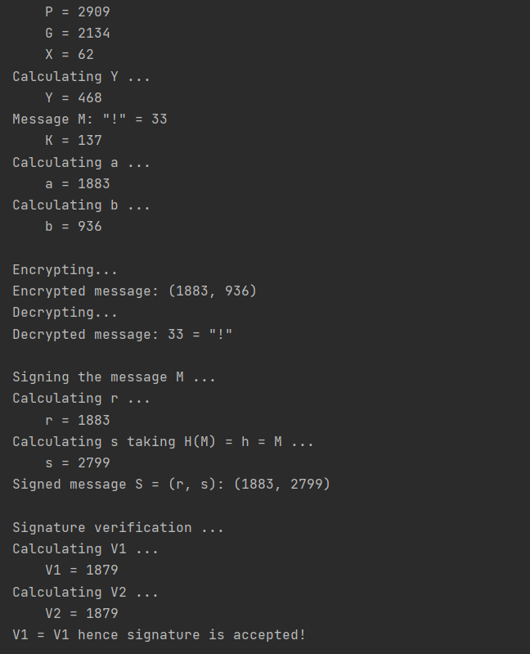

Conclusion:

Применив асимметричный алгоритм шифрования El Gamal, мне удалось зашифровать сообщение и создать для него электронную подпись. Результат ручного подсчета совпал с правильным ответом в ходе проверки решения. Результаты ручного вычисления совпали с результатами запрограммированного алгоритма, что подтверждает правильность ответа.
Bibliography:

Code: The Hidden Language of Computer Hardware and Software, Book by Charlez Petzold, Microsoft Press, October 23, 1999

Serious Cryptography: A Practical Introduction to Modern Encryption, Book by Jean-Philippe Aumasson, 2017

Cryptography, Book by Rubinstein-Salzedo Simon, 2018

Information Security, 2Ed: Principles And Practices, book by Mark Stamp, 2018

Introduction to Cryptography, Book by Sahadeo Padhye, Rajeev A.Sahu, Vishal Saraswat, 2018

