Moldova State University
Department of Mathematics and Computer Science

Laboratory Work #3.2
on course “Java for Internet Technologies”
topic: Программирование Java Server Pages (JSP)



Выполнил студент группы I1802:
Vigulear Constantin

Проверил преподаватель:
Latul Gheorge

Chisinau, 2020
Task

/*
Лабораторная работа 3.2. Программирование Java Server Pages (JSP)
1. Разработать страницу html для тестирования знаний или чего-либо ещё в какой-либо области. Например, география, геометрия, иностранный язык, анатомия, и т.д. Тему можно выбрать самостоятельно и прислать мне на одобрение.
Необходимо использовать все элементы формы (html-form). Используйте также элемент map (map с примером), для генерации кода можно использовать map генератор (http://htmlmapgenerator.ru/), данные от map можно хранить в hidden поле, а записывать данные в это поле можно при помощи маленькой JavaScript функции.
2. Данные из формы отправляются файлу JSP. JSP обрабатывает данные, формирует и отправляет страницу с результатами теста клиенту (браузеру).
3. Вопросы и ответы хранить в базе данных.
*/

Используемые библиотеки

import java.io.*
- provides for system output and output through data streams, serialization and the file system
import java.sql.*
- provides the API for accessing and processing data stored in a data source (usually a relational database) using the Java programming language
import javax.servlet.http.*
- the javax.servlet.http package contains a number of classes that describe and define the contracts between a servlet class running under the HTTP protocol and the runtime environment provided for an instance of such a class by a conforming servlet container
import javax.servlet.annotation.*
- the javax.servlet.http package contains a number of annotations that allow users to use annotations to declare servlets, filters, listeners and specify metadata for the declared component

JSTL – the JSP Standard Tag Library represents a set of tags to simplify the JSP development

Структура проекта

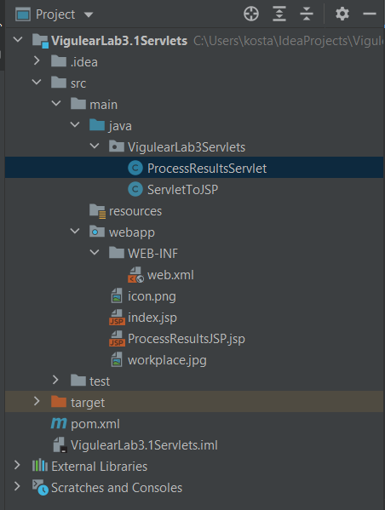

Структура базы данных

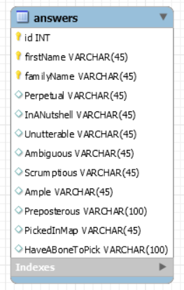
Настройки проекта Maven
pom.xml

<?xml version="1.0" encoding="UTF-8"?>
<project xmlns="http://maven.apache.org/POM/4.0.0"
xmlns:xsi="http://www.w3.org/2001/XMLSchema-instance"
xsi:schemaLocation="http://maven.apache.org/POM/4.0.0 http://maven.apache.org/xsd/maven-4.0.0.xsd">
<modelVersion>4.0.0</modelVersion>
<groupId>com.example</groupId>
<artifactId>VigulearLab31Servlets</artifactId>
<version>1.0-SNAPSHOT</version>
<name>VigulearLab3.1Servlets</name>
<packaging>war</packaging>
<properties>
<maven.compiler.target>1.8</maven.compiler.target>
<maven.compiler.source>1.8</maven.compiler.source>
<junit.version>5.7.0</junit.version>
</properties>
<dependencies>
<dependency>
<groupId>javax.servlet</groupId>
<artifactId>javax.servlet-api</artifactId>
<version>4.0.1</version>
<scope>provided</scope>
</dependency>
<dependency>
<groupId>org.apache.bval</groupId>
<artifactId>bval-jsr</artifactId>
<version>2.0.3</version>
</dependency>
<dependency>
<groupId>org.apache.cxf</groupId>
<artifactId>cxf-rt-frontend-jaxrs</artifactId>
<version>3.3.7</version>
</dependency>
<dependency>
<groupId>org.apache.cxf</groupId>
<artifactId>cxf-rt-frontend-jaxws</artifactId>
<version>3.3.7</version>
</dependency>
<dependency>
<groupId>org.apache.activemq</groupId>
<artifactId>activemq-client</artifactId>
<version>5.16.0</version>
</dependency>
<dependency>
<groupId>org.junit.jupiter</groupId>
<artifactId>junit-jupiter-api</artifactId>
<version>${junit.version}</version>
<scope>test</scope>
</dependency>
<dependency>
<groupId>org.junit.jupiter</groupId>
<artifactId>junit-jupiter-engine</artifactId>
<version>${junit.version}</version>
<scope>test</scope>
</dependency>
<dependency>
<groupId>javax.servlet</groupId>
<artifactId>jstl</artifactId>
<version>1.2</version>
</dependency>
<!--MySQL-->
<dependency>
<groupId>mysql</groupId>
<artifactId>mysql-connector-java</artifactId>
<version>8.0.12</version>
</dependency>
</dependencies>
<build>
<plugins>
<plugin>
<groupId>org.apache.maven.plugins</groupId>
<artifactId>maven-war-plugin</artifactId>
<version>3.3.0</version>
</plugin>
</plugins>
</build>
</project>

Настройки web.xml

<?xml version="1.0" encoding="UTF-8"?>
<web-app xmlns="http://xmlns.jcp.org/xml/ns/javaee"
xmlns:xsi="http://www.w3.org/2001/XMLSchema-instance"
xsi:schemaLocation="http://xmlns.jcp.org/xml/ns/javaee http://xmlns.jcp.org/xml/ns/javaee/web-app_4_0.xsd"
version="4.0">
<servlet>
<servlet-name>ProcessResultsServlet</servlet-name>
<servlet-class>VigulearLab3Servlets.ProcessResultsServlet</servlet-class>
</servlet>
<servlet-mapping>
<servlet-name>ProcessResultsServlet</servlet-name>
<url-pattern>/VigulearLab3Servlets.ProcessResultsServlet</url-pattern>
</servlet-mapping>
<servlet>
<servlet-name>ServletToJSP</servlet-name>
<servlet-class>VigulearLab3Servlets.ServletToJSP</servlet-class>
</servlet>
<servlet-mapping>
<servlet-name>ServletToJSP</servlet-name>
<url-pattern>/VigulearLab3Servlets.ServletToJSP</url-pattern>
</servlet-mapping>
</web-app>
Main HTML Page

index.jsp

<%@ page contentType="text/html; charset=UTF-8" pageEncoding="UTF-8" %>
<!DOCTYPE html>
<html>
<head>
<title>Custom English Test </title>
<link rel = icon href="icon.png" type="image/png">
</head>
<body>
<table width=500>
<tr>
<td>
<img src = "icon.png" width="128" height="128" alt="Flag">
<h3> Custom English Vocabulary Test </h3>
<FORM action="processResults-servlet" method="post">
<!User Credentials>
<fieldset WIDTH=400>
<legend> User: &nbsp;</legend>
<label>
<INPUT TYPE="text" NAME="firstName" placeholder="firstName" required>
</label><BR><BR>
<label>
<INPUT TYPE="text" NAME="familyName" placeholder="familyName" required>
</label> <BR>
</fieldset>
<br>
<!Question1 Radio>
<fieldset WIDTH=400>
<legend><b>1.</b> Perpetual: &nbsp;</legend>
<label>
<INPUT TYPE="RADIO" NAME="question1" VALUE="Eternal">
</label> Eternal.<BR>
<label>
<INPUT TYPE="RADIO" NAME="question1" VALUE="Nice">
</label> Nice.<BR>
<label>
<INPUT TYPE="RADIO" NAME="question1" VALUE="Tasty">
</label> Tasty.<BR>
</fieldset>
<br>
<!Question2 Radio>
<fieldset WIDTH=400>
<legend><b>2.</b> In a nutshell: &nbsp;</legend>
<label>
<INPUT TYPE="RADIO" NAME="question2" VALUE="God bless you!">
</label> God bless you!<BR>
<label>
<INPUT TYPE="RADIO" NAME="question2" VALUE="It is a long story">
</label> It is a long story.<BR>
<label>
<INPUT TYPE="RADIO" NAME="question2" VALUE="Something of small size, amount, or scope">
</label> Something of small size, amount, or scope.<BR>
</fieldset>
<br>
<!Question3 Radio>
<fieldset WIDTH=400>
<legend><b>3.</b> Unutterable: &nbsp;</legend>
<label>
<INPUT TYPE="RADIO" NAME="question3" VALUE="Indescribable">
</label> Indescribable.<BR>
<label>
<INPUT TYPE="RADIO" NAME="question3" VALUE="Awful">
</label> Awful.<BR>
<label>
<INPUT TYPE="RADIO" NAME="question3" VALUE="Mediocre">
</label> Mediocre.<BR>
</fieldset>
<br>
<!Question4 Radio>
<fieldset WIDTH=400>
<legend><b>4.</b> Ambiguous: &nbsp;</legend>
<label>
<INPUT TYPE="RADIO" NAME="question4" VALUE="Plain">
</label> Plain.<BR>
<label>
<INPUT TYPE="RADIO" NAME="question4" VALUE="Paramount">
</label> Paramount.<BR>
<label>
<INPUT TYPE="RADIO" NAME="question4" VALUE="Equivocal">
</label> Equivocal.<BR>
</fieldset>
<br>
<!Question5 Radio>
<fieldset WIDTH=400>
<legend><b>5.</b> Scrumptious: &nbsp;</legend>
<label>
<INPUT TYPE="RADIO" NAME="question5" VALUE="Tasty">
</label> Tasty.<BR>
<label>
<INPUT TYPE="RADIO" NAME="question5" VALUE="Disgusting">
</label> Disgusting.<BR>
<label>
<INPUT TYPE="RADIO" NAME="question5" VALUE="Ambivalent">
</label> Ambivalent.<BR>
</fieldset>
<br>
<!Question6 List>
<fieldset WIDTH=400>
<legend><b>6.</b> Ample: &nbsp;</legend>
<label>
<select name = "question6">
<option value="Minimal">Minimal</option>
<option value="Tangled">Tangled</option>
<option value="Abundant">Abundant</option>
<option value="Corrupt">Corrupt</option>
</select>
</label>
</fieldset>
<br>
<!Question7 Checkbox>
<fieldset WIDTH=400>
<legend><b>7.</b> Preposterous: &nbsp;</legend>
<label>
<INPUT TYPE="CHECKBOX" NAME="question7" VALUE="Reasonable">
</label> Reasonable.<BR>
<label>
<INPUT TYPE="CHECKBOX" NAME="question7" VALUE="Insane">
</label> Insane.<BR>
<label>
<INPUT TYPE="CHECKBOX" NAME="question7" VALUE="Absurd">
</label> Absurd.<BR>
<label>
<INPUT TYPE="CHECKBOX" NAME="question7" VALUE="Hypocritical">
</label> Hypocritical.<BR>
<label>
<INPUT TYPE="CHECKBOX" NAME="question7" VALUE="Bizarre">
</label> Bizarre.<BR>
</fieldset>
<br>
<!Question8 Map>
<fieldset WIDTH=400>
<legend><b>8.</b> Click on what best corresponds the description given below: &nbsp;</legend>
<p><i>A device that can be instructed to carry out arbitrary sequences of arithmetic or logical
operations automatically</i></p>
<img src="workplace.jpg" alt="Workplace" usemap="#workmap" width="400" height="379">
<map name="workmap">
<area onclick="processInputValue('Computer');" shape="rect" coords="34,44,270,350"
alt="Computer" href="#">
<area onclick="processInputValue('Phone');" shape="rect" coords="290,172,333,250"
alt="Phone" href="#">
<area onclick="processInputValue('Cup of coffee');" shape="circle" coords="337,300,44"
alt="Cup of coffee" href="#">
<input id="pictureId" type="hidden" name="pictureId" value = "">
<script>
function processInputValue(param) {
// Selecting the input element and get its value
document.getElementById('pictureId').value = param;
// Displaying the value
alert("You have selected '" + param + "'");
}
</script>
</map>
</fieldset>
<br>
<!Question9 TextArea>
<fieldset WIDTH=400>
<legend><b>9.</b> Please type in your understanding of the following idiom: &nbsp;</legend>
<p><i>Have a bone to pick.</i></p>
<br>
<label>
<textarea rows="5" cols="60" name="question9" placeholder="Enter text here..."></textarea>
</label>
<br><br><br>
<INPUT TYPE="SUBMIT" VALUE="Test yourself">
<br><br>
</fieldset>
</FORM>
</td>
</tr>
</table>
</body>
</html>

Servlet class ServletToJSP.java

/*
Лабораторная работа 3.2. Программирование Java Server Pages (JSP)
1. Разработать страницу html для тестирования знаний или чего-либо ещё в какой-либо области. Например, география, геометрия, иностранный язык, анатомия, и т.д. Тему можно выбрать самостоятельно и прислать мне на одобрение.
Необходимо использовать все элементы формы (html-form). Используйте также элемент map (map с примером), для генерации кода можно использовать map генератор (http://htmlmapgenerator.ru/), данные от map можно хранить в hidden поле, а записывать данные в это поле можно при помощи маленькой JavaScript функции.
2. Данные из формы отправляются файлу JSP. JSP обрабатывает данные, формирует и отправляет страницу с результатами теста клиенту (браузеру).
3. Вопросы и ответы хранить в базе данных.
*/
package VigulearLab3Servlets;
import java.io.*;
import javax.servlet.ServletException;
import javax.servlet.http.*;
import javax.servlet.annotation.*;
@WebServlet(name = "servletToJsp", value = "/servlet-to-jsp")
public class ServletToJSP extends HttpServlet {
public ServletToJSP() {
super();
}
public void doGet(HttpServletRequest request, HttpServletResponse response) throws IOException, ServletException {
getServletContext().getRequestDispatcher("/ProcessResultsJSP.jsp").forward(request, response);
}
public void doPost(HttpServletRequest request, HttpServletResponse response) throws IOException, ServletException {
doGet(request, response);
}
public void destroy() {
}
}

JSP ProcessResultsJSP.jsp

<%@ page contentType="text/html;charset=UTF-8" %>
<%@ taglib prefix="c" uri="http://java.sun.com/jsp/jstl/core" %>
<%@ taglib uri="http://java.sun.com/jsp/jstl/sql" prefix="sql"%>
<html>
<head>
<title>Answers from <c:out value="${param['firstName']}"/> <c:out value="${param['familyName']}"/></title>
<link rel=icon href="icon.png" type="image/png"/>
</head>
<body>
<h1>Thank you for taking this test!</h1><br/>
<h2>Answers for <b><c:out value="${param.firstName}"/> <c:out value="${param.familyName}"/></b></h2>
1. Perpetual:<br/><c:out value="${param.question1}"/><br/><br/>
2. In a nutshell:<br/><c:out value="${param.question2}"/><br/><br/>
3. Unutterable:<br/><c:out value="${param.question3}"/><br/><br/>
4. Ambiguous:<br/><c:out value="${param.question4}"/><br/><br/>
5. Scrumptious:<br/><c:out value="${param['question5']}"/><br/><br/>
6. Ample:<br/><c:out value="${param.question6}"/><br/><br/>
7. Preposterous:<br/>
<c:set var = "answers7" scope="session" value="${param['question7']}"/>
<c:if test = "${not empty answers7}">
<c:forEach var="answer" items="${paramValues.question7}">
<c:out value = "${answer}"/><br/>
</c:forEach>
</c:if>
<c:if test = "${empty answers7}">
No Answer<br/>
</c:if>
<br/><br/>
8. Picked in map:<br/><c:out value="${param.pictureId}"/><br/><br/>
9. Have a bone to pick:<br/>
<c:set var = "answers9" scope="session" value="${param['question9']}"/>
<c:choose>
<c:when test="${not empty answers9}">
<c:out value = "${answers9}"/><br/><br/>
</c:when>
<c:otherwise>
No Answer<br/><br/>
</c:otherwise>
</c:choose>
<%--Acquire parametres from request--%>
<c:set var="firstName">${param.firstName}</c:set>
<c:set var="familyName">${param.familyName}</c:set>
<c:set var="question1">${param.question1}</c:set>
<c:set var="question2">${param.question2}</c:set>
<c:set var="question3">${param.question3}</c:set>
<c:set var="question4">${param.question4}</c:set>
<c:set var="question5">${param.question5}</c:set>
<c:set var="question6">${param.question6}</c:set>
<c:set var="question7"/>
<c:forEach var = "subString" items="${paramValues.question7}" varStatus="stat">
<c:set var = "question7" value="${stat.first ? '' : question7} ${subString}"/>
</c:forEach>
<c:set var="question8">${param.pictureId}</c:set>
<c:set var="question9">${param.question9}</c:set>
<c:catch var = "exception">
<sql:setDataSource var = "dataBase" driver="com.mysql.jdbc.Driver" url = "jdbc:mysql://localhost:3306/englishtest" user = "root" password="root"/>
<sql:update dataSource = "${dataBase}" var = "update">
insert into answers(firstName, familyName, Perpetual, InANutshell, Unutterable, Ambiguous, Scrumptious, Ample, Preposterous, PickedInMap, HaveABoneToPick)
values('${firstName}', '${familyName}', '${question1}', '${question2}', '${question3}', '${question4}', '${question5}', '${question6}', '${question7}', '${question8}', '${question9}')
</sql:update>
</c:catch>
<c:choose>
<c:when test="${exception != null}">
<b>Error saving answers on server!</b><br/>
<b>You must have already taken this test before...</b>
</c:when>
<c:otherwise>
<b>Your answers were successfully saved in data base!</b>
</c:otherwise>
</c:choose>
</body>
</html>

Используемые функции

JavaScript function that retrieves parameter from Map form depending on area chosen, it passes parameter to hidden input value and makes alert with chosen area

function processInputValue(param) {
// Selecting the input element and get its value
document.getElementById('pictureId').value = param;
// Displaying the value
alert("You have selected '" + param + "'");
}

Результаты работы приложения

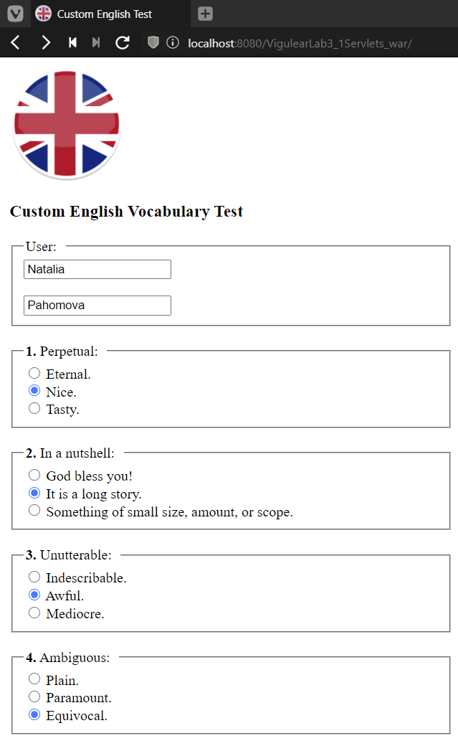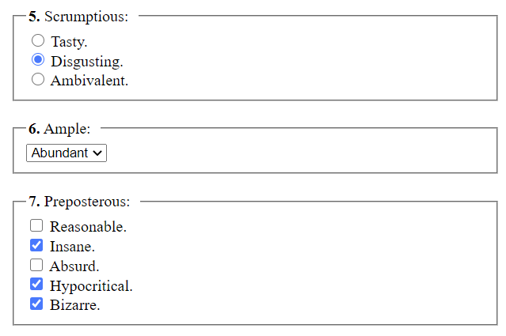
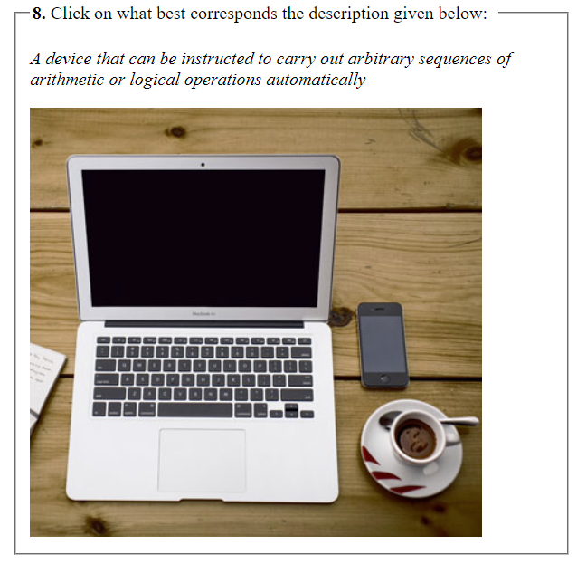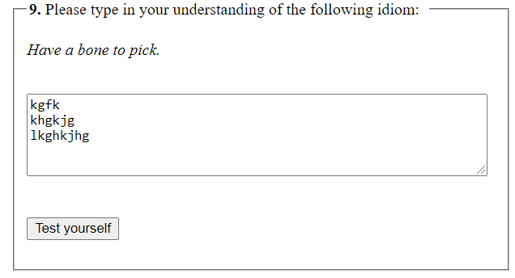

On clocking on certain object on the picture, e.g. “Phone”

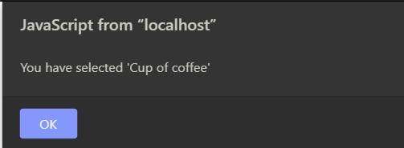
Response generated by .jsp

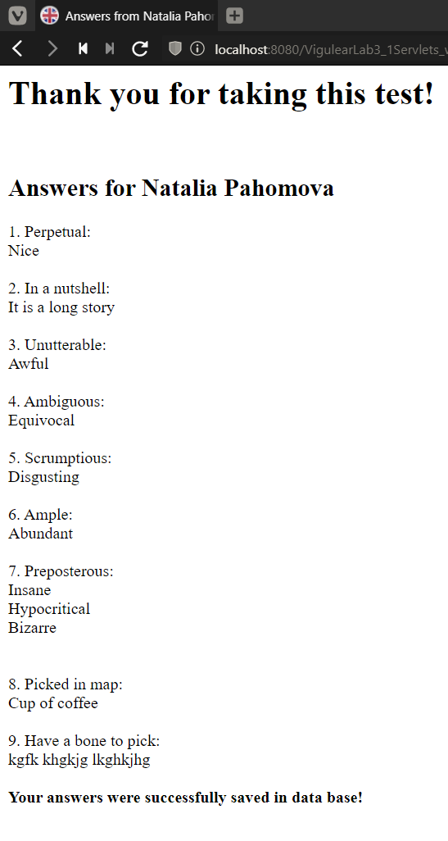

In case of dublicating any entries:

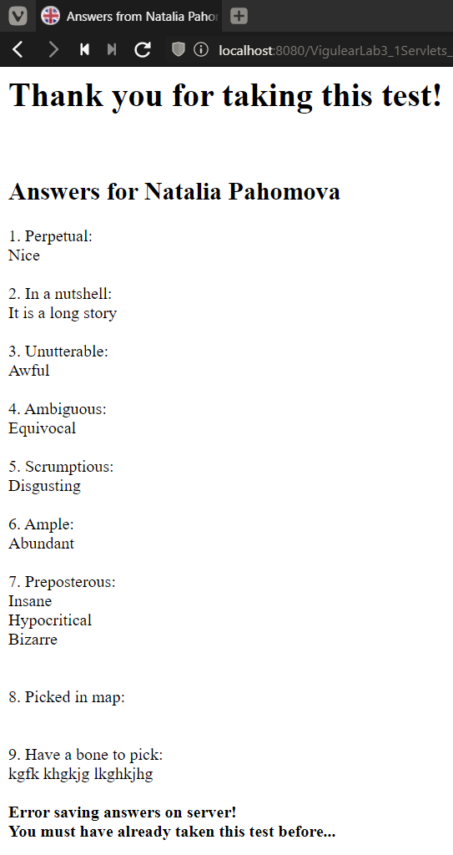
Результат записи ответов в базу данных:

