Moldova State University
Department of Mathematics and Computer Science

Laboratory Work #3.1
on course “Java for Internet Technologies”
topic: Servlets



Выполнил студент группы I1802:
Vigulear Constantin

Проверил преподаватель:
Latul Gheorge

Chisinau, 2020
Task

Создать приложение, работающее с БД посредством ГПИ(GUI). Пользователь должен иметь возможность в окне приложения
• вводить данные в БД (из полей GUI) и из текстового файла;
• выводить данные из БД в окне;
• выводить данные из БД по определённым критериям (минимум 2);
• выводить отсортированные данные.
В БД должно быть минимум 3 таблицы. При проектировании графического пользовательского интерфейса использовать модель MVC (Model/View/Controller, модель – вид – контроллер)
1. БД содержит данные об услугах tattoo салона, включая татуировки по категориям, размерам, ценам, мастерам, способным их выполнять etc.
Работу выполнить в Hibernate Framework

Используемые библиотеки

import java.io.*
- provides for system output and output through data streams, serialization and the file system
import java.sql.*
- provides the API for accessing and processing data stored in a data source (usually a relational database) using the Java programming language
import javax.servlet.http.*
- the javax.servlet.http package contains a number of classes that describe and define the contracts between a servlet class running under the HTTP protocol and the runtime environment provided for an instance of such a class by a conforming servlet container
import javax.servlet.annotation.*
- the javax.servlet.http package contains a number of annotations that allow users to use annotations to declare servlets, filters, listeners and specify metadata for the declared component

Структура проекта

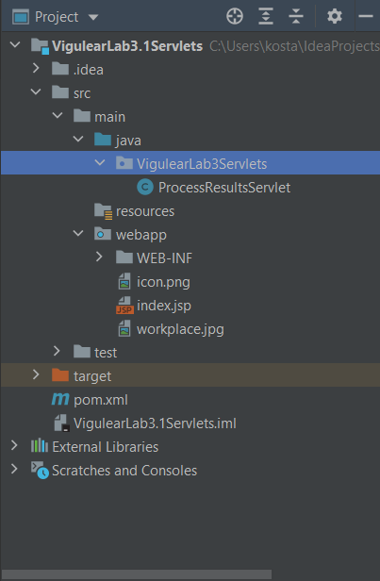
Структура базы данных

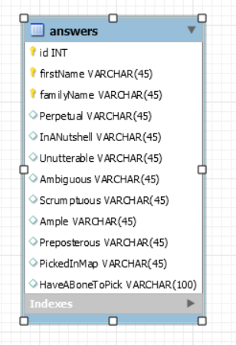
Настройки проекта Maven
pom.xml

<?xml version="1.0" encoding="UTF-8"?>
<project xmlns="http://maven.apache.org/POM/4.0.0"
xmlns:xsi="http://www.w3.org/2001/XMLSchema-instance"
xsi:schemaLocation="http://maven.apache.org/POM/4.0.0 http://maven.apache.org/xsd/maven-4.0.0.xsd">
<modelVersion>4.0.0</modelVersion>
<groupId>com.example</groupId>
<artifactId>VigulearLab31Servlets</artifactId>
<version>1.0-SNAPSHOT</version>
<name>VigulearLab3.1Servlets</name>
<packaging>war</packaging>
<properties>
<maven.compiler.target>1.8</maven.compiler.target>
<maven.compiler.source>1.8</maven.compiler.source>
<junit.version>5.7.0</junit.version>
</properties>
<dependencies>
<dependency>
<groupId>javax.servlet</groupId>
<artifactId>javax.servlet-api</artifactId>
<version>4.0.1</version>
<scope>provided</scope>
</dependency>
<dependency>
<groupId>org.apache.bval</groupId>
<artifactId>bval-jsr</artifactId>
<version>2.0.3</version>
</dependency>
<dependency>
<groupId>org.apache.cxf</groupId>
<artifactId>cxf-rt-frontend-jaxrs</artifactId>
<version>3.3.7</version>
</dependency>
<dependency>
<groupId>org.apache.cxf</groupId>
<artifactId>cxf-rt-frontend-jaxws</artifactId>
<version>3.3.7</version>
</dependency>
<dependency>
<groupId>org.apache.activemq</groupId>
<artifactId>activemq-client</artifactId>
<version>5.16.0</version>
</dependency>
<dependency>
<groupId>org.junit.jupiter</groupId>
<artifactId>junit-jupiter-api</artifactId>
<version>${junit.version}</version>
<scope>test</scope>
</dependency>
<dependency>
<groupId>org.junit.jupiter</groupId>
<artifactId>junit-jupiter-engine</artifactId>
<version>${junit.version}</version>
<scope>test</scope>
</dependency>
<!--MySQL-->
<dependency>
<groupId>mysql</groupId>
<artifactId>mysql-connector-java</artifactId>
<version>8.0.12</version>
</dependency>
</dependencies>
<build>
<plugins>
<plugin>
<groupId>org.apache.maven.plugins</groupId>
<artifactId>maven-war-plugin</artifactId>
<version>3.3.0</version>
</plugin>
</plugins>
</build>
</project>

Настройки web.xml

<?xml version="1.0" encoding="UTF-8"?>
<web-app xmlns="http://xmlns.jcp.org/xml/ns/javaee"
xmlns:xsi="http://www.w3.org/2001/XMLSchema-instance"
xsi:schemaLocation="http://xmlns.jcp.org/xml/ns/javaee http://xmlns.jcp.org/xml/ns/javaee/web-app_4_0.xsd"
version="4.0">
<servlet>
<servlet-name>ProcessResultsServlet</servlet-name>
<servlet-class>VigulearLab3Servlets.ProcessResultsServlet</servlet-class>
</servlet>
<servlet-mapping>
<servlet-name>ProcessResultsServlet</servlet-name>
<url-pattern>/VigulearLab3Servlets.ProcessResultsServlet</url-pattern>
</servlet-mapping>
</web-app>
Main HTML Page

index.jsp

<%@ page contentType="text/html; charset=UTF-8" pageEncoding="UTF-8" %>
<!DOCTYPE html>
<html>
<head>
<title>Custom English Test </title>
<link rel = icon href="icon.png" type="image/png">
</head>
<body>
<table width=500>
<tr>
<td>
<img src = "icon.png" width="128" height="128" alt="Flag">
<h3> Custom English Vocabulary Test </h3>
<FORM action="processResults-servlet" method="post">
<!User Credentials>
<fieldset WIDTH=400>
<legend> User: &nbsp;</legend>
<label>
<INPUT TYPE="text" NAME="firstName" placeholder="firstName" required>
</label><BR><BR>
<label>
<INPUT TYPE="text" NAME="familyName" placeholder="familyName" required>
</label> <BR>
</fieldset>
<br>
<!Question1 Radio>
<fieldset WIDTH=400>
<legend><b>1.</b> Perpetual: &nbsp;</legend>
<label>
<INPUT TYPE="RADIO" NAME="question1" VALUE="Eternal">
</label> Eternal.<BR>
<label>
<INPUT TYPE="RADIO" NAME="question1" VALUE="Nice">
</label> Nice.<BR>
<label>
<INPUT TYPE="RADIO" NAME="question1" VALUE="Tasty">
</label> Tasty.<BR>
</fieldset>
<br>
<!Question2 Radio>
<fieldset WIDTH=400>
<legend><b>2.</b> In a nutshell: &nbsp;</legend>
<label>
<INPUT TYPE="RADIO" NAME="question2" VALUE="God bless you!">
</label> God bless you!<BR>
<label>
<INPUT TYPE="RADIO" NAME="question2" VALUE="It is a long story">
</label> It is a long story.<BR>
<label>
<INPUT TYPE="RADIO" NAME="question2" VALUE="Something of small size, amount, or scope">
</label> Something of small size, amount, or scope.<BR>
</fieldset>
<br>
<!Question3 Radio>
<fieldset WIDTH=400>
<legend><b>3.</b> Unutterable: &nbsp;</legend>
<label>
<INPUT TYPE="RADIO" NAME="question3" VALUE="Indescribable">
</label> Indescribable.<BR>
<label>
<INPUT TYPE="RADIO" NAME="question3" VALUE="Awful">
</label> Awful.<BR>
<label>
<INPUT TYPE="RADIO" NAME="question3" VALUE="Mediocre">
</label> Mediocre.<BR>
</fieldset>
<br>
<!Question4 Radio>
<fieldset WIDTH=400>
<legend><b>4.</b> Ambiguous: &nbsp;</legend>
<label>
<INPUT TYPE="RADIO" NAME="question4" VALUE="Plain">
</label> Plain.<BR>
<label>
<INPUT TYPE="RADIO" NAME="question4" VALUE="Paramount">
</label> Paramount.<BR>
<label>
<INPUT TYPE="RADIO" NAME="question4" VALUE="Equivocal">
</label> Equivocal.<BR>
</fieldset>
<br>
<!Question5 Radio>
<fieldset WIDTH=400>
<legend><b>5.</b> Scrumptious: &nbsp;</legend>
<label>
<INPUT TYPE="RADIO" NAME="question5" VALUE="Tasty">
</label> Tasty.<BR>
<label>
<INPUT TYPE="RADIO" NAME="question5" VALUE="Disgusting">
</label> Disgusting.<BR>
<label>
<INPUT TYPE="RADIO" NAME="question5" VALUE="Ambivalent">
</label> Ambivalent.<BR>
</fieldset>
<br>
<!Question6 List>
<fieldset WIDTH=400>
<legend><b>6.</b> Ample: &nbsp;</legend>
<label>
<select name = "question6">
<option value="Minimal">Minimal</option>
<option value="Tangled">Tangled</option>
<option value="Abundant">Abundant</option>
<option value="Corrupt">Corrupt</option>
</select>
</label>
</fieldset>
<br>
<!Question7 Checkbox>
<fieldset WIDTH=400>
<legend><b>7.</b> Preposterous: &nbsp;</legend>
<label>
<INPUT TYPE="CHECKBOX" NAME="question7" VALUE="Reasonable">
</label> Reasonable.<BR>
<label>
<INPUT TYPE="CHECKBOX" NAME="question7" VALUE="Insane">
</label> Insane.<BR>
<label>
<INPUT TYPE="CHECKBOX" NAME="question7" VALUE="Absurd">
</label> Absurd.<BR>
<label>
<INPUT TYPE="CHECKBOX" NAME="question7" VALUE="Hypocritical">
</label> Hypocritical.<BR>
<label>
<INPUT TYPE="CHECKBOX" NAME="question7" VALUE="Bizarre">
</label> Bizarre.<BR>
</fieldset>
<br>
<!Question8 Map>
<fieldset WIDTH=400>
<legend><b>8.</b> Click on what best corresponds the description given below: &nbsp;</legend>
<p><i>A device that can be instructed to carry out arbitrary sequences of arithmetic or logical
operations automatically</i></p>
<img src="workplace.jpg" alt="Workplace" usemap="#workmap" width="400" height="379">
<map name="workmap">
<area onclick="processInputValue('Computer');" shape="rect" coords="34,44,270,350"
alt="Computer" href="#">
<area onclick="processInputValue('Phone');" shape="rect" coords="290,172,333,250"
alt="Phone" href="#">
<area onclick="processInputValue('Cup of coffee');" shape="circle" coords="337,300,44"
alt="Cup of coffee" href="#">
<input id="pictureId" type="hidden" name="pictureId" value = "">
<script>
function processInputValue(param) {
// Selecting the input element and get its value
document.getElementById('pictureId').value = param;
// Displaying the value
alert("You have selected '" + param + "'");
}
</script>
</map>
</fieldset>
<br>
<!Question9 TextArea>
<fieldset WIDTH=400>
<legend><b>9.</b> Please type in your understanding of the following idiom: &nbsp;</legend>
<p><i>Have a bone to pick.</i></p>
<br>
<label>
<textarea rows="5" cols="60" name="question9" placeholder="Enter text here..."></textarea>
</label>
<br><br><br>
<INPUT TYPE="SUBMIT" VALUE="Test yourself">
<br><br>
</fieldset>
</FORM>
</td>
</tr>
</table>
</body>
</html>

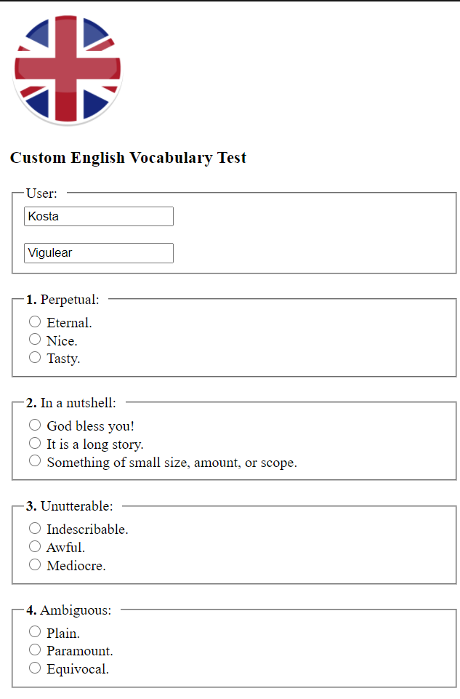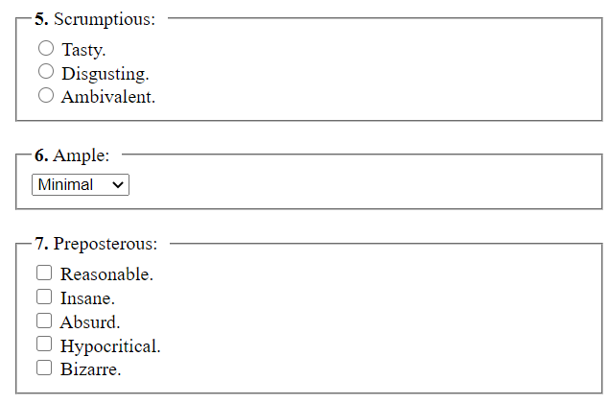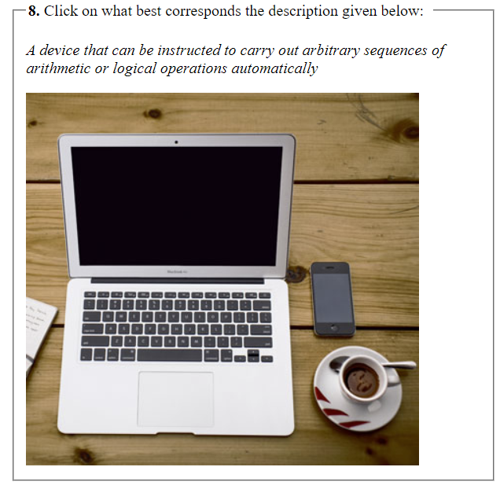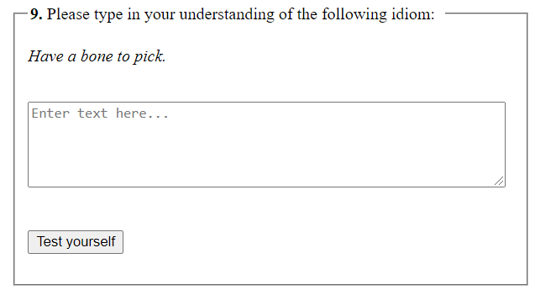

On clocking on certain object on the picture, e.g. “Phone”

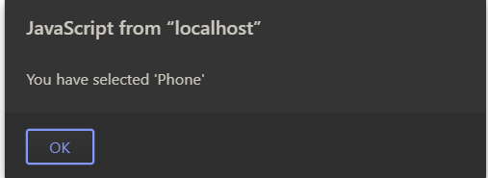
Generated response by servlet

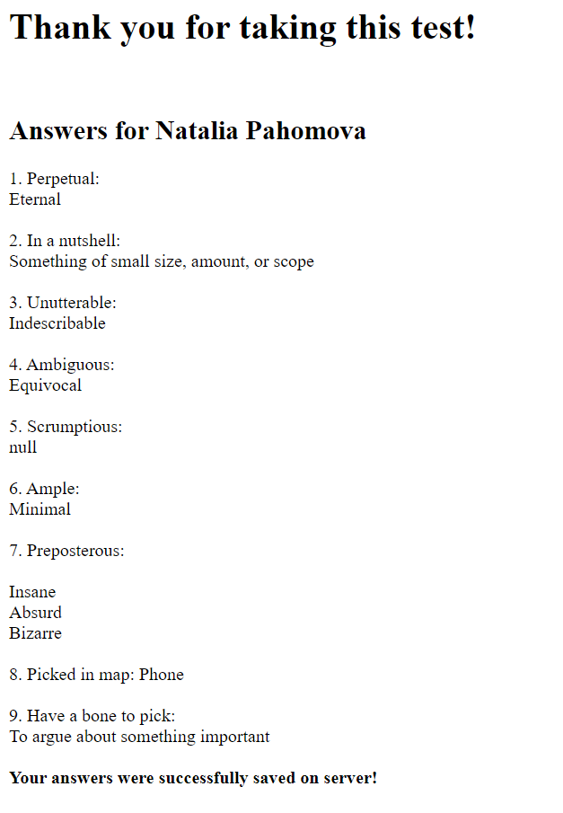

Результат записи ответов в базу данных

Servlet class ProcessResultsServlets.java

/*
Лабораторная работа 3-1. Программирование сервлетов (Servlet)
1. Разработать страницу html для тестирования знаний или чего-либо ещё в какой-либо области. Например, география, геометрия, иностранный язык, анатомия, и т.д. Тему можно выбрать самостоятельно и прислать мне на одобрение.
Необходимо использовать все элементы формы (html-form). Используйте также элемент map (map с примером), для генерации кода можно использовать map генератор (http://htmlmapgenerator.ru/), данные от map можно хранить в hidden поле, а записывать данные в это поле можно при помощи маленькой JavaScript функции.
2. Данные из формы отправляются сервлету для обработки. Сервлет обрабатывает данные, формирует и отправляет страницу с результатами теста клиенту (браузеру).
3. Вопросы и ответы хранить в базе данных. Это требование не касается п1.
*/
package VigulearLab3Servlets;
import java.io.*;
import java.sql.*;
import javax.servlet.http.*;
import javax.servlet.annotation.*;
@WebServlet(name = "processResultsServlet", value = "/processResults-servlet")
public class ProcessResultsServlet extends HttpServlet {
private String message;
static Connection connection;
static Statement statement;
static String query;
public void init() {
message = "Answers for ";
}
public void doGet(HttpServletRequest request, HttpServletResponse response) throws IOException {
response.setContentType("text/html");
String firstName = request.getParameter("firstName");
String familyName = request.getParameter("familyName");
String question1 = request.getParameter("question1");
String question2 = request.getParameter("question2");
String question3 = request.getParameter("question3");
String question4 = request.getParameter("question4");
String question5 = request.getParameter("question5");
String question6 = request.getParameter("question6");
String[] question7 = request.getParameterValues("question7");
String question7String = "";
String question8 = request.getParameter("pictureId");
String question9 = request.getParameter("question9");
PrintWriter out = response.getWriter();
out.println("<html><head><title>Answers from " + firstName + " " + familyName +"</title><link rel = icon " +
"href=\"icon.png\" type=\"image/png\"></head><body>");
out.println("<h1>Thank you for taking this test!</h1><br/>");
out.println("<h2>" + message + "<b>" + firstName + " " + familyName + "</b></h2>");
out.println("1. Perpetual:<br/>" + question1 + "<br/><br/>");
out.println("2. In a nutshell:<br/>" + question2 + "<br/><br/>");
out.println("3. Unutterable:<br/>" + question3 + "<br/><br/>");
out.println("4. Ambiguous:<br/>" + question4 + "<br/><br/>");
out.println("5. Scrumptious:<br/>" + question5 + "<br/><br/>");
out.println("6. Ample:<br/>" + question6 + "<br/><br/>");
if (question7 != null) {
out.println("7. Preposterous:<br/>" + "<br/>");
for (String answer : question7) {
out.println(answer + "<br/>");
question7String = question7String.concat(answer).concat(" ");
}
} else out.println("7. Preposterous:<br/>No Answer" + "<br/>");
out.println("<br/>");
out.println("8. Picked in map: " + question8 + "<br/><br/>");
out.println("9. Have a bone to pick:<br/>" + question9 + "<br/><br/>");
// Connecting to DataBase
try {
Class.forName("com.mysql.jdbc.Driver");
connection = DriverManager.getConnection("jdbc:mysql://localhost:3306/englishtest", "root", "root");
statement = connection.createStatement();
query = "insert into answers(firstName, familyName, Perpetual, InANutshell, Unutterable, Ambiguous, Scrumptuous, Ample, Preposterous, PickedInMap, HaveABoneToPick) " +
"values('" + firstName + "', '" + familyName + "', '" + question1 + "', '" + question2 +"', '" + question3 +"', '" + question4 + "', " +
"'" + question5 + "', '" + question6 + "', '" + question7String + "', '" + question8 + "', '" + question9 + "')";
int flag = statement.executeUpdate(query);
if (flag == 1)
out.println("<b>Your answers were successfully saved on server!</b>");
else
out.println("Error saving answers on server!");
} catch (ClassNotFoundException | SQLException exception) {
exception.printStackTrace();
}
out.println("</body></html>");
}
public void doPost(HttpServletRequest request, HttpServletResponse response) throws IOException {
doGet(request, response);
}
public void destroy() {
}
}

Используемые функции

JavaScript function that retrieves parameter from Map form depending on area chosen, it passes parameter to hidden input value and makes alert with chosen area

function processInputValue(param) {
// Selecting the input element and get its value
document.getElementById('pictureId').value = param;
// Displaying the value
alert("You have selected '" + param + "'");
}

