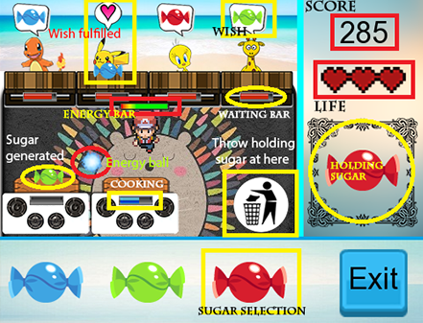 **A Day In Candy Shop**

1. The player will play as a waitress that need to serve the order of the customer.
2. Customer will randomly pop out with random sugar they wish to enjoy.
3. The player would need to first generate the sugar by clicking corresponding candy in the sugar selection bar. Then the stove would require some time to generate the sugar. After the sugar is generated, it will appear on the table in front of the stove.
4. The player needs to collect the sugar. The collected sugar will show up in the frame under the life bar. After successfully collect the correct sugar, deliver it to the correct customer.
5. However, if the collected sugar is not needed, there is an area to throw it indicated by a logo showing a person throwing rubbish into a dustbin.
6. The waitress has an energy bar which moving around will decrease it. When the energy is too low, the movement speed of the waitress will decrease.
7. There are two ways to refill energy. One is by standing still and the other is by collecting energy ball. The score of the game will keep the increase as time pass.
8. When the red bar under the dining table reaches full, half-life will be deducted. It is game over when all three lives expense.