GROUP 9 OF ITE E CLASS
ALMIGHTY DRIVING SCHOOL DATABASE PROJECT
STATEMENT OF WORK
Project background
Almighty Driving School traditionally manages student lessons, instructors, vehicles and payments manually. This often leads to problems such as scheduling conflicts, missing records, and difficulty tracking student eligibility for lessons.
To solve these issues, group 9 of ITE Level 200 E class has decided to develop a database management system. The new system will help organize information about students, instructors, vehicles, lessons and payments. It will ensure that lessons are scheduled correctly and effective management of driving school activities.
Scope
The project will involve designing and implementing a relational database system for the Almighty driving school.
The System will:
- Store information about students, instructors, manager, vehicles, lessons and payments.
- Allow proper lesson scheduling.
- Prevent conflict between instructors and vehicle scheduling.
- Verify that students are eligible for lessons based on permits and payments status.

Constraints
The project will not include:
- Advance mobile Applications online payment gateways.
- External System integration.
Objectives
The main objectives of this project are:
To design a structural relational database for managing Almighty Driving School operations.
- To improve lesson scheduling efficiency.
- To prevent resource conflicts (instructors or vehicles booked at the same time)
- To ensure student meet permit and payment requirements before taking lessons.
- To provide a system that makes data management easier and more accurate.
Deliverables
- Requirement Analysis Document
This includes the business rules, data requirements, report requirements, and access requirements for the driving school management system.
- Entity Relationship Diagram (ERD)
A graphical representation showing the entities (Student, Registration, Payment, Lesson, Instructor, Vehicle, and Manager), their attributes, and the relationships between them using crow’s foot notation.

- Metadata (Data Dictionary)
A table describing each attribute in the database including attribute name, data type, size, domain, attribute class, and source of data.
- Project Documentation
A report explaining the database design process, system rules, ER diagram.
- Presentation Materials
Slides and a recorded video presentation explaining the project, including the Organization chosen, Entities and Relationships and ERD explanation
Roles and responsibilities
Tasks | Names
Video recording and editing | Arthur Amoah Peter & Eric Boateng
Typing works | Obed Asomani & Emmanuel Owusu
Drawing of ER Diagram | Abdul-Somed Iddi & Isaac Yakubu Ngor
Project coordinator | Moses Sedodey & Hafsah Salifu
Secretary | Divine Paul Kwabla Wornyo
Photography | Joseph Apostle Agyepong

Timeline
Week One | Visitation to project site; preparation of questionnaire
Week Two | Interviews
Week Three | Identification of Entities and their Relationships
Week Four | Preparation of meta data tables
Week Five | Preparation of introductory video
Week Six | Sketching of ER Diagram  Onscreen explanation of the organization chosen Entities and relationships  ERD explanation.
Week Seven | Final editing of the project work

EVIDENCE OF REQUIREMENT GATHERING
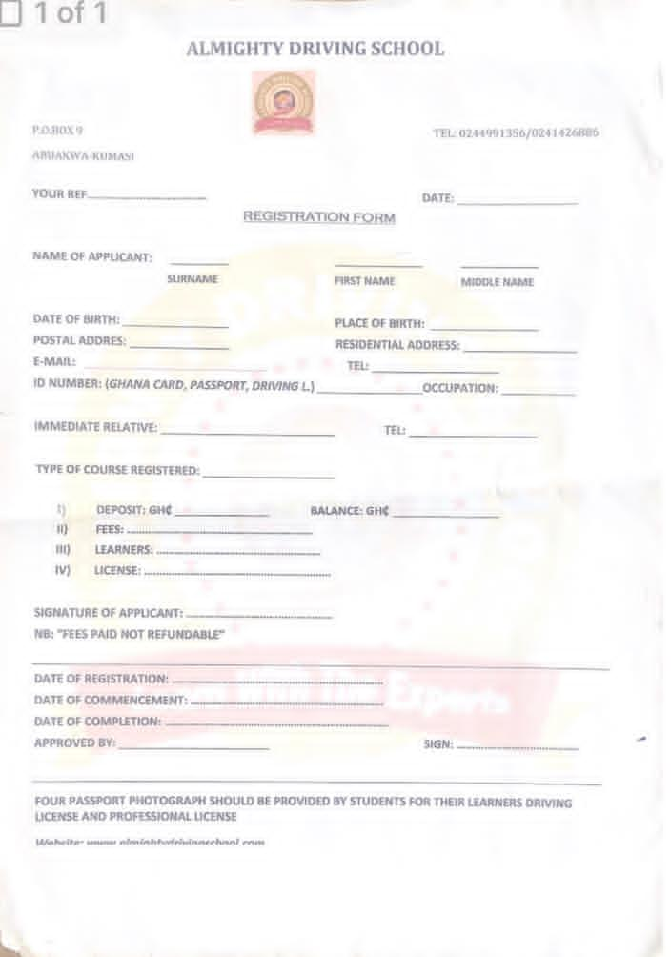

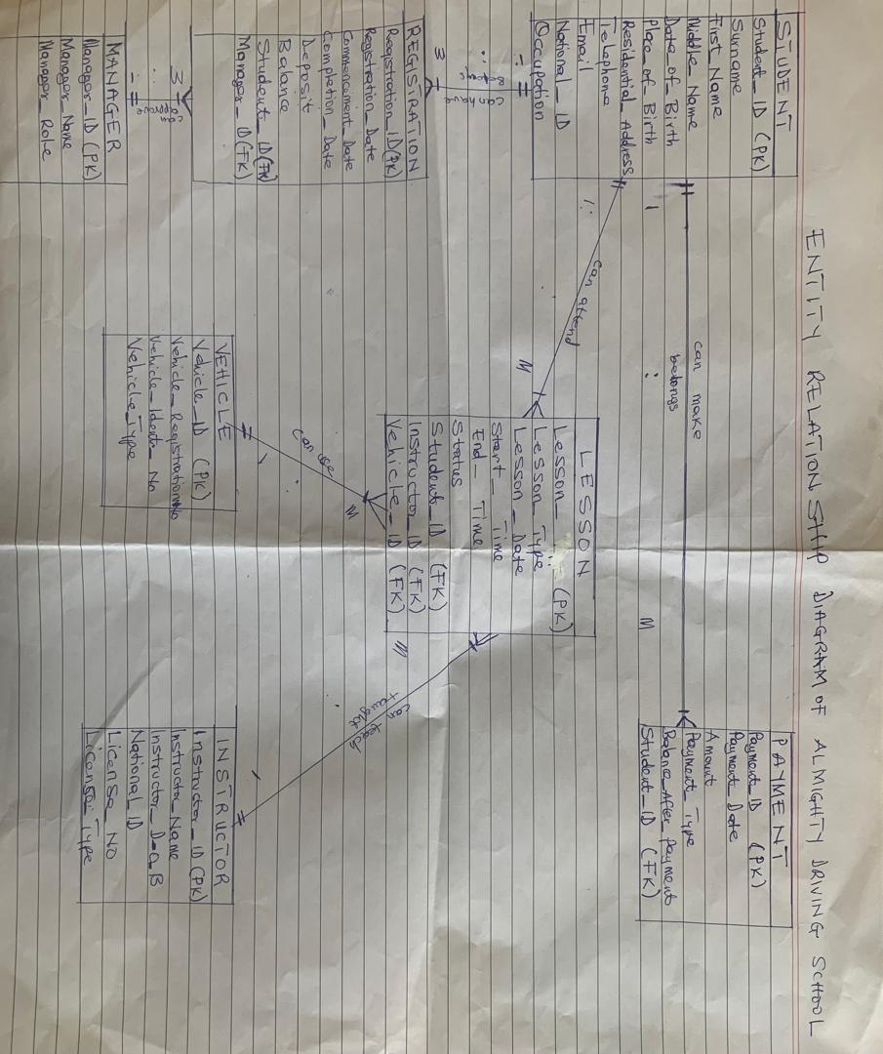

INTERVIEW QUESTIONS USED

GENERAL INFORMATION
- What service does the driving school offer?
- How does the school register students?
- What information is collected about the students?
STUDENT
- What student details are required?
- Can a student enrol in multiple driving lessons?
INSTRUCTORS
- What instructor information is collected?
- Can an instructor teach multiple students at the same time?
- Are instructors assigned to a specific vehicle?
VEHICLES
- What details are stored for each vehicle?
- Can a vehicle be used by multiple instructors?
- How often is vehicle maintenance recorded?
LESSONS
- What type of driving courses are offered (Beginner, Refresher, Defensive)?
- What does each course include? (Number of lessons, Duration, Cost, etc.)
- Does the driving school conduct an official test before sending students for official exams?
- How many times can a student retake an exam?
ADMINISTRATIVE RULES
- Who manages the system?
- Are there different user access levels? (Admin, Instructor)
- How long should records be kept?

MINUTES OF MEETINGS
DATE | DURATION | MEMBERS  PRESENT | ISSUES  DISCUSSED | MEMBERS  CONTRIBUTION | DECISION  TAKEN
DAY 1  27/01/2026 | 1 Hour | All Members | Selection of organization | Divine P.K Wornyo suggested Axle Load station.  Moses Sedodey and Arthur Amoah Peter, Emmanuel Owusu and Apostle Joseph Agyapong suggested Pharmacy  Eric Boateng, Obed Asumani, Isaac Yakubu Ngor, Hafsa Salifu, Iddi Abdul-Somed suggested Driving School | Divine P.K Wornyo, Arthur Amoah Peter,  Moses Sedodey, Isaac Yakubu and Iddi Abdul-Somed visited the Axle Load station to talk to the manager and sought permission for the project.  The axle load station could not grant our request due to the renovation work going on at the premises.  On that same day we moved to the Almighty Driving School at Tanoso to ask for their permission and was granted.
DAY 2  18/02/2026 | 2 Hours 10 minutes | All members | Discussion was on which questions to ask to derive a good Business Rules for our project. | Members take part in the discussion | 15 questions were generated for the Driving School.
DAY 3  25/02/2026 | 2 Hours 15 minutes | All Members | Visit to Almighty Driving School to administer the questions (Interview) | Every member was given a question to ask. | Questions were distributed members and the questions were asked accordingly.
DAY 4  04/03/2026 | 1 Hour 30 minutes | All members | Identification of the Business Rules and their Relationships | All members contributed in identifying the entities and their Relationship. | Business Rules were accepted by all members
DAY 5  08/03/2026 | 3 Hours | All members | Preparation of metadata Tables | Sedodey Moses, Divine P.K Wornyo, Abdul -Somed Iddi and Isaac Yakubu Ngor prepare the metadata table | Preparation of metadata table
DAY6  10/03/2026 | 1 Hour 19 minutes | All members | Preparation and production of project introductive video | Arthur Amoah Peter and Eric Boateng directed and produce the videos | Production of video
DAY 7  11/03/2026 | 2Hours | All members | Hand Sketching of Entity Relationship Diagram. | Wornyo P.K Divine and Moses Sedodey sketched the handwritten Diagram of the ER Diagram | Sketching the ER Diagram
12/03/2026 | 4 Hours 29 minutes | All members | Drawing of Entity Relationship Diagram  Final Editing of the project work  Corrections of typing works | Abdul-Somed Iddi and Isaac Yakubu Ngor were assigned to draw the ER Diagram  Arthur Amoah Peter, Eric Boateng  Divine P.K Wornyo Moses Sedodey. | Drawing the ER Diagram using the draw.io Diagram software  Video editing  Corrections and type setting works.

METADATA TABLE (Data Dictionary)
Attribute Name | Data Type | Size | Domain | Attribute Class | Source of Data
Student_ID | Integer | 10 | Positive Name | Primary key | System generated
Surname | Varchar | 30 | Alphabet | Simple | Registration form
First_Name | Varchar | 30 | Alphabet | Simple | Registration form
Middle_Name | Varchar | 30 | Alphabet | Simple | Registration form
Date_Of_Birth | Date | - | Valid dates | Simple | Registration form
Place_ Of_Birth | Varchar | 50 | Alphabets | Simple | Registration form
Residential-_Address | Varchar | 50 | Letters/numbers | Simple | Registration form
Telephone | Varchar | 15 | Digits 0-9, + | Simple | Registration form
Email | Varchar | 50 | Valid Email format | Simple | Registration form
National_ID | Varchar | 20 | Letters/numbers | Simple | Registration form
Occupation | Varchar | 50 | Alphabets | Simple | Registration form
STUDENT METADATA TABLE

Attribute Name | Data type | Size | Domain | Attribute class | Source of Data
Registration_ID | Integer | 10 | Positive number | Primary key | System generated
Registration_date | Date | 10 | Valid dates | simple | Registration form
Commencement_date | Date | 10 | Valid dates | Simple | Registration form
Completion_date | Date | 10 | Valid dates | Simple | Registration form
Deposit | Decimal | 10,2 | Positive currency values | Simple | Registration form
Balance | Decimal | 10,2 | Positive currency values | Derived | Registration form
Student_ID | Integer | 10 | Positive Name | Foreign key | System generated
Manager_ID | Integer | 10 | Positive Number | Foreign key | System generated
REGISTRATION METADATA TABLE

PAYMENT METADATA TABLE
Attribute Name | Date type | Size | Domain | Attribute class | Source of data
Payment_ID | Integer | 10 | Positive numbers | Primary key | System generated
Payment_Date | Date | - | Valid date | Simple | Registration form
Amount | Decimal | 10,2 | Positive currency values | Simple | Payment records
Payment_Type | Varchar | 20 | Cash, Bank transfer | Simple | Payment records
Balance_After_payment | Decimal | 10,2 | Positive currency value | Derived | Payment records
Student_ID | Integer | 10 | Positive Name | Foreign key | System generated

Attribute Name | Date type | Size | Domain | Attribute class | Source of data
Lesson_ID | Integer | 10 | Positive number | Primary key | System generated
Lesson_Type | Varchar | 20 | Valid date | Simple | Lesson schedule
Lesson_Date | Date | 20 | Valid value | Simple | Lesson schedule
Start_Time | Time | 20 | Valid time value | Simple | Lesson schedule
End_Time | Time | 20 | Valid time value | Simple | Lesson schedule
Status | Varchar | 20 | Scheduled, Completed, Cancelled | Simple | Lesson schedule
Student_ID | Integer | 10 | Positive Number | Foreign key | System generated
Instructor_ID | Integer | 10 | Positive Number | Foreign key | System generated
Vehicle_ID | Integer | 10 | Positive Number | Foreign key | System generated
LESSON METADATA TABLE

Attribute Name | Date type | Size | Domain | Attribute class | Source of data
Instructor_ID | Integer | 10 | Positive Number | Primary key | System generated
Instructor_Name | Varchar | 50 | Alphabet | Simple | School records
Instructor_D-O-B | Date | - | Valid date | Simple | School records
National_ID | Varchar | 20 | Letter/numbers | Simple | School records
License_Number | Varchar | 20 | Letters/numbers | Simple | School records
License_Type | Varchar | 15 | Alphabet | Simple | School records
INSTRUCTOR METADATA TABLE

VEHICLE METADATA TABLE
Attribute Name | Date type | Size | Domain | Attribute class | Source of data
Vehicle_ID | Integer | 10 | Positive Number | Primary key | System generated
Vehicle_Registration_No. | Varchar | 20 | Letters/ numbers | Simple | Vehicle record
Vehicle_Identity_No | Varchar | 30 | Letter/numbers | Simple | Vehicle record
Vehicle_Type | Varchar | 30 | Alphabets | Simple | Vehicle record

Attribute Name | Date type | Size | Domain | Attribute class | Source of data
Manager_ID | Integer | 10 | Positive Number | Primary key | System generated
Manager_Name | Varchar | 30 | Alphabets | Simple | Company register
Manager_Role | varchar | 20 | Manager | Simple | Company register
MANAGER METADATA TABLE

DATA, REPORT, AND ACCESS REQUIREMENTS
a) Data Requirements
The system must store:
- Student details such as surname, first name, middle name, date of birth, place of birth, residential address, telephone number, email, occupation, and national ID.
- Instructor details such as instructor name, date of birth, national ID, and license number, license type.
- Vehicle details such as vehicle registration number, vehicle identification number (VIN), and vehicle type.
- Registration details such as registration date, commencement date, completion date, deposit, balance.
- Payment details such as payment date, amount paid, payment type, and balance after payment.
- Lesson details such as lesson type, lesson date, start time, end time, lesson status.
- Manager details such as manager name and role.

b) Report Requirements
Report Name | Description | Frequency
Student Registration Report | Shows all registered students and their registration details | Daily
Student Payment Report | Shows payments made by students and their balances | Daily
Lesson Schedule Report | Shows scheduled lessons, including student, instructor, vehicle date, and time | Daily
Instructor Assignment Report | Shows which instructor is assigned to which lesson. | Daily
Vehicle Assignment Report | Shows which vehicle is assigned to which lesson. | Daily
Outstanding Balance Report | Shows students with unpaid balances | Weekly
Completed Lesson Report | Shows lessons that have been completed | Weekly
Registration Approval Report | Shows registration approved by the manager. | Weekly

c) Access Requirements
Manager | Access Level
Manager | Full access to all records, including approval of registrations, updating records, registering and viewing reports
Instructor | View lesson schedules and assigned student only

BUSINESS RULES
- Each student can have many registrations and each registration belongs to one student.
- Each student can make many payments and each payment belongs to one student.
- Each student can attend many lessons and each lesson belongs to one student.
- Each instructor can teach many lessons and each lesson taught by one instructor.
- Each vehicle can be used for many lessons and each lesson uses one vehicle.
- Each manager can approve many registrations and each registration is approved by one manager.

