
CAF Compliance · Test Evidence Record
TC-INT-036
Evidence and attestation are separate panels for separate people
RESULT: PASS

Row actions match the specified set for every state observed; the two jobs open different panels; the approver’s copy of the evidence is read-only; no standalone Criteria met button.
Test case | TC-INT-036
Priority | P2
Type | Positive
Component under test | cafEvidence, cafAttestation LWCs
Application | CAF Compliance — scope x_gskn2_caf_compli
Environment | https://orgfarm-4938c7f768-dev-ed.develop.lightning.force.com + https://dev281754.service-now.com
Executed by | admin.070b86ccf531@agentforce.com (Salesforce) / admin (ServiceNow)
Execution method | Playwright driving Lightning Experience. Every screen assertion is cross-checked against the ServiceNow record over cnit and the Salesforce record over the sf CLI. No case in this file writes to either platform.
Specification | TEST-CASES-INTEGRATION.md

From the specification
Upload evidence
opens cafEvidence alone, writable.
Attest
opens cafEvidence read-only beside cafAttestation — an
approver must see the evidence and must not be adding to it.
Row actions by state:
Regression
there must be no standalone "Criteria met" button. It used to set met_criteria on its own; the attestation form now carries it as a yes/no alongside the decision.
Expected result
- Upload evidence opens cafEvidence alone, writable.
- Attest opens cafEvidence read-only beside cafAttestation.
- Row actions by state: Open → Start + Upload evidence; In Progress → Upload evidence + Attest; Closed → View evidence only.
- There is no standalone "Criteria met" button.
Steps executed
Step 1 Read the row actions offered on RCAF0001022 — an Open and a Closed task.
Step 2 Read the row actions offered on RCAF0001037 — an In Progress task.
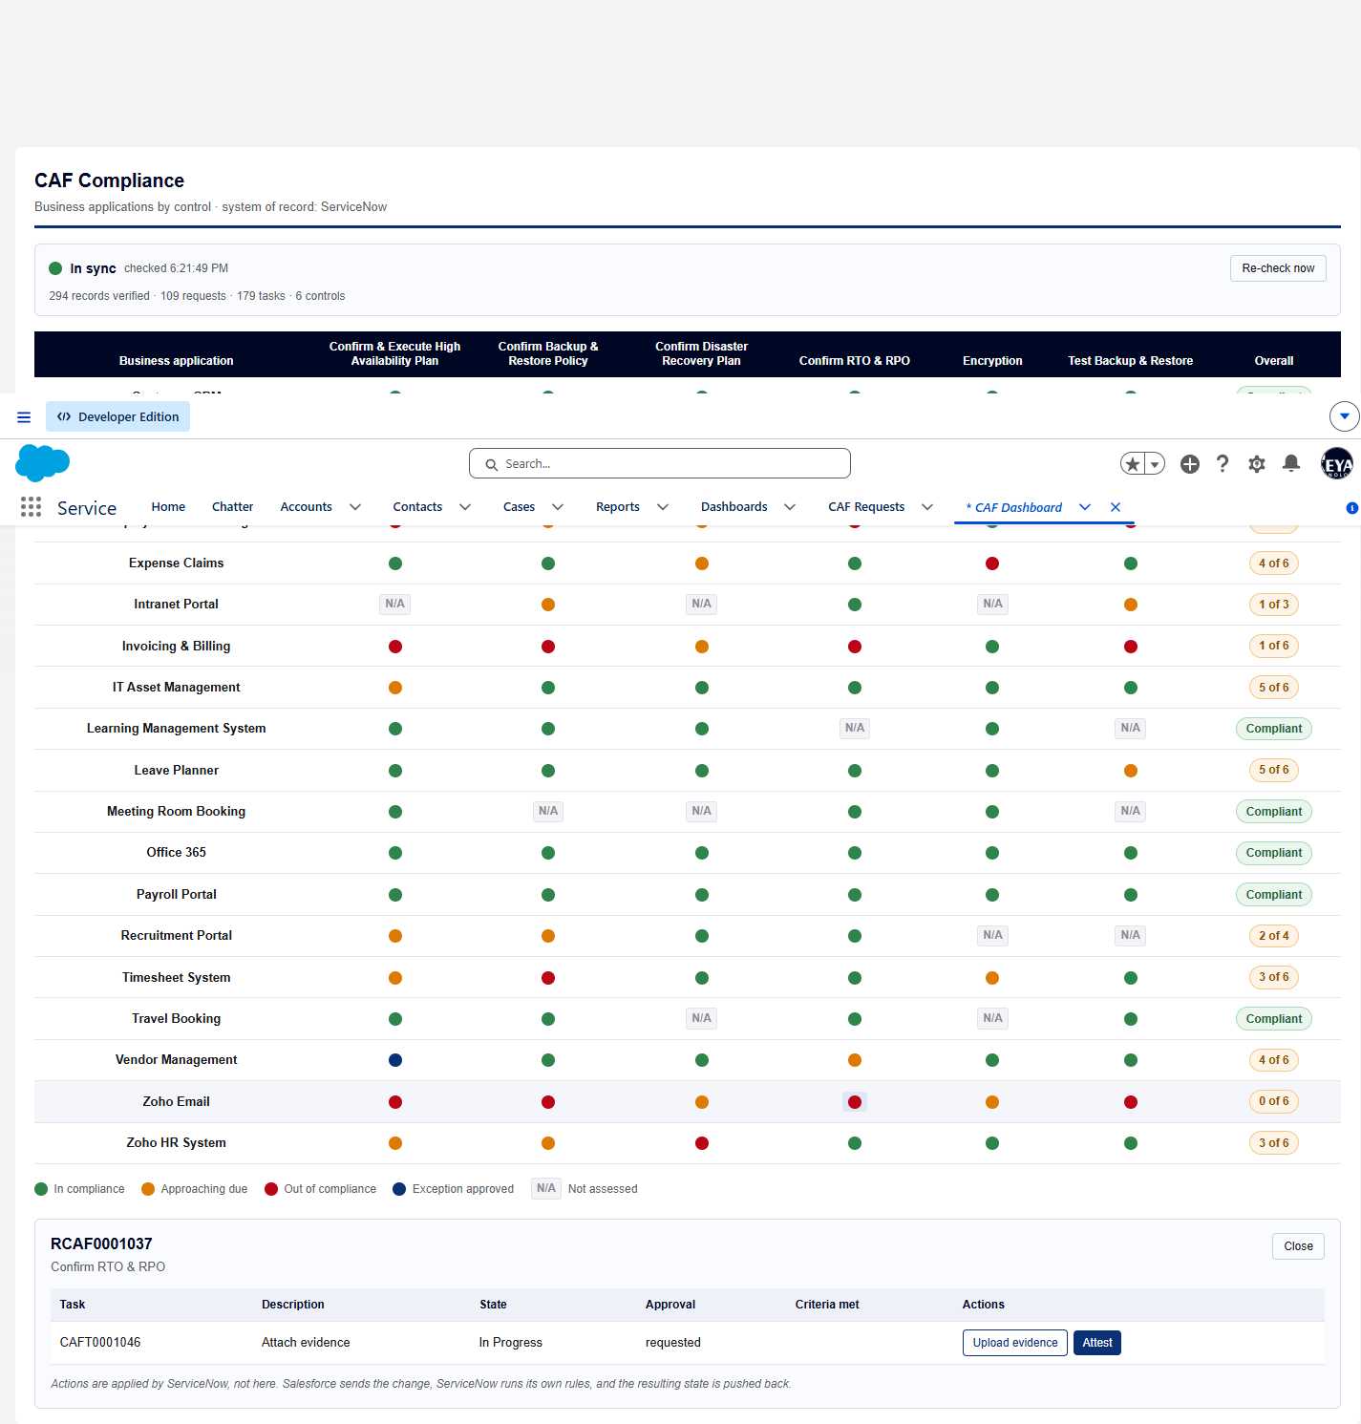
Screen capture — 02-row-actions-in-progress.png
Step 3 Open the evidence panel on the In Progress task — the owner’s view.
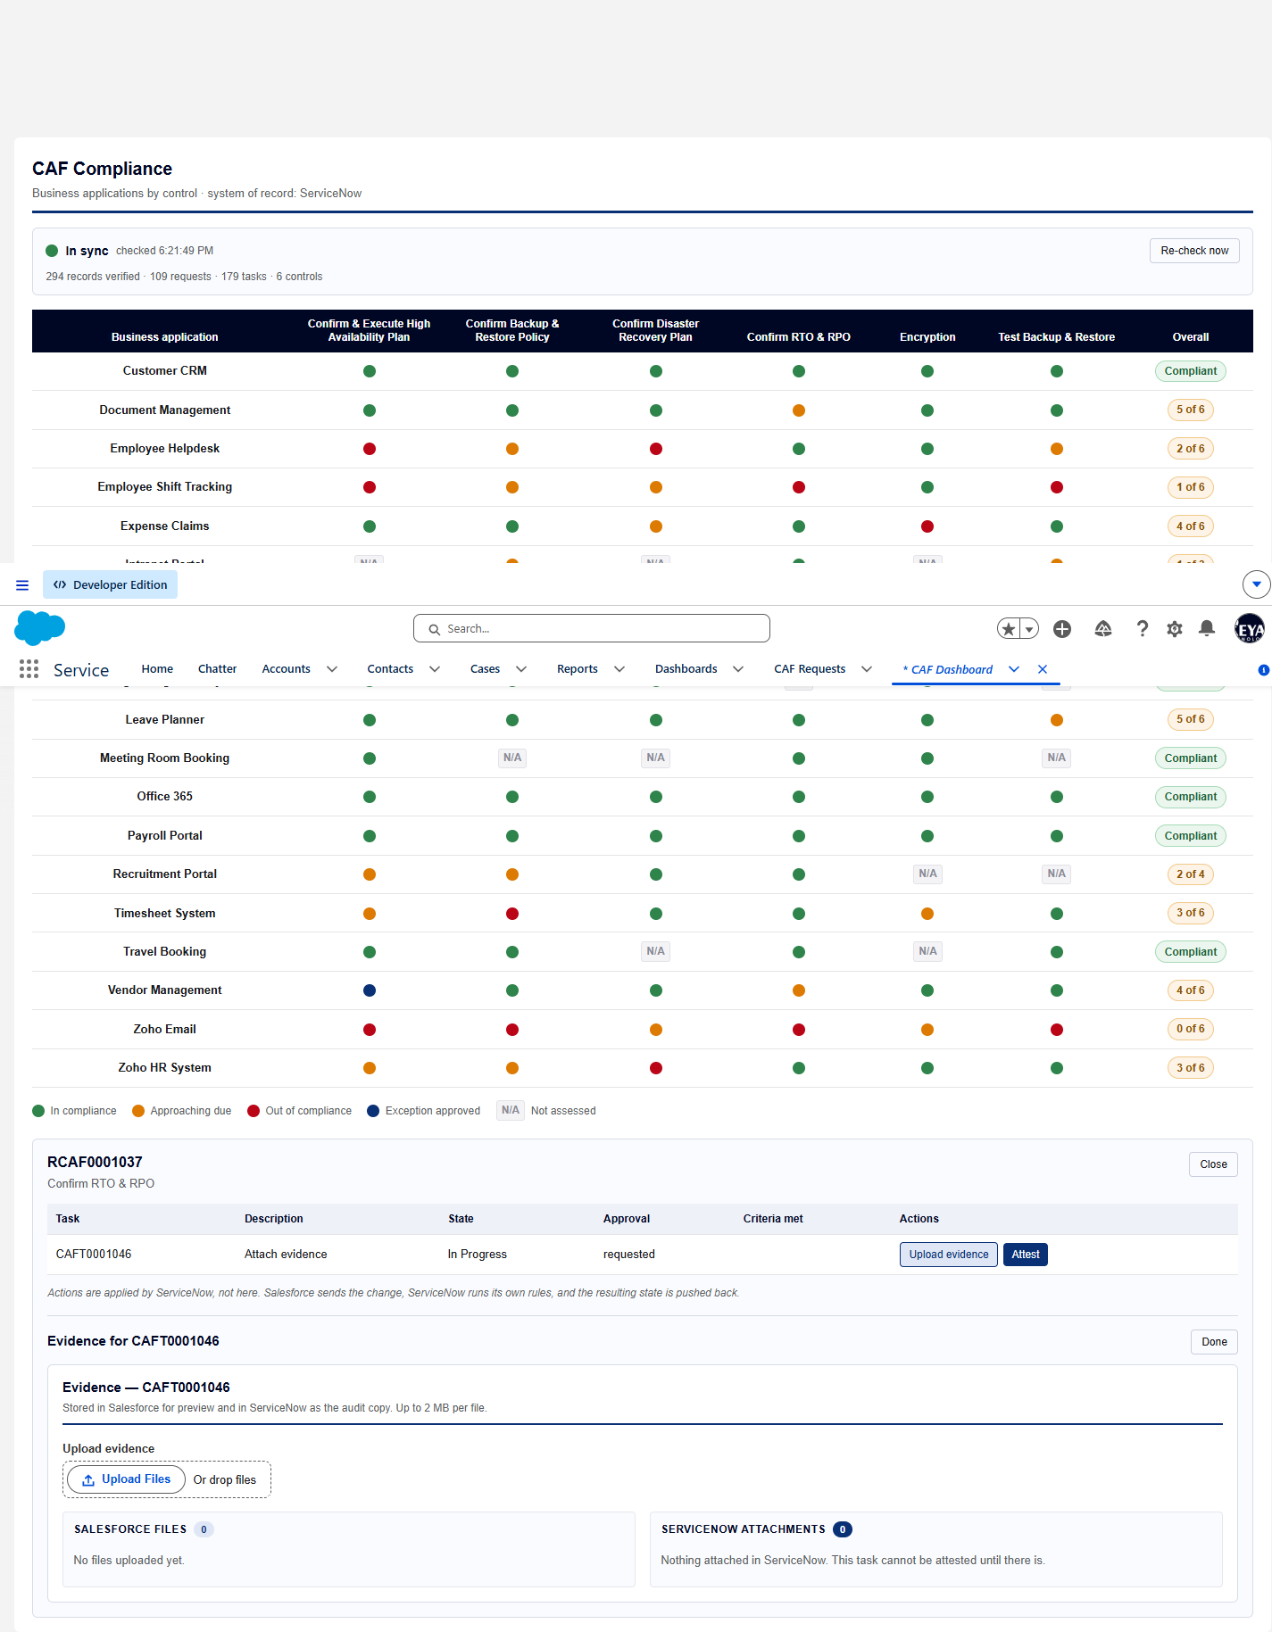
Screen capture — 03-evidence-panel-owner-view.png
Step 4 Open the attest panel on the same task — the approver’s view.
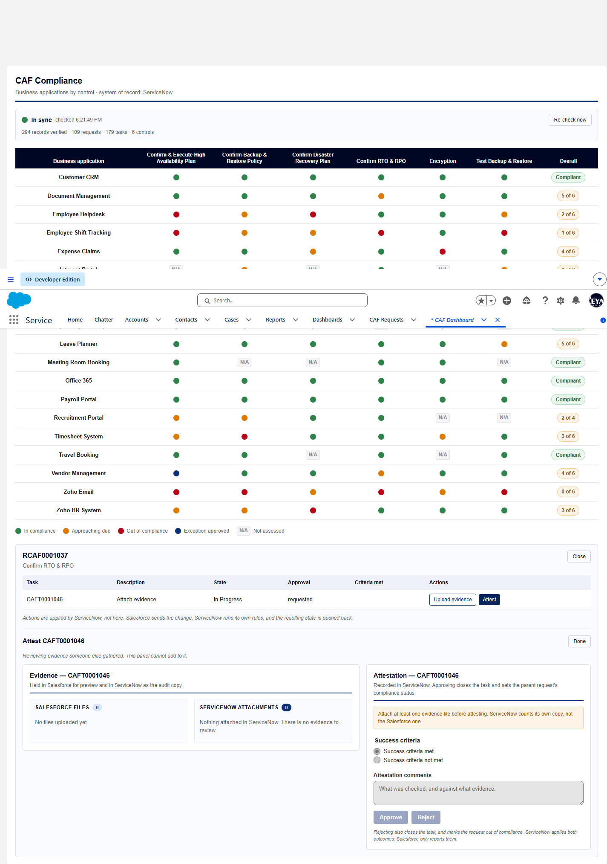
Screen capture — 04-attest-panel-approver-view.png
Actual result
- Open → Start, Upload evidence
- In Progress → Upload evidence, Attest
- Closed Complete → View evidence
- Owner view: upload control present = true; attestation panel alongside = false
- Approver view: upload control present = false; attestation panel alongside = true
- Attestation offers criteria options [] beside Approve/Reject.
- Standalone "Criteria met" buttons found: 0
Record evidence
Read directly from the ServiceNow Table API during execution. This is the evidence that determines the verdict; a screen capture shows what was displayed, not what was stored.
Row actions offered, by task state
cafDashboard · drill-in on RCAF0001022 and RCAF0001037
state | actions
Open | Start, Upload evidence
Closed Complete | View evidence
In Progress | Upload evidence, Attest

Evidence panel in each mode
cafEvidence · task CAFT0001046
mode | heading | upload_control | attestation_alongside
Upload evidence (owner) | Evidence — CAFT0001046 | true | false
Attest (approver) | Evidence — CAFT0001046 | false | true

Attestation panel
cafAttestation · task CAFT0001046
heading | criteria_options | approve_enabled | reject_enabled | blocked_reason
Attestation — CAFT0001046 |  | false | false | Attach at least one evidence file before atte…

Observations
- met_criteria is carried on the attestation form as a yes/no alongside the decision, not as its own button. Whether it belongs with the approver at all is HANDOFF open item 3 — decided, not settled.
- Approve and Reject were read as controls and deliberately not clicked; either would close the task.
Verdict
PASS
Row actions match the specified set for every state observed; the two jobs open different panels; the approver’s copy of the evidence is read-only; no standalone Criteria met button.

Confidential. Prepared by Reyan Technologies. Contains system test evidence and must not be redistributed without written consent.

