
CAF Compliance · Test Evidence Record
TC-SN-069
A new CAF control appears as a new column, with no code change
RESULT: PASS

All 6 active controls are bound to grid columns. The column set is data-driven, not hard-coded. Causation still to be proven by Part B.
Test case | TC-SN-069
Priority | P1
Type | Positive
Component under test | Widget hln-caf-apps-list server script
Application | CAF Compliance — scope x_gskn2_caf_compli
Environment | https://dev281754.service-now.com
Executed by | admin
Execution method | Playwright (automated); every assertion cross-checked against the ServiceNow Table API
Specification | TEST-CASES-SERVICENOW.md

Purpose
The dynamic-column claim, tested at its source. The grid must not carry a hard-coded control list; adding a control to the data must add a column.
The mechanism, confirmed from the widget source 2026-08-07:
var cafTypeGR = new GlideRecord('x_gskn2_caf_compli_caf_conformance_type'); cafTypeGR.addQuery('active', true); cafTypeGR.orderBy('name'); // columns are alphabetical, not sequenced ... data.cafTypesArr = cafTypesArr; // one column per active control
Columns are every active row in caf_conformance_type, ordered by name. The widget still contains the commented-out sys_choice query it replaced, which is direct evidence the dynamic behaviour was a deliberate migration rather than a happy accident.
From the specification
Expected cell content
and this is the part worth reading the source for. The new control has no requests, so getLatestCAFstatus, getCAFLastComplianceDetails and getCAFNextDueDetails all return empty. The widget then applies:
if (overall_status != 'Not initiated' && all three empty) showNA = true;
So the new column reads N/A for every application whose CAF process has been initiated, and blank for every application still Not initiated. Both are correct; a tester expecting one uniform value will raise a false defect.
Naming boundary, from the source — results are keyed by control name (businessAppObj[ele.value] = cafDetailsObj), not by sys_id. Two controls sharing a name would collide into one column, and a name carrying characters the Angular binding cannot use as a key may render an empty column. Worth one deliberate probe given cmdb_ci_business_app already contains two records named "SAP HANA".
The TEST-ZZ prefix is deliberate — alphabetical ordering puts the new column last, so the screenshot before and after differs only by an appended column. Name it Confirm Encryption… instead and it lands mid-grid, every column shifts, and the two captures are far harder to compare.
The two grids derive their columns from different sources. ServiceNow reads the control table, so a control with no requests still gets a column. Salesforce has no mirrored control object at all — the LWC derives columns from the request data it holds, so a control with no requests produces no column there.
A newly added control therefore appears immediately in ServiceNow as an N/A column and is absent from Salesforce until a request exists for it. That is not drift and Sync Health will not report it, because no mirrored record disagrees. See TC-INT-049.
The design document is generated from instance metadata dated 2026-06-18. These cases audit it, because a client-facing document that misdescribes the build is a deliverable defect.
Expected result
- The portal grid's control columns equal the active rows of caf_conformance_type exactly, in name order.
- No hard-coded control list exists anywhere in the widget — the column set is bound to the data.
- The filter panel above the grid carries one dropdown per control, from the same array.
Steps executed
Step 1 Read every active CAF control, ordered by name — the widget's own ordering.
Step 2 Open the portal compliance grid and read its column headers.
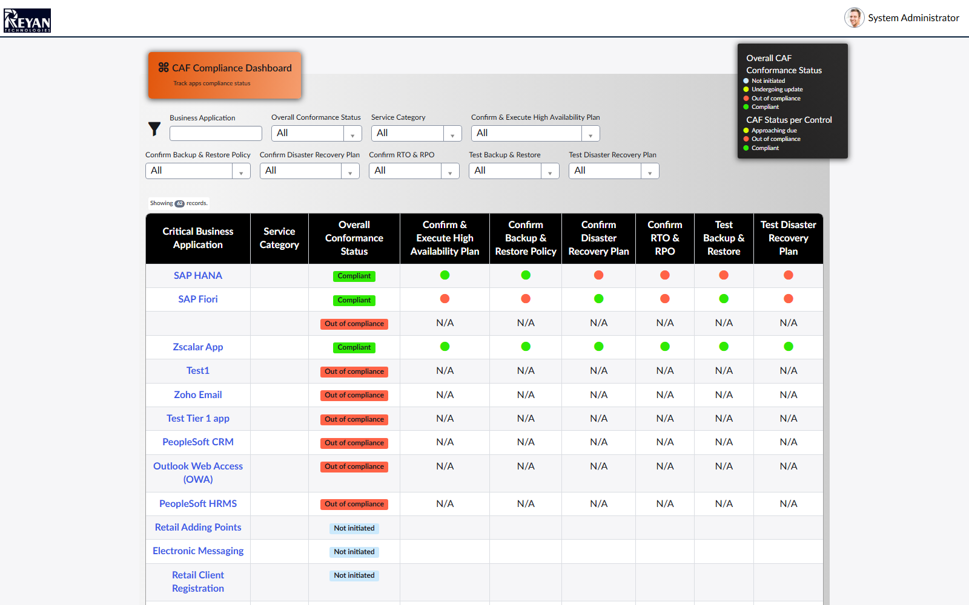
Screen capture — 02-portal-grid-columns.png
Step 3 Compare the control names against the column headers.
Actual result
- 6 active control(s); 6 appear as grid columns with none missing.
Record evidence
Read directly from the ServiceNow Table API during execution. This is the evidence that determines the verdict; a screen capture shows what was displayed, not what was stored.
Active CAF controls
x_gskn2_caf_compli_caf_conformance_type · active=true^ORDERBYname
sys_id | name | active
f1e5e8a61b7925d46f1e76e5d34bcb84 | Confirm & Execute High Availability Plan | true
95d568ea1b7925d46f1e76e5d34bcb9f | Confirm Backup & Restore Policy | true
12952c261b7925d46f1e76e5d34bcb5e | Confirm Disaster Recovery Plan | true
4c85e8a21b7925d46f1e76e5d34bcbfb | Confirm RTO & RPO | true
fc1288fb1b61a154eede76e5d34bcb81 | Test Backup & Restore | true
05f10c7f1b61a154eede76e5d34bcb25 | Test Disaster Recovery Plan | true

Grid column headers as rendered
/caf?id=caf_apps · thead row
position | header
0 | Critical Business Application
1 | Service Category
2 | Overall Conformance Status
3 | Confirm & Execute High Availability Plan
4 | Confirm Backup & Restore Policy
5 | Confirm Disaster Recovery Plan
6 | Confirm RTO & RPO
7 | Test Backup & Restore
8 | Test Disaster Recovery Plan

Column binding
(derived) · active controls vs rendered headers
active_controls | columns_matched | columns_missing | leading_attribute_columns
6 | 6 | 0 | Critical Business Application / Service Categ…

Observations
- Columns are rendered in name order: true. The widget sorts with orderBy('name'), so a new control lands alphabetically rather than at the end of the grid.
- Mechanism confirmed from the widget source: columns come from a GlideRecord over caf_conformance_type filtered active=true, keyed by control NAME. The superseded sys_choice query it replaced is still present, commented out — the dynamic behaviour was a deliberate migration.
- DIVERGENCE: the Salesforce LWC derives its columns from request data, not from a control table, so a control with no requests gets an N/A column here and NO column in Salesforce. Sync Health cannot report that, because the control table is not mirrored. See TC-INT-049.
- Part B of this case — insert a control and watch a seventh column appear — is a WRITE that leaves a permanent column on the demo grid. Not executed here; it needs explicit approval.
Verdict
PASS
All 6 active controls are bound to grid columns. The column set is data-driven, not hard-coded. Causation still to be proven by Part B.

Confidential. Prepared by Reyan Technologies. Contains system test evidence and must not be redistributed without written consent.

