
CAF Compliance · Test Evidence Record
TC-INT-020
Both lists are shown side by side
RESULT: PASS

Two labelled columns, each agreeing with its own platform — a failed push would show as an empty column beside a populated one.
Test case | TC-INT-020
Priority | P2
Type | Positive
Component under test | cafEvidence LWC
Application | CAF Compliance — scope x_gskn2_caf_compli
Environment | https://orgfarm-4938c7f768-dev-ed.develop.lightning.force.com + https://dev281754.service-now.com
Executed by | admin.070b86ccf531@agentforce.com (Salesforce) / admin (ServiceNow)
Execution method | Playwright driving Lightning Experience. Every screen assertion is cross-checked against the ServiceNow record over cnit and the Salesforce record over the sf CLI. No case in this file writes to either platform.
Specification | TEST-CASES-INTEGRATION.md

Expected result
- The panel lists Salesforce files and ServiceNow attachments separately.
- A failed push is therefore visible rather than inferred.
Steps executed
Step 1 Open the evidence panel on CAFT0001022, which holds files on both sides.
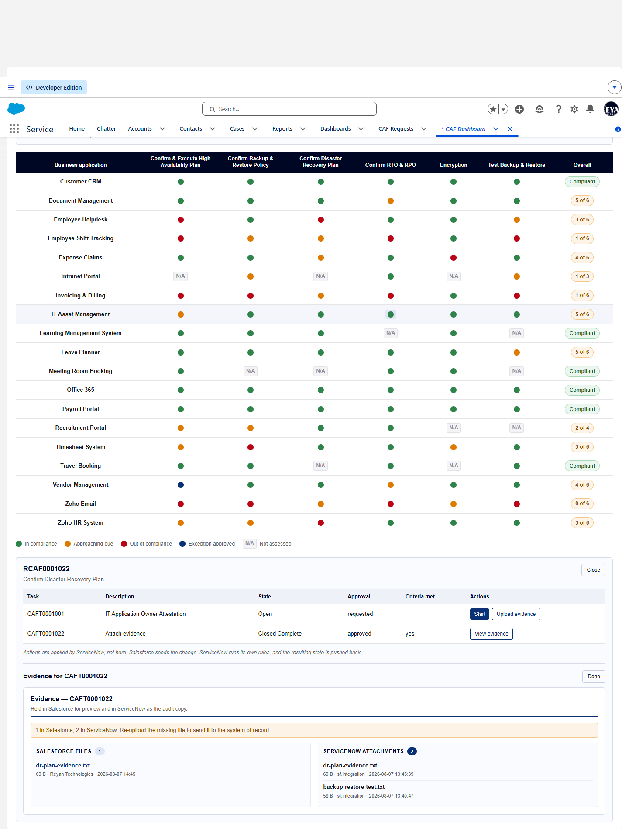
Screen capture — 01-evidence-both-lists.png
Step 2 Confirm each column against its own platform.
Actual result
- Panel shows two separate columns: "Salesforce Files" (1) and "ServiceNow attachments" (2).
- Salesforce column lists: dr-plan-evidence.txt
69 B · Reyan Technologies · 2026-08-07 14:45
- ServiceNow column lists: dr-plan-evidence.txt
69 B · sf.integration · 2026-08-07 13:45:39 | backup-restore-test.txt
58 B · sf.integration · 2026-08-07 13:40:47
- Underneath: 1 ContentVersion(s) and 2 sys_attachment(s).
Record evidence
Read directly from the ServiceNow Table API during execution. This is the evidence that determines the verdict; a screen capture shows what was displayed, not what was stored.
Evidence panel
cafEvidence · task CAFT0001022
column | count | items
Salesforce Files | 1 | dr-plan-evidence.txt  69 B · Reyan Technologie…
ServiceNow attachments | 2 | dr-plan-evidence.txt  69 B · sf.integration · …

sys_attachment in ServiceNow
sys_attachment · cnit get sys_attachment -Query "table_name=x_gskn2_caf_compli_caf_tsk^table_sys_id=8f936cf483431210bd2a5860ceaad36c" -ProfileName caf-reyan
size_bytes | file_name
58 | backup-restore-test.txt
69 | dr-plan-evidence.txt

Files linked to the task in Salesforce
ContentDocumentLink · sf data query --query "SELECT ContentDocument.Title, ContentDocument.ContentSize FROM ContentDocumentLink WHERE LinkedEntityId IN (SELECT Id FROM CAF_Task__c WHERE SN_Number__c = 'CAFT0001022')" --target-org caf-sf
title | size
dr-plan-evidence | 69

Observations
- Two copies on purpose, and not reconciled. Salesforce’s copy makes preview and download work with no round trip; ServiceNow’s is the copy an auditor is entitled to and the only one the attestation gate counts.
Verdict
PASS
Two labelled columns, each agreeing with its own platform — a failed push would show as an empty column beside a populated one.

Confidential. Prepared by Reyan Technologies. Contains system test evidence and must not be redistributed without written consent.

