
CAF Compliance · Test Evidence Record
TC-INT-053
Sync Health strip sits above the grid
RESULT: PASS

Strip renders above the grid at 255px, in the first viewport, already resolved to "In sync".
Test case | TC-INT-053
Priority | P2
Type | Positive
Component under test | —
Application | CAF Compliance — scope x_gskn2_caf_compli
Environment | https://orgfarm-4938c7f768-dev-ed.develop.lightning.force.com + https://dev281754.service-now.com
Executed by | admin.070b86ccf531@agentforce.com (Salesforce) / admin (ServiceNow)
Execution method | Playwright driving Lightning Experience. Every screen assertion is cross-checked against the ServiceNow record over cnit and the Salesforce record over the sf CLI. No case in this file writes to either platform.
Specification | TEST-CASES-INTEGRATION.md

Expected result
- cafSyncHealth renders above cafDashboard’s grid.
- It runs on load, without being asked.
- Its state is legible at a glance, and visible without scrolling.
Steps executed
Step 1 Open the CAF Dashboard tab and let it settle.
Step 2 Read the strip, and measure where it sits relative to the grid.
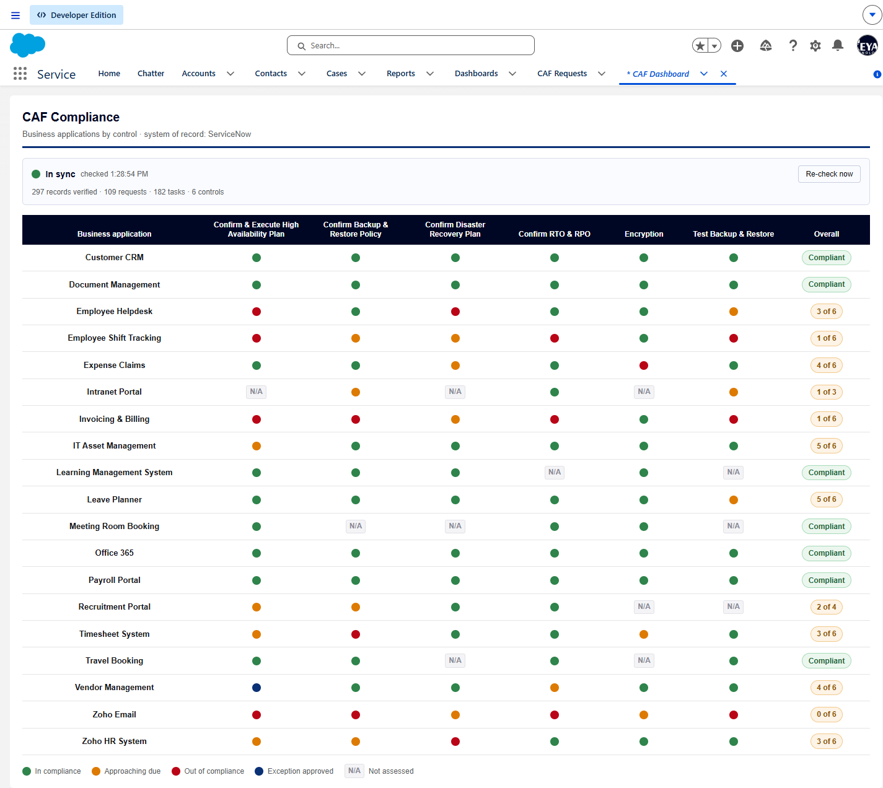
Screen capture — 02-dashboard-with-sync-strip.png
Actual result
- Strip reads "In sync" (green) — 297 records verified · 109 requests · 182 tasks · 6 controls
- Strip top 255px, grid top 347px; strip is above the grid: true
- Strip visible without scrolling: true
Record evidence
Read directly from the ServiceNow Table API during execution. This is the evidence that determines the verdict; a screen capture shows what was displayed, not what was stored.
Sync Health strip, as rendered
cafSyncHealth · CAF Dashboard tab
headline | colour | summary | differences
In sync | green | 297 records verified · 109 requests · 182 tas… | 0

Layout
CAF Dashboard tab · bounding boxes in CSS pixels
element | top | height | in_first_viewport
c-caf-sync-health | 255 | 76 | true
table.grid | 347 | 872 | true

Observations
- It ran on load without Re-check being pressed — the headline had resolved from "Checking ServiceNow…" to a verdict by the time the grid was readable.
Verdict
PASS
Strip renders above the grid at 255px, in the first viewport, already resolved to "In sync".

Confidential. Prepared by Reyan Technologies. Contains system test evidence and must not be redistributed without written consent.

