
CAF Compliance · Test Evidence Record
TC-INT-071
Mismatch advice names the side that is short
RESULT: FAIL

Salesforce is the short side (1 against 2) yet the advice is still "re-upload": "1 in Salesforce, 2 in ServiceNow. Re-upload the missing file to send it to the system of record.". cafEvidence.mismatchLabel is unconditional and does not branch on which side is short, so following it would create a third ServiceNow attachment rather than repair anything. Fix: branch the label on servicenowCount - salesforceCount.
Test case | TC-INT-071
Priority | P2
Type | Negative
Component under test | cafEvidence.mismatchLabel
Application | CAF Compliance — scope x_gskn2_caf_compli
Environment | https://orgfarm-4938c7f768-dev-ed.develop.lightning.force.com + https://dev281754.service-now.com
Executed by | admin.070b86ccf531@agentforce.com (Salesforce) / admin (ServiceNow)
Execution method | Playwright driving Lightning Experience. Every screen assertion is cross-checked against the ServiceNow record over cnit and the Salesforce record over the sf CLI. No case in this file writes to either platform.
Specification | TEST-CASES-INTEGRATION.md

From the specification
Ready-made subject
CAFT0001022 carries 1 Salesforce file against 2 ServiceNow attachments, so ServiceNow — the system of record — holds more.
Fix
branch the label on servicenowCount - salesforceCount. The case passes once the advice is direction-correct; it does not prescribe the wording.
Not covered here, deliberately
Engine behaviour — TEST-CASES-SERVICENOW.md.
Experience Cloud — no site exists; TC-INT-055 is marked blocked.
Platform Events — not built (HANDOFF open item 4).
Credential rotation and secret hygiene — an operational review, not a test pass.
Note that the Salesforce client secret and the sf.integration password both passed through a session transcript on 2026-08-06 and should be rotated if this outlives the demo.
Load and concurrency. Two users attesting the same task simultaneously is
untested, and the endpoint has no optimistic-locking check.
In order: TC-INT-016 (the reconcile — silent failure, hardest-won fix),
TC-INT-027
(the flagship journey), TC-INT-030 (evidence visible but gate refuses), TC-INT-013 (allow-list refuses the whole call), TC-INT-058 (cleanup recreates what you deleted), TC-INT-001 (parity by record, not by count), TC-INT-031 (does the spawned task reach Salesforce?).
TC-INT-031 is the one most likely to find a genuine, currently-unknown defect — the reasoning in that case suggests the flow-created sibling task may never be pushed. It has not been checked.
Expected result
- When ServiceNow holds fewer files than Salesforce, the advice is to re-upload.
- When Salesforce holds fewer — the state on this instance — the advice does NOT say re-upload, because the system of record already holds the file and re-uploading creates a third copy.
Steps executed
Step 1 Open the evidence panel on CAFT0001022 and read the mismatch warning.
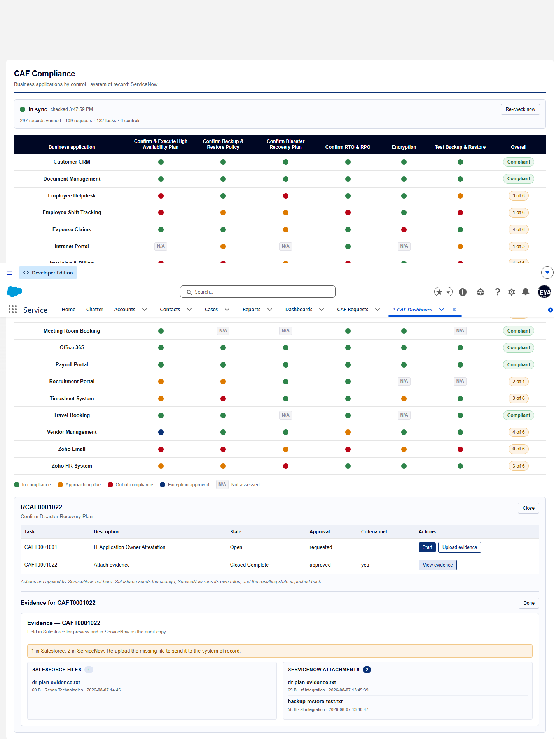
Screen capture — 01-mismatch-advice.png
Step 2 Confirm the direction of the mismatch against the ServiceNow record.
Actual result
- Panel: 1 Salesforce file(s) against 2 ServiceNow attachment(s). ServiceNow itself reports 2 attachment(s) on the task.
- Advice rendered: "1 in Salesforce, 2 in ServiceNow. Re-upload the missing file to send it to the system of record."
Record evidence
Read directly from the ServiceNow Table API during execution. This is the evidence that determines the verdict; a screen capture shows what was displayed, not what was stored.
Counts and advice, as rendered
cafEvidence · task CAFT0001022
salesforce_files | servicenow_attachments | short_side | advice
1 | 2 | Salesforce | 1 in Salesforce, 2 in ServiceNow. Re-upload t…

ServiceNow attachments on CAFT0001022
sys_attachment · cnit get sys_attachment -Query "table_name=x_gskn2_caf_compli_caf_tsk" -ProfileName caf-reyan
size_bytes | file_name | table_sys_id
58 | backup-restore-test.txt | 8f936cf483431210bd2a5860ceaad36c
69 | dr-plan-evidence.txt | 8f936cf483431210bd2a5860ceaad36c

Observations
- Re-uploading is the correct remedy only when the push to ServiceNow failed, i.e. Salesforce holds MORE. Where ServiceNow already holds more, the file is safe in the system of record and the advice is not merely unhelpful — acting on it adds another copy.
Verdict
FAIL
Salesforce is the short side (1 against 2) yet the advice is still "re-upload": "1 in Salesforce, 2 in ServiceNow. Re-upload the missing file to send it to the system of record.". cafEvidence.mismatchLabel is unconditional and does not branch on which side is short, so following it would create a third ServiceNow attachment rather than repair anything. Fix: branch the label on servicenowCount - salesforceCount.

Confidential. Prepared by Reyan Technologies. Contains system test evidence and must not be redistributed without written consent.

