
CAF Compliance · Test Evidence Record
TC-INT-021
A count mismatch raises a warning
RESULT: PASS

Mismatch detected and surfaced informatively: "1 in Salesforce, 2 in ServiceNow. Re-upload the missing file to send it to the system of record.". The case's stated expectation is met — but see the observation on the remediation advice, which is wrong for this direction of mismatch and should be raised separately.
Test case | TC-INT-021
Priority | P2
Type | Positive
Component under test | cafEvidence mismatch check
Application | CAF Compliance — scope x_gskn2_caf_compli
Environment | https://orgfarm-4938c7f768-dev-ed.develop.lightning.force.com + https://dev281754.service-now.com
Executed by | admin.070b86ccf531@agentforce.com (Salesforce) / admin (ServiceNow)
Execution method | Playwright driving Lightning Experience. Every screen assertion is cross-checked against the ServiceNow record over cnit and the Salesforce record over the sf CLI. No case in this file writes to either platform.
Specification | TEST-CASES-INTEGRATION.md

From the specification
Ready-made subject
CAFT0001022 carries 1 Salesforce file against 2 ServiceNow attachments, because of a stray backup-restore-test.txt left by a direct-HTTP smoke test.
Expected result
- CAFT0001022 carries 1 Salesforce file against 2 ServiceNow attachments.
- The panel shows a warning, and it reads as informative rather than alarming.
Steps executed
Step 1 Open the evidence panel on CAFT0001022.
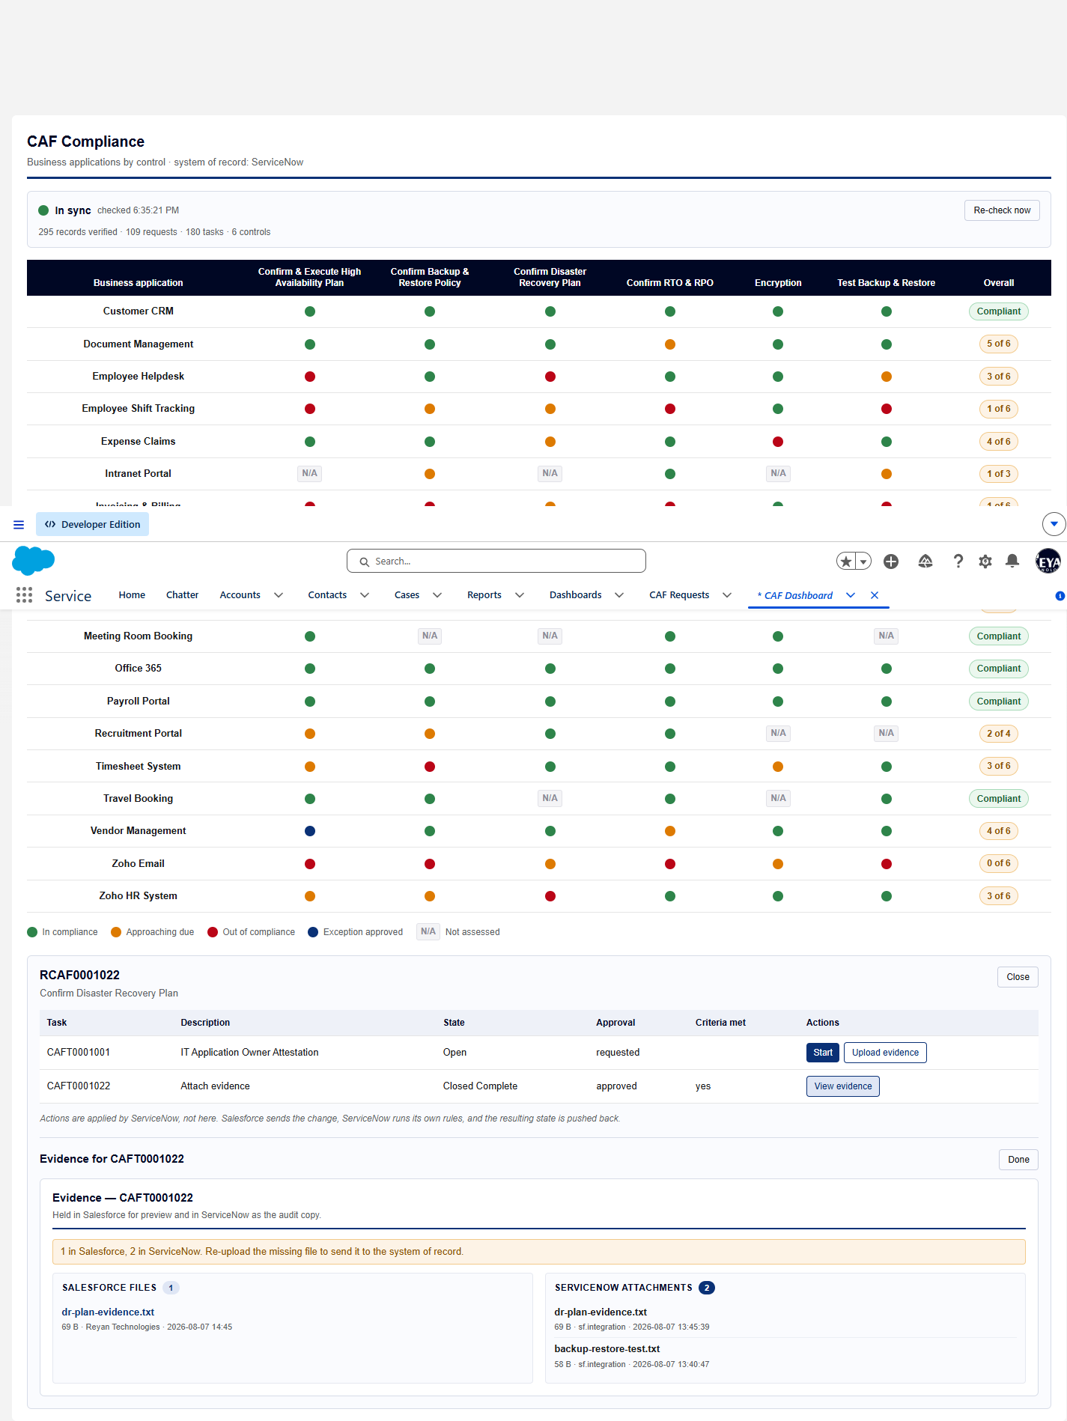
Screen capture — 01-evidence-count-mismatch-warning.png
Actual result
- Salesforce 1 file(s) against ServiceNow 2 attachment(s) — mismatch present: true
- Warning shown: 1 in Salesforce, 2 in ServiceNow. Re-upload the missing file to send it to the system of record.
- Wording judged informative: "1 in Salesforce, 2 in ServiceNow. Re-upload the missing file to send it to the system of record."
Record evidence
Read directly from the ServiceNow Table API during execution. This is the evidence that determines the verdict; a screen capture shows what was displayed, not what was stored.
Counts and warning, as rendered
cafEvidence · task CAFT0001022
salesforce_files | servicenow_attachments | warning
1 | 2 | 1 in Salesforce, 2 in ServiceNow. Re-upload t…

Observations
- The extra ServiceNow attachment is backup-restore-test.txt, left by a direct-HTTP smoke test. Two copies of evidence is not a compliance failure, which is why the wording matters more than the fact of the warning.
- Finding — the advice is backwards for this mismatch. cafEvidence.mismatchLabel is unconditional: it always says "Re-upload the missing file to send it to the system of record", which is correct only when Salesforce holds more than ServiceNow, i.e. a push failed. Here ServiceNow holds more (2 against 1), so the system of record already has the file and following the advice would create a third ServiceNow attachment rather than repair anything. This is the only mismatch state present on the instance today, so it is the one a user will actually meet. The label needs to branch on which side is short.
Verdict
PASS
Mismatch detected and surfaced informatively: "1 in Salesforce, 2 in ServiceNow. Re-upload the missing file to send it to the system of record.". The case's stated expectation is met — but see the observation on the remediation advice, which is wrong for this direction of mismatch and should be raised separately.

Confidential. Prepared by Reyan Technologies. Contains system test evidence and must not be redistributed without written consent.

