
CAF Compliance · Test Evidence Record
TC-INT-024
A closed task shows its evidence and takes no more
RESULT: PASS

Reads "View evidence", offers no upload, no Start and no Attest, and still shows every file held on both sides.
Test case | TC-INT-024
Priority | P2
Type | Positive
Component under test | cafEvidence with hide-upload
Application | CAF Compliance — scope x_gskn2_caf_compli
Environment | https://dev281754.service-now.com
Executed by | admin
Execution method | Playwright (automated); every assertion cross-checked against the ServiceNow Table API
Specification | TEST-CASES-INTEGRATION.md

Expected result
- Row action reads "View evidence".
- The panel opens with no upload control.
- A closed task’s evidence is exactly what an audit wants to see, so it is still shown in full.
Steps executed
Step 1 Confirm CAFT0001022 is closed on both platforms before judging the UI.
Step 2 Open the drill-in and read the action offered on it.
Step 3 Open the panel and confirm it shows the evidence but offers no upload.
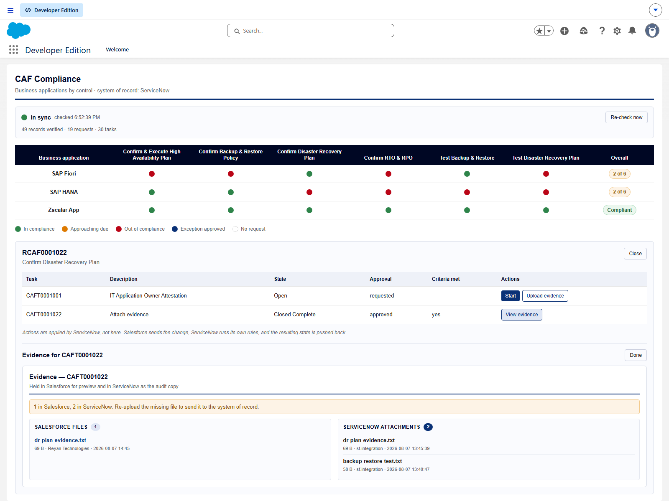
Screen capture — 03-closed-task-view-evidence.png
Actual result
- ServiceNow: state=3, active=false, approval=approved
- Row actions: View evidence
- Panel heading "Evidence — CAFT0001022"; upload control present: false
- Evidence still listed: 1 Salesforce file(s), 2 ServiceNow attachment(s).
Record evidence
Read directly from the ServiceNow Table API during execution. This is the evidence that determines the verdict; a screen capture shows what was displayed, not what was stored.
The task in ServiceNow
x_gskn2_caf_compli_caf_tsk · cnit get x_gskn2_caf_compli_caf_tsk -Query "number=CAFT0001022" -ProfileName caf-reyan
number | approval | active | state
CAFT0001022 | approved | false | 3

Row actions on the closed task
cafDashboard · task CAFT0001022
number | state | approval | actions
CAFT0001022 | Closed Complete | approved | View evidence

Panel on the closed task
cafEvidence · task CAFT0001022
heading | upload_control | salesforce_files | servicenow_attachments
Evidence — CAFT0001022 | false | 1 | 2

Observations
- One component serves both modes through the hide-upload flag rather than a second read-only component existing to say the same things.
Verdict
PASS
Reads "View evidence", offers no upload, no Start and no Attest, and still shows every file held on both sides.

Confidential. Prepared by Reyan Technologies. Contains system test evidence and must not be redistributed without written consent.

