
CAF Compliance · Test Evidence Record
TC-INT-048
Grid matches the ServiceNow portal exactly
RESULT: PASS

Every populated cell in the Salesforce grid matches caf_req.caf_status, and both grids show the same 3 applications.
Test case | TC-INT-048
Priority | P1
Type | Positive
Component under test | cafDashboard LWC
Application | CAF Compliance — scope x_gskn2_caf_compli
Environment | https://dev281754.service-now.com
Executed by | admin
Execution method | Playwright (automated); every assertion cross-checked against the ServiceNow Table API
Specification | TEST-CASES-INTEGRATION.md

Purpose
The parity case. Capture this screenshot in the same session as TC-SN-065 so the two grids sit side by side in the evidence pack.
Expected result
- Same applications, same controls, same status per cell as the /caf portal grid.
- Both grids reconcile to caf_req.caf_status, which is the system of record.
Steps executed
Step 1 Read the Salesforce grid.
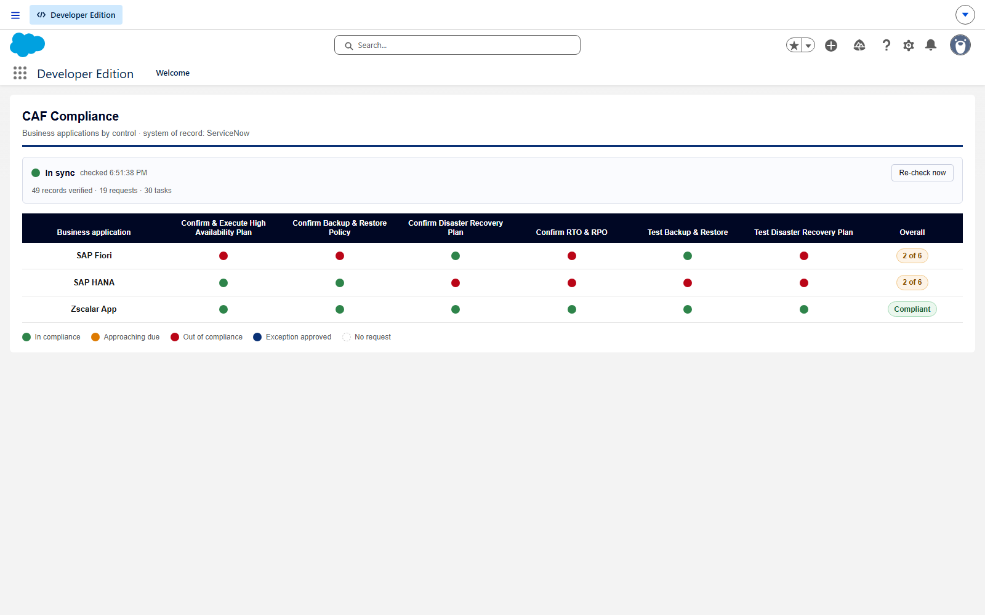
Screen capture — 01-salesforce-compliance-grid.png
Step 2 Capture the ServiceNow /caf portal grid in the same session.
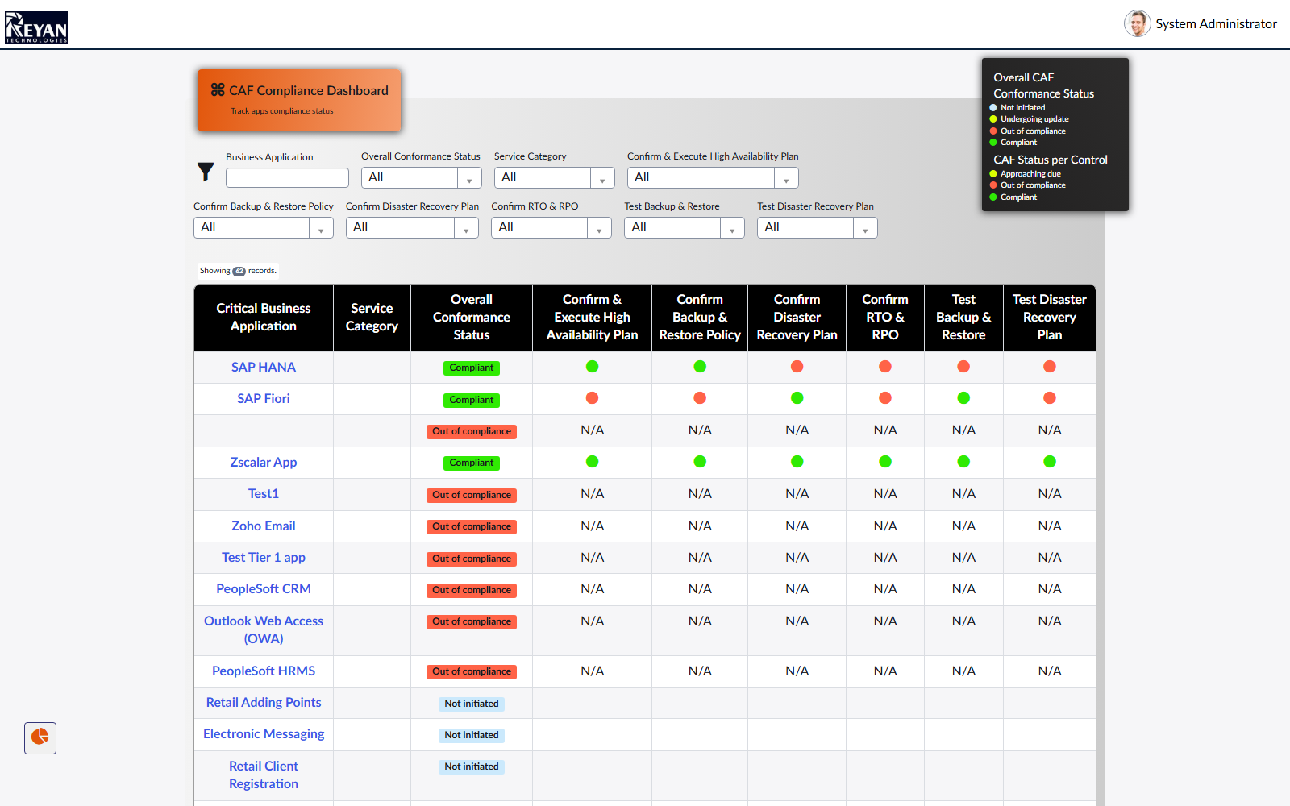
Screen capture — 02-servicenow-portal-grid.png
Step 3 Reconcile both grids against caf_req.caf_status, the system of record.
Actual result
- Salesforce grid: 3 application(s), 6 control column(s).
- SAP Fiori — 2 of 6; dots: red, red, green, red, green, red
- SAP HANA — 2 of 6; dots: green, green, red, red, red, red
- Zscalar App — Compliant; dots: green, green, green, green, green, green
- ServiceNow portal grid: 62 application row(s) — SAP HANA, SAP Fiori, , Zscalar App, Test1, Zoho Email, Test Tier 1 app, PeopleSoft CRM, Outlook Web Access (OWA), PeopleSoft HRMS, Retail Adding Points, Electronic Messaging, Retail Client Registration, SAP HANA, PeopleSoft Enterprise Services, PeopleSoft Reporting, SAP Labor Distribution, Bond Trading - DR, PeopleSoft Supply Chain Management, Unix Server Hosting, External Networking (Internet), SAP Financial Accounting, SAP Enterprise Services, SAP Payroll, Retail Client Lookup, Email, SAP Materials Management, Campus Network (LAN), Desktop Support, PeopleSoft Portals, Tibco ESB, Securities Lending, Apache Web Hosting, ServiceNow Enterprise Services, Sales Force Automation, Windows Server Hosting, SAP Human Resources, Retail, Client Services, Bond Trading, Shared Storage (SAN), z/OS Platform Hosting, Printing Services, PeopleSoft Financials, SAP Controlling, Windows Mobile, E-Commerce, Voice Communication, PeopleSoft Governance, Inter-Site Networking (WAN), PeopleSoft Asset Lifecycle Management, IT Services, Oracle Database Hosting, Workday Enterprise Services, Jobvite Enterprise Recruitment Services, IIS Web Hosting, OpenText Enterprise Services, This Service-now instance, SAP Plant Maintenance, Retail POS (Point of Sale), Test EU, Zoho HR System
- Cells disagreeing with caf_status: 0
Record evidence
Read directly from the ServiceNow Table API during execution. This is the evidence that determines the verdict; a screen capture shows what was displayed, not what was stored.
Salesforce grid
cafDashboard · CAF Dashboard tab
application | overall | Confirm & Execute High Availability Plan | Confirm Backup & Restore Policy | Confirm Disaster Recovery Plan | Confirm RTO & RPO | Test Backup & Restore
SAP Fiori | 2 of 6 | RCAF0001024 red | RCAF0001020 red | RCAF0001022 green | RCAF0001019 red | RCAF0001021 green
SAP HANA | 2 of 6 | RCAF0001042 green | RCAF0001038 green | RCAF0001040 red | RCAF0001037 red | RCAF0001039 red
Zscalar App | Compliant | RCAF0001036 green | RCAF0001032 green | RCAF0001034 green | RCAF0001031 green | RCAF0001033 green
1 further column(s) not shown. Full data in the run JSON.
ServiceNow /caf portal grid
caf_apps · /caf?id=caf_apps
application | overall
SAP HANA | Compliant
SAP Fiori | Compliant
 | Out of compliance
Zscalar App | Compliant
Test1 | Out of compliance
Zoho Email | Out of compliance
Test Tier 1 app | Out of compliance
PeopleSoft CRM | Out of compliance
Outlook Web Access (OWA) | Out of compliance
PeopleSoft HRMS | Out of compliance
Retail Adding Points | Not initiated
Electronic Messaging | Not initiated
Retail Client Registration | Not initiated
SAP HANA | Not initiated
48 further row(s) not shown. Full data in the run JSON.
caf_req.caf_status — the system of record
x_gskn2_caf_compli_caf_req · cnit get x_gskn2_caf_compli_caf_req -Fields number,caf_status -ProfileName caf-reyan
number | application | caf_status
RCAF0001032 | Zscalar App | in_compliance
RCAF0001033 | Zscalar App | in_compliance
RCAF0001034 | Zscalar App | in_compliance
RCAF0001039 | SAP HANA | out_of_compliance
RCAF0001038 | SAP HANA | in_compliance
RCAF0001019 | SAP Fiori | out_of_compliance
RCAF0001020 | SAP Fiori | out_of_compliance
RCAF0001022 | SAP Fiori | in_compliance
RCAF0001042 | SAP HANA | in_compliance
RCAF0001024 | SAP Fiori | out_of_compliance
RCAF0001041 | SAP HANA | out_of_compliance
RCAF0001023 | SAP Fiori | out_of_compliance
RCAF0001040 | SAP HANA | out_of_compliance
RCAF0001035 | Zscalar App | in_compliance
4 further row(s) not shown. Full data in the run JSON.
Observations
- Baseline in the case text is SAP HANA 6 out of compliance, SAP Fiori 4 out / 2 compliant, Zscalar App 6 compliant. Observed: SAP Fiori 2 compliant / 4 out; SAP HANA 2 compliant / 4 out; Zscalar App 6 compliant / 0 out.
- The Overall column is NOT part of this comparison — the two surfaces compute it from different sources and disagree, which is TC-INT-050. This case is about the per-control cells, which come from the same mirrored caf_status on both sides.
Verdict
PASS
Every populated cell in the Salesforce grid matches caf_req.caf_status, and both grids show the same 3 applications.

Confidential. Prepared by Reyan Technologies. Contains system test evidence and must not be redistributed without written consent.

