
CAF Compliance · Test Evidence Record
TC-INT-051
Drill-in shows the request's tasks
RESULT: PASS

Drill-in lists exactly the 2 task(s) ServiceNow holds for RCAF0001022, each with its state-appropriate actions.
Test case | TC-INT-051
Priority | P1
Type | Positive
Component under test | —
Application | CAF Compliance — scope x_gskn2_caf_compli
Environment | https://orgfarm-4938c7f768-dev-ed.develop.lightning.force.com + https://dev281754.service-now.com
Executed by | admin.070b86ccf531@agentforce.com (Salesforce) / admin (ServiceNow)
Execution method | Playwright driving Lightning Experience. Every screen assertion is cross-checked against the ServiceNow record over cnit and the Salesforce record over the sf CLI. No case in this file writes to either platform.
Specification | TEST-CASES-INTEGRATION.md

Expected result
- Clicking a cell lists that request’s tasks with state-appropriate row actions.
- The task set matches ServiceNow exactly.
Steps executed
Step 1 Open the dashboard and drill into RCAF0001022.
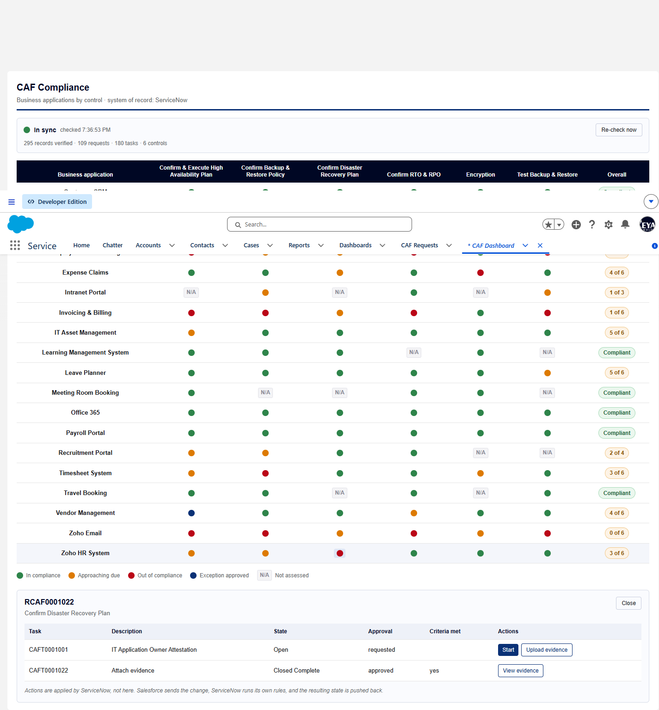
Screen capture — 01-drill-in-task-list.png
Step 2 Read the same request’s tasks from ServiceNow.
Step 3 Read the same request’s tasks from Salesforce, behind the screen.
Actual result
- Screen lists 2 task(s): CAFT0001001, CAFT0001022
- ServiceNow holds 2: CAFT0001001, CAFT0001022
- On screen but not in ServiceNow: none; in ServiceNow but not on screen: none
- CAFT0001001 is Open; row actions: Start, Upload evidence
- CAFT0001022 is Closed Complete; row actions: View evidence
Record evidence
Read directly from the ServiceNow Table API during execution. This is the evidence that determines the verdict; a screen capture shows what was displayed, not what was stored.
Tasks as the drill-in lists them
cafDashboard · cell click on RCAF0001022
number | state | approval | met_criteria | actions
CAFT0001001 | Open | requested |  | Start, Upload evidence
CAFT0001022 | Closed Complete | approved | yes | View evidence

Tasks in ServiceNow
x_gskn2_caf_compli_caf_tsk · cnit get x_gskn2_caf_compli_caf_tsk -Query "caf_request.number=RCAF0001022" -ProfileName caf-reyan
number | approval | met_criteria | state
CAFT0001022 | approved | yes | 3
CAFT0001001 | requested |  | 1

Tasks in Salesforce
CAF_Task__c · sf data query --query "SELECT SN_Number__c, State__c, Approval__c FROM CAF_Task__c WHERE CAF_Request__r.SN_Number__c = 'RCAF0001022' ORDER BY SN_Number__c" --target-org caf-sf
SN_Number__c | State__c | Approval__c
CAFT0001001 | Open | requested
CAFT0001022 | Closed Complete | approved

Verdict
PASS
Drill-in lists exactly the 2 task(s) ServiceNow holds for RCAF0001022, each with its state-appropriate actions.

Confidential. Prepared by Reyan Technologies. Contains system test evidence and must not be redistributed without written consent.

