
CAF Compliance · Test Evidence Record
TC-SN-006
state is read-only on the request but writable on the task
RESULT: FAIL

The dictionary and the form disagree about caf_tsk.state. The dictionary assertion passes; the form contradicts it. Referred for a decision on intended behaviour before this is classed as a defect.
Test case | TC-SN-006
Priority | P2
Type | Regression
Component under test | caf_req.state / caf_tsk.state
Application | CAF Compliance — scope x_gskn2_caf_compli
Environment | https://dev281754.service-now.com
Executed by | admin
Execution method | Playwright (automated); every assertion cross-checked against the ServiceNow Table API
Specification | TEST-CASES-SERVICENOW.md

Expected result
- caf_req.state.read_only = true — a request's state moves only through business rules and flows.
- caf_tsk.state.read_only = false — a task's state can be set directly.
Steps executed
Step 1 Read both dictionary entries.
Step 2 Open an Open CAF Task form and ask g_form whether state is editable there.
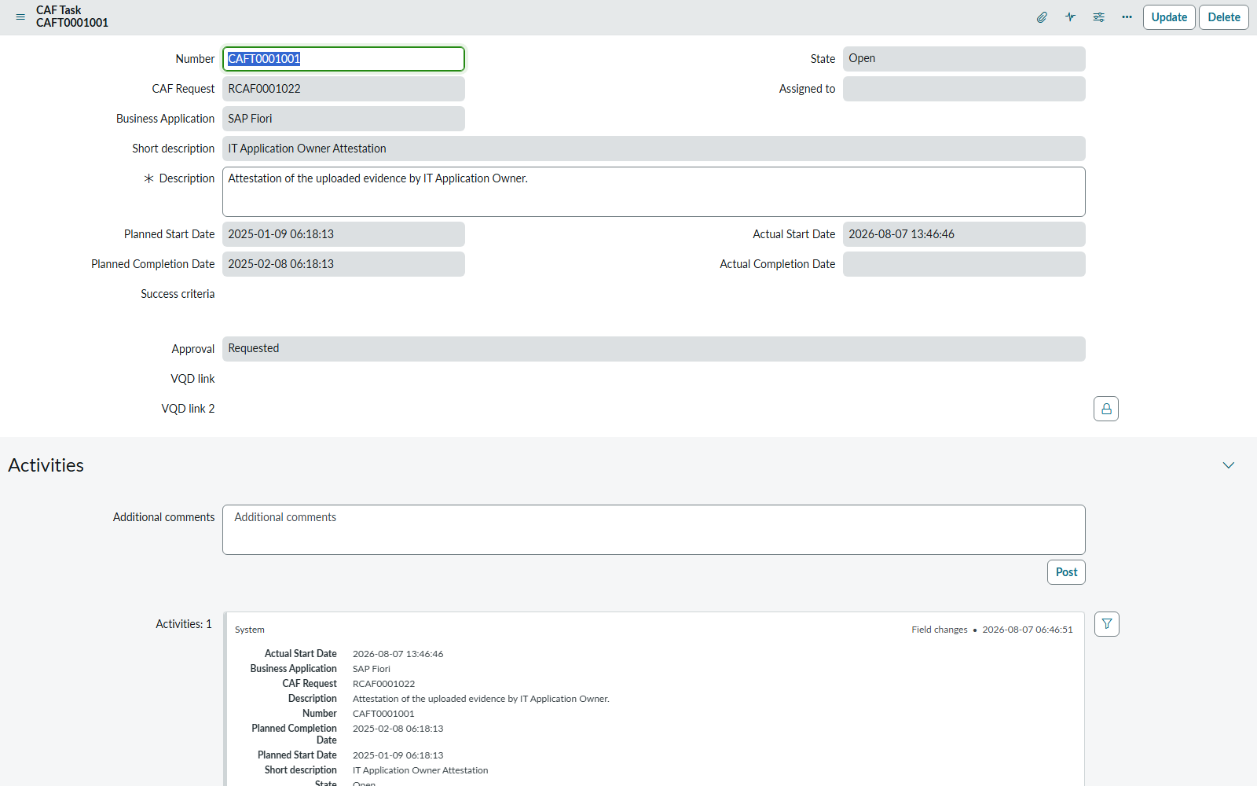
Screen capture — 02-caft0001001-form.png
Actual result
- Dictionary: caf_req.state read_only=true, caf_tsk.state read_only=false
- Form: state readOnly=true, approval readOnly=true, description mandatory=true
Record evidence
Read directly from the ServiceNow Table API during execution. This is the evidence that determines the verdict; a screen capture shows what was displayed, not what was stored.
state field, both tables
sys_dictionary · caf_req.state and caf_tsk.state
read_only | name | default_value | element
true | x_gskn2_caf_compli_caf_req | 1 | state
false | x_gskn2_caf_compli_caf_tsk | 1 | state

Form introspection via g_form
x_gskn2_caf_compli_caf_tsk · CAFT0001001 (state=1, Open)
field_state_readOnly | field_approval_readOnly | field_description_mandatory
true | true | true

Observations
- GAP: the dictionary makes caf_tsk.state writable, but the form reports it read-only on an OPEN task. Something on the form — most likely the client script "CAF Task On Load Logic" — is locking it.
- Consequence: state is writable by the API but not through the native form. Either TC-SN-026 needs rewriting, or a task cannot be started from the ServiceNow form at all, which is an unstated workflow claim.
Verdict
FAIL
The dictionary and the form disagree about caf_tsk.state. The dictionary assertion passes; the form contradicts it. Referred for a decision on intended behaviour before this is classed as a defect.

Confidential. Prepared by Reyan Technologies. Contains system test evidence and must not be redistributed without written consent.

