
CAF Compliance · Test Evidence Record
TC-SN-017
Business application flips to Compliant
RESULT: FAIL

2 business application(s) are reported compliant while controls are out of compliance. Severity: high — this is the headline number on the compliance dashboard.
Test case | TC-SN-017
Priority | P1
Type | Positive
Component under test | BR CAF - update BA when req compliant (after update, order 1500, filter caf_statusCHANGESTOin_compliance^ORcaf_statusCHANGESTOarcher_exception_approved)
Application | CAF Compliance — scope x_gskn2_caf_compli
Environment | https://dev281754.service-now.com
Executed by | admin
Execution method | Playwright (automated); every assertion cross-checked against the ServiceNow Table API
Specification | TEST-CASES-SERVICENOW.md

From the specification
Critical sub-case
the business application must go compliant only when every control is compliant. Set one request to in_compliance while a sibling request on the same application is out_of_compliance; the application must not read compliant.
The instance already fails this, on two of the three demo applications:
The rule's filter is caf_statusCHANGESTOin_compliance, which fires whenever any request goes compliant. It appears to set the application compliant without checking whether its siblings still are not.
Consequence. The /caf portal grid renders u_caf_compliance_status faithfully, so it shows SAP HANA — Compliant beside four red control dots. The grid is not lying; the field it reads is wrong. An executive looking at the dashboard sees two critical applications as compliant when eight controls between them are not — which is the exact failure a compliance product exists to prevent.
This also falsifies a claim in HANDOFF §3 — "An app is compliant only when every control is, matching the ServiceNow widget" — and the Salesforce LWC is documented as deliberately mirroring that behaviour, so the same wrong answer is very likely on both platforms. Cross-reference TC-INT-050.
Reproduce
no setup needed; read the two records as they stand. To prove causation, take a fourth application, set one of several requests to in_compliance, and watch the application flip.
Expected result
- cmdb_ci_business_app.u_caf_compliance_status reads "compliant" only when EVERY CAF Request for that application is in_compliance.
- An application with any out_of_compliance control must not read compliant.
Steps executed
Step 1 Read the compliance status of the three demo business applications.
Step 2 For each application, read the CAF Requests it claims to summarise.
Step 3 Open the /caf compliance grid and confirm what a user is shown.
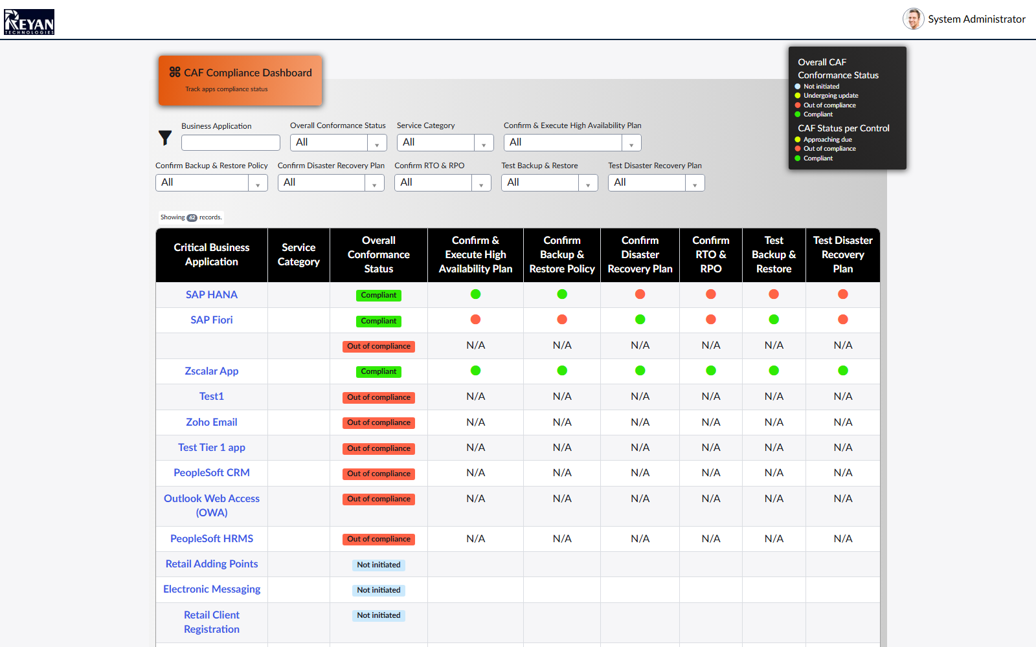
Screen capture — 03-caf-compliance-grid.png
Actual result
- 2 application(s) report Compliant while holding out-of-compliance controls: SAP Fiori (7661e43483431210bd2a5860ceaad360) reads "compliant" while 4 of 6 controls are out_of_compliance; SAP HANA (6e81683483431210bd2a5860ceaad398) reads "compliant" while 4 of 6 controls are out_of_compliance
Record evidence
Read directly from the ServiceNow Table API during execution. This is the evidence that determines the verdict; a screen capture shows what was displayed, not what was stored.
Business applications
cmdb_ci_business_app · nameINSAP HANA,SAP Fiori,Zscalar App
sys_id | u_caf_compliance_status | name
7661e43483431210bd2a5860ceaad360 | compliant | SAP Fiori
5470cc8583d31210bd2a5860ceaad372 | not_ini | SAP HANA
6e81683483431210bd2a5860ceaad398 | compliant | SAP HANA
41b1e83483431210bd2a5860ceaad366 | compliant | Zscalar App

Requests for SAP Fiori (7661e43483431210bd2a5860ceaad360)
x_gskn2_caf_compli_caf_req · business_application=7661e43483431210bd2a5860ceaad360
number | caf_status | active | state
RCAF0001019 | out_of_compliance | true | 2
RCAF0001020 | out_of_compliance | true | 2
RCAF0001022 | in_compliance | true | 2
RCAF0001024 | out_of_compliance | true | 1
RCAF0001023 | out_of_compliance | true | 2
RCAF0001021 | in_compliance | false | 3

Requests for SAP HANA (6e81683483431210bd2a5860ceaad398)
x_gskn2_caf_compli_caf_req · business_application=6e81683483431210bd2a5860ceaad398
number | caf_status | active | state
RCAF0001039 | out_of_compliance | true | 2
RCAF0001038 | in_compliance | true | 2
RCAF0001042 | in_compliance | true | 2
RCAF0001041 | out_of_compliance | true | 1
RCAF0001040 | out_of_compliance | true | 1
RCAF0001037 | out_of_compliance | true | 2

Requests for Zscalar App (41b1e83483431210bd2a5860ceaad366)
x_gskn2_caf_compli_caf_req · business_application=41b1e83483431210bd2a5860ceaad366
number | caf_status | active | state
RCAF0001032 | in_compliance | false | 3
RCAF0001033 | in_compliance | false | 3
RCAF0001034 | in_compliance | false | 3
RCAF0001035 | in_compliance | false | 3
RCAF0001036 | in_compliance | false | 3
RCAF0001031 | in_compliance | false | 3

Roll-up reconciliation
(derived) · business application status vs its controls
application | sys_id | u_caf_compliance_status | controls_compliant | controls_out_of_compliance | consistent
SAP Fiori | 7661e43483431210bd2a5860ceaad360 | compliant | 2 | 4 | NO
SAP HANA | 6e81683483431210bd2a5860ceaad398 | compliant | 2 | 4 | NO
Zscalar App | 41b1e83483431210bd2a5860ceaad366 | compliant | 6 | 0 | YES

Grid as rendered to the user
/caf?id=caf_apps · Overall Conformance Status column
application | overall_status_shown
SAP HANA | Compliant
SAP Fiori | Compliant
Zscalar App | Compliant
SAP HANA | Not initiated

Observations
- The /caf grid renders u_caf_compliance_status faithfully, so it displays "Compliant" beside red control dots. The grid is not at fault; the field it reads is wrong.
- Suspected cause: business rule "CAF - update BA when req compliant" (after update, order 1500, filter caf_statusCHANGESTOin_compliance) sets the application compliant whenever ANY request goes compliant, without checking whether its siblings still are not.
- This falsifies HANDOFF section 3: "An app is compliant only when every control is, matching the ServiceNow widget." The Salesforce LWC is documented as mirroring that behaviour, so the same wrong answer is likely on both platforms — see TC-INT-050.
Notes from the specification
- This rule is not in the design document. See TC-SN-068.
Verdict
FAIL
2 business application(s) are reported compliant while controls are out of compliance. Severity: high — this is the headline number on the compliance dashboard.

Confidential. Prepared by Reyan Technologies. Contains system test evidence and must not be redistributed without written consent.

