Digital Signal Processing Lab

Experiment 1.a & 1.b

By Hardik Tibrewal (18EC10020)

Part A:

To sample a band-limited signal (limited to B Hz) at a sampling frequency (Fs) such that Fs > 2B, then apply DFT with N = 64, 128, 256 points and plot the magnitude spectra.

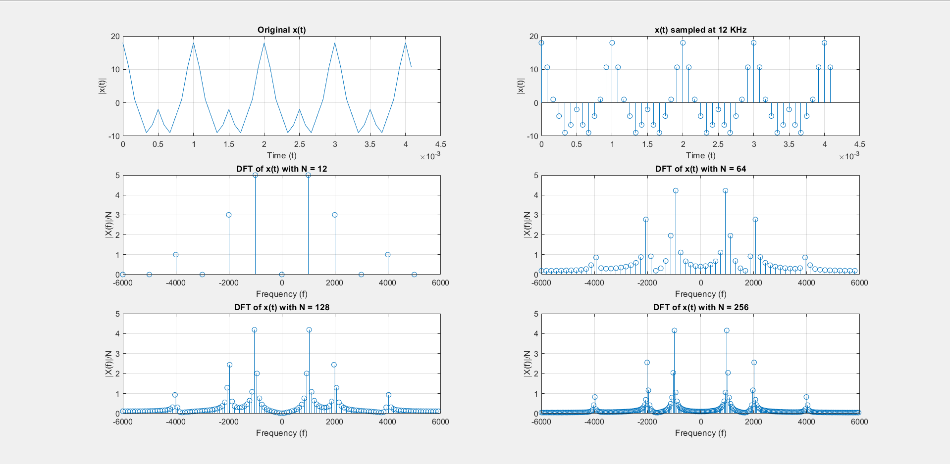Fs = 12 kHz

Here we can see the original signal in time domain, the sampled signal, and the DFT with 12, 64, 128, and 256 points. Since the DFT has been normalised with respect to the number of points, the amplitudes are same for N=64, 128, and 256.

Code:

f = 1000;

fs = 12000;

t = 0:1/fs:0.1;

x = 10*cos(2*pi*f*t)+6*cos(2*pi*2*f*t)+2*cos(2*pi*4*f*t);

subplot(3,2,1);

plot(t(1:50), x(1:50));

grid on;

title('Original x(t)');

xlabel('Time (t)');

ylabel('|x(t)|');

subplot(3,2,2);

stem(t(1:50), x(1:50));

grid on;

title('x(t) sampled at 12 KHz');

xlabel('Time (t)');

ylabel('|x(t)|');

N = 12;

dft_1 = fft(x, N);

dft_1 = fftshift(dft_1);

mag_1 = abs(dft_1/N);

f1 = -fs/2:fs/N:(fs/2 - fs/N);

subplot(3,2,3);

stem(f1, mag_1);

grid on;

title('DFT of x(t) with N = 12');

xlabel('Frequency (f)');

ylabel('|X(f)|/N');

N = 64;

dft_1 = fft(x, N);

dft_1 = fftshift(dft_1);

mag_1 = abs(dft_1/N);

f1 = -fs/2:fs/N:(fs/2 - fs/N);

subplot(3,2,4);

stem(f1, mag_1);

grid on;

title('DFT of x(t) with N = 64');

xlabel('Frequency (f)');

ylabel('|X(f)|/N');

N = 128;

dft_1 = fft(x, N);

dft_1 = fftshift(dft_1);

mag_1 = abs(dft_1)/N;

f1 = -fs/2:fs/N:(fs/2 - fs/N);

subplot(3,2,5);

stem(f1, mag_1);

grid on;

title('DFT of x(t) with N = 128');

xlabel('Frequency (f)');

ylabel('|X(f)|/N');

N = 256;

dft_1 = fft(x, N);

dft_1 = fftshift(dft_1);

mag_1 = abs(dft_1)/N;

f1 = -fs/2:fs/N:(fs/2 - fs/N);

subplot(3,2,6);

stem(f1, mag_1);

grid on;

title('DFT of x(t) with N = 256');

xlabel('Frequency (f)');

ylabel('|X(f)|/N');

Part B:

To repeat part A with Fs = 8 kHz, 5 kHz, and 4 kHz, which are frequencies below the Nyquist rate.

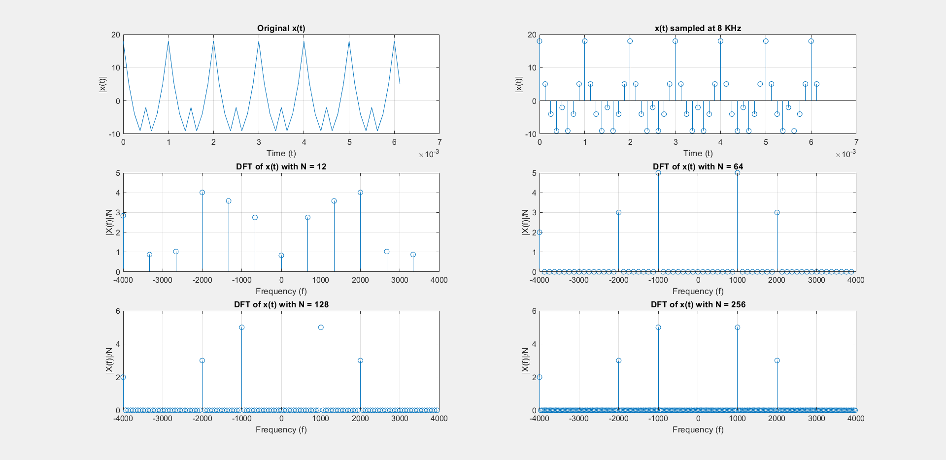Fs = 8 kHz

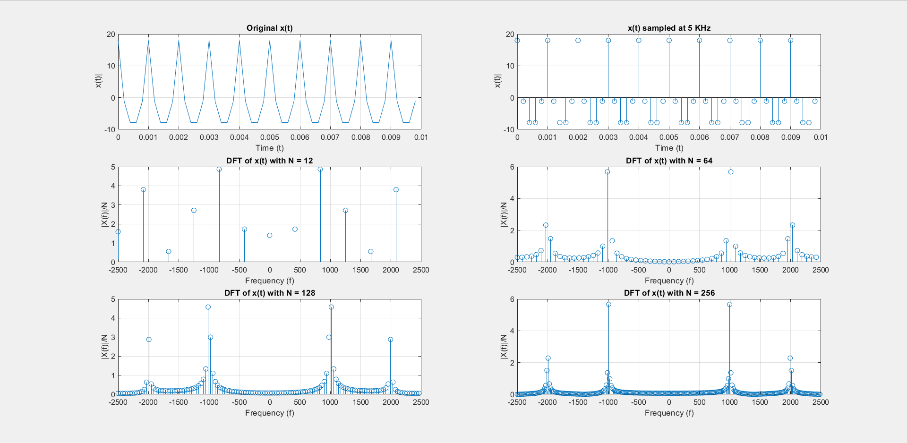Fs = 5 kHz

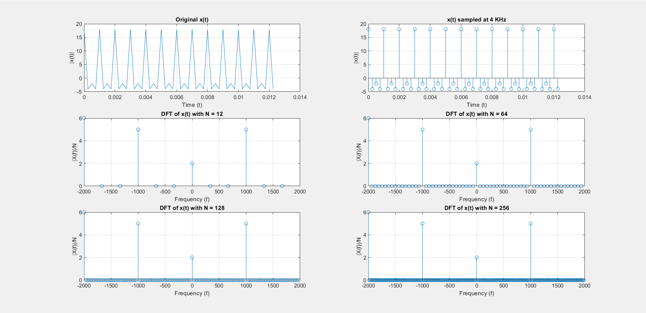Fs = 4 kHz

Here, we see the plots of DFTs are quite different from when Fs = 12 kHz. Reasons will be discussed in the full lab report. Code will be included in the full report.

Code same as Part A: (N changed manually)