Digital Signal Processing Lab

Experiment 1.c & 1.d

By Hardik Tibrewal (18EC10020)

Part C:

To plot the frequency spectrum of a square wave.

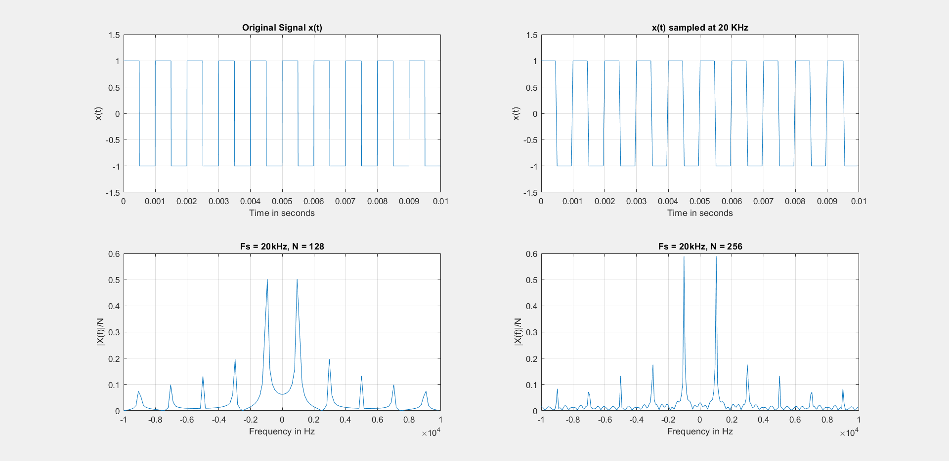Frequency Spectrum of square wave

The original signal in the figure is sampled at 200 kHz to show a distinct effect of sampling at 20 kHz (rise and fall time behaviour is visible).

N-point FFT was done using N=128 and N=256, and peaks were observed at certain frequencies. Reasons will be discussed in the complete lab report.

Code:

clc

close all

f = 1000;

fs = 20000;

t = 0:1/(10*fs):0.1;

ts = 0:1/fs:0.1;

y = square(2*pi*f*t);

subplot(2,2,1);

plot(t(1:2000), y(1:2000));

grid on;

axis([0 0.01 -1.5 1.5]);

xlabel('Time in seconds'); ylabel('x(t)'); title('Original Signal x(t)');

ys = square(2*pi*f*ts);

subplot(2,2,2);

plot(ts(1:200), ys(1:200));

grid on;

axis([0 0.01 -1.5 1.5]);

xlabel('Time in seconds'); ylabel('x(t)'); title('x(t) sampled at 20 KHz');

N=128;

Xs = fftshift(fft(ys, N));

mag_s = abs(Xs)/N;

f1 = -fs/2:fs/N:(fs/2 - fs/N);

subplot(2,2,3);

plot(f1, mag_s);

grid on;

xlabel('Frequency in Hz'); ylabel('|X(f)|/N'); title('Fs = 20kHz, N = 128');

N=256;

Xs = fftshift(fft(ys, N));

mag_s = abs(Xs)/N;

f1 = -fs/2:fs/N:(fs/2 - fs/N);

subplot(2,2,4);

plot(f1, mag_s);

grid on;

xlabel('Frequency in Hz'); ylabel('|X(f)|/N'); title('Fs = 20kHz, N = 256');

Part D:

To interpolate (or upsample) a signal originally sampled at 12 kHz to twice the frequency (24 kHz) by zero interpolation and lowpass filtering.

Original signal (actually sampled at 120 kHz)

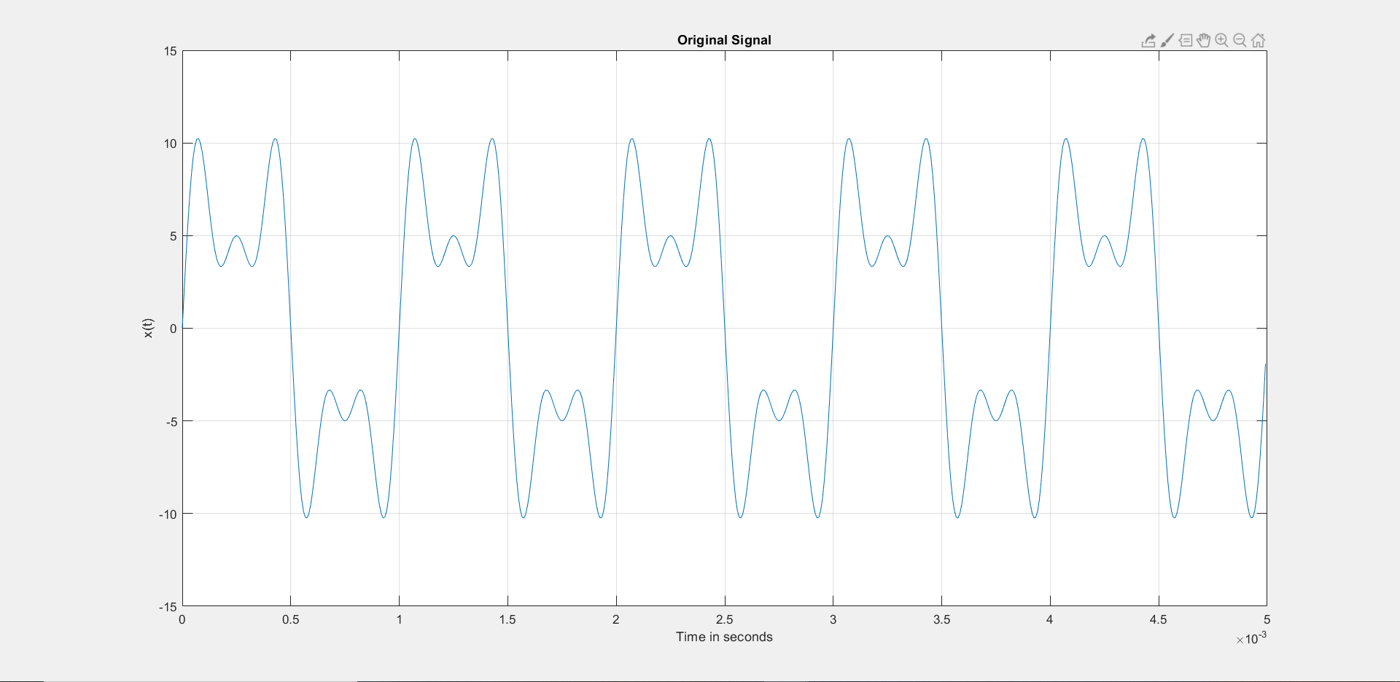Equation: 3sin(2π*5000t)+5sin(2π*3000t)+7sin(2π*1000t)

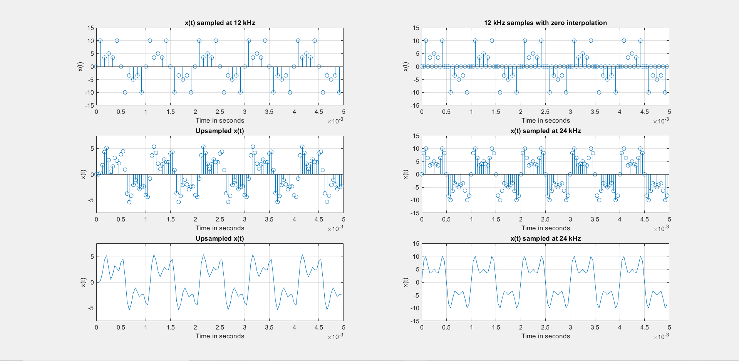Upsampling and comparison with sampling at 24 kHz

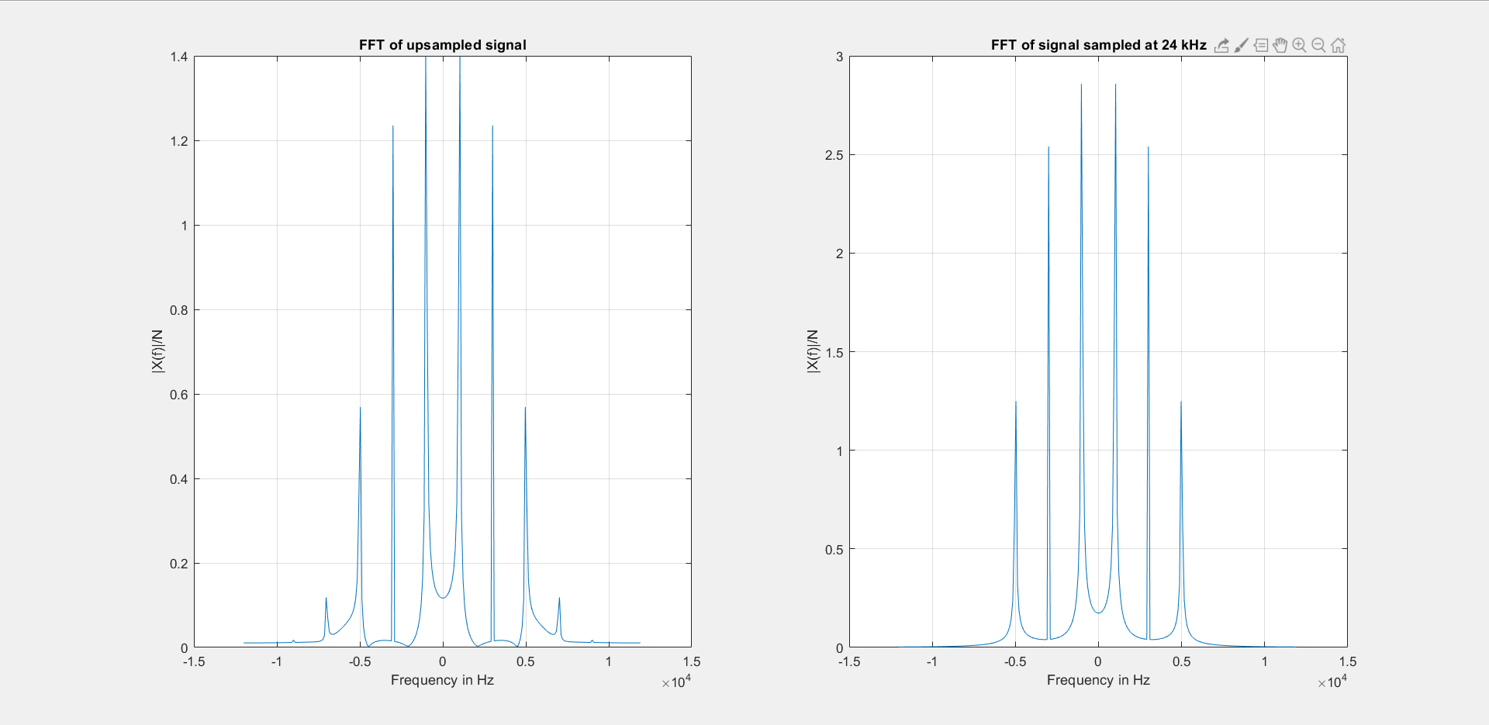FFTs of upsampled signal and signal sampled at 24 kHz

The interpolation process and the sampling at 24 kHz is compared. There are slight differences such as delay and degradation of magnitude. Reasons for the same will be discussed in the complete lab report.

Code:

clc

close all

f = 1000;

fs1 = 12000;

fs2 = 24000;

t = 0:1/(10*fs1):0.1;

ts1 = 0:1/fs1:0.1;

ts2 = 0:1/fs2:0.1;

x = 3*sin(2*pi*5*f*t)+5*sin(2*pi*3*f*t)+7*sin(2*pi*f*t);

figure();

len = (length(t)-1)/20;

plot(t(1:len), x(1:len));

grid on;

axis([0, 0.005 -15 15]);

xlabel('Time in seconds'); ylabel('x(t)'); title('Original Signal');

figure();

xs1 = 3*sin(2*pi*5*f*ts1)+5*sin(2*pi*3*f*ts1)+7*sin(2*pi*f*ts1);

subplot(321);

len = (length(ts1)-1)/20;

stem(ts1(1:len), xs1(1:len));

grid on;

axis([0, 0.005 -15 15]);

xlabel('Time in seconds'); ylabel('x(t)'); title('x(t) sampled at 12 kHz');

z = zeros(1,length(ts1));

xs2 = [xs1(:) z(:)]';

xs2 = xs2(:);

subplot(322);

len = (length(ts2)-1)/20;

stem(ts2(1:len), xs2(1:len));

grid on;

axis([0, 0.005 -15 15]);

xlabel('Time in seconds'); ylabel('x(t)'); title('12 kHz samples with zero interpolation');

[b,a] = butter(6,(6*f)/(fs2/2));

data = filter(b,a,xs2);

up_xs1 = data(1:length(data)-1);

len = (length(ts2)-1)/20;

subplot(323);

stem(ts2(1:len), up_xs1(1:len));

grid on;

axis([0, 0.005 -7.5 7.5]);

xlabel('Time in seconds'); ylabel('x(t)'); title('Upsampled x(t)');

len = (length(ts2)-1)/20;

subplot(325);

plot(ts2(1:len), up_xs1(1:len));

grid on;

axis([0, 0.005 -7.5 7.5]);

xlabel('Time in seconds'); ylabel('x(t)'); title('Upsampled x(t)');

xs2 = 3*sin(2*pi*5*f*ts2)+5*sin(2*pi*3*f*ts2)+7*sin(2*pi*f*ts2);

subplot(324);

len = (length(ts2)-1)/20;

stem(ts2(1:len), xs2(1:len));

grid on;

axis([0, 0.005 -15 15]);

xlabel('Time in seconds'); ylabel('x(t)'); title('x(t) sampled at 24 kHz');

subplot(326);

len = (length(ts2)-1)/20;

plot(ts2(1:len), xs2(1:len));

grid on;

axis([0, 0.005 -15 15]);

xlabel('Time in seconds'); ylabel('x(t)'); title('x(t) sampled at 24 kHz');

figure();

N = 256;

up_ys1 = fftshift(fft(up_xs1, N));

mag_ys1 = abs(up_ys1)/N;

f1 = -fs2/2:fs2/N:(fs2/2 - fs2/N);

subplot(1,2,1);

plot(f1, mag_ys1);

grid on;

xlabel('Frequency in Hz'); ylabel('|X(f)|/N'); title('FFT of upsampled signal');

ys2 = fftshift(fft(xs2, N));

mag_ys2 = abs(ys2)/N;

f1 = -fs2/2:fs2/N:(fs2/2 - fs2/N);

subplot(1,2,2);

plot(f1, mag_ys2);

grid on;

xlabel('Frequency in Hz'); ylabel('|X(f)|/N'); title('FFT of signal sampled at 24 kHz');