Digital Signal Processing Lab

Experiment 2

By Hardik Tibrewal (18EC10020)

**Aim:**

To design various FIR Filters using windowing

To check whether the filter works as desired

To check how the filters work on noisy signals

**Plots:** (Phase plots are zoomed for N=512 in to show the pattern clearly)

Cut-off angular frequency = 0.8 rads

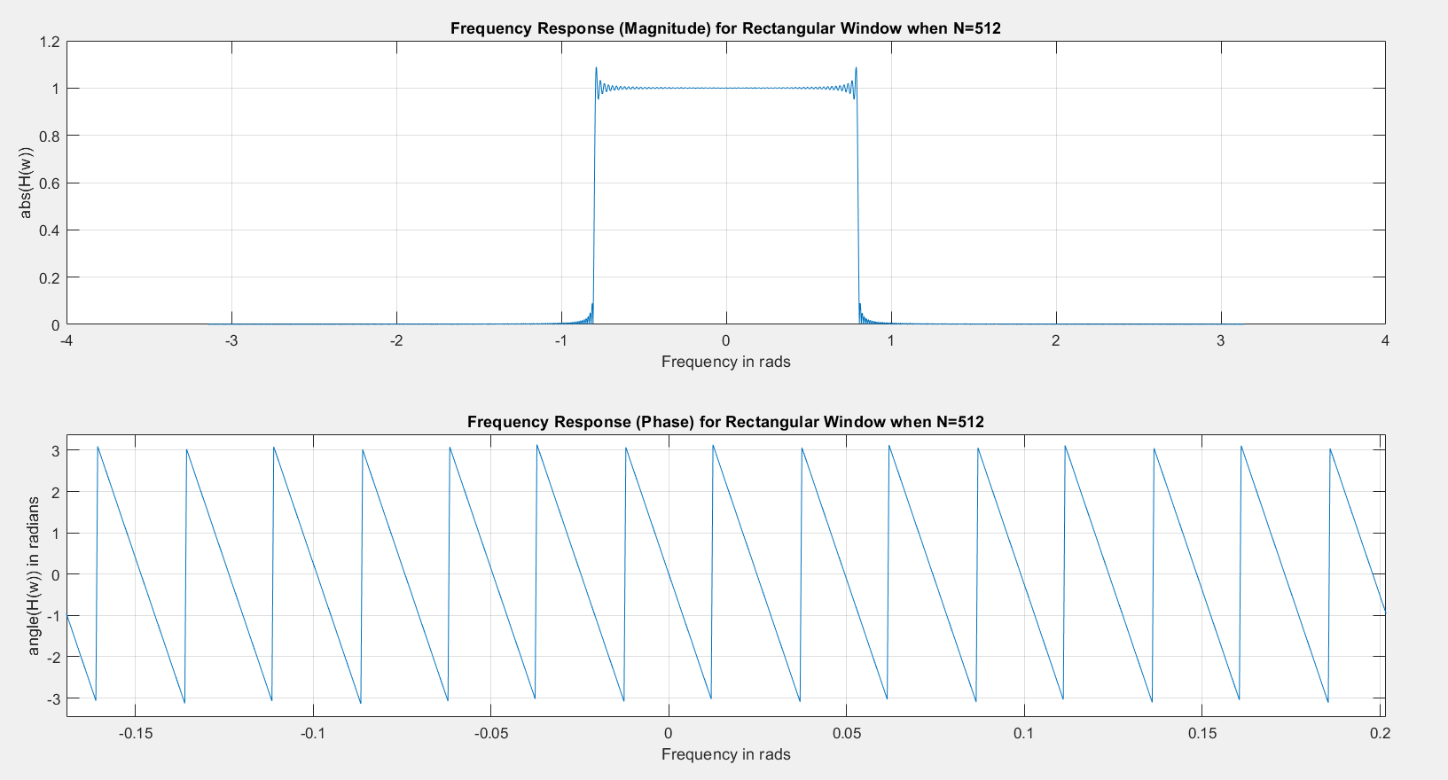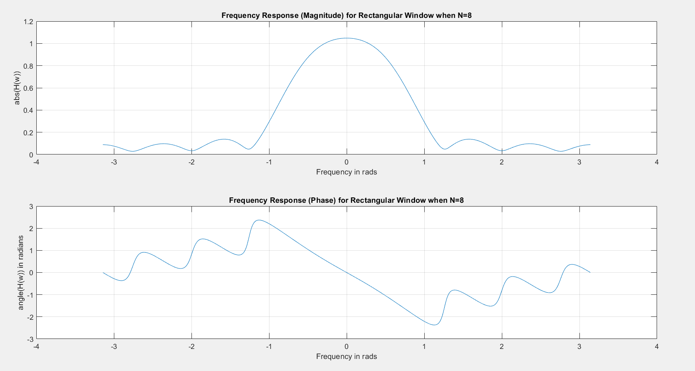

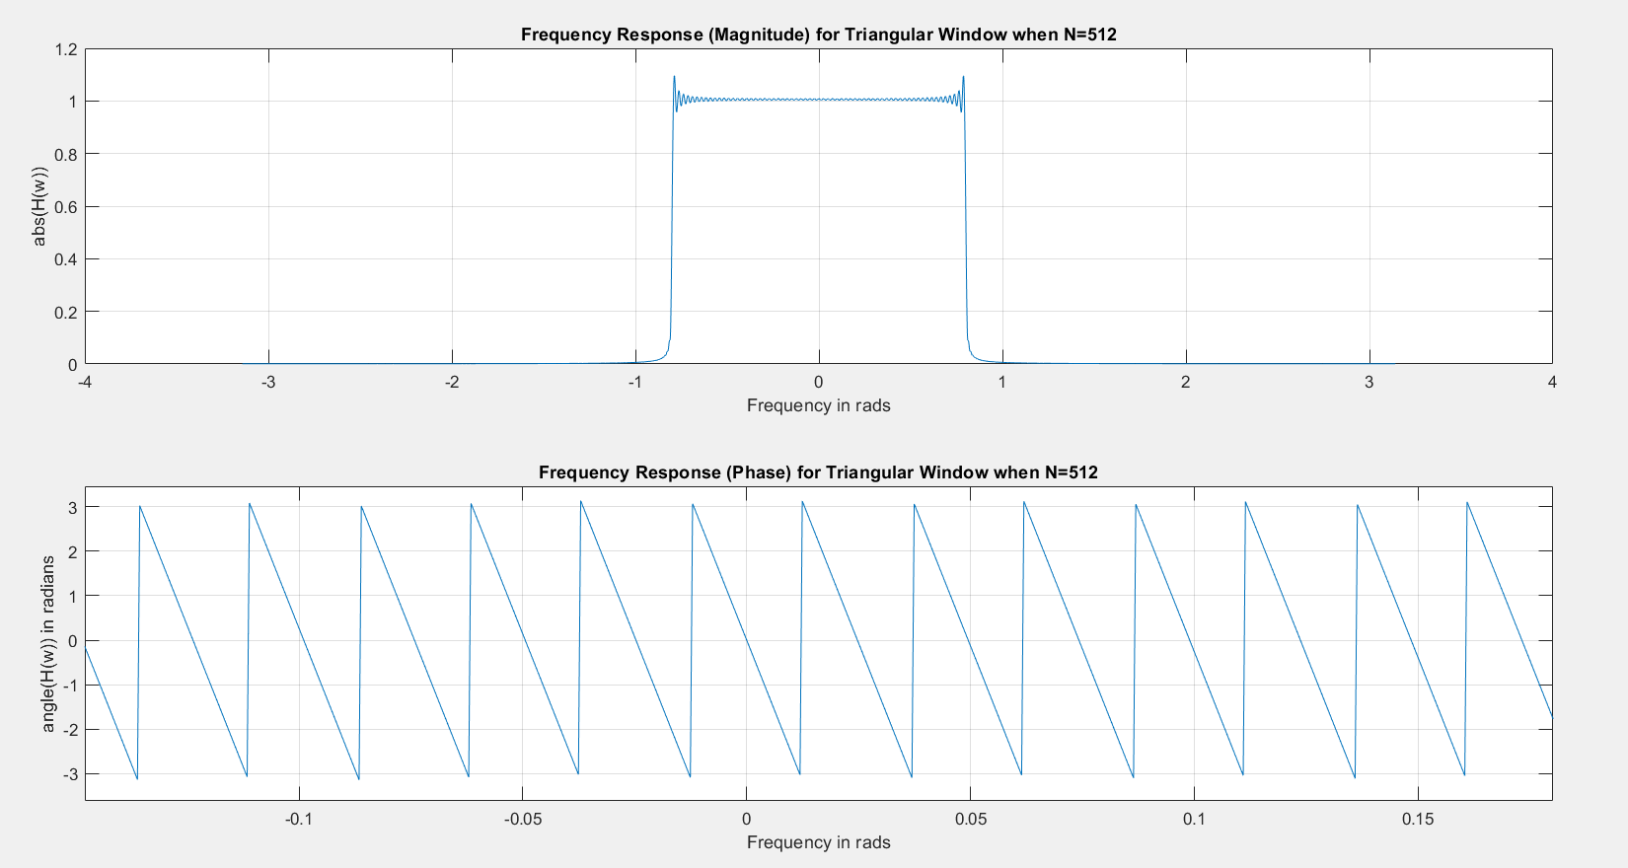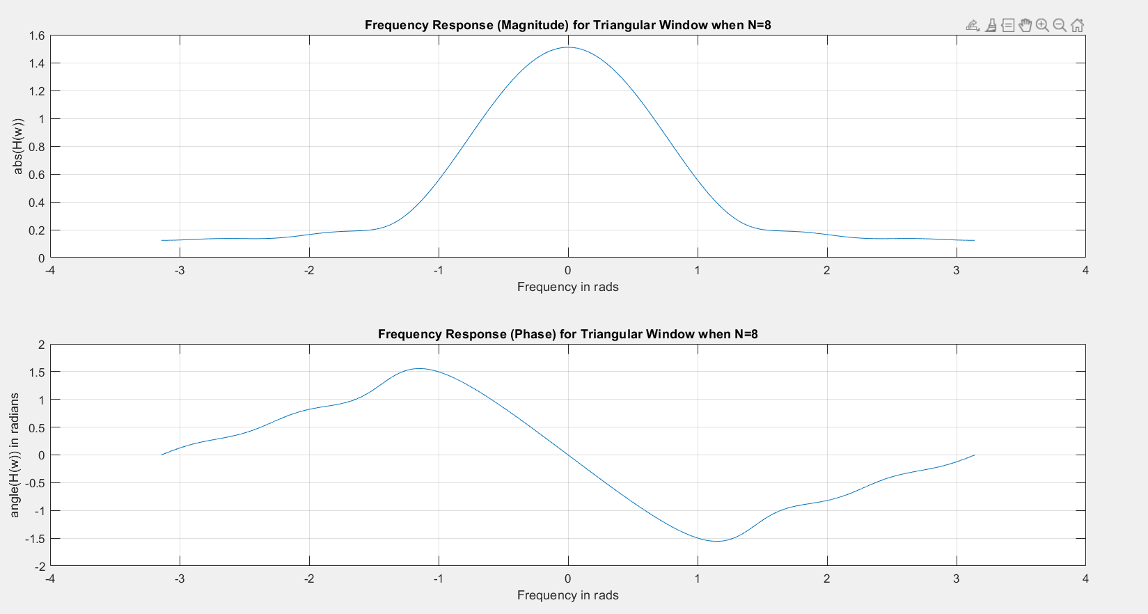

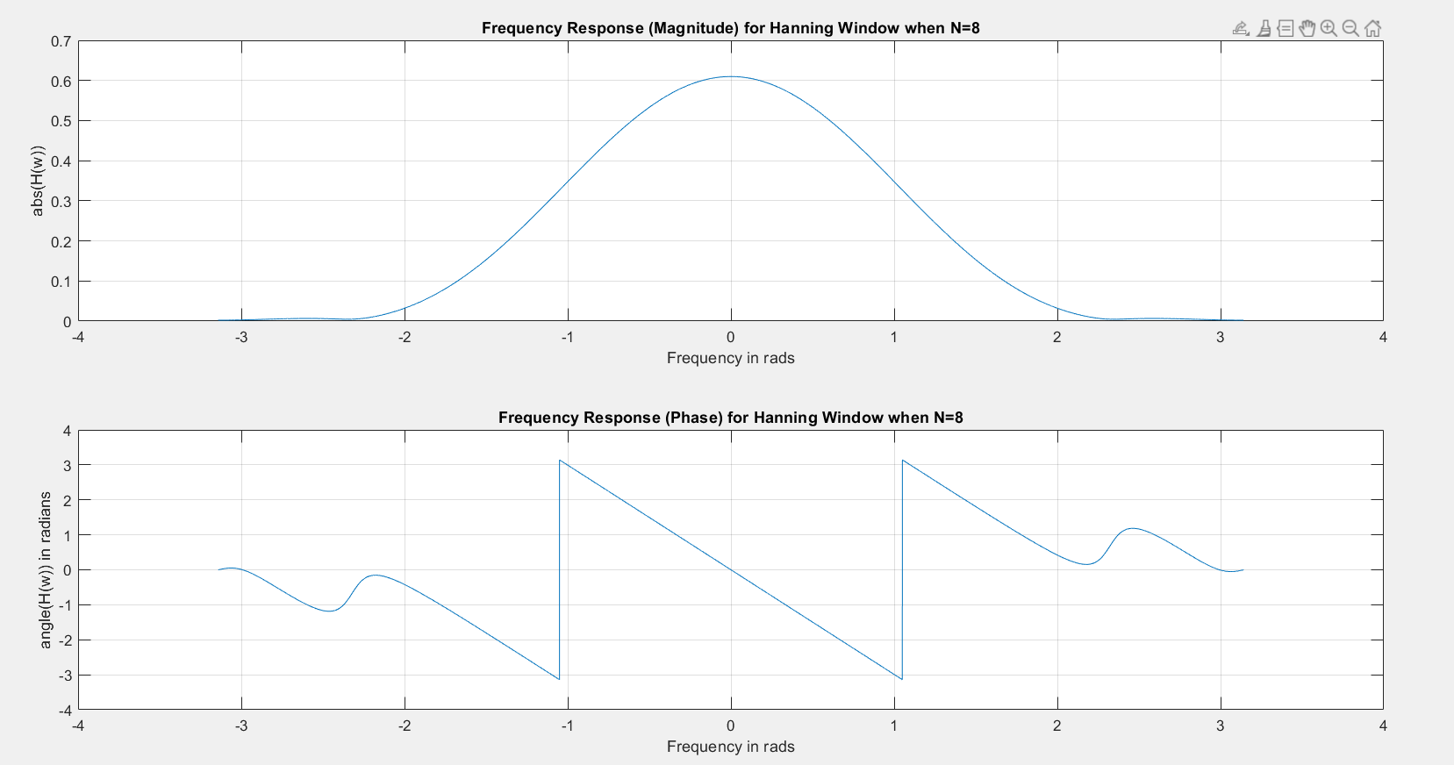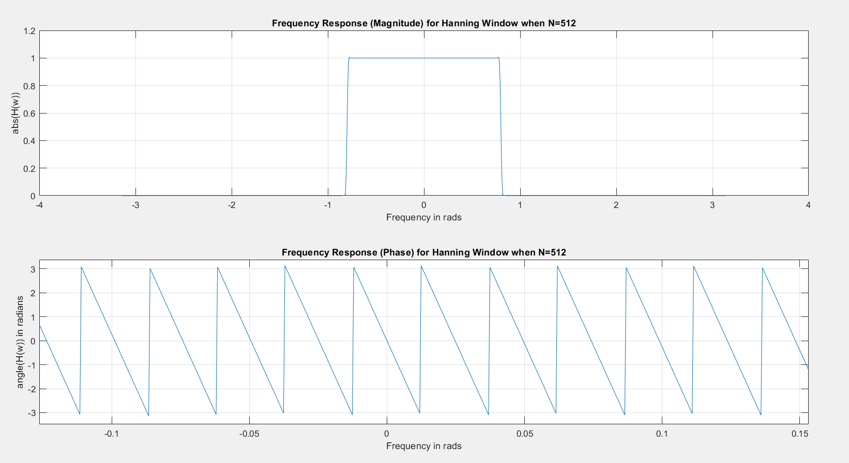

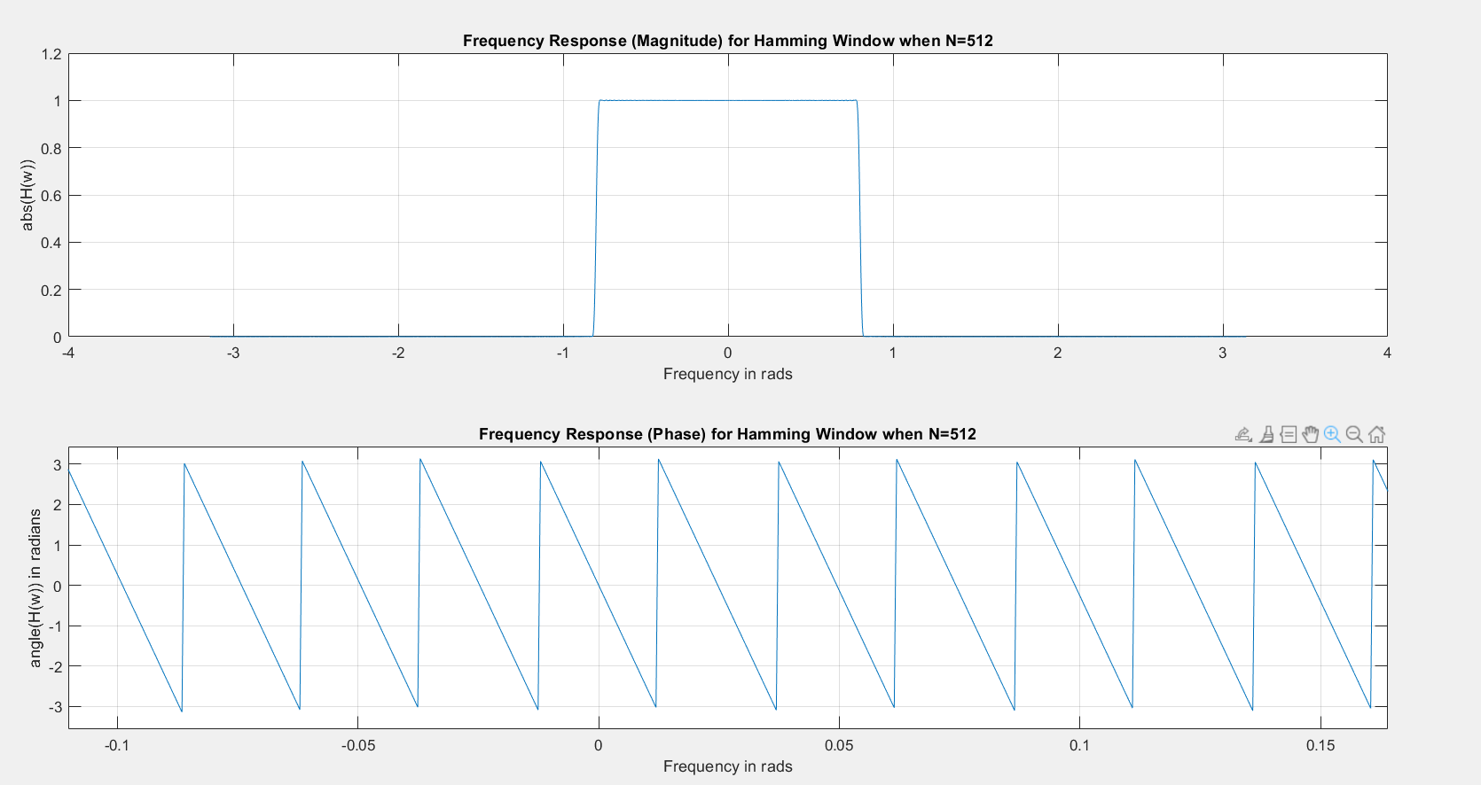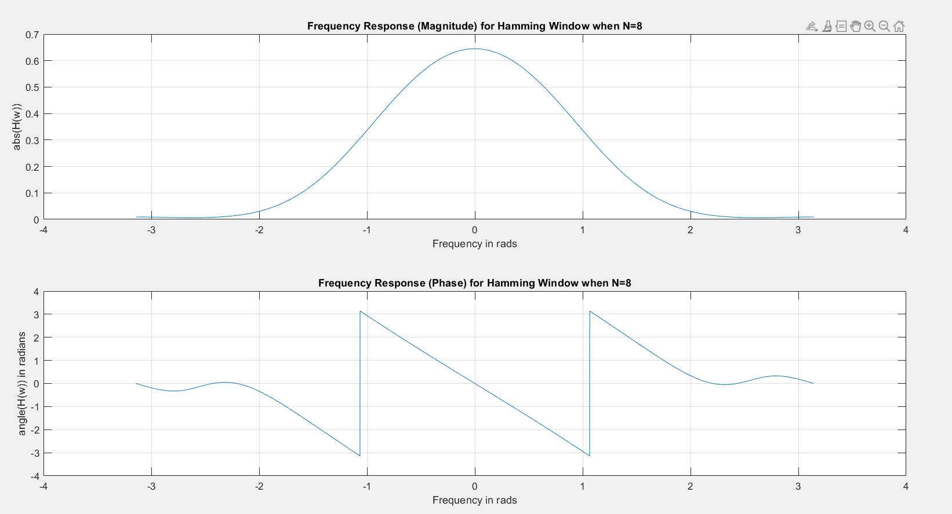

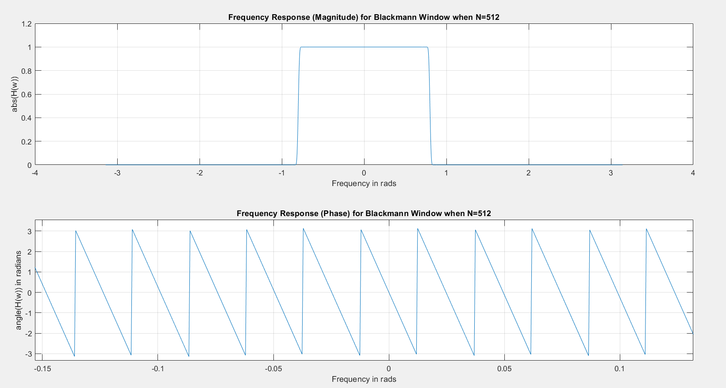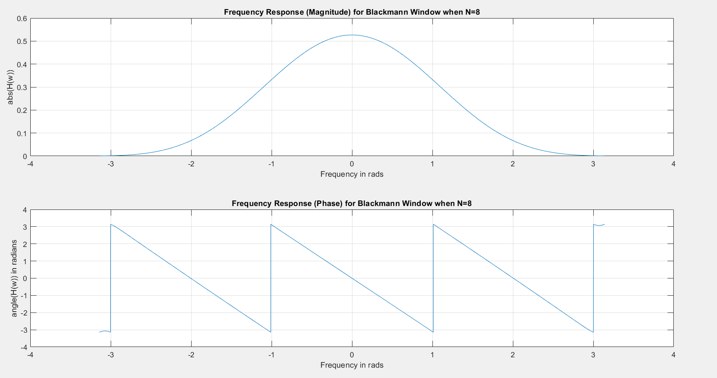

**Code:**

clc

clear all

close all

N = 8;

k = floor((N-1)/2);

n = 0:1:(N-1);

wc = 0.8;

w = -pi:1/2000:pi;

hd = zeros(1, N);

for ii = 1:N

if ii == k

hd(ii) = wc/pi;

else

hd(ii) = sin(wc*(ii-k))/(pi*(ii-k));

end

end

rectangular = ones(1, N);

triangular = 1 - 2*(n-(N-1)/2)/(N-1);

hanning = 0.5 - 0.5*cos((2*pi/(N-1))*n);

hamming = 0.54 - 0.46*cos((2*pi/(N-1))*n);

blackmann = 0.42 - 0.5*cos((2*pi/(N-1))*n) + 0.08*cos((4*pi/(N-1))*n);

h_rect = hd.*rectangular;

h_trig = hd.*triangular;

h_hann = hd.*hanning;

h_hamm = hd.*hamming;

h_black = hd.*blackmann;

[H, W] = freqz(h_rect, 1, w);

figure();

subplot(2,1,1)

plot(W, abs(H));

grid on

xlabel('Frequency in rads');

ylabel('abs(H(w))');

title("Frequency Response (Magnitude) for Rectangular Window when N=" + N);

subplot(2,1,2)

plot(W, angle(H));

grid on

xlabel('Frequency in rads');

ylabel('angle(H(w)) in radians');

title("Frequency Response (Phase) for Rectangular Window when N=" + N);

[H, W] = freqz(h_trig, 1, w);

figure();

subplot(2,1,1)

plot(W, abs(H));

grid on

xlabel('Frequency in rads');

ylabel('abs(H(w))');

title("Frequency Response (Magnitude) for Triangular Window when N=" + N);

subplot(2,1,2)

plot(W, angle(H));

grid on

xlabel('Frequency in rads');

ylabel('angle(H(w)) in radians');

title("Frequency Response (Phase) for Triangular Window when N=" + N);

[H, W] = freqz(h_hann, 1, w);

figure();

subplot(2,1,1)

plot(W, abs(H));

grid on

xlabel('Frequency in rads');

ylabel('abs(H(w))');

title("Frequency Response (Magnitude) for Hanning Window when N=" + N);

subplot(2,1,2)

plot(W, angle(H));

grid on

xlabel('Frequency in rads');

ylabel('angle(H(w)) in radians');

title("Frequency Response (Phase) for Hanning Window when N=" + N);

[H, W] = freqz(h_hamm, 1, w);

figure();

subplot(2,1,1)

plot(W, abs(H));

grid on

xlabel('Frequency in rads');

ylabel('abs(H(w))');

title("Frequency Response (Magnitude) for Hamming Window when N=" + N);

subplot(2,1,2)

plot(W, angle(H));

grid on

xlabel('Frequency in rads');

ylabel('angle(H(w)) in radians');

title("Frequency Response (Phase) for Hamming Window when N=" + N);

[H, W] = freqz(h_black, 1, w);

figure();

subplot(2,1,1)

plot(W, abs(H));

grid on

xlabel('Frequency in rads');

ylabel('abs(H(w))');

title("Frequency Response (Magnitude) for Blackmann Window when N=" + N);

subplot(2,1,2)

plot(W, angle(H));

grid on

xlabel('Frequency in rads');

ylabel('angle(H(w)) in radians');

title("Frequency Response (Phase) for Blackmann Window when N=" + N);