Digital Signal Processing Lab

Experiment 2

By Hardik Tibrewal (18EC10020)

**Aim:**

To design various FIR Filters using windowing, and test them on noisy signals

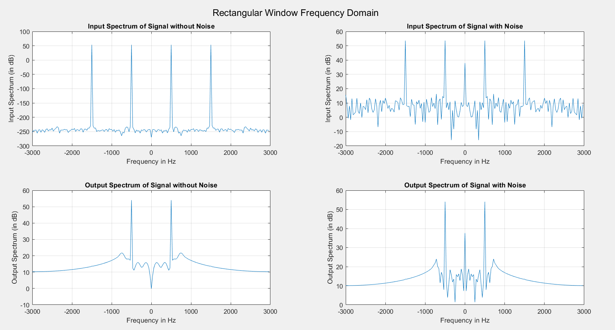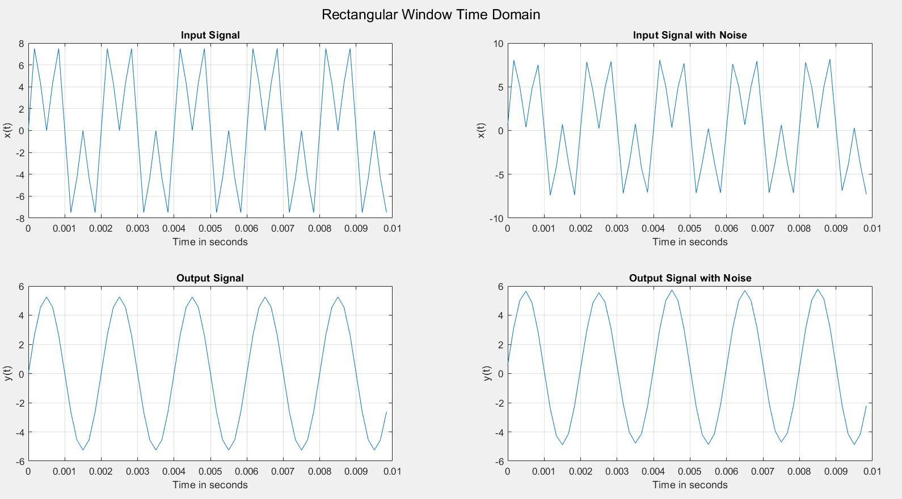**Plots: (**N = 64 for filter)

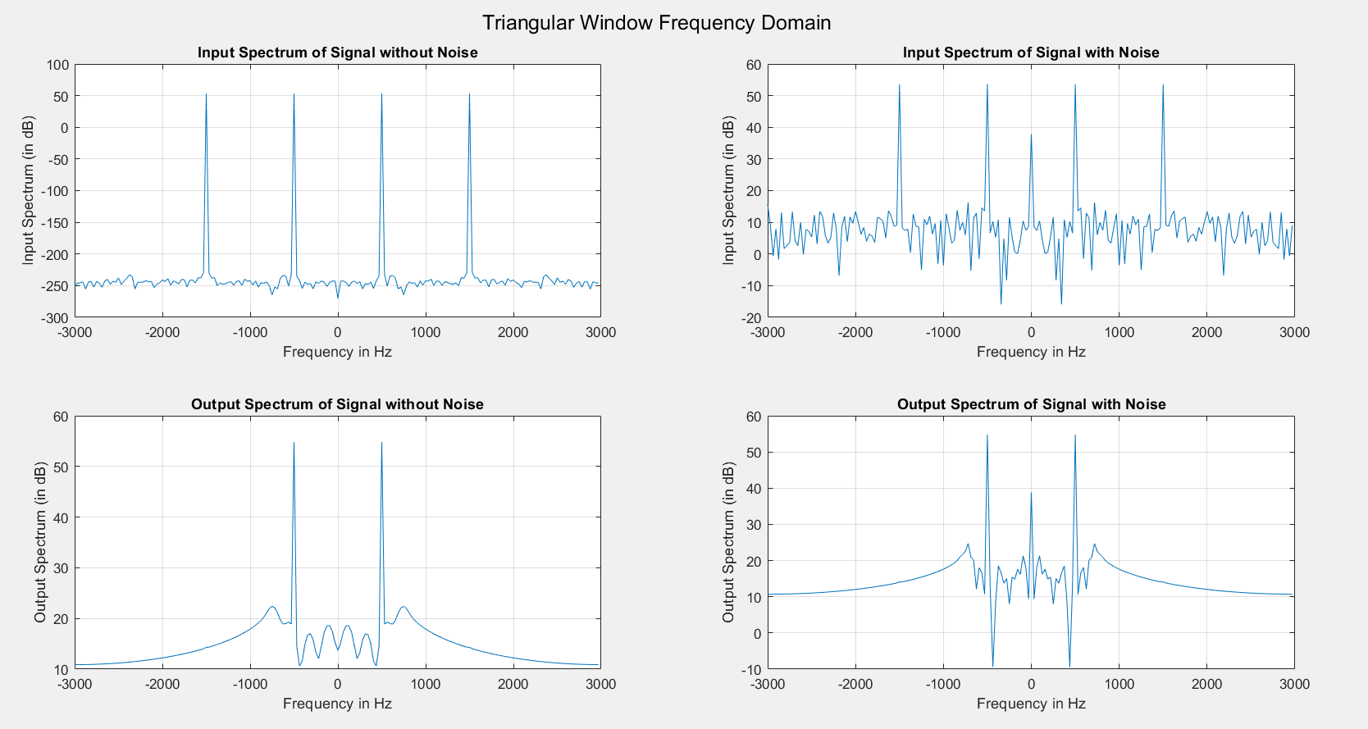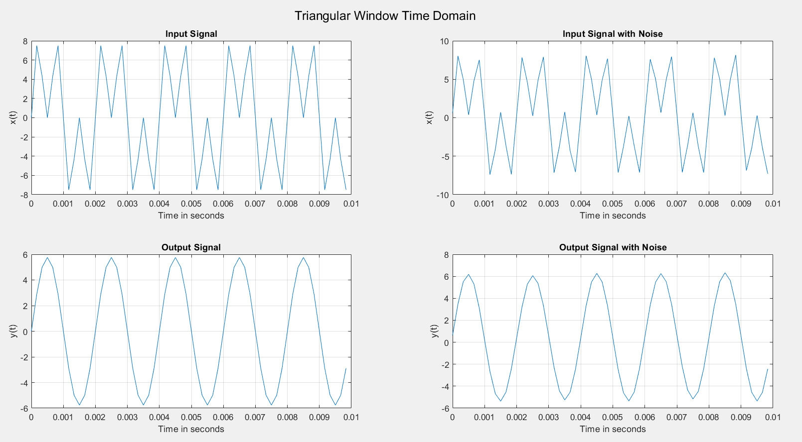

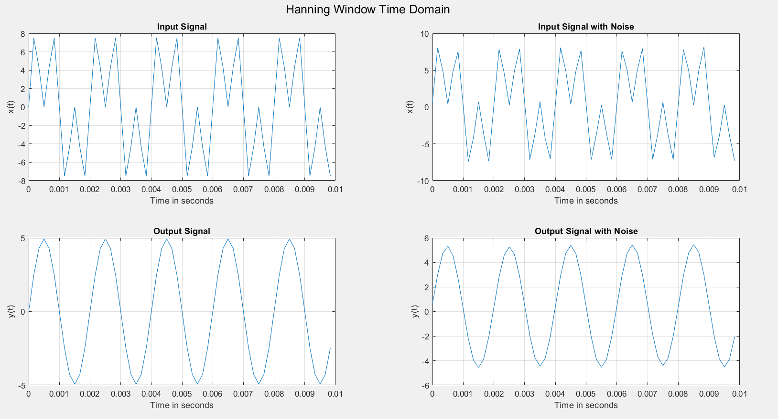

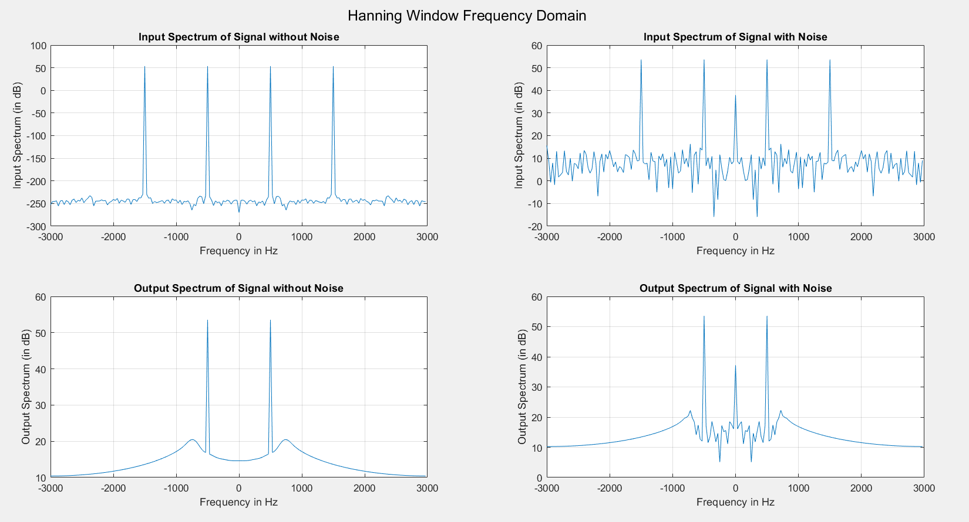

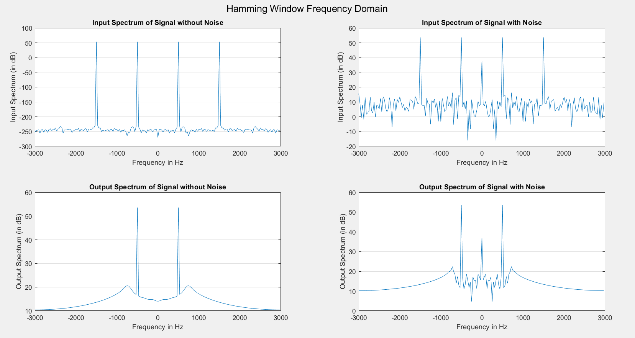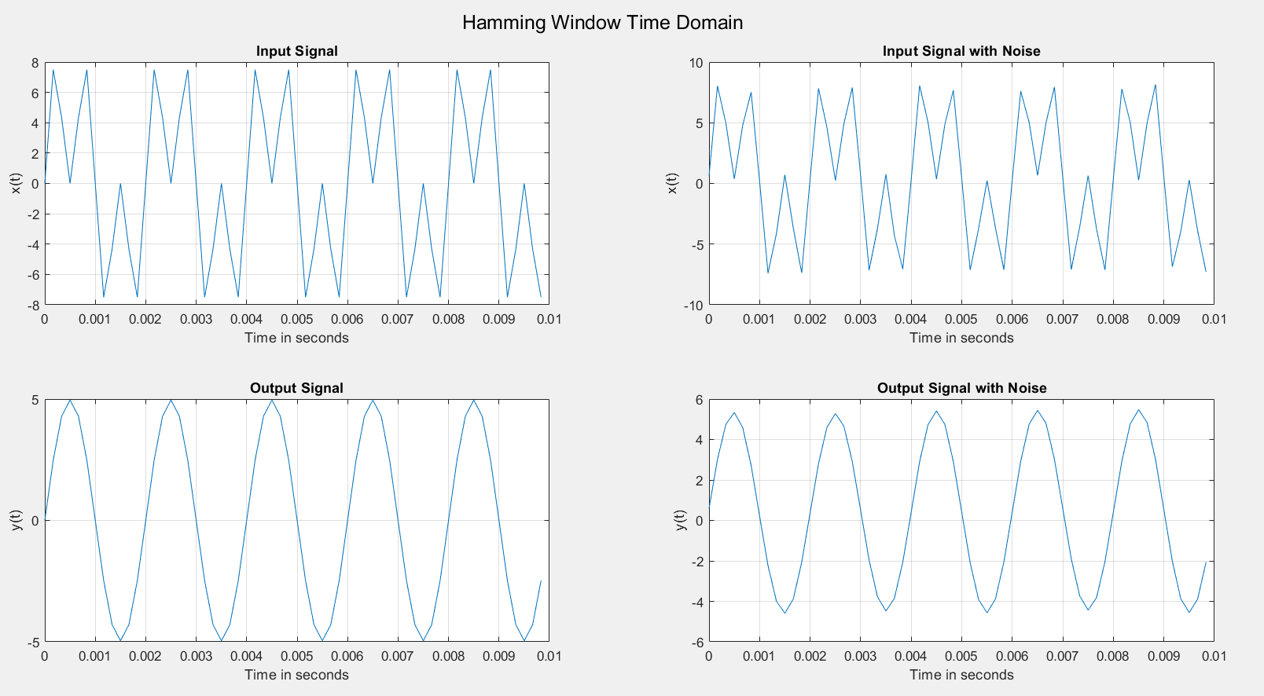

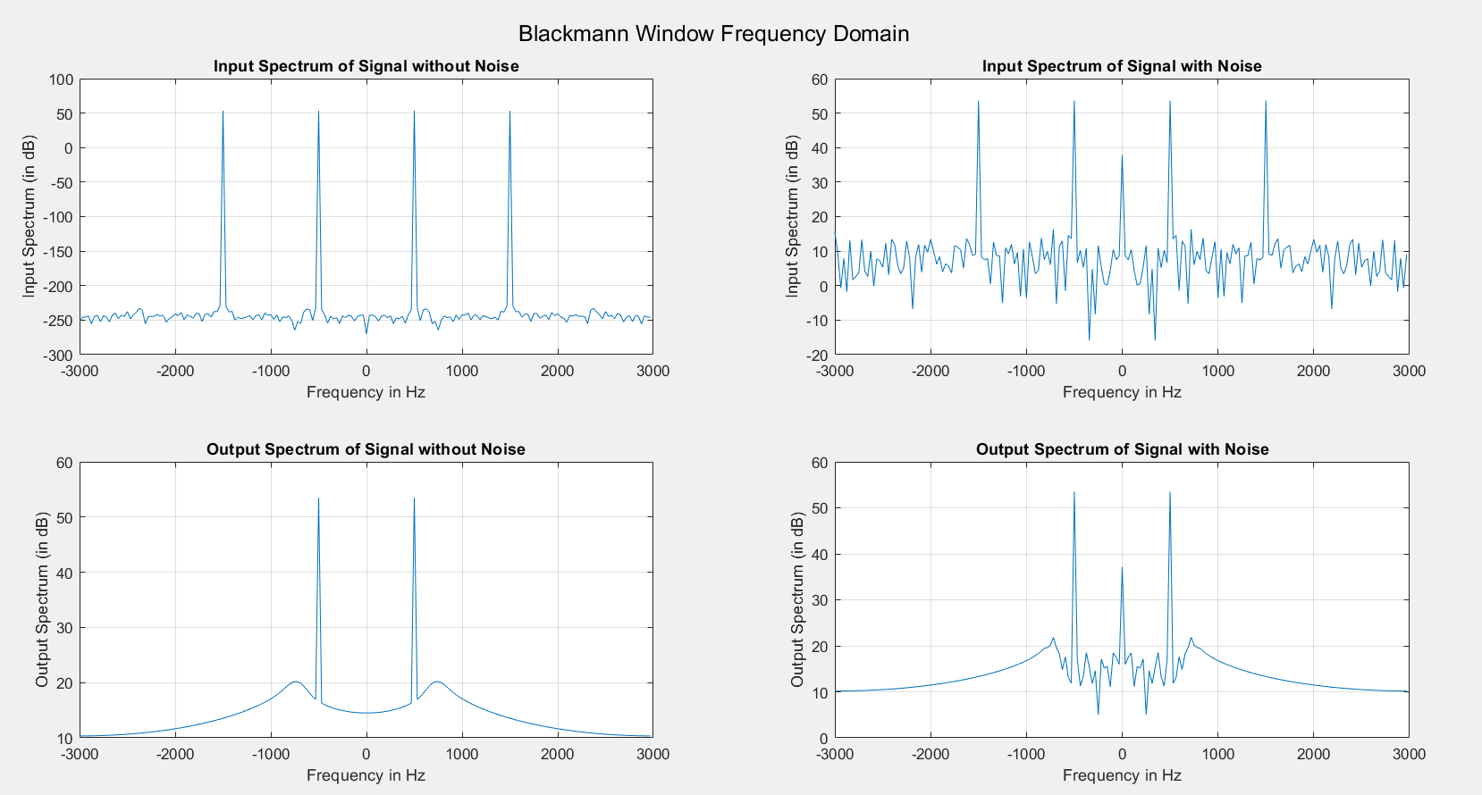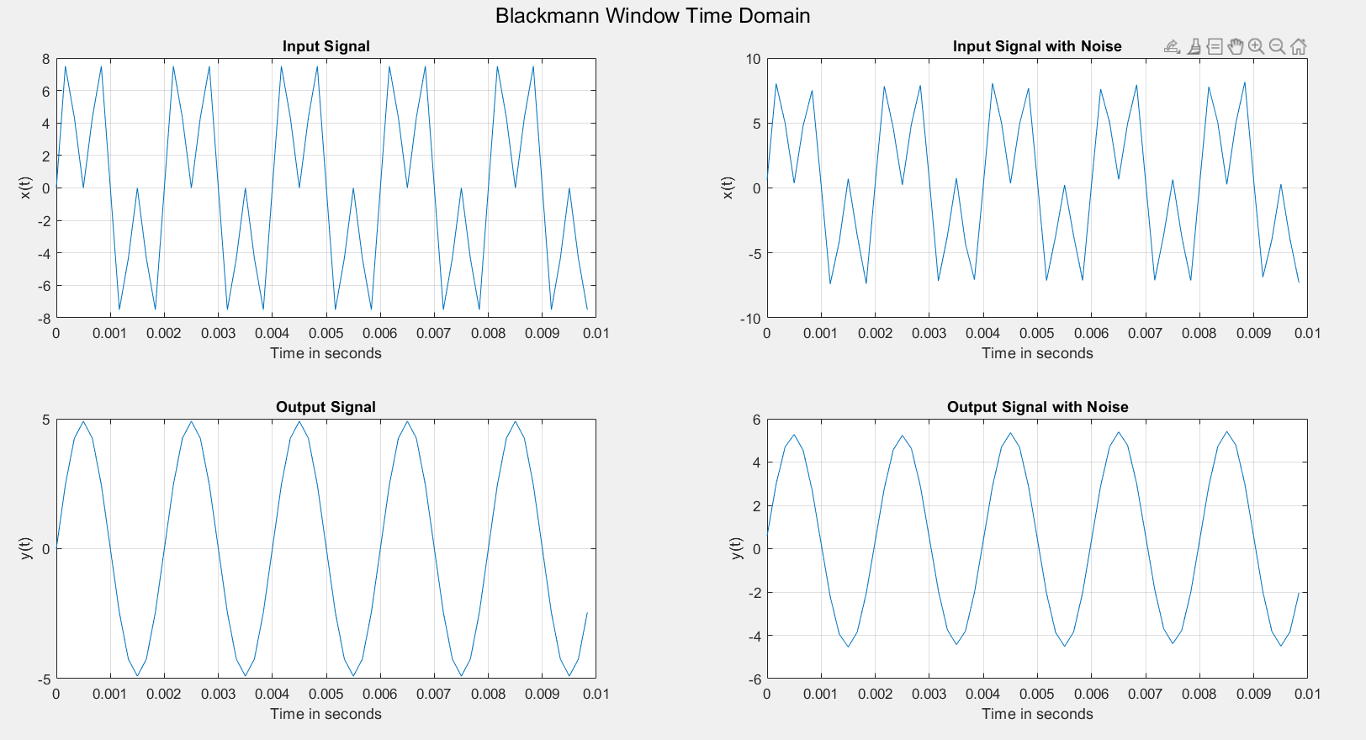

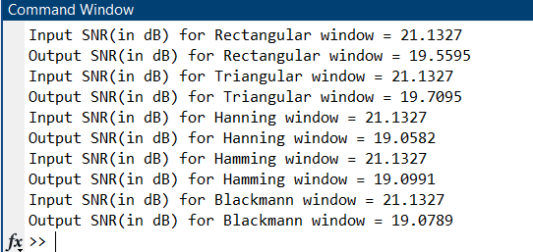

**Code:**

clc

clear all

close all

N = 64;

k = floor((N-1)/2);

n = 0:1:(N-1);

wc = 0.8;

w = -pi:1/2000:pi;

hd = zeros(1, N);

for ii = 1:N

if ii == k

hd(ii) = wc/pi;

else

hd(ii) = sin(wc*(ii-k))/(pi*(ii-k));

end

end

rectangular = ones(1, N);

triangular = 1 - 2*(n-(N-1)/2)/(N-1);

hanning = 0.5 - 0.5*cos((2*pi/(N-1))*n);

hamming = 0.54 - 0.46*cos((2*pi/(N-1))*n);

blackmann = 0.42 - 0.5*cos((2*pi/(N-1))*n) + 0.08*cos((4*pi/(N-1))*n);

h_rect = hd.*rectangular;

h_trig = hd.*triangular;

h_hann = hd.*hanning;

h_hamm = hd.*hamming;

h_black = hd.*blackmann;

%%%%%%%%%%%%%%%%%%%%%%%%%%%%%%%%%%%%%%%%%%%%%%%%%%%%%%%%%%%%

f_pass = 500;

f_stop = 1500;

fs = 6000;

t = 0:1/fs:(3*N-1)/fs;

noise = rand(1, 3*N);

x = 5*sin(2*pi*f_pass*t) + 5*sin(2*pi*f_stop*t);

add_noise = (max(x)/10)*noise/abs(max(noise));

noisy_x = x + add_noise;

f_eq = -3000:2000/N:3000-2000/N;

h_matrix = [h_rect; h_trig; h_hann; h_hamm; h_black];

%%%%%%%%%%%%%%%%%%%%%%%%%%%%%%%%%%%%%%%%%%%%%%%%%%%%%%%%%%

for ii=1:5

if ii == 1

name = "Rectangular";

elseif ii == 2

name = "Triangular";

elseif ii == 3

name = "Hanning";

elseif ii == 4

name = "Hamming";

else

name = "Blackmann";

end

y = filtfilt(h_matrix(ii,:), 1, x);

y_n = filtfilt(h_matrix(ii,:), 1, noisy_x);

figure();

sgtitle(name+" Window Time Domain");

subplot(221);

plot(t(1:floor(15*fs/f_stop)),x(1:floor(15*fs/f_stop)));

grid on

xlabel('Time in seconds'); ylabel('x(t)'); title('Input Signal');

subplot(222);

plot(t(1:floor(15*fs/f_stop)),noisy_x(1:floor(15*fs/f_stop)));

grid on

xlabel('Time in seconds'); ylabel('x(t)'); title('Input Signal with Noise');

subplot(223);

plot(t(1:floor(15*fs/f_stop)),y(1:floor(15*fs/f_stop)));

grid on

xlabel('Time in seconds'); ylabel('y(t)'); title('Output Signal');

subplot(224);

plot(t(1:floor(15*fs/f_stop)),y_n(1:floor(15*fs/f_stop)));

grid on

xlabel('Time in seconds'); ylabel('y(t)'); title('Output Signal with Noise');

figure();

sgtitle(name+" Window Frequency Domain");

subplot(2,2,1)

plot(f_eq, 20*log10(abs(fftshift(fft(x)))));

xlabel('Frequency in Hz'); ylabel('Input Spectrum (in dB)'); title('Input Spectrum of Signal without Noise')

grid on;

subplot(2,2,2)

plot(f_eq, 20*log10(abs(fftshift(fft(noisy_x)))));

xlabel('Frequency in Hz'); ylabel('Input Spectrum (in dB)'); title('Input Spectrum of Signal with Noise')

grid on;

subplot(2,2,3)

plot(f_eq, 20*log10(abs(fftshift(fft(y)))));

xlabel('Frequency in Hz'); ylabel('Output Spectrum (in dB)'); title('Output Spectrum of Signal without Noise')

grid on;

subplot(2,2,4)

plot(f_eq, 20*log10(abs(fftshift(fft(y_n)))));

xlabel('Frequency in Hz'); ylabel('Output Spectrum (in dB)'); title('Output Spectrum of Signal with Noise')

grid on;

disp("Input SNR(in dB) for "+name+" window = "+snr(x, noisy_x-x))

disp("Output SNR(in dB) for "+name+" window = "+snr(y, y_n-y))

end