Digital Signal Processing Lab

Experiment 3

By Hardik Tibrewal (18EC10020)

**Aim:**

To study and analyse a Dual Tone Multi-Frequency (DTMF) coder and decoder using Digital FIR Filters in MATLAB

**Plots:**

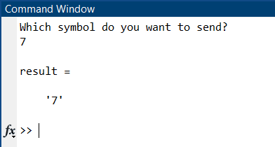

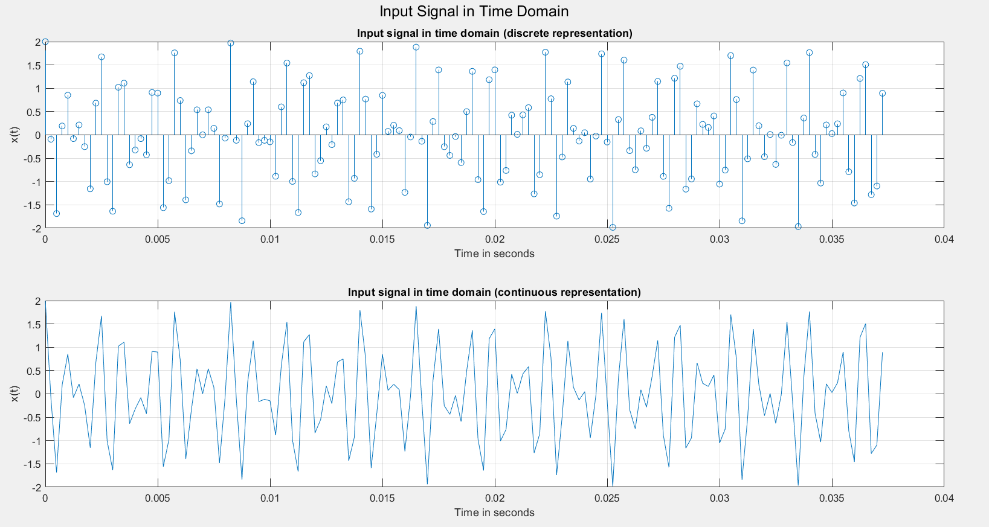

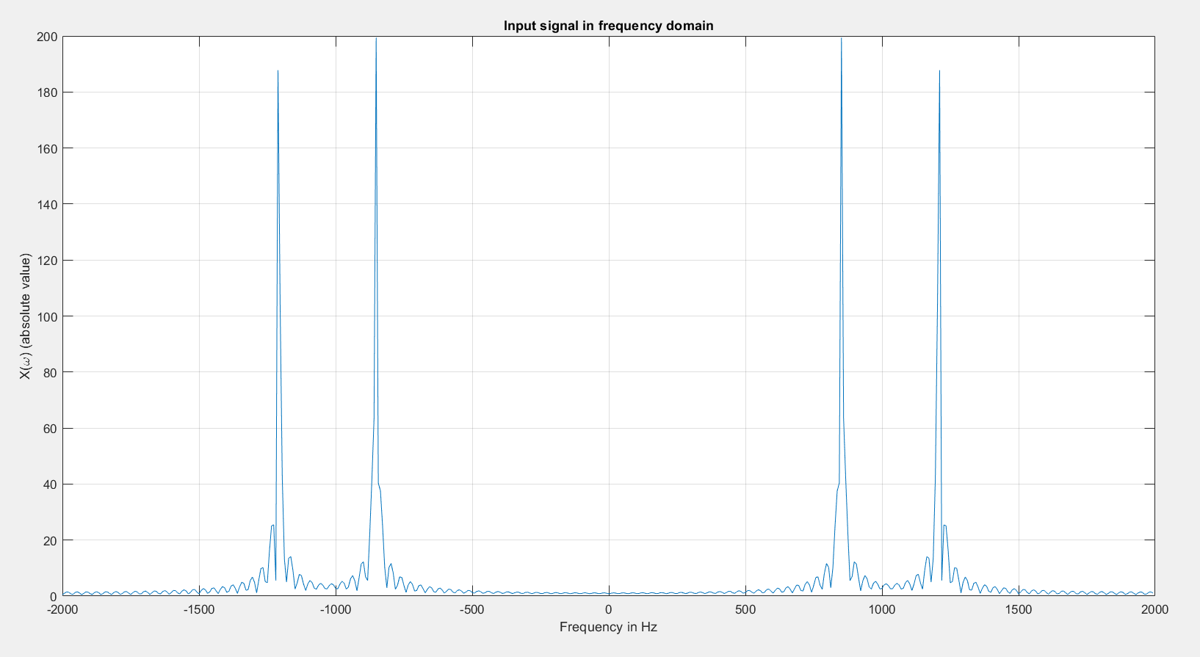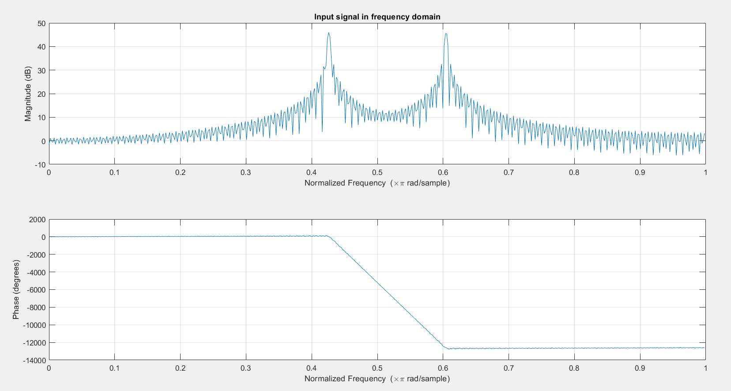

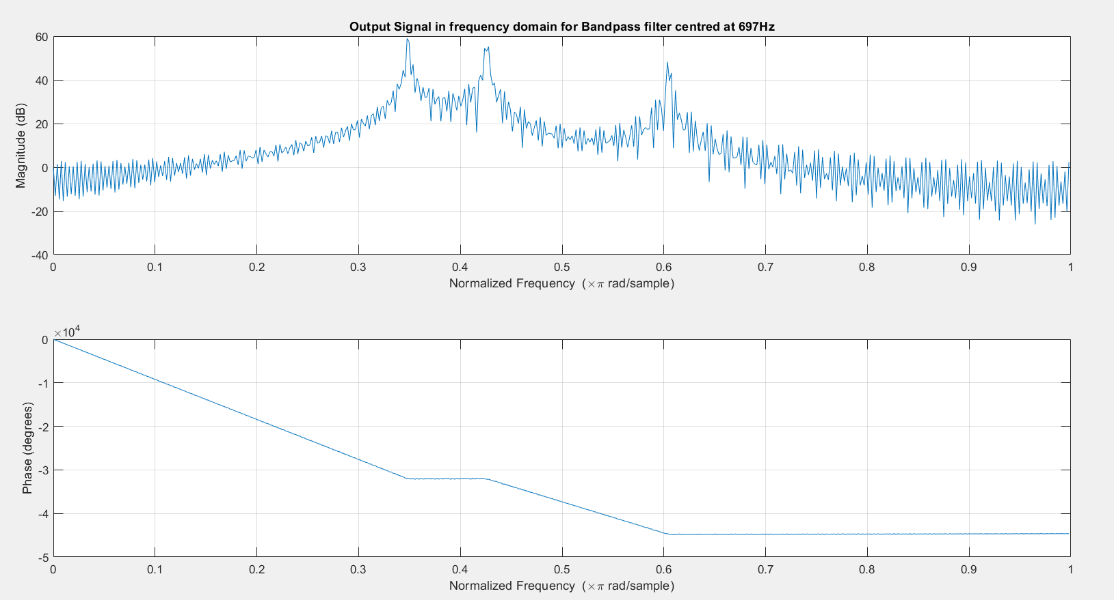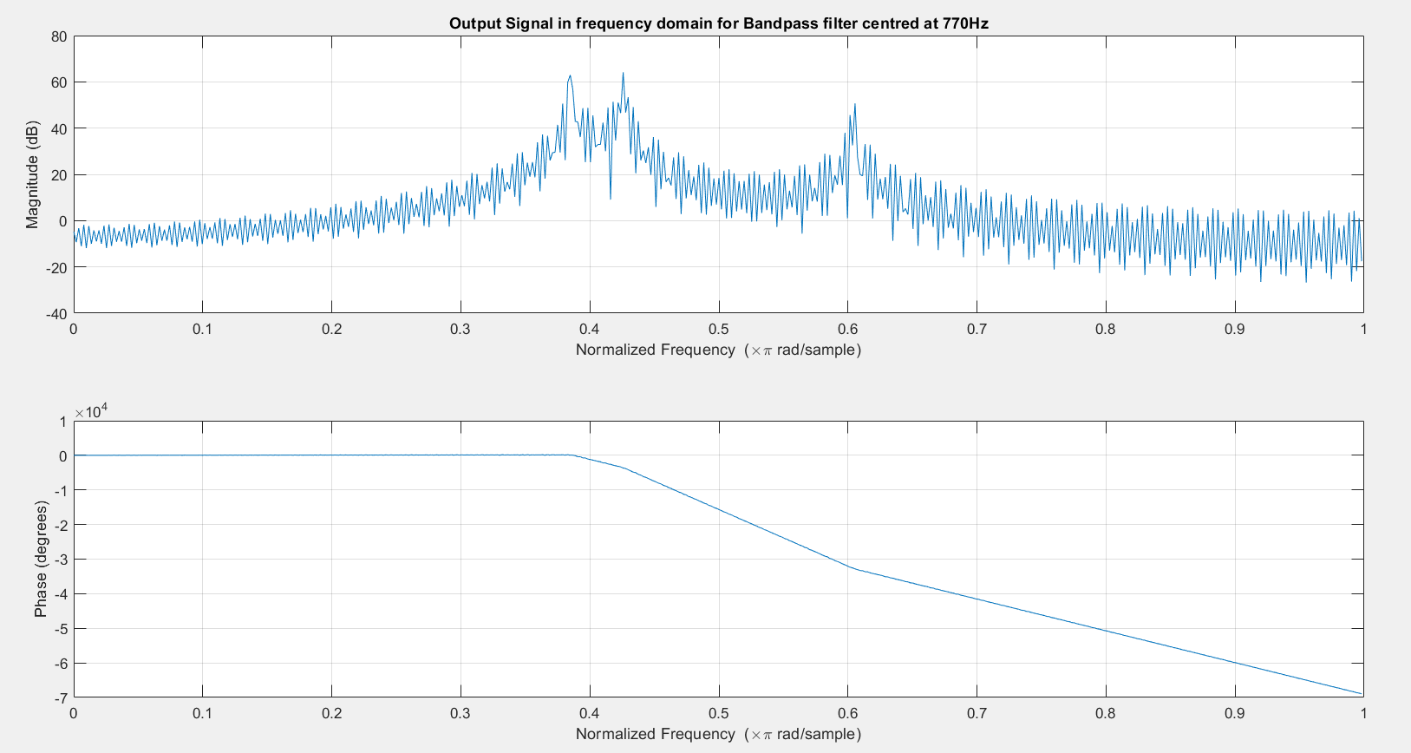

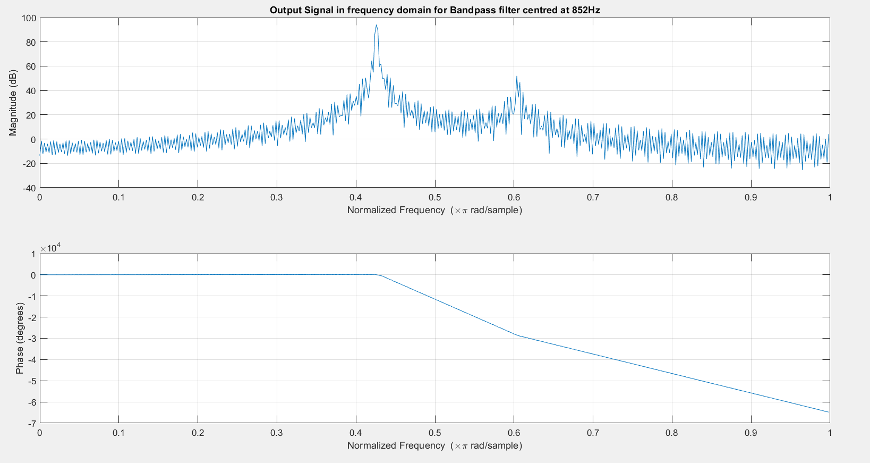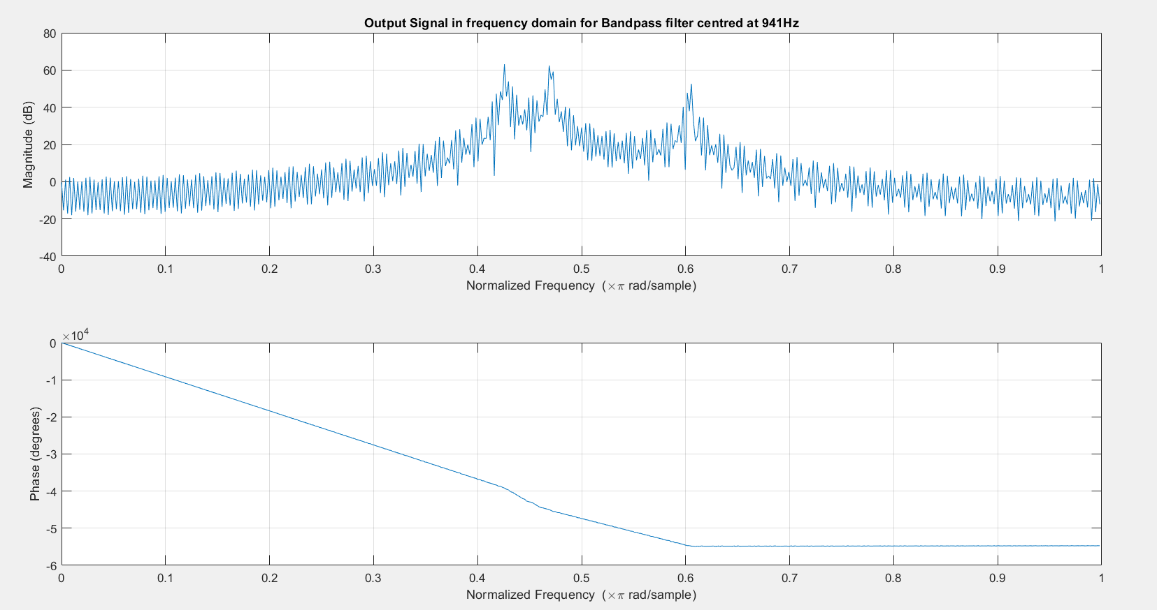

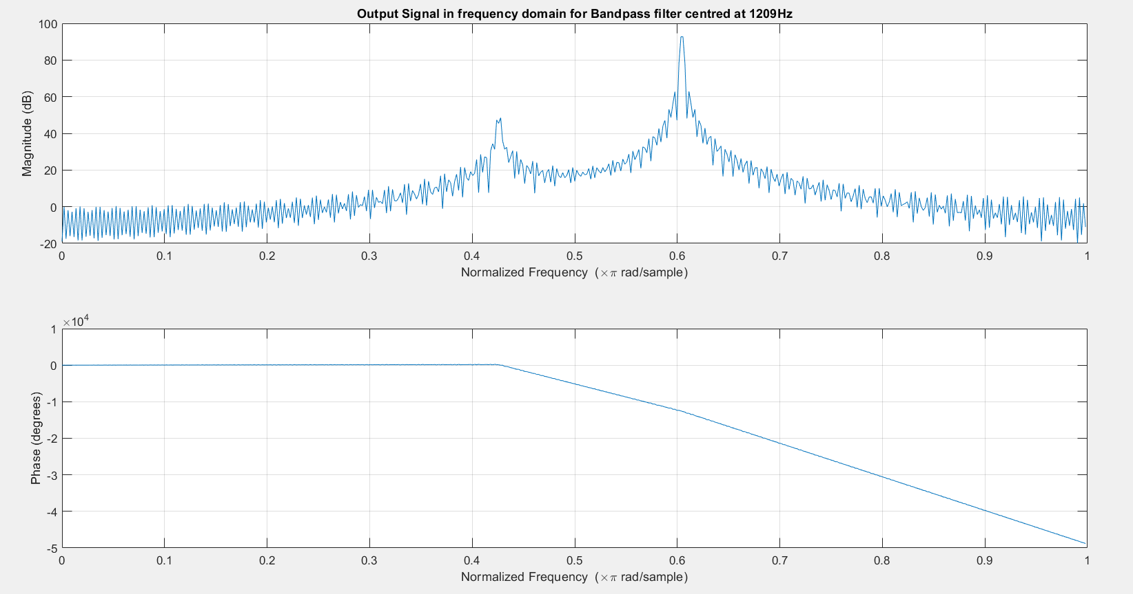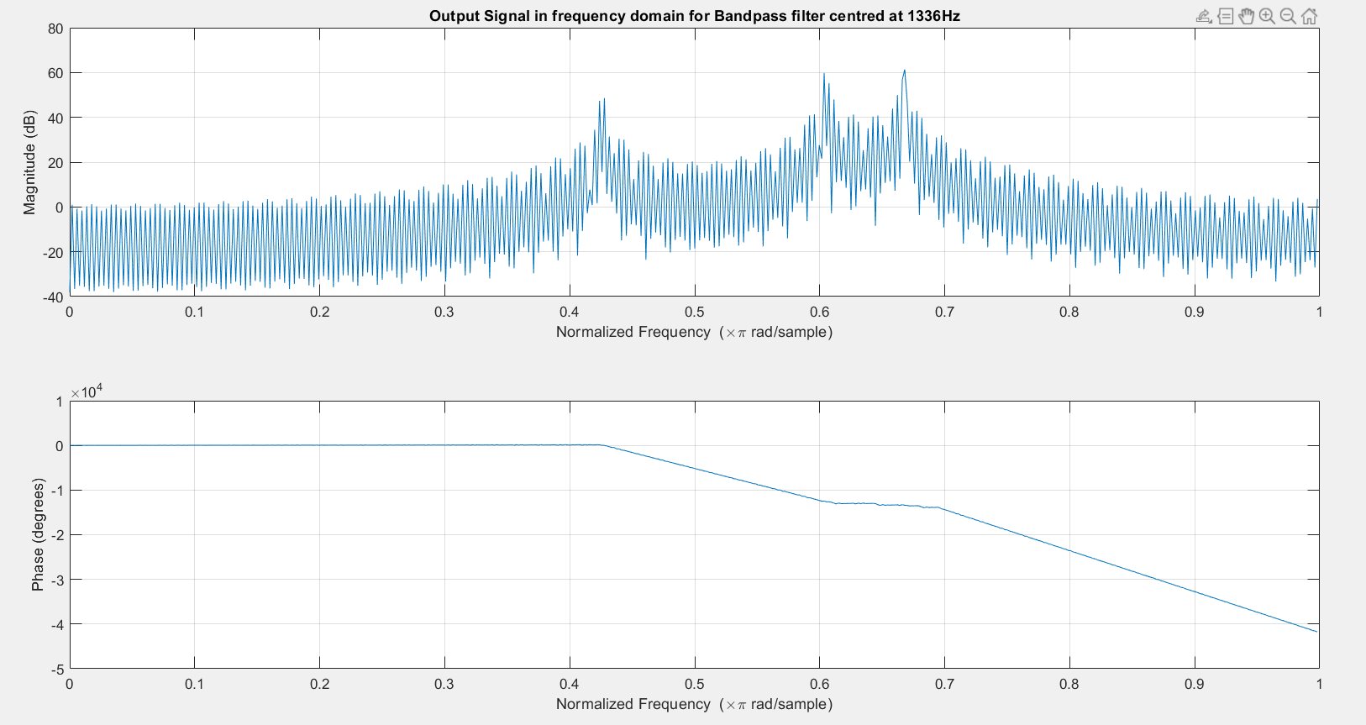

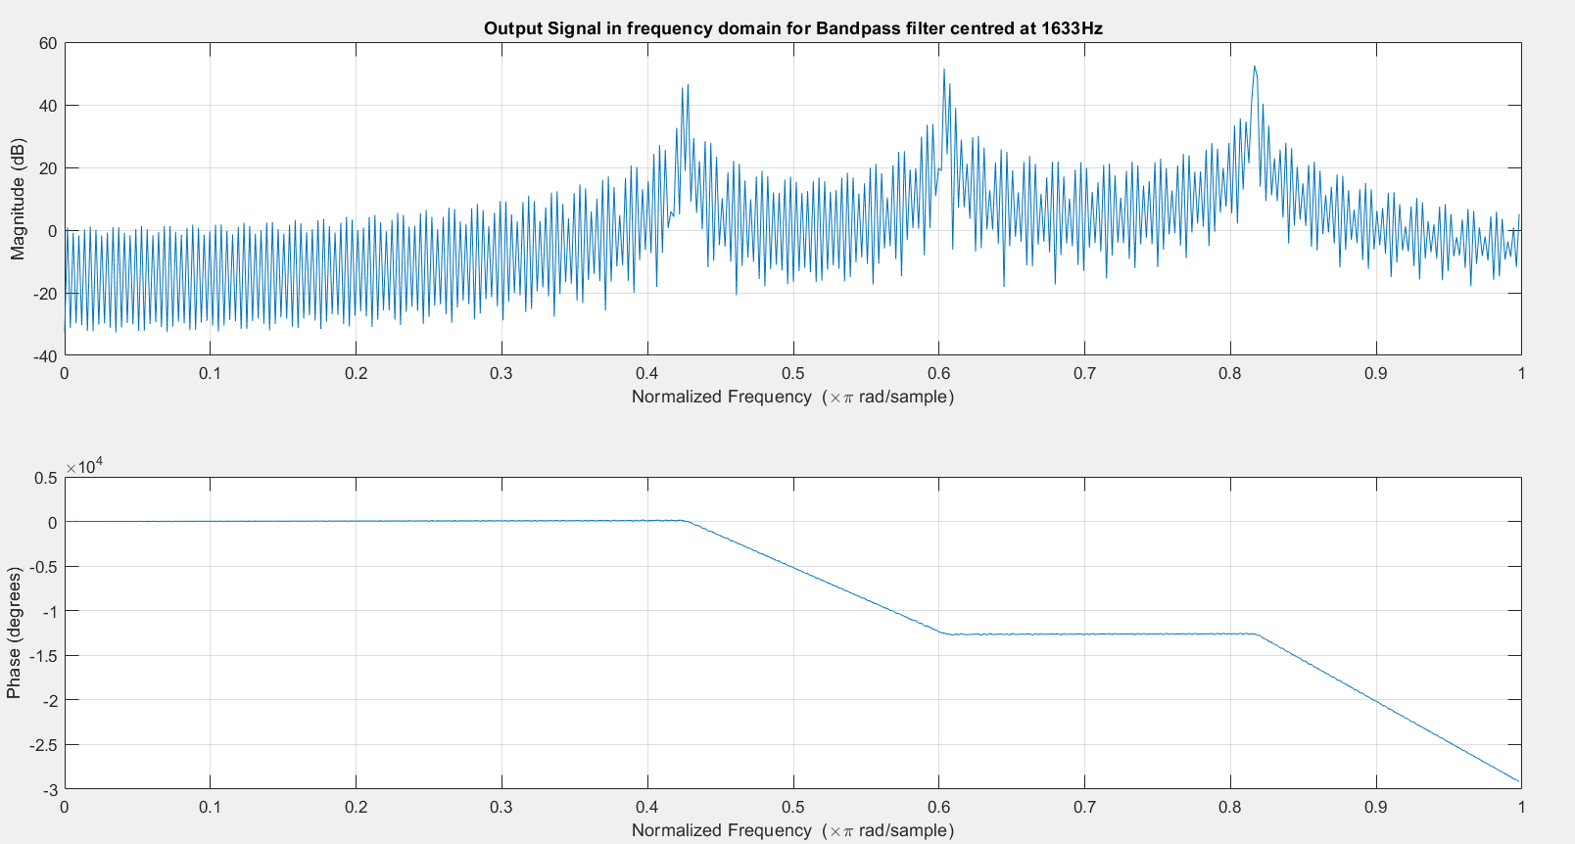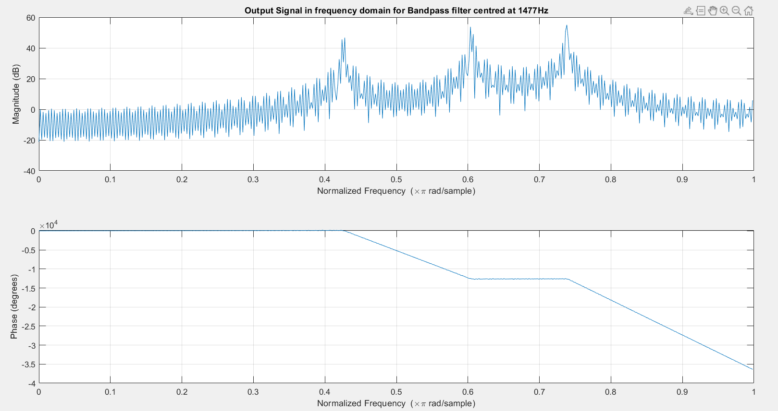

We see that the magnitude of the frequency response of the peaks is much higher in filters centred at frequencies present in the input signal. Further discussion will be done in lab report.

Look-up tables have been made for frequencies and symbols in the code. The formulae are apparent from the code, but will be discussed in the lab report as well.

**Code:**

clc

clear all

close all

L = 512;

Fs = 4000;

fc = [697, 770, 852, 941, 1209, 1336, 1477, 1633];

len = 0:L-1;

h_n = zeros(8,L);

y_n = zeros(8,L+Fs/10-1);

H = zeros(8,L);

W = zeros(8,L);

pwr = zeros(1,8);

t = 0:1/Fs:0.1-1/Fs;

for ii = 1:8

h_n(ii,:) = cos(len*(2*pi*fc(ii)/Fs));

end

%Arranging matrix like this according to MATLAB indexing convention

mat_symbol = ['1' '4' '7' '*'; '2' '5' '8' '0'; '3' '6' '9' '#'; 'A' 'B' 'C' 'D'];

symbol = input('Which symbol do you want to send?\n', 's');

%%% Encoder %%%

idx = find(mat_symbol == symbol);

f1 = fc(floor((idx-1)/4)+1);

f2 = fc(4+mod(idx-1,4)+1);

x = cos(2*pi*f1*t)+cos(2*pi*f2*t);

%%% End %%%

figure();

sgtitle('Input Signal in Time Domain')

subplot(211);

stem(t(1:50*floor(Fs/f2)),x(1:50*floor(Fs/f2)))

grid on

xlabel('Time in seconds');ylabel('x(t)');title('Input signal in time domain (discrete representation)');

subplot(212);

plot(t(1:50*floor(Fs/f2)),x(1:50*floor(Fs/f2)))

grid on

xlabel('Time in seconds');ylabel('x(t)');title('Input signal in time domain (continuous representation)');

figure();

freq = -Fs/2:Fs/L:Fs/2-Fs/L;

plot(freq, abs(fftshift(fft(x, L))))

grid on

xlabel('Frequency in Hz');ylabel('X(\omega) (absolute value)');title('Input signal in frequency domain');

figure();

freqz(x)

title('Input signal in frequency domain');

for ii = 1:8

y_n(ii,:) = conv(x, h_n(ii,:));

[H(ii,:), W(ii,:)] = freqz(y_n(ii,:), L);

H(ii,:) = abs(H(ii,:));

pwr(ii) = rms(y_n(ii,:))^2;

figure();

freqz(y_n(ii,:));

title("Output Signal in frequency domain for Bandpass filter centred at " + num2str(fc(ii)) + "Hz")

end

%%% Decoder %%%

[max, idx] = maxk(pwr, 2);

idx = sort(idx);

result = mat_symbol(idx(2)-4, idx(1));

result

%%% Decoder end %%%