Digital Signal Processing Lab

Experiment 4b

By Hardik Tibrewal (18EC10020)

**Aim:**

Power Spectrum Estimation using Parametric Method (Yule-Walker AR Model)

**Plots:**

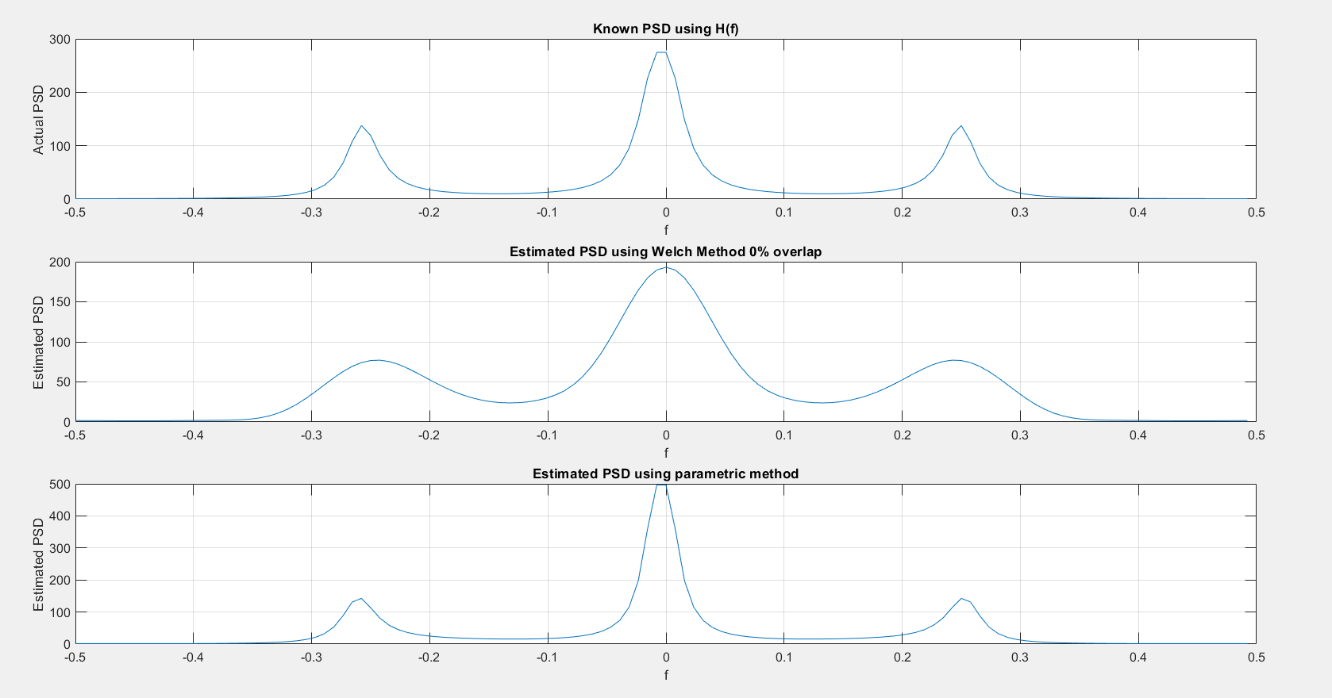(Denominator of transfer function is 1z0 - 0.9z-1 + 0.81z-2 - 0.729z-3)

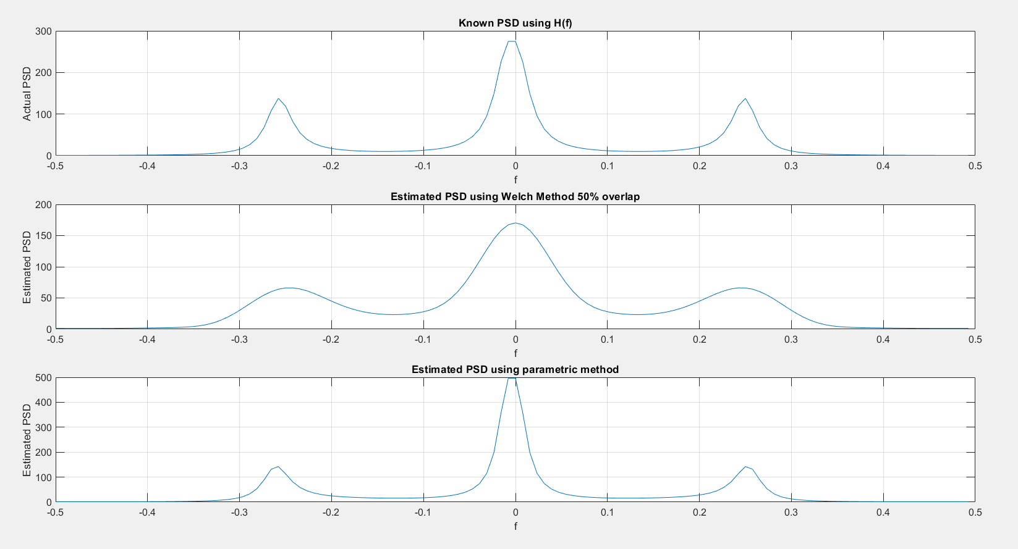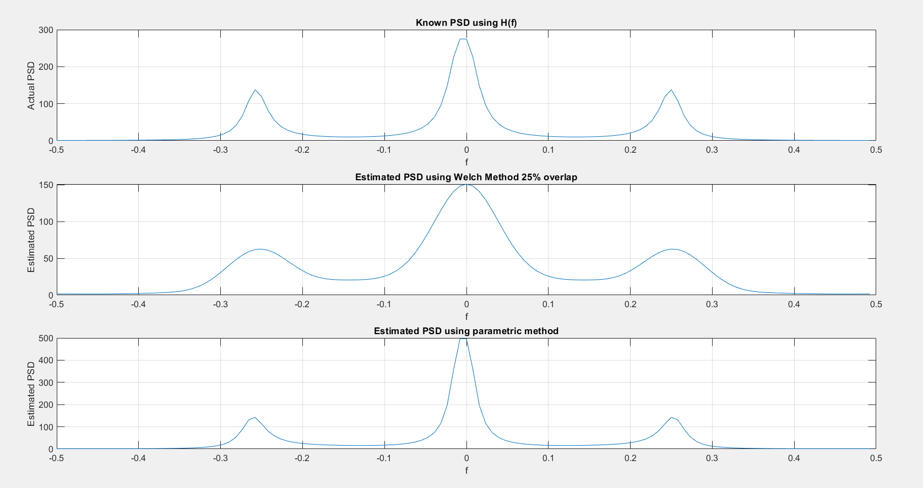

**Code:**

clc

clear all

close all

mean = 0;

std_dev = 3;

N = 128;

rng('default');

noise = std_dev.*randn(N,1) + mean;

denom = 0.9;

A = [1, -denom, denom^2, -denom^3];

X = filter(1, A, noise);

%L = 8;

for ov_lap = [0, 0.25, 0.5]

M = 16;

D = ov_lap;

L = floor((N-1)/(M*(1-D)));

num_blocks = ceil((N-1)/(M*(1-D)));

X_divs = zeros(num_blocks, M);

end_case = L ~= num_blocks;

for ii = 1:L

X_divs(ii,:) = X((1+(ii-1)*floor(M*(1-D))):(M+(ii-1)*floor(M*(1-D))));

end

if end_case

idx = 1+L*floor(M*(1-D));

X_divs(L+1,:) = [X(idx:end)' zeros(1, M-(N-idx+1))];

end

n = 0:1:(M-1);

hamming = 0.54 - 0.46*cos(2*pi*n/(M-1));

U = (1/M)*sum(hamming.*hamming);

P_n = zeros(num_blocks, M);

for ii = 1:num_blocks

P_n(ii,:) = X_divs(ii,:).*hamming;

end

f = -0.5:1/N:(0.5-(1/N));

cosine = 0; sine = 0;

P_f = zeros(num_blocks, N);

for ii = 1:num_blocks

for F = 1:length(f)

cosine = 0; sine = 0;

for jj = 1:M

cosine = cosine + cos(2*pi*f(F)*jj)*P_n(ii,jj);

sine = sine + sin(2*pi*f(F)*jj)*P_n(ii,jj);

end

idx = floor((N - length(f))/2)+F;

P_f(ii, idx) = (cosine^2 + sine^2)/(M*U);

end

end

Pw_f = zeros(1, N);

for ii = 1:num_blocks

Pw_f = Pw_f + P_f(ii,:);

end

Pw_f = Pw_f/num_blocks;

[H, W] = freqz(1,A,N/2);

figure();

subplot(311);

l1 = (abs(H).^2).*std_dev^2;

l2 = flip(l1);

l = [l2' l1'];

plot(f, l);

grid on;

xlabel('f');ylabel("Actual PSD");title("Known PSD using H(f)");

subplot(312);

plot(f, Pw_f);

grid on;

xlabel('f');ylabel("Estimated PSD");title("Estimated PSD using Welch Method "+num2str(D*100)+"% overlap");

p = 6;

r = zeros(p+1);

for ii = 0:p

for jj = 1:(N-ii)

r(ii+1) = r(ii+1) + X(jj)*X(jj+ii);

end

r(ii+1) = r(ii+1)/N;

end

mat = zeros(p,p);

mat2 = zeros(1,p);

for ii = 1:p

mat2(1,ii) = -r(ii+1);

end

for ii = 1:p

for jj = 1:p

mat(ii,jj) = r(abs(ii-jj)+1);

end

end

mat_inv = inv(mat);

coeff_a = mat2*mat_inv;

coeff_a = coeff_a';

new_std_dev = 0;

for ii = 1:p

new_std_dev = new_std_dev + coeff_a(ii,1)*r(ii+1);

end

new_std_dev = new_std_dev + r(1);

A_new = ones(p+1);

for ii = 1:p

A_new(ii+1) = coeff_a(ii);

end

[h_new, w_new] = freqz(1, A_new(:,1), N/2);

subplot(313);

l2_new = (abs(h_new).^2)*(new_std_dev);

l1_new = flip(l2_new);

l_new = [l1_new' l2_new'];

plot(f,l_new);

grid on;

xlabel('f');ylabel("Estimated PSD");title("Estimated PSD using parametric method");

end