Digital Signal Processing Lab

Experiment 5

By Hardik Tibrewal (18EC10020)

**Aim:**

Designing an Adaptive Line Enhancer/Adaptive Filter

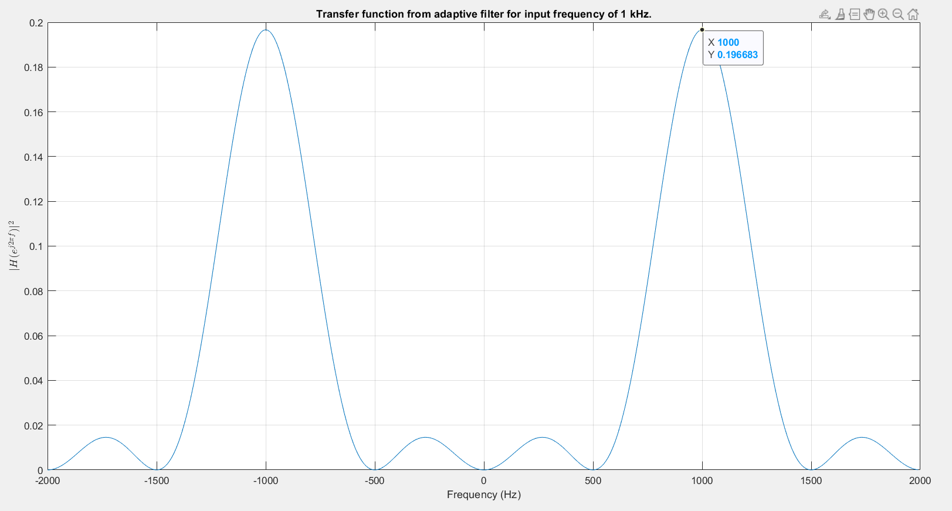**Plots:**

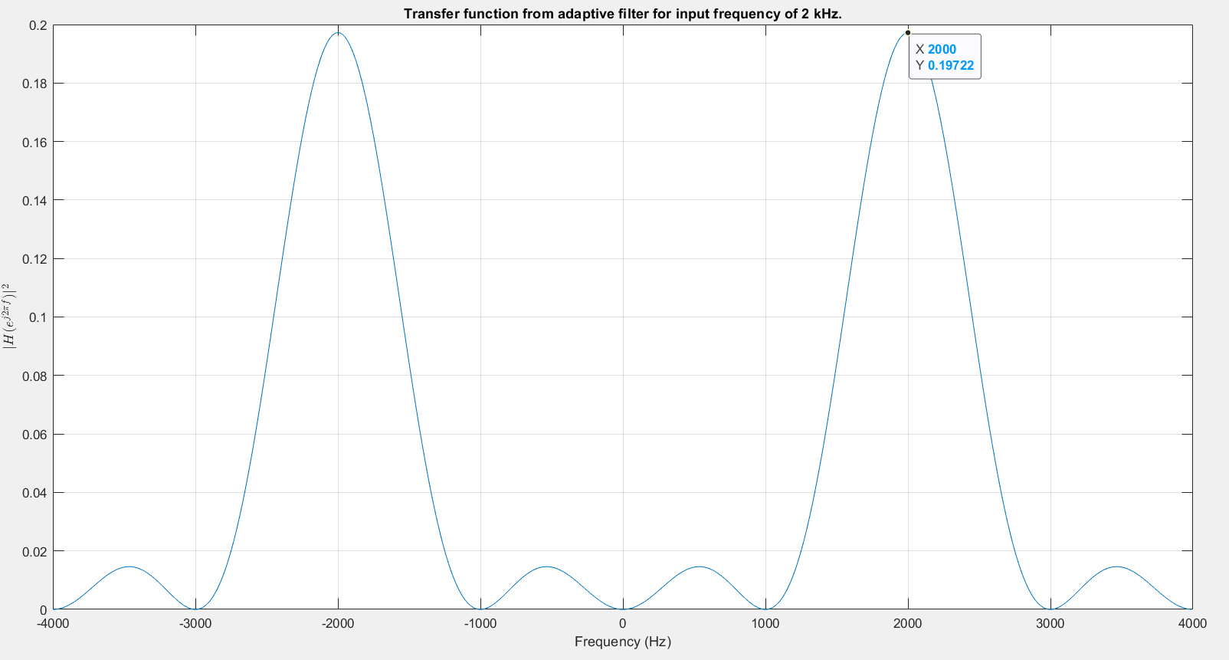

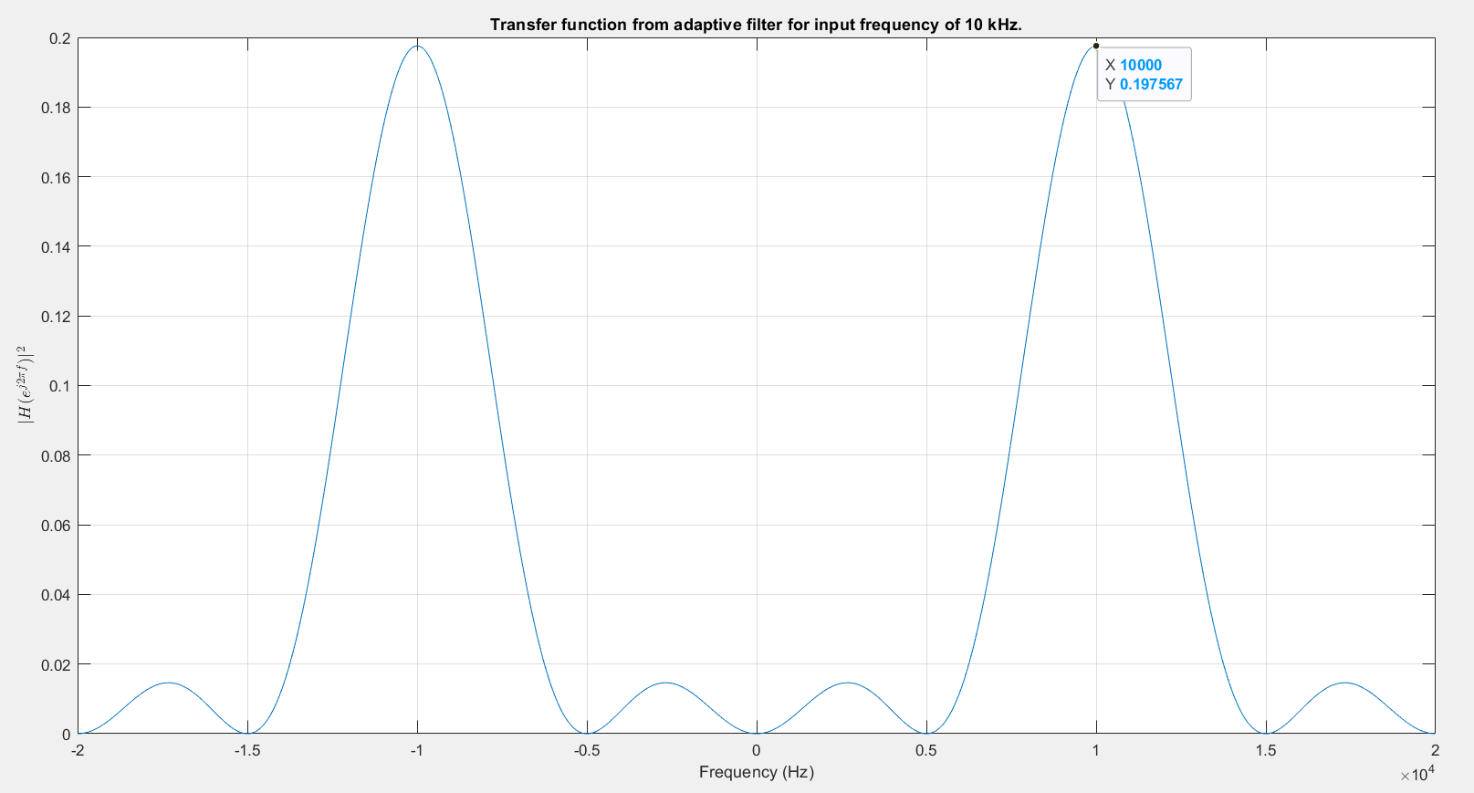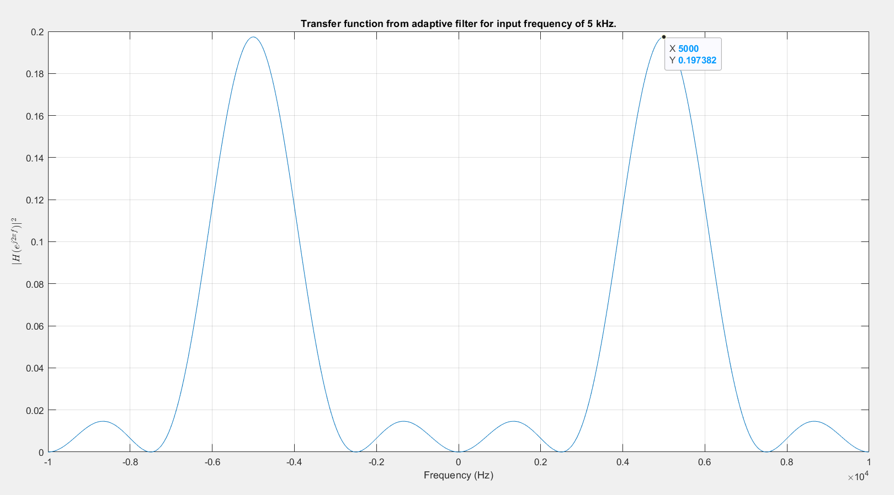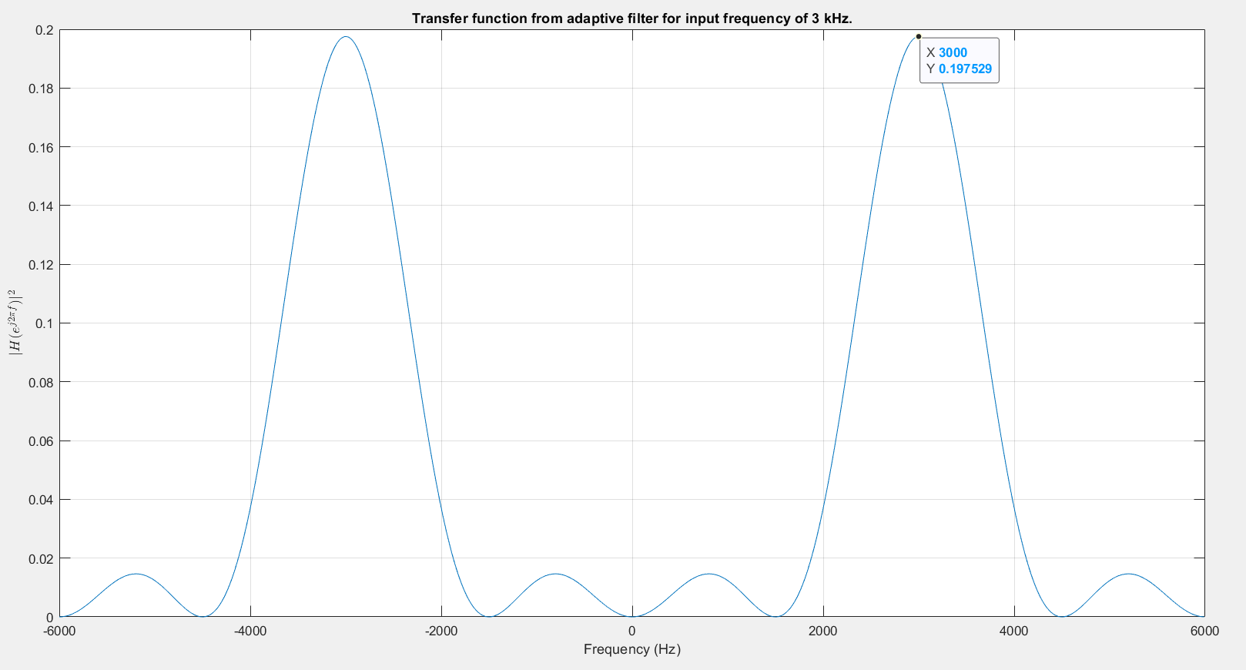

**Code:**

clc

clear all

close all

for k = [1,2,3,5,10]

f = k*1000;

fs = 4*f;

t = 0:1/fs:0.1-1/fs;

N = length(t);

f_range = -fs/2:fs/N:fs/2-fs/N;

m = 8; mu = 1e-4; epsilon = 1e-6;

x = 2*sin(2*pi*f*t)';

h = zeros(m,1);

x_n = buffer(x, m, m-1);

x_n = flip(x_n, 1);

y = x_n'*h;

diff = (x-y);

error = zeros(m, N);

for ii = 1:N

error(:, ii) = x_n(:, ii)*diff(ii);

end

update = sum(error,2);

h_new = h + mu*update/N;

change = sum((h_new-h).^2)/sum(h.^2);

while change >= epsilon

h = h_new;

y = x_n'*h;

diff = (x-y);

for ii = 1:size(x_n,2)

error(:, ii) = x_n(:, ii)*diff(ii);

end

update = sum(error,2);

h_new = h + mu*update/N;

change = sum((h_new-h).^2)/sum(h.^2);

end

figure();

spectrum = fftshift(abs(fft(h, N)).^2);

[M, I] = max(spectrum);

fprintf("Maximum Value at f = %d Hz\n", abs(f_range(I)))

plot(f_range, spectrum);

grid on;

xlabel('Frequency (Hz)'); title("Transfer function from adaptive filter for input frequency of "+k+" kHz.")

ylabel('$|H(e^{j2\pi f})|^2$', 'Interpreter', 'latex');

end