Digital Signal Processing Lab

Experiment 6

By Hardik Tibrewal (18EC10020)

**Aim:**

Speech Recognition with Primarily Temporal Cues

**Plots:**

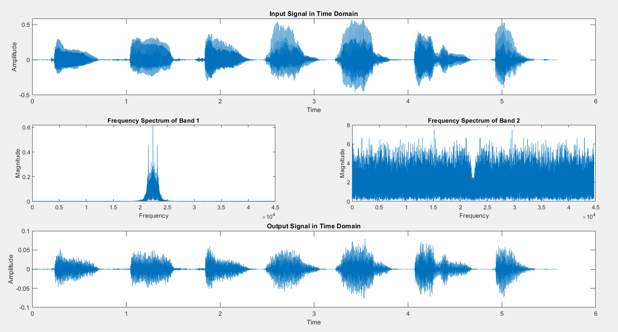For 2 Bands

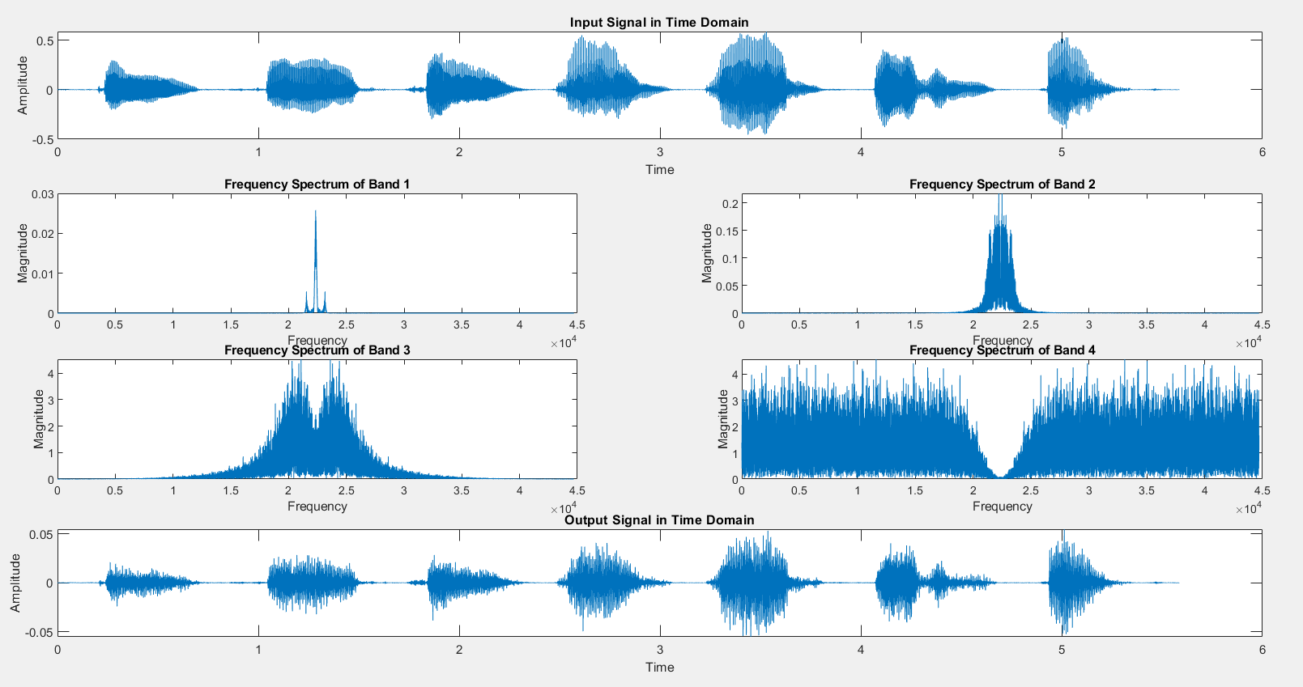For 4 Bands

**Code:**

clc

clear all

close all

order = 4;

[y,Fs] = audioread("./Samples/B1_M1.wav");

subplot(4,1,1);

t = 0:1/Fs:(length(y)-1)/Fs;

plot(t,y);

xlabel("Time");ylabel("Amplitude");

title("Input Signal in Time Domain");

norm = Fs/2;

N = 4;

Fc = 160;

[B_l, A_l] = butter(order*2, Fc/norm);

noise = rand(size(y));

output = zeros(size(y));

bands = logspace(log10(1), log10(Fs/2-1), N+1);

for i = 1:N

[B, A] = butter(order/2, [bands(i)/norm, bands(i+1)/norm]);

Y = filter(B,A,y);

Y_e = Y.*(Y>0);

Y_el = filter(B_l, A_l, Y_e);

n = filter(B,A,noise);

subplot(4,2,2+i);

plot(abs(fftshift(abs(fft(n.*Y_el)))));

xlabel("Frequency");ylabel("Magnitude");

title("Frequency Spectrum of Band " + num2str(i));

output = output + n.*Y_el;

end

subplot(4,1,4);

plot(t,output);

xlabel("Time");ylabel("Amplitude");

title('Output Signal in Time Domain');

out_file = "answer_"+num2str(N)+".wav";

audiowrite(out_file,output,Fs);