Digital Signal Processing Lab

Experiment 6

By Hardik Tibrewal (18EC10020)

**Aim:**

Speech Recognition with Primarily Temporal Cues

**Plots:** (Frequency spectrum is for the white noise modulated with the envelope of the speech signal)

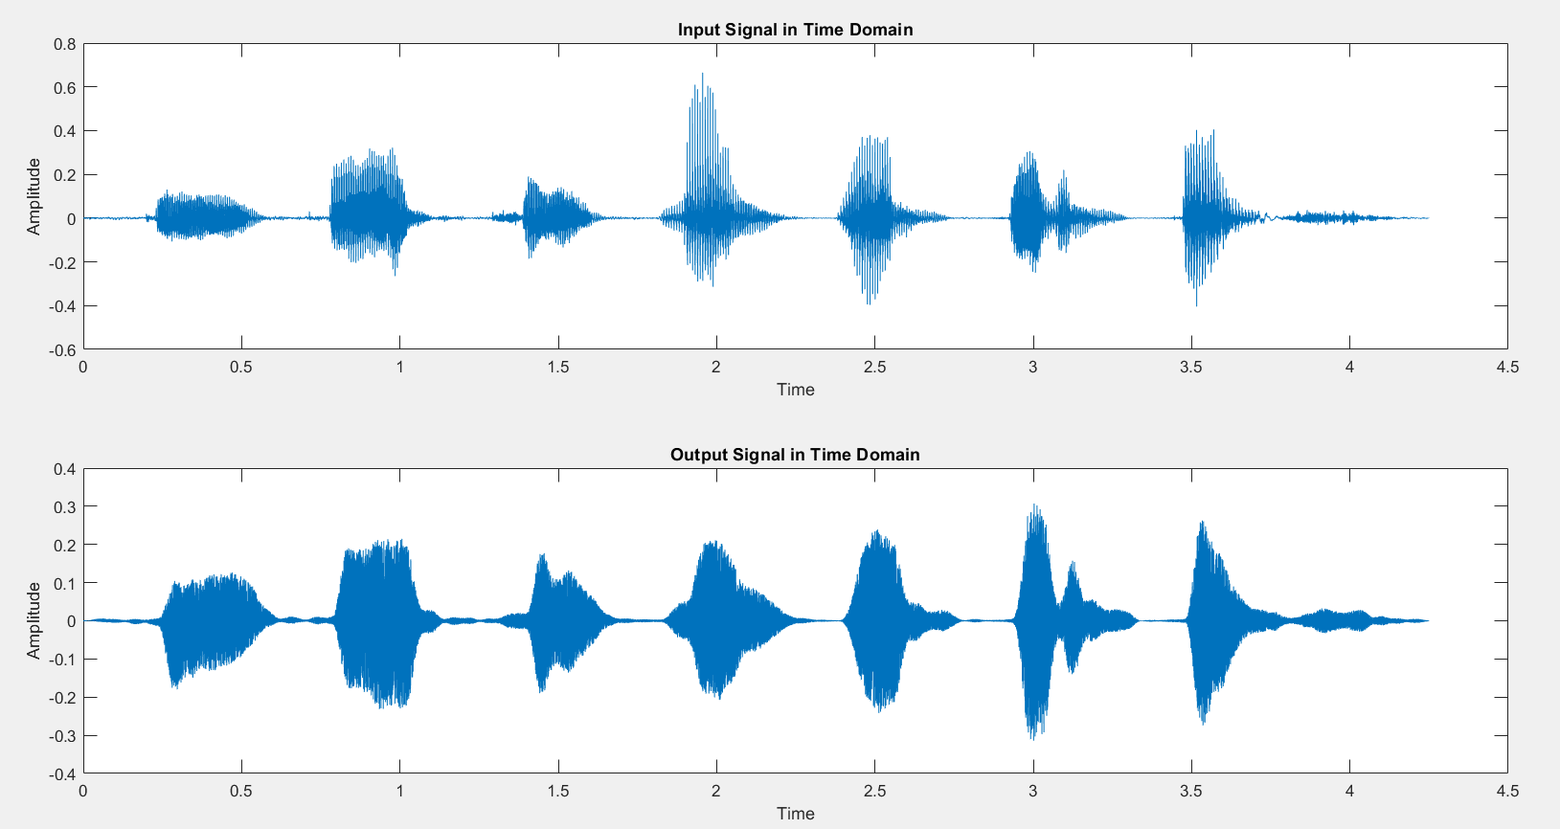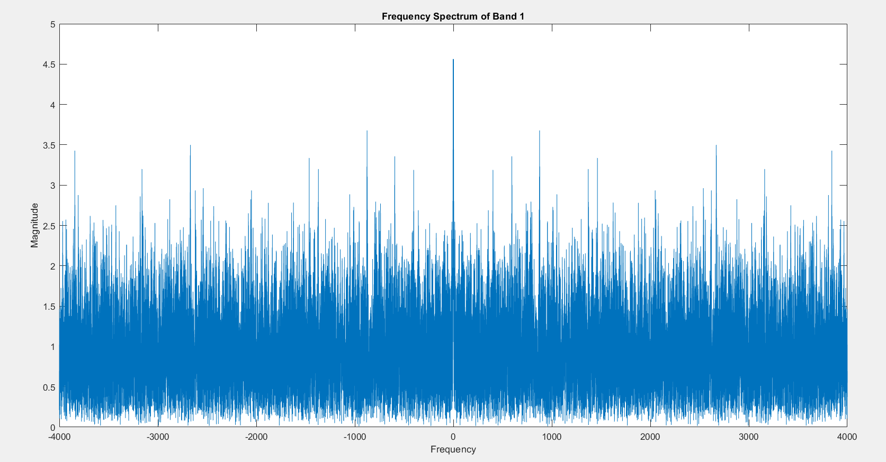For 1 Band, LPF cut-off = 16 Hz

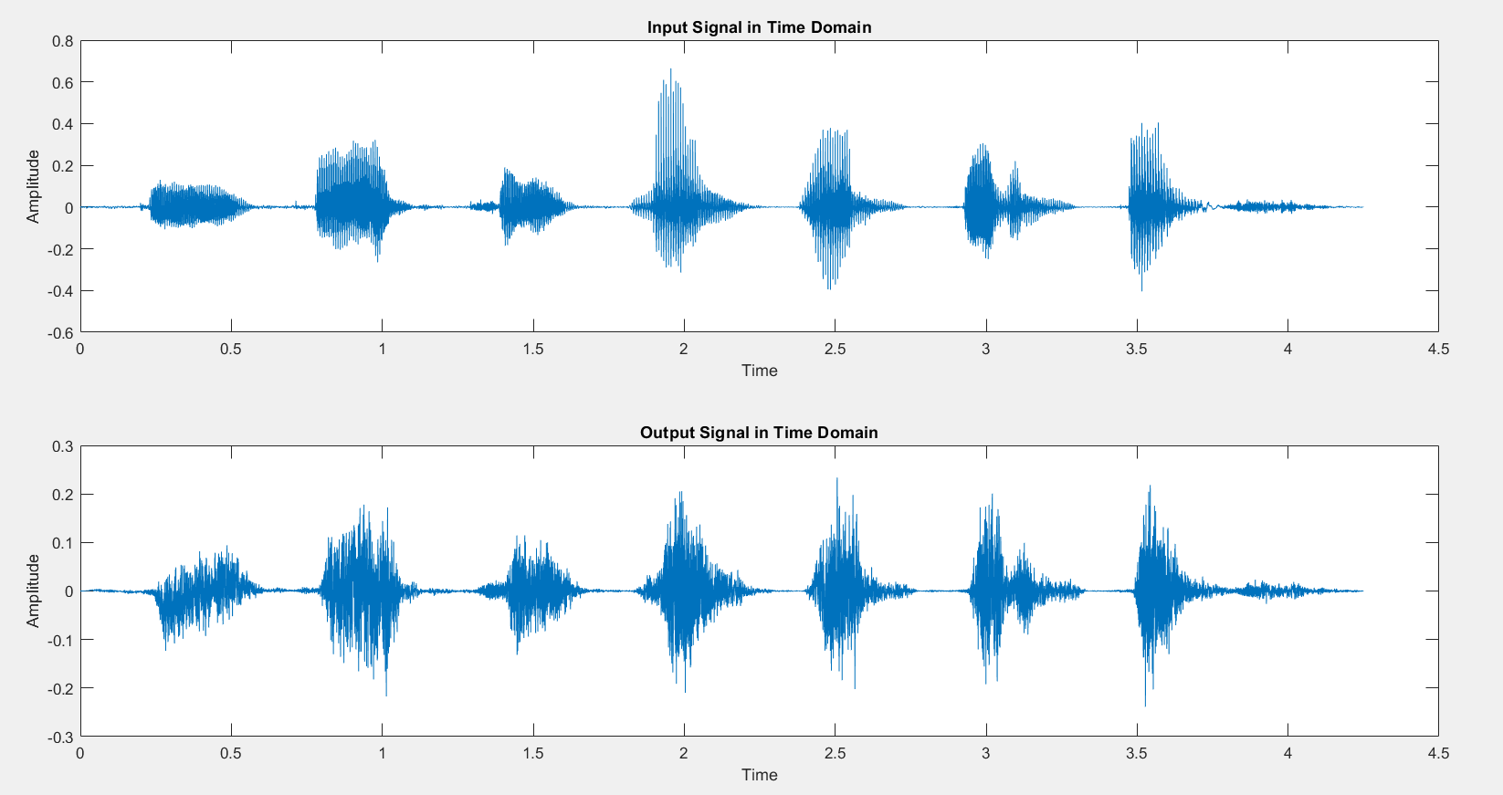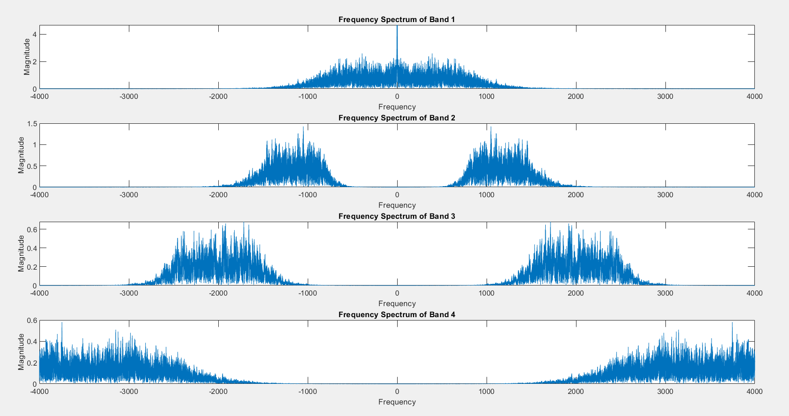For 4 Bands, LPF cut-off = 16 Hz

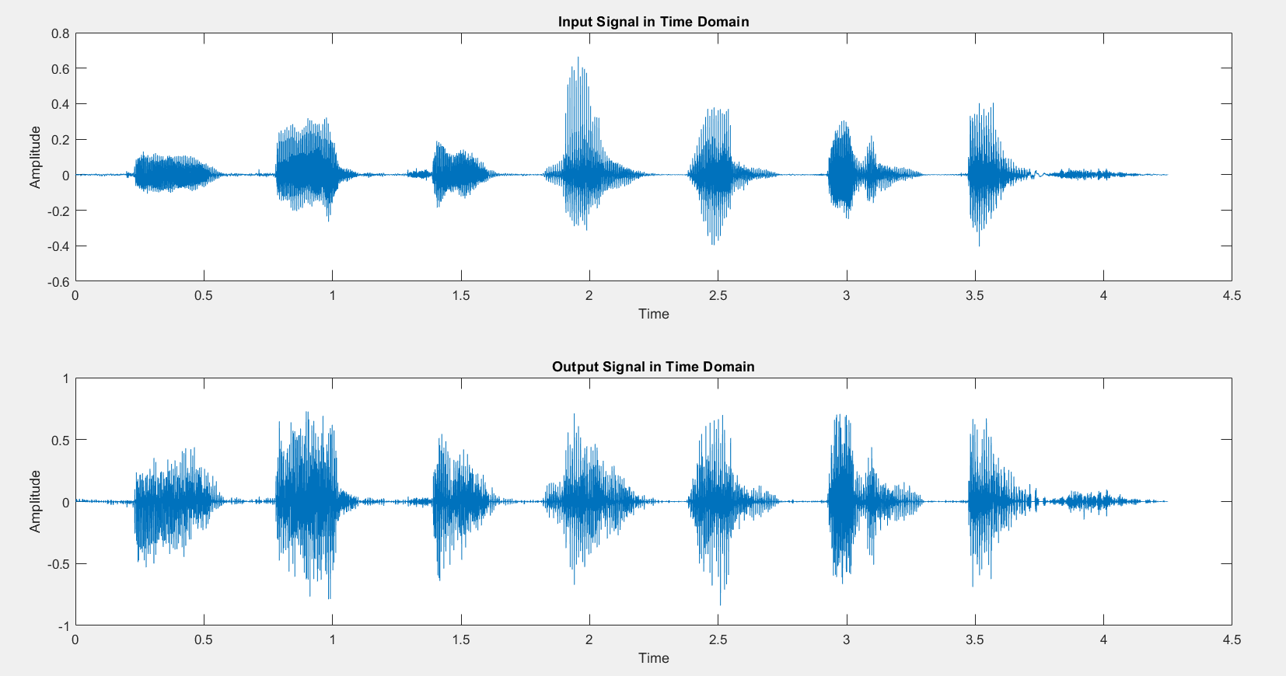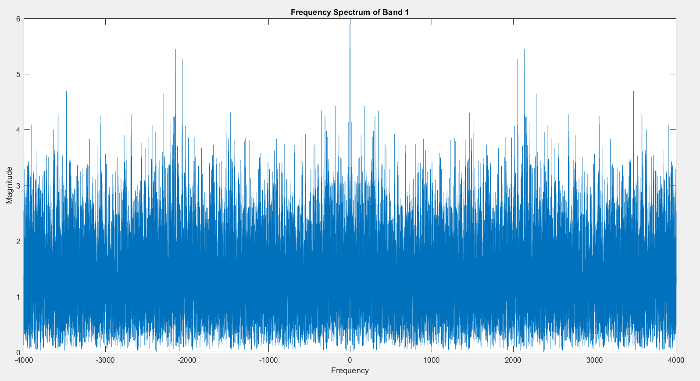For 1 Band, LPF cut-off = 500 Hz

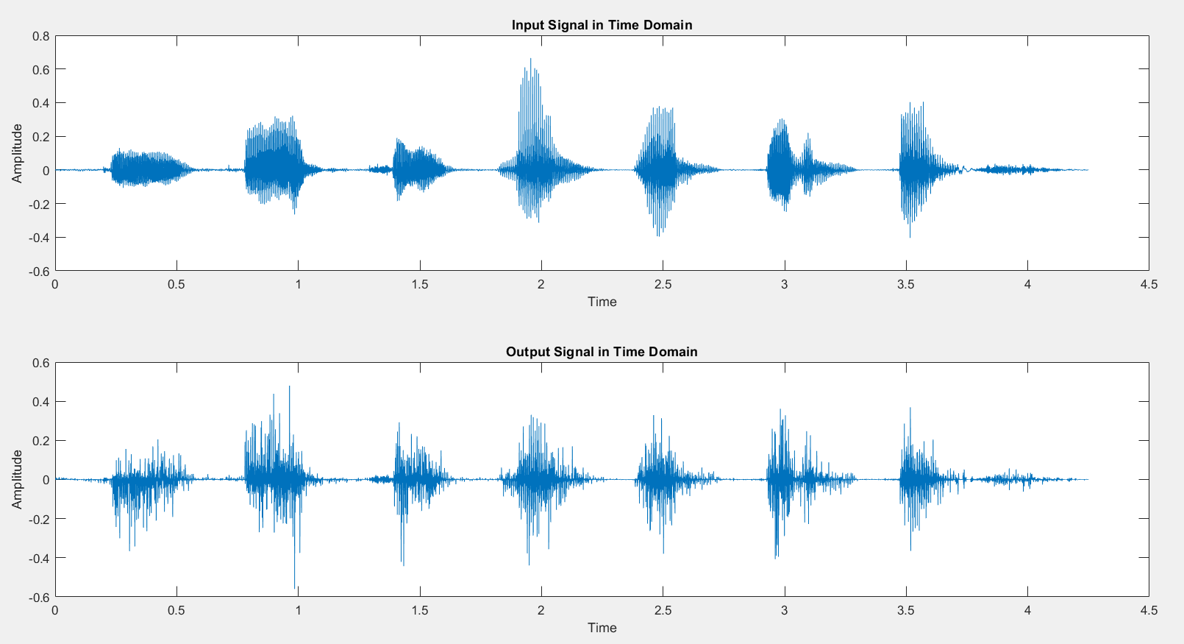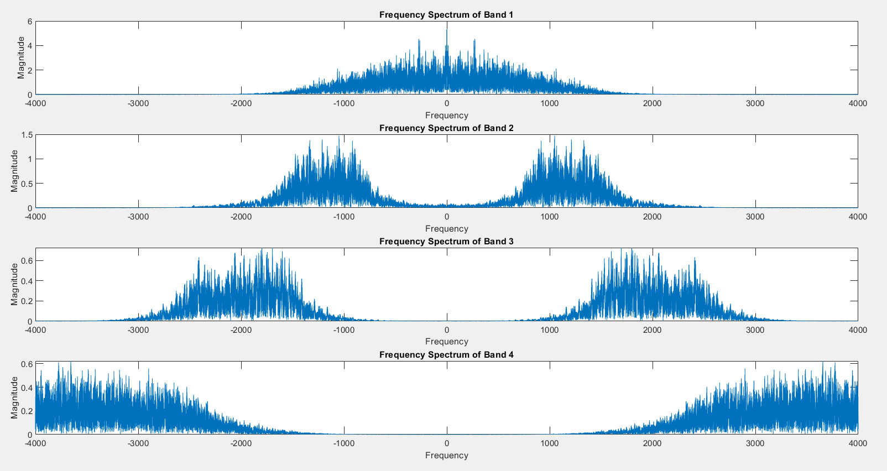For 4 Bands, LPF cut-off = 500 Hz

**Code:**

clc

clear all

close all

order = 4;

[y,Fs] = audioread("./Samples/B1_A1.wav");

norm = Fs/2;

for N = [1,4]

Fc = 500;

[B_l, A_l] = butter(order, Fc/norm);

noise = rand(size(y));

output = zeros(size(y));

bands = zeros(4,5);

bands(1,:) = [1, 3999, 0, 0, 0];

bands(2,:) = [1, 1500, 3999, 0, 0];

bands(3,:) = [1, 800, 1500, 3999, 0];

bands(4,:) = [1, 800, 1500, 2500, 3999];

figure();

for ii = 1:N

[B, A] = butter(order, [bands(N,ii)/norm, bands(N,ii+1)/norm]);

Y = filter(B,A,y);

Y_e = Y.*(Y>=0);

Y_el = filter(B_l, A_l, Y_e);

n = filter(B,A,noise);

subplot(N,1,ii);

NUM = length(Y_el);

f_range = -norm:2*norm/NUM:norm-1/NUM;

plot(f_range, abs(fftshift(abs(fft(n.*Y_el)))));

xlabel("Frequency");ylabel("Magnitude");

title("Frequency Spectrum of Band " + num2str(ii));

output = output + n.*Y_el;

end

output = output*10;

figure();

subplot(2,1,1);

t = 0:1/Fs:(length(y)-1)/Fs;

plot(t,y);

xlabel("Time");ylabel("Amplitude");

title("Input Signal in Time Domain");

subplot(2,1,2);

plot(t,output);

xlabel("Time");ylabel("Amplitude");

title('Output Signal in Time Domain');

out_file = "answer_"+num2str(N)+".wav";

audiowrite(out_file,output,Fs);

end