Digital Signal Processing Lab

Experiment 6

By Hardik Tibrewal (18EC10020)

**Aim:**

Speech Recognition with Primarily Temporal Cues

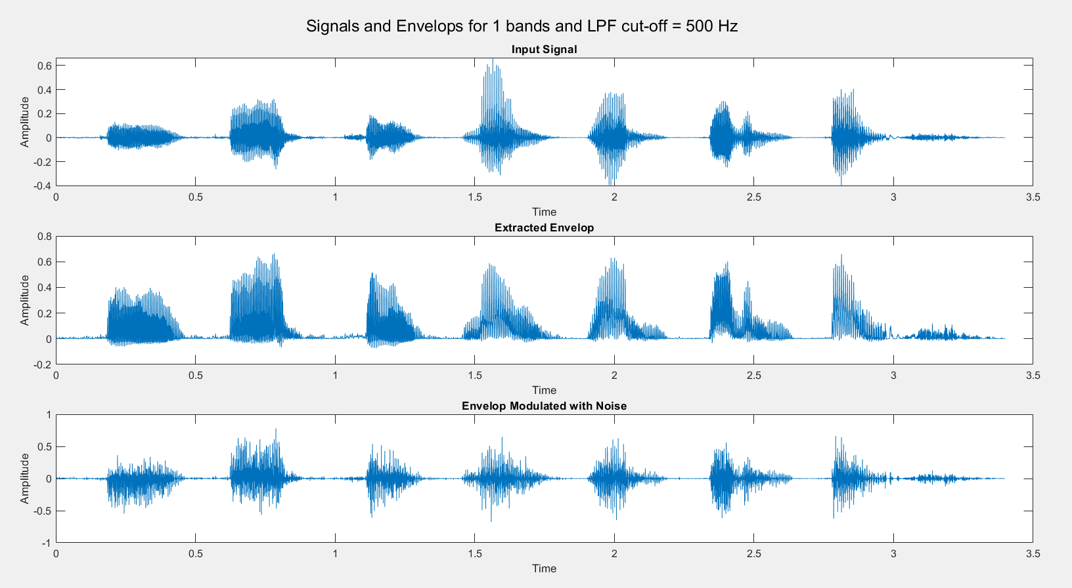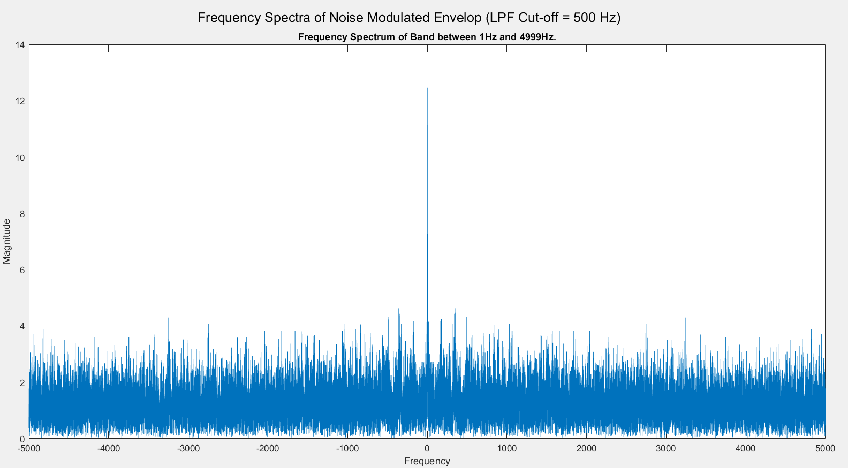**Plots:** (Not all plots are shown, since total number of plots for the experiment is 32 (16 conditions, 2 plots for each). They will be included in the report. Extreme cases are shown here)

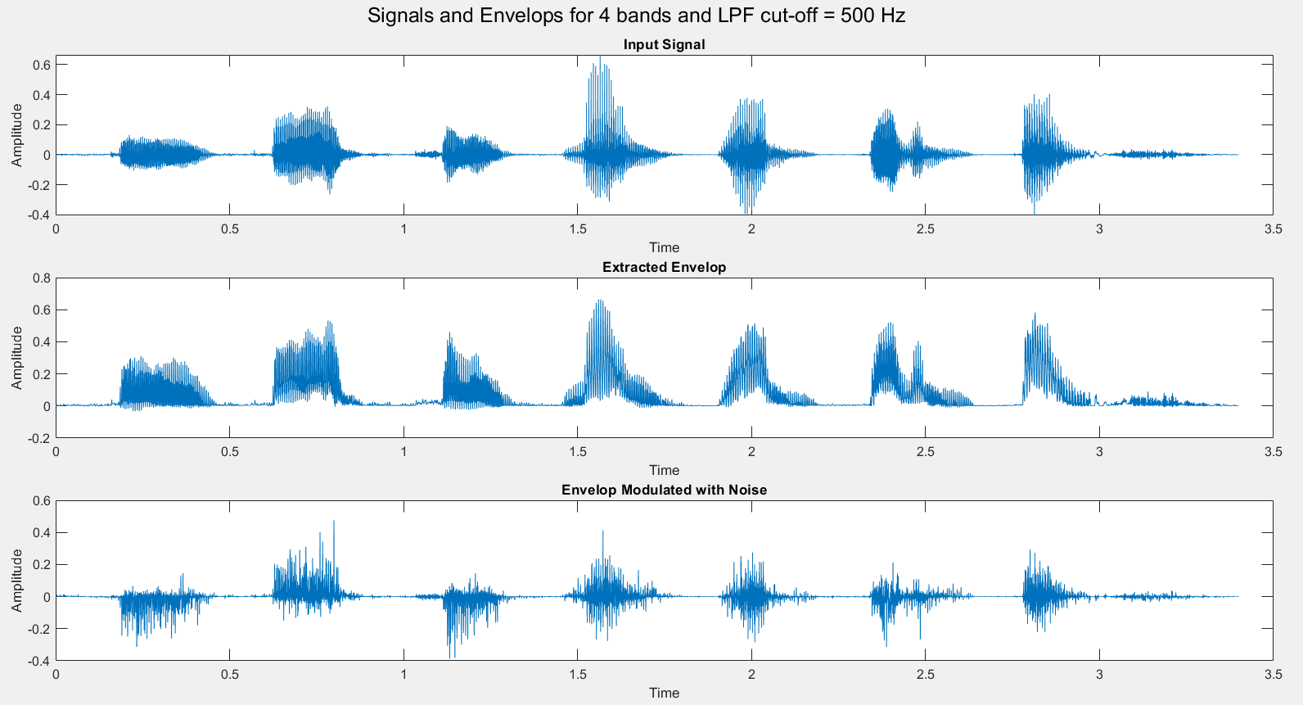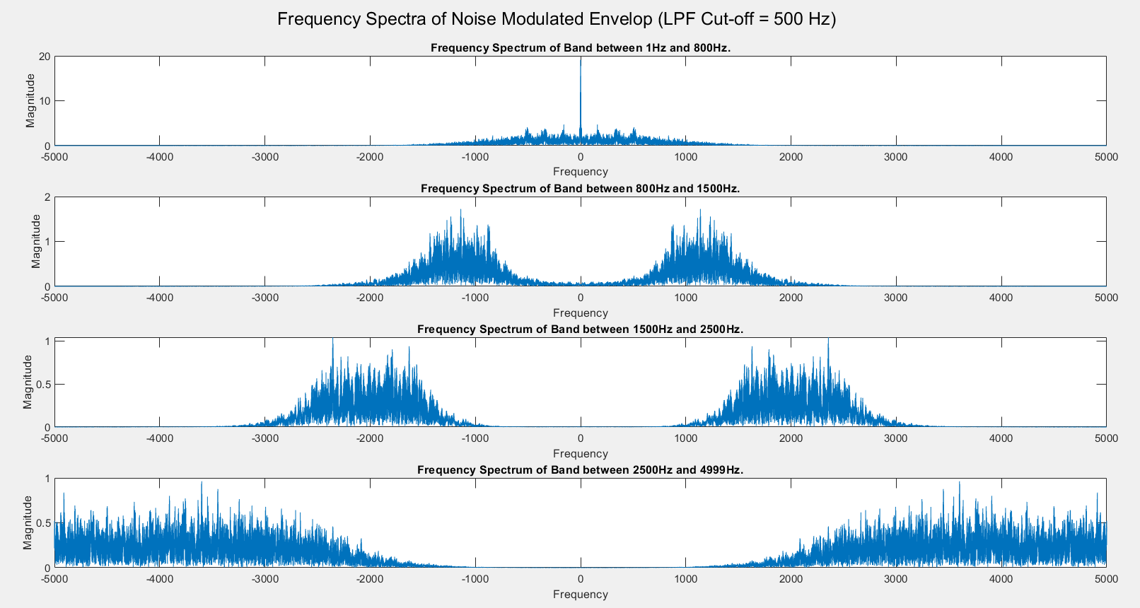

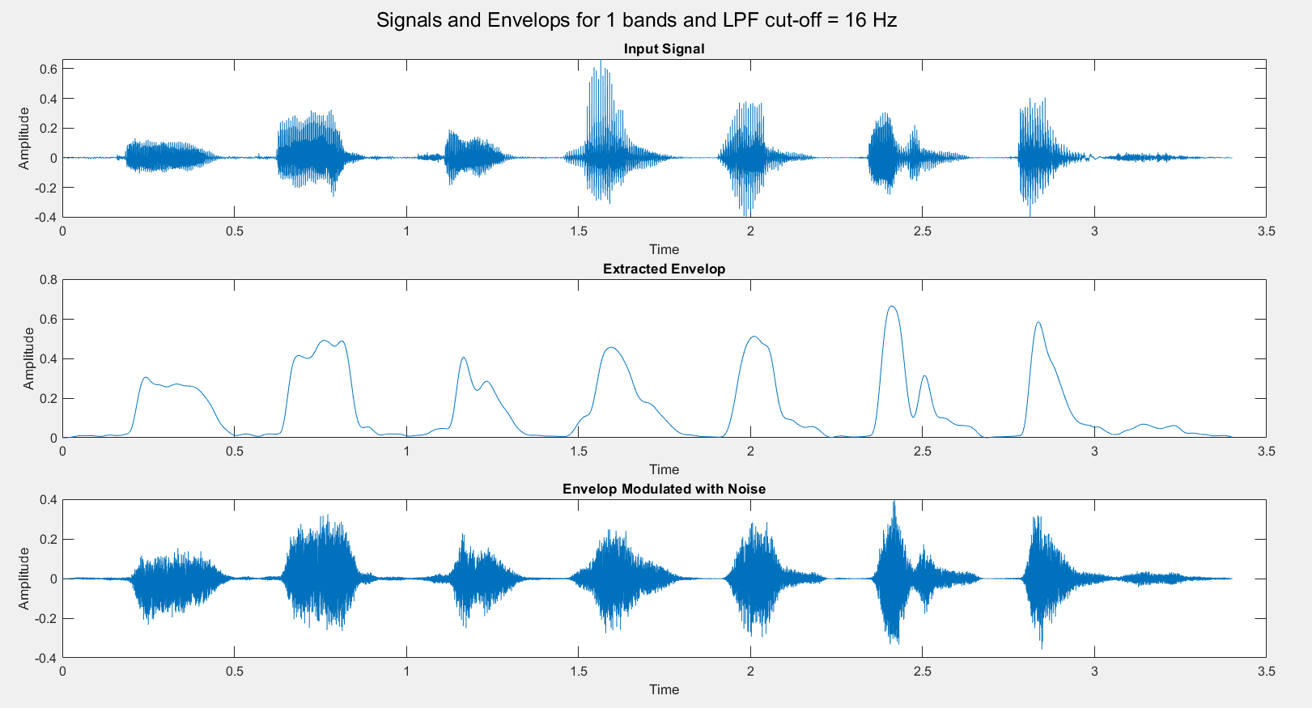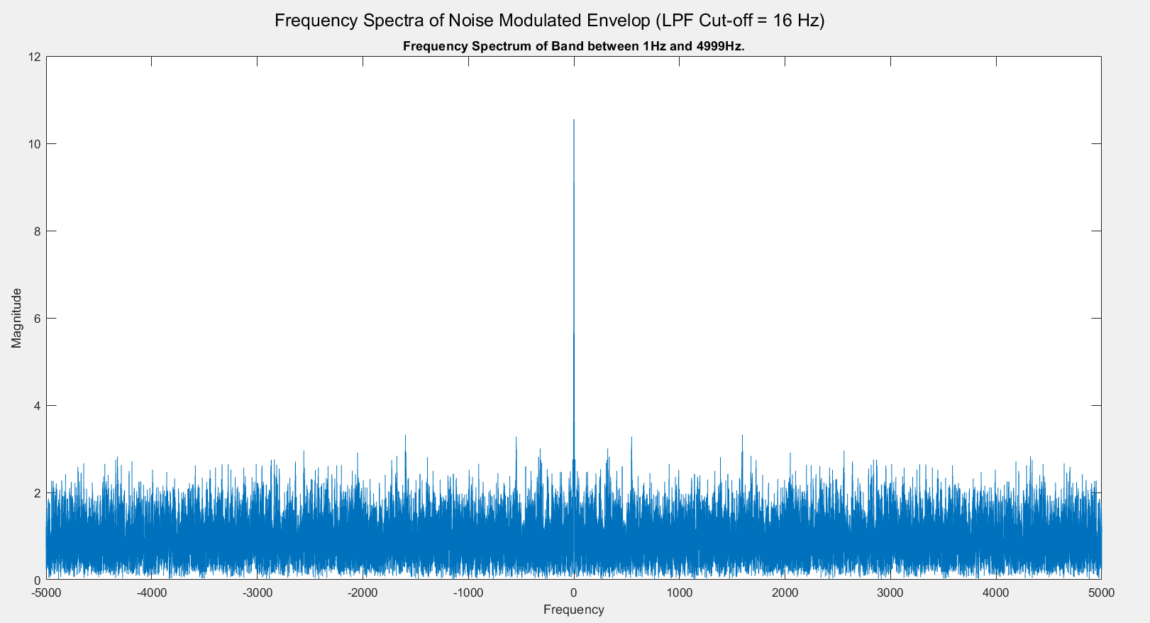

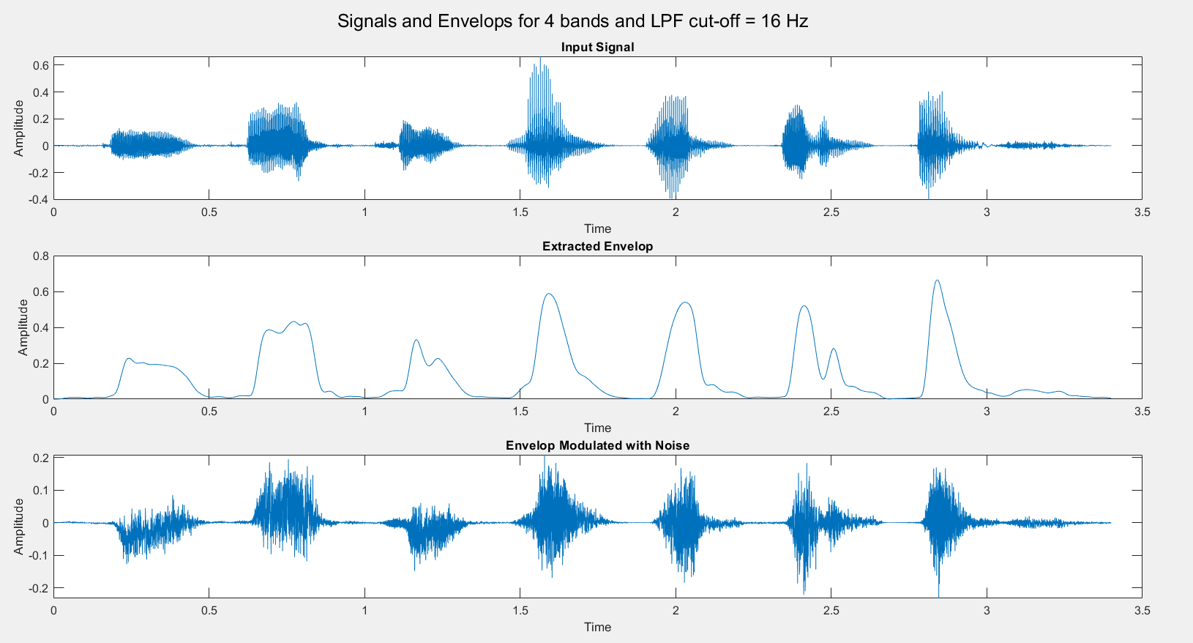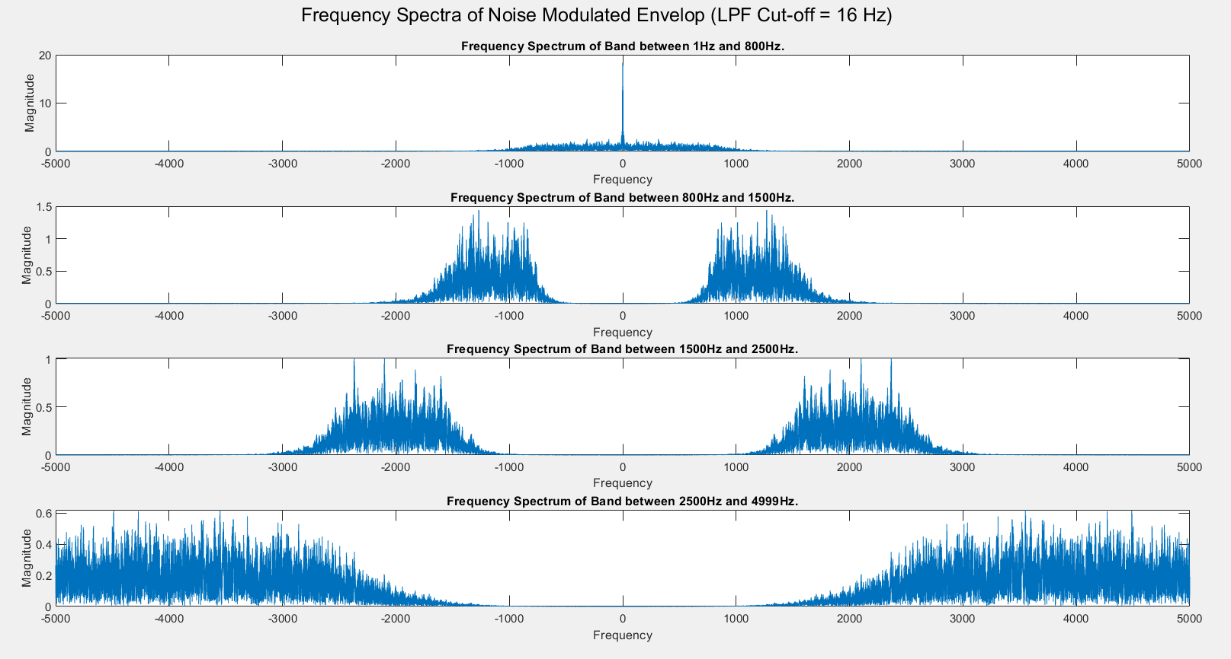

**Code:**

clc

clear all

close all

order = 4;

[y,F] = audioread("./Samples/B1_A1.wav");

audiowrite("Original.wav",y, 10000);

[y,Fs] = audioread("Original.wav");

norm = Fs/2;

for N = [1,2,3,4]

Fc = 500;

[B_l, A_l] = butter(order, Fc/norm);

noise = rand(size(y));

output = zeros(size(y));

envelop = zeros(size(y));

bands = zeros(4,5);

bands(1,:) = [1, norm-1, 0, 0, 0];

bands(2,:) = [1, 1500, norm-1, 0, 0];

bands(3,:) = [1, 800, 1500, norm-1, 0];

bands(4,:) = [1, 800, 1500, 2500, norm-1];

figure();

sgtitle("Frequency Spectra of Noise Modulated Envelop (LPF Cut-off = "+Fc+" Hz)")

for ii = 1:N

[B, A] = butter(order, [bands(N,ii)/norm, bands(N,ii+1)/norm]);

Y = filter(B,A,y);

Y_e = Y.*(Y>=0);

Y_el = filter(B_l, A_l, Y_e);

n = filter(B,A,noise);

subplot(N,1,ii);

NUM = length(Y_el);

f_range = -norm:2*norm/NUM:norm-1/NUM;

plot(f_range, abs(fftshift(abs(fft(n.*Y_el)))));

xlabel("Frequency");ylabel("Magnitude");

title("Frequency Spectrum of Band between "+bands(N,ii)+"Hz and "+bands(N,ii+1)+"Hz.");

output = output + n.*Y_el;

envelop = envelop+Y_el;

end

[B_f, A_f] = butter(order, 4000/norm);

output = filter(B_f, A_f, output);

output = output*10;

envelop = filter(B_f, A_f, envelop);

envelop = envelop.*(max(y)/max(envelop));

t = 0:1/Fs:(length(y)-1)/Fs;

figure();

sgtitle("Signals and Envelops for "+N+" bands and LPF cut-off = "+Fc+" Hz");

subplot(311)

plot(t, y);

xlabel("Time");ylabel("Amplitude");

title("Input Signal");

subplot(312)

plot(t, envelop);

xlabel("Time");ylabel("Amplitude");

title("Extracted Envelop");

subplot(313);

plot(t,output);

xlabel("Time");ylabel("Amplitude");

title('Envelop Modulated with Noise');

out_file = "./Audio_outputs/answer_"+N+"_freq_"+Fc+".wav";

audiowrite(out_file,output,Fs);

out_file = "./Audio_outputs/envelop_"+N+"_freq_"+Fc+".wav";

audiowrite(out_file,envelop,Fs);

end