**FOOD WASTAGE MANAGEMENT SYSTEM**

**Team Details:**

Mohamed Sameer (R1911652)

Mohammed Rumaan Nawaz (R1911658)

**Introduction**

Food Wastage Management System is a web-based technology which manages foods. This web application provides interface between food donor and food require. In this application food donor enter their food quantity details and addresses.

The donator can create the account and whenever they are having wastage food, they can login and give request to the admin. The admin collects foods from donator through their nearby agent then provide to nearest orphanages or poor people. After receiving the food from the agent by admin and give alert message to that donator. This project is food redistribution is an enormously successful social innovation that tackles food waste and food poverty. The donor details are maintained confidential because it maintains a separate account for each donor.

In this project we use PHP and MySQL database and it has only three modules i.e., Admin, donor, and user.

**Advantages**

* Provide platform between food donor and food hunger.
* Reduce time consumption.
* All system managements are automated.

**Objective**

In recent times, Food wastage is increasing at an unprecedented rate and creating a negative effect on the economic growth factors. This in turn creates a major impact on the agricultural processing industries. As food recycling is always remaining as a complex task, in this project, we are focusing mainly on the food wastage in the office premises, wedding, events etc. This web application is used to manage wastage foods in a useful way. Every day the people are wasting lots of foods. So, we have to reduce that food wastage problem through online. In general, we are automating the process of the food wastages.

**List of Modules**

**Modules:**

In this project consist of the different types of modules. The modules are:

* Donator Module
* Agent Module
* Admin Module

**Admin Module**

In admin module, the administrator maintains the agent details as well as the donator details. The administrator collects the food from the agent. The administrator gives the orphanage details directly to the donator.

**Donator Module**

In donator module, the donator gives the wastage of food to the orphanage. The donator gives the request to the admin for the purpose of to collect the wastage food. The donator views the orphanage details and agent details.

**Agent Module**

In Agent module, the agent maintains the orphanage details. It can also maintain the donator details. The agent gives the request to the admin for collect the food from the donator. After collect the food the agent gives the alert message for the donator.

|  |  |
| --- | --- |
| **HARDWARE REQUIREMENTS** | |
| Hardware | Pentium |
| Speed | 1.1 GHz |
| RAM | 1GB |
| Hard Disk | 20 GB |
| Floppy Drive | 1.44MB |
| Key Board | Standard Windows Keyboard |
| Mouse | Two or Three Button Mouse |
| Monitor | SVGA |
| **SOFTWARE REQUIREMENTS** | |
| Operating System | Windows |
| Technology | PHP |
| Web Technologies | HTML, JavaScript, CSS |
| IDE | Notepad++ |
| Web Server | XAMPP |
| Database | My SQL |

**SCHEMA DIAGRAM**

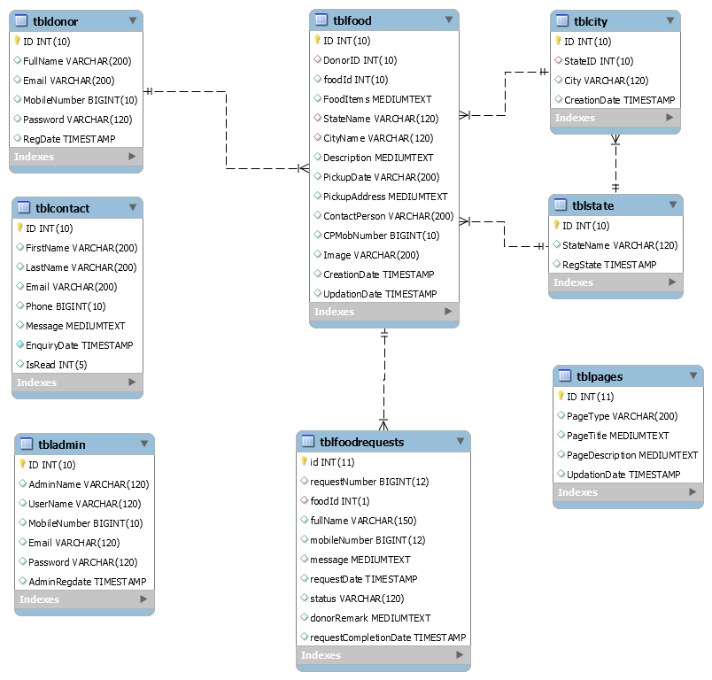

**ER DIAGRAM**

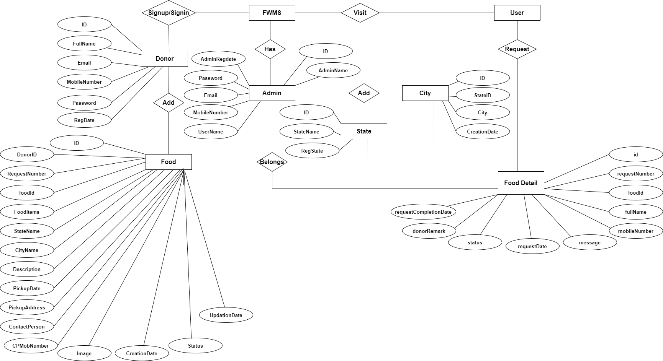

**DFD DIAGRAM**

**LEVEL 0**

Donor

Admin

**LEVEL 1**

Admin

Database

Donor

**LEVEL 2**

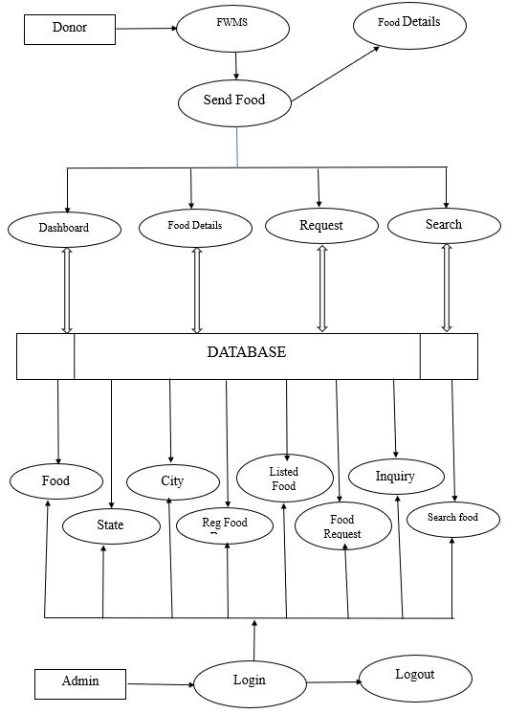

**CONCLUSION**

The project titled as Food Wastage Management System was deeply studied and analyzed to design the code and implement. It was done under the guidance of the experienced project guide. All the current requirements and possibilities have been taken care during the project time.

In our project, we are targeting the person who wants to donate wastage food this will create a greater impact on the cost saving as well as the food wastage management system, and there will be greater impact on the day-by-day food wastage. In our future work, we will try to integrate with other emerging technology such as block chain and also it will cover more areas

**FUTURE ENHANCEMENT**

The project's proposed approach can effectively prevent food waste due to expiration. However, many users could find it tedious to manually enter their inventories into the application. There was no standardised food information system on food at the time of writing. Packaging that provides the user with information about the food's name and as its time limit. Get the food's name from the label would be a practical improvement tools can read the expiration date from a product's bar code. But the degree of This option's simplicity of use is only marginally easier than the manual option of completing the food data.

Some businesses have begun testing the use of QR codes on their food packaging to provide specific information Despite this, there are still many obstacles to overcome before it becomes a standard. However, in the meanwhile, this programme offers a workable and sensible option.

.