**Practice report No.4**

|  |  |
| --- | --- |
| Nguyễn Mạnh Hiếu | 20215203 |
| Nguyễn Hoàng Việt | 20215255 |
| Phạm Trung Hiếu | 20215205 |
| Võ Chiến Huy | 20215208 |
| Đỗ Tùng Lâm | 20215218 |

Part 2:

1. When installing voltage rectifier, we have the result:

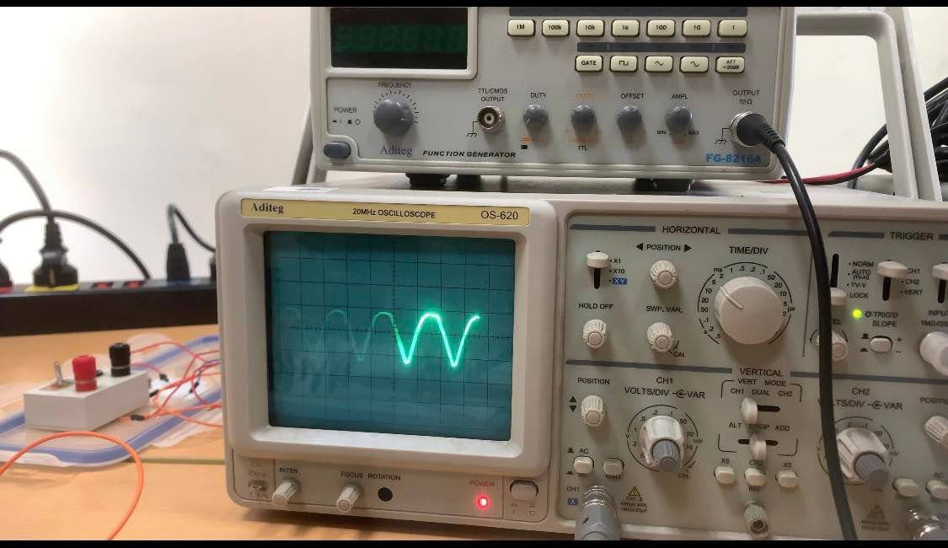

*) Remark:

For the load output voltage, we always see a point in both cycles connected to the positive (+) terminal of the Vin source. And point b is always connected to the negative (-) terminal of the Vin source. Therefore, the output voltage of the save configuration correction between the two half-cycles is exactly the same

b) When installing a stable DC power supply circuit 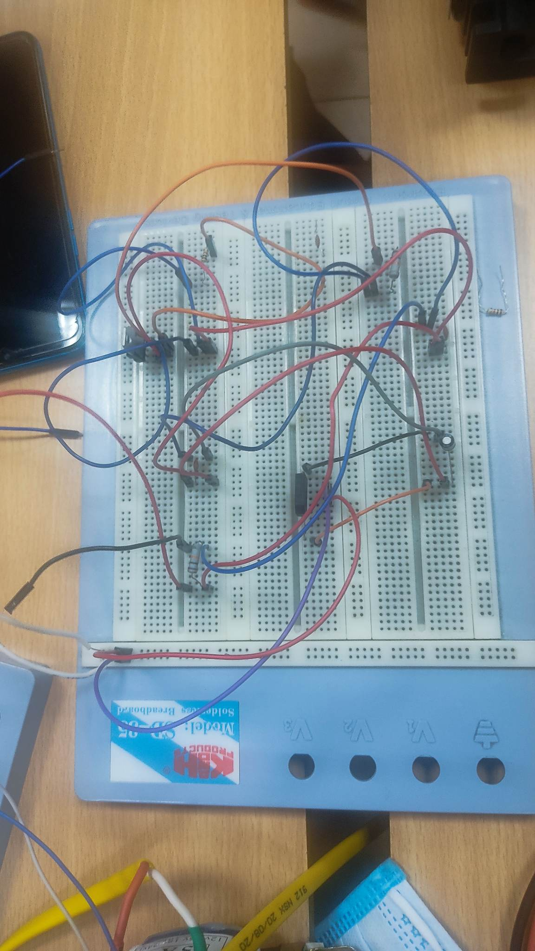

|  |  |  |
| --- | --- | --- |
| R1/R2 | V out theory | V out in measuring |
| 1 | 2.5 | 2.65 |
| 2 | 3.85 | 3.95 |
| 3 | 5.15 | 5.05 |
| 4 | 6.45 | 6.35 |
| >5 (=10) | 13.8 | 9.23 |

*Remark: The value of Vout on the resistor can only reach a maximum of approximately 10V, because the input secondary voltage is 10V.

+) Theory 𝑽𝒐𝒖𝒕=𝟏.𝟐𝟓×(𝟏+𝑹𝟐𝑹𝟏)+𝑰𝑨𝑫𝑱𝑹𝟐, with 𝐼𝐴𝐷𝐽 having a very small value (≈50𝜇𝐴) so it can be ignored.

=> The result is different from the theory due to reality

When passing AC 220V to the head, the ratio of the primary to the secondary is 20:1

Then the voltage on the secondary will be Vin = 11V, then continue to pass through the rectifier circuit and suffer a decrease of 1 amount with the voltage drop = 2 times the Diode's V 

=>> Then Vout = Vin - 2 V<= 10.08 V