Service prototype using Twilio API

TWILIO API offers the possibility to send and reply to SMS and to get access to your Twilio account from a program. This package shows some examples using python (3.6.3).

Requirements
- twilio ~=6.0.0
- flask
- flask-sqlalchemy
- flask-migrate
- flask-login
- flask-admin
- flask-bootstrap

Features
- Send SMS
- Reply to incoming SMS
- Retrieve message from messageSID
- Get the outbox list
- Get the inbox list
- Get the last message sent
- Get the count of sent messages
- Get the count of outbox messages
- Get the count of inbox messages

Getting Started

Register on Twilio to get your Twilio account identifier and authentication token.

Sending SMS and replying programmatically

Create and activate a virtual environment
To create a virtualenv run the following command:
$ python3 -m venv env

Navigate to your virtualenv folder activate it with the following:
$ source bin/activate

Setting environment variables
To protect the credentials, we avoid their direct declaration by defining the following environment variables.
TW_ACCOUNT_SID - your Twilio account identifier
TW_AUTH_TOKEN - your Twilio authentication token
TW_PHONE_NR - your Twilio phone number
(env) $ export TW_ACCOUNT_SID=Your_Twilio_Account_Identifier
(env) $ export TW_AUTH_TOKEN=Your_Twilio_Authentication_Token

You can optionally add your Twilio phone number.
(env) $ export TW_PHONE_NR=Your_Twilio_Phone_Number

Sending a SMS programmatically
To test the _send_ function, run inside the projet directory the following commands
(env) $ python
...
>>> from twlapi.sms import send
>>> send('+33062333xx', PHONE, 'Hi there!')

Replying to incoming SMS from Flask

Install flask and other listed dependencies in your virtualenv with the following command:
(env) $ pip install flask
...

Inside the project directory, navigate to the folder flaskapp/
(env) $ cd flaskapp

and set Flask environment variables:
(env) $ export FLASK_CONFIG=development
(env) $ export FLASK_APP=run.py

You can't now start the Flask APP with
(env) $ flask run

To see if the app is running open a browser and enter the following URL
http://127.0.0.1:5000

Using Ngrok
Download Ngrok and unzip it at a location of your choice and run
$ ./ngrok http 5000

Ngrok console is now started and you can see the given public URL
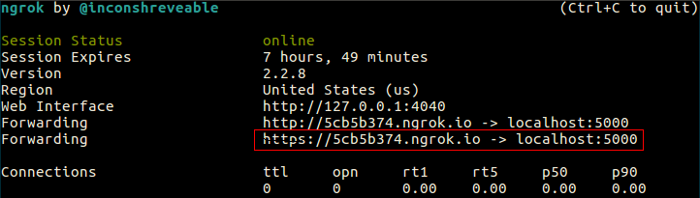

Configuring Webhook
This step defines the endpoint from where the reply is executed. The endpoint is composed of your Ngrok public URL and the path to the view, in this example
/sms/reply

The URL of the endpoint is now:
https://5cb5b374.ngrok.io/sms/reply

To register the endpoint you need to configure the Twilio Webhook. On your Twilio dashboard navigate to your phone number page and click on the number you'll like to use from the Active Numbers. On the configuration page of the selected phone number set the new URL of the endpoint as shown in the picture.
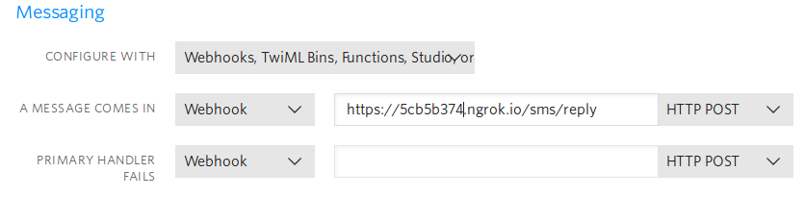
The Flask APP is now ready to reply to incoming SMS.
** Note that in Twilio trial version the phone number of
incoming SMS should be registered on your Twilio account.

The Flask APP shows in further examples how to interact with your Twilio account from a program / WebAPP.
Following actions are implemented in the app.
Paths | Returns
/sms/list | list all sms
/sms/inbox | list of received sms
/sms/inbox/count | count of received sms
/sms/outbox | list of sms sent
/sms/outbox/count | count of sms sent
/sms/count | count of all sms
/sms/ | retrieve the last sms transaction
/sms/reply | reply to incoming sms

