Experimental section

General experimental techniques

¹H NMR spectra were recorded in CDCl₃ or C₆D₆ at 200 MHz, 400 MHz or 600 MHz on Bruker DRX-200, DRX-400 or DRX-600 spectrometers and are reported as follows: chemical shift δ (ppm), (number of protons, multiplicity, coupling constant J in Hz, assignment). For spectra recorded in CDCl₃, residual protic solvent CHCl₃ (δ_{H} = 7.26 ppm) was used as the internal reference. ¹³C NMR spectra were recorded in CDCl₃ at 150 MHz, 100 MHz or 50 MHz on Bruker DRX-600, DRX-400 or Bruker DRX-200 spectrometers respectively, using the central resonance of CDCl₃ (δ_{C} = 77.0 ppm) as the internal reference. Infra-red spectra were recorded as thin films between sodium chloride plates, deposited from chloroform solution or as a nujol mull in the case of solids, on Perkin Elmer 983G, ATR Spectrum 1 or FTIR 1620 spectrometers. Mass spectra were obtained on a Kratos MS890MS, Bruker BIOAPEX 4.7 T FTICR or Micromass Q-TOF spectrometers at the Department of Chemistry, University of Cambridge, and at the EPSRC Mass Spectrometry service at Swansea. The following ionisation techniques were used: electron ionisation (EI), chemical ionisation (CI), electrospray (ES) and fast atom bombardement (FAB). Liquid Chromatography-Mass Spectrometry (LCMS) spectra were obtained on a Hewlett-Packard Series 1100 instrument. Optical rotation (OR) measurements are reported in 10⁻¹ deg cm² g⁻¹; the concentration (c) is g/100ml. Melting points were measured on a Reichert hot-stage apparatus and are uncorrected. X-Ray crystal structures were measured, solved and provided by the X-Ray section of the Chemistry department, University of Cambridge.
For those cases in which an inseparable mixture of compounds was produced, the data reported was obtained on the mixture. Where considerable assignment of ¹H NMR spectra of individual compounds in mixtures is possible, the interpretation is for each component. Flash column chromatography was carried out using Merck Kieselgel (230-400 mesh) unless otherwise indicated. The solvents for chromatography were distilled. Analytical thin layer chromatography (tlc) was performed using precoated glass-backed plates (Merck Kieselgel 60 F254) and visualised by UV-light (wavelength 254 nm), acidic ammonium molybdate (IV) or acidic potassium permanganate solutions. Petrol (PE) refers to petroleum ether bp = 40-60 °C, which was distilled prior to use, and ether refers to diethyl ether (Et₂O). When mixtures of solvents were applied, the ratios stated refer to the volumes used. All reactions were carried out under an argon atmosphere in oven-dried glassware unless otherwise stated. Reactions involving preparation of the iron complexes were carried out using degassed tetrahydrofuran (THF). Solvents were degassed by successively evacuating and purging the solvent three times with argon while simultaneously subjecting the solvent to sonication using a 80W 55KHz cleaning bath. Ether and THF were distilled from sodium benzophenone ketyl; Dichloromethane (DCM) was distilled from calcium hydride. Other reagents and solvents were used as supplied or purified using standard procedures as required.¹⁴⁷ Aqueous solutions are saturated unless otherwise specified. Molecular sieves were powdered and oven-dried. Note that in the synthesis of the π-allyltricarbonyliron lactone complexes, diironnonacarbonyl [Fe₂(CO)₉] is used. This is extremely toxic. Furthermore, ironpentacarbonyl [Fe(CO)₅] is a highly toxic by-product from the iron reactions. All work involving the handling of these species was carried out in a well ventilated fume hood and all glassware was treated with bleach to destroy any iron carbonyl residues before re-use.

Specific experimental procedures

Experimental procedures for chapter 3: decarestrictine D

Preparation of (2E,4R*,5R*)-ethyl-4,5-epoxy-hex-2-enoate (172)

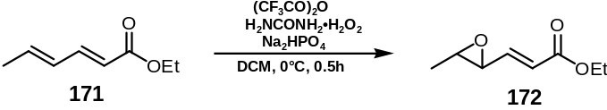

Trifluoroacetic anhydride (14.8 ml, 104 mmol) was added slowly to a suspension of (2E,4E) ethyl hexa-2,4-dienoate 171 (2.44 g, 17.4 mmol), urea hydrogen peroxide addition compound (37.7 g, 0.39 mol) and disodium hydrogenphosphate (27.6 g, 195 mmol) in DCM (250 ml) at 0°C. After removing from the ice bath, the reaction mixture was stirred at rt for 30 min and then cautiously poured into a vigorously stirred and precooled (0°C) solution of NaHCO₃ (800 ml). After effervescence had ceased, the phases were separated and the organic phase washed sequentially with NaHCO₃ solution (3 x 300 ml) and NaCl solution (300 ml), dried (MgSO₄) and filtered. Concentration in vacuo followed by flash column chromatography (eluent PE:Et₂O 7:1) provided the epoxide 172 (1.09 g, 7 mmol, 41%) as a colourless oil; ν_{max} (film)/cm⁻¹: 2981, 1716 (C=O), 1655 (C=C), 1446, 1378, 1367, 1340, 1302, 1258, 1185, 1140, 1096, 1031, 1005, 975; δ_{H} (400 MHz, CDCl₃): 1.15 (3H, t, J 7.1, OCH₂CH₃), 1.24 (3H, d, J 5.2, 6-H x 3), 2.84 (1H, qd, J 5.2, 2.0, 5-H), 3.05 (1H, dd, J 7.0, 2.0, 4-H), 4.07 (2H, q, J 7.1, OCH₂CH₃), 5.99 (1H, dd, J 15.7, 0.6, 2-H), 6.54 (1H, dd, J 15.7, 7.0, 3-H); δ_{C} (100 MHz, CDCl₃): 165.5, 144.5, 123.6, 60.4, 57.3, 57.1, 17.4, 14.1; m/z (+EI): 179 ([MNa]⁺, 100%). Found: [MNa]⁺, 179.060. [C₈H₁₂O₃Na]⁺ requires 179.0684. Data was consistent with those reported in the literature.¹⁶

Preparation of (2E,4R*,5R*)-4,5-epoxy-hex-2-en-1-ol (173)

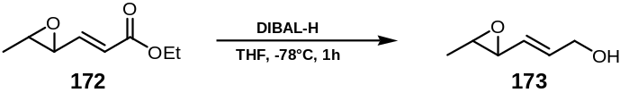

Diisobutylaluminium hydride (17.70 ml of a 1 M solution in THF, 17.70 mmol) was slowly added to the epoxide ester 172 (1.20 g, 7.68 mmol) in THF (10 ml) at -78°C. After stirring at this temperature for 1h, methanol (10 ml) was added slowly and the resultant solution was warmed to rt. Triethanolamine (8 ml) was subsequently added and the mixture was stirred at rt overnight. Filtration through a pad of Celite® followed by washing with Et₂O (150 ml) and concentration in vacuo provided the crude product which was purified by flash column chromatography (eluent PE:Et₂O 4:1 to 1:4, gradient) to give alcohol 173 (718 mg, 6.29 mmol, 82%) as a colourless oil; ν_{max} (film)/cm⁻¹: 3404 (OH), 2988, 2927, 2862, 1673 (C=C), 1447, 1429, 1379, 1336, 1296, 1245, 1144, 1128, 1092, 1060, 1009; δ_{H} (400 MHz, CDCl₃): 1.31 (3H, d, J 5.2, 6-H x 3), 1.61 (1H, s, OH), 2.89 (1H, qd, J 5.2, 2.1, 5-H), 3.06 (1H, dd, J 7.9, 2.1, 4-H), 4.11 (2H, d, J 5.2, 1-H x 2), 5.41 (1H, dd, J 15.6, 7.8, 3-H), 6.02 (1H, dt, J 15.6, 5.2, 2-H); δ_{C} (100 MHz, CDCl₃): 134.2 (CH), 128.8 (CH), 62.7 (CH₂), 58.9 (CH), 56.5 (CH), 17.5 (CH₃); m/z (+EI): Found: [MNa]⁺, 137.0575. [C₆H₁₀O₂Na]⁺ requires 137.0578. Data was consistent with those reported in the literature.¹⁶

Preparation of (2E,4R*,5R*)-4,5-epoxy-1-[(2’-methoxy-ethoxymethloxy)]-hex-2-en (174)

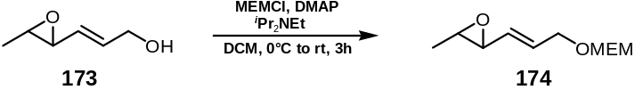

(2-Methoxyethoxy)methyl chloride (MW=124.57, 342 μl, 3.0 mmol) was added slowly to a stirred solution of epoxide 173 (170 mg, 1.49 mmol), ^{i}Pr₂NEt (783 μl, 582 mg, 4.5 mmol, d=0.742, MW=129.25) and DMAP (MW=122.7, 18.4 mg, 0.15 mmol) in DCM (10 ml) at 0°C. After allowing to warm to rt and stirring overnight, the reaction mixture was poured into NaHCO₃ solution (100 ml), the layers were separated and the aqueous phase extracted with DCM (3 x 30 ml). The combined organic extracts were washed with water (30 ml), brine (30 ml), dried (MgSO₄), filtered and concentrated in vacuo. The crude product was purified by flash column chromatography (eluent PE:Et₂O 9:1 to 1:2, gradient) to yield product 174 (194 mg, 0.96 mmol, 64%); ν_{max} (film)/cm⁻¹: 2928, 2879, 1452 (C=C), 1382, 1338, 1243, 1199, 1175, 1097, 1020, 967, 933, 853, 735; δ_{H} (400 MHz, CDCl₃): 1.30 (3H, d, J 5.2, 6-H x 3), 2.87 (1H, qd, J 5.2, 2.1, 5-H), 3.04 (1H, dd, J 7.9, 2.1, 4-H), 3.36 (3H, s, OCH₃), 3.51 (2H, t, J 4.7, OCH₂CH₂O), 3.65 (2H, t, J 4.7, OCH₂CH₂O), 4.05 (2H, d, J 5.2, 1-H x 2), 5.42 (1H, dd, J 15.6, 7.8, 3-H), 5.95 (1H, dt, J 15.6, 5.2, 2-H); δ_{C} (100 MHz, CDCl₃): 130.9 (3-C), 130.3 (2-C), 94.7 (OCH₂O), [71.7, 66.8 (OCH₂CH₂O)], 58.9 (OCH₃), 58.9 (4-C), 56.3 (5-C), 17.4 (6-C); m/z (+EI): Found: [MNa]⁺, 225.1109. [C₁₀H₁₈O₄Na]⁺ requires 225.1103.

Preparation of [(4E,2SR,3SR)-2-(carbonyloxy-κC)-6-[(2’-methoxyethoxy)-
methyloxy]-(3,4,5-η)-hex-4-en-3-yl]tricarbonyliron (175) and [(4E,2SR,3RS)-2-(carbonyloxy-κC)-6-[(2’-methoxyethoxy)methyloxy]-(3,4,5-η)-hex-4-en-3-yl]tricarbonyliron (176)

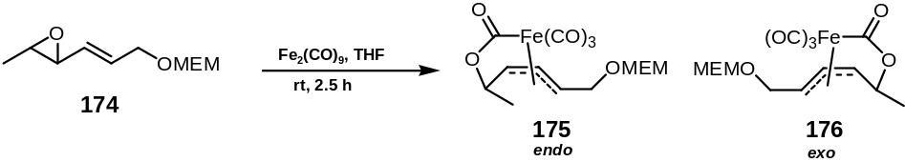

Iron complexes 175 and 176 were prepared according to Error: Reference source not found (page Error: Reference source not found) from precursor epoxide 174 (145 mg, 0.71 mmol) and Fe₂(CO)₉ (2.5 eq., 1.77 mmol, 0.645 g) in THF (20 ml). Crude products were purified by flash chromatography (eluent PE:Et₂O 5:1 to 1:4, gradient) to yield (in order of elution) endo iron complex 175 (90 mg, 0.24 mmol, 34%) as a white crystalline solid; ν_{max} (film)/cm⁻¹: 3079, 2943, 2888, 2065, 1998, 1650, 1458, 1369, 1171, 1010, 950, 830; δ_{H} (400 MHz, CDCl₃): 1.35 (3H, d, J 5.2, 1-H x 3), 3.38 (3H, s, OCH₃), 3.52 (2H, t, J 4.7, OCH₂CH₂O), 3.65 (2H, t, J 4.7, OCH₂CH₂O), 4.05 (1H, dt, J 9.1, 2.9, 5-H x 1), 4.08 (1H, dd, J 4.7, 3.8, 6-H x 1), 4.22 (1H, dq, J 6.5, 4.3, 2-H), 4.39 (1H, ddd, J 15.0, 10.9, 4.0, 6-H x 1), 4.63 (1H, dd, J 8.0, 4.7, 3-H x 1), 4.80 (2H, s, OCH₂O), 4.85 (1H, dd, J 11.7, 8.4, 4-H x 1); δ_{C} (100 MHz, CDCl₃): 209.2 (CO), 207.9 (CO), 206.1 (CO), 203.4 (CO), 95.4 (OCH₂O), 88.3 (4-C), 78.4 (5-C), 77.6 (2-C), 74.3 (3-C), [71.6, 67.2 (OCH₂CH₂O)], 59.0 (OCH₃), 30.3 (6-C), 21.9 (1-C); m/z (+EI): Found: [MNa]⁺, 393.0246. [C₁₄H₁₈O₈FeNa]⁺ requires 393.0249; and exo iron complex 176 as oil (21 mg, 0.056 mmol, 8%, not fully characterized) in a combined unoptimised overall yield for both compounds of 0.30 mmol = 42%. (Single crystal X-ray analysis of compound 175 confirmed the endo conformation.)

Preparation of 4-(tert-butyl-dimethyl-silanyloxy)butyne (155)

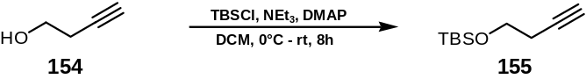

To a solution of butynyl alcohol 154 (16.5 g, 0.235 mol) in DCM (250 ml) at 0°C was added TBSCl (1.02 eq., 0.24 mol, 36.18 g) and DMAP (MW=122.17, 200 mg, 1.6 mmol). NEt₃ (MW=101.19, d=0.726, bp=89°C, 0.25 mol, 25.29 g = 34.85 ml) was subsequently added via syringe and the reaction mixture stirred at 0°C for 2 h, after which it was warmed to rt and stirred for a further 6 h, until completion as judged by tlc. The mixture was poured onto saturated NH₄Cl solution (800 ml) and extracted with Et₂O (3 x 300 ml). The combined organic extracts were washed with brine (500 ml) and dried (MgSO₄), filtered, and concentrated in vacuo, yielding an oil which was purified by filtration through a pad of SiO₂ (eluent PE:Et₂O 10:1) giving compound 155 (36.10 g, 19.6 mmol, 83%) as colourless oil; ν_{max} (film)/cm⁻¹: 3315, 2955, 2929, 2858, 1472, 1463, 1386, 1361, 1255, 1102, 1060, 1006, 938, 915, 820, 775; δ_{H} (400 MHz, CDCl₃): 0.06 (6H, s, Si(CH₃) x 2), 0.89 (9H, s, SiC(CH₃)₃ x 1), 1.93 (1H, t, J 2.6, 1-H), 2.38 (2H, td, J 7.3, 2.9, 3-H x 2), 3.72 (2H, t, J 7.3, 4-H x 2); δ_{C} (100 MHz, CDCl₃): 81.4 (2-C), 69.2 (1-C), 61.7 (4-C), 25.8 (SiC(CH₃)₃ x 1), 22.8 (3-C), 18.2 (SiC(CH₃)₃), -5.4 (Si(CH₃) x 2); m/z (+EI): 207.1 ([MNa⁺], 60%). Found: [MNa⁺] 207.1182. [C₁₀H₂₀OsiNa]⁺ requires 207.1181.¹⁴⁸

Preparation of 5-(tert-butyl-dimethyl-silanyloxy)-pent-2-yn-1-ol (156)
(Method 1)

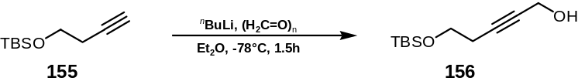

^{n}BuLi (1.6M solution in Et₂O, 18.75 ml, 30 mmol) was added to a stirred solution of alkyne 155 (5.0 g, 27 mmol) in Et₂O (20 ml) at -78°C and the mixture stirred for 1 h. Freshly cracked paraformaldehyde (mp=163-165°C) was bubbled through the reaction mixture, which was under a constant argon flow. After 20-30 min, the mixture was diluted with Et₂O (200 ml) and poured onto saturated NaCl solution (150 ml), the phases were separated, and the aqueous layer extracted with Et₂O (2 x 50 ml). The combined organic phases were dried (MgSO₄), filtered and concentrated in vacuo. Purification by flash column chromatography (eluent PE:Et₂O 4:1 to 1:1, gradient) yielded alcohol 156 (4.67 g, 21 mmol, 81%) as an oil; ν_{max} (film)/cm⁻¹: 3418 (OH), 2929, 2858, 2249, 1471, 1385, 1256, 1101, 1006, 905, 836, 778, 710; δ_{H} (400 MHz, CDCl₃): 0.04 (6H, s, Si(CH₃) x 2), 0.86 (9H, s, SiC(CH₃)₃ x 1), 2.40 (2H, t, J 7.3, 4-H x 2), 2.50 (1H, br s, OH), 3.69 (2H, t, J 6.9, 5-H x 2), 4.19 (2H, s, 1-H x 2); δ_{C} (100 MHz, CDCl₃): 83.0 (3-C), 79.6 (2-C), 61.8 (5-C), 51.0 (1-C), 25.8 (SiC(CH₃)₃ x 1), 23.1 (4-C), 18.3 (SiC(CH₃)₃), -5.1 (Si(CH₃) x 2); m/z (+EI): 237.1287 (([MNa]⁺, 100%), 238.1320 (12.2%), 238.1282 (5.1%), 239.1255 (3.4%). Found [MNa]⁺ 237.1288. [C₁₁H₂₂O₂SiNa]⁺ requires 237.1287. Data was consistent with the literature.¹⁴⁹

Preparation of 5-(tert-butyl-dimethyl-silanyloxy)-pent-2-Z-en-1-ol (157) (Method 1)

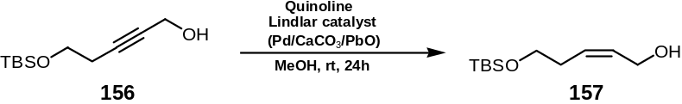

Quinoline (MW=129.16, d=1.093, 200 mg, 1.52 mmol) and Lindlar-catalyst Pd/C/CaCO₃/PbO (50 mg) were added to a solution of the alkyne 156 (0.75 g, 3.5 mmol) in MeOH (20 ml). The flask was flushed twice with hydrogen and the reaction mixture then stirred under an atmosphere of hydrogen for 24 h. Et₂O (100 ml) was added, then aqueous HCl (3M) and the mixture was stirred shortly for 2 min, the phases were separated, and the aqueous acidic phase re-extracted with Et₂O (100 ml). The combined organic phases were filtered through a pad of silica, washed with phosphate buffer solution (100 ml), NH₄Cl solution (150 ml), dried (MgSO₄), filtered and concentrated in vacuo. Purification by flash column chromatography (eluent PE:Et₂O 5:1) afforded cis-alkene 157 (0.35 g, 1.61 mmol, 46%) as a colourless oil; ν_{max} (film)/cm⁻¹: 3350 br, 3020; δ_{H} (400 MHz, CDCl₃): 0.04 (6H, s, Si(CH₃) x 2), 0.89 (9H, s, SiC(CH₃)₃ x 1), 2.23 (1H, br s, OH), 2.32 (2H, app. q, J 7.3, 4-H x 2), 3.62 (2H, t, J 6.2, 5-H x 2), 4.11 (2H, br s, 1-H x 2), 5.54 (1H, m, 2-H x 1), 5.76 (1H, m, 2-H x 1); δ_{C} (100 MHz, CDCl₃): 129.4 (2-C), 128.2 (3-C), 62.3 (5-C), 57.9 (1-C), 30.9 (4-C), 25.9 (SiC(CH₃)₃ x 1), 18.3 (SiC(CH₃)₃), -5.4 (Si(CH₃) x 2); m/z (+EI): 239.1443 ([MNa]⁺, 100%), 240.1477 (12.2%), 240.1439 (5.1%), 241.1412 (3.4%). Found [MNa]⁺ 239.1421. [C₁₁H₂₄O₂SiNa]⁺ requires 237.1443. Data was consistent with the literature.¹⁵⁰

Preparation of 5-(tert-butyl-dimethyl-silanyloxy)-pent-2-ynoic acid methyl ester (159)

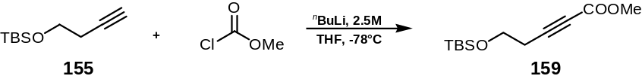

^{n}BuLi (2.5M, 1.1 eq., 71 mmol, 28.6 ml) (titrated according to Error: Reference source not found (page Error: Reference source not found) was added dropwise over 10 min to a solution of the alkyne 155 (1.0 eq., 12.0 g, 65 mmol) at -78°C in THF (100 ml). The mixture was warmed to 0°C, and cooled back down to -78°C before being transferred via cannula into a precooled (-78°C) solution of ClCO₂Me (1.1 eq., 6.8 g, 72 mmol) in THF (150 ml). The reaction mixture was then poured onto saturated NH₄Cl solution (200 ml), extracted with Et₂O (3 x 100 ml), the combined organic extracts washed with H₂O (100 ml), brine (100 ml), dried (MgSO₄), filtered and concentrated in vacuo. Purification by column chromatography (eluent PE:Et₂O 10:1 to 5:1, gradient) afforded the alkyne ester 159 (12.25 g, 50.6 mmol, 78%) as an oil; ν_{max} (film) /cm⁻¹: 2954, 2930, 2885, 2858, 2242, 1709, 1471, 1435, 1254, 1109, 1076, 1056, 908, 837, 710; δ_{H} (400 MHz, CDCl₃): 0.03 (6H, s, Si(CH₃) x 2), 0.86 (9H, s, SiC(CH₃)₃ x 1), 2.51 (2H, t, J 7.0, 4-H x 2), 3.70 (3H, s, OCH₃), 3.74 (2H, t, J 7.0, 5-H x 2); δ_{C} (100 MHz, CDCl₃): 153.9 (C=O), 86.7 (3-C), 73.6 (2-C), 60.6 (5-C), 52.4 (OCH₃), 25.7 (SiC(CH₃)₃ x 1), 23.0 (4-C), 18.2 (SiC(CH₃)₃), -5.4 (Si(CH₃) x 2); m/z (+EI): 265.1236 ([MNa]⁺, 100%), 266.1269 (13.3%), 266.1232 (5.1%), 267.1204 (3.4%). Found [MNa]⁺ 265.1233. [C₁₂H₂₂O₃SiNa]⁺ requires 265.1236. Data was consistent with the literature.^{151,152}

Preparation of 5-(tert-butyl-dimethyl-silanyloxy)-pent-2-yn-1-ol (156)
(Method 2)

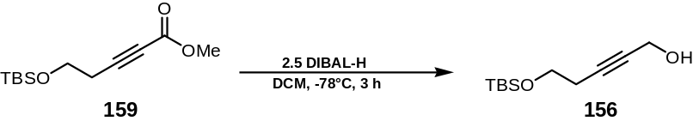

Alkynyl alcohol 156 was prepared according to Error: Reference source not found (page Error: Reference source not found) from alkyne ester 159 (8.1 g, 33.5 mmol). Workup as described and flash column chromatography (eluent PE:Et₂O 5:1) afforded alkynyl alcohol 156 (7.0 g, 32.6 mmol, 97%) as an oil; ν_{max} (film)/cm⁻¹: 3418 (OH), 2929, 2858, 2249, 1471, 1385, 1256, 1101, 1006, 905, 836, 778, 710; δ_{H} (400 MHz, CDCl₃): 0.04 (6H, s, Si(CH₃) x 2), 0.86 (9H, s, SiC(CH₃)₃ x 1), 2.40 (2H, t, J 7.3, 4-H x 2), 2.50 (1H, br s, OH), 3.69 (2H, t, J 6.9, 5-H x 2), 4.19 (2H, s, 1-H x 2); δ_{C} (100 MHz, CDCl₃): 83.0 (3-C), 79.6 (2-C), 61.8 (5-C), 51.0 (1-C), 25.8 (SiC(CH₃)₃ x 1), 23.1 (4-C), 18.3 (SiC(CH₃)₃), -5.1 (Si(CH₃) x 2); m/z (+EI): 237.1287 ([MNa]⁺, 100%), 238.1320 (12.2%), 238.1282 (5.1%), 239.1255 (3.4%). Found [MNa]⁺ 237.1288. [C₁₁H₂₂O₂SiNa]⁺ requires 237.1287. Spectral data was identical to that of the compound synthesised via method 1 (vide supra).

Preparation of 3-[2-(tert-butyl-dimethyl-silanyloxy)-ethyl]-oxiranyl-methanol (158)

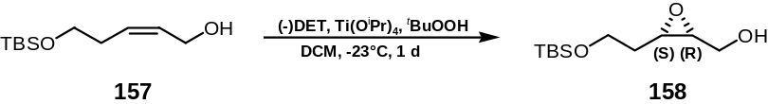

Epoxy alcohol 158 was prepared according to Error: Reference source not found (page Error: Reference source not found) from allylic alcohol 157 (0.35 g, 1.62 mmol), titanium tetraisopropoxide (MW=284.26, d=0.963, 1.0 eq., 1.62 mmol, 460 mg, 0.477 ml), (-)-D-diethyltartrate (MW=206.19, d=1.205, 1.2 eq., 1.94 mmol, 0.40 ml) and tert-butylhydroperoxide [5.0-6.0M solution in decanes] (2.0 eq., 3.24 mmol, 0.59 ml) in DCM (20 ml). Workup was performed as described with FeSO₄ (2.5 g) and D/L-tartaric acid (10%, 3.0 g in 30 ml H₂O). Purification by flash column chromatography (eluent PE:Et₂O 9:1 to 1:3, gradient) afforded epoxy alcohol 158 (150 mg, 0.65 mmol, 40% unoptimised) as a colourless oil; ν_{max} (film)/cm⁻¹: 3445 (OH), 2955, 2929, 2857, 1471, 1388, 1361, 1254, 1099, 1039, 1005, 925, 820, 811, 774, 661; δ_{H} (400 MHz, CDCl₃): 0.05 (6H, s, Si(CH₃) x 2), 0.87 (9H, s, SiC(CH₃)₃ x 1), 1.63-1.94 (2H, m, 4-H x 2), 3.04 (1H, s, OH), 3.05 (1H, dt, J 4.2, 5.1, 3-H x 1), 3.15 (1H, dt, J 4.2, 4.4, 2-H x 1), 3.57-3.75 (2H, m, 1-H x 2), 3.78 (2H, t, J 4.8, 5-H x 2); δ_{C} (100 MHz, CDCl₃): 60.5 (1-C), 60.4 (5-C), 55.9 (2-C), 54.8 (3-C), 30.7 (4-C), 25.9 (SiC(CH₃)₃ x 1), 18.4 (SiC(CH₃)₃), -5.5 (Si(CH₃) x 1), -5.6 (Si(CH₃) x 1); m/z (+EI): 255.1392 ([MNa]⁺, 100%), 256.1426 (12.2%), 256.1388 (5.1%), 257.1361 (3.4%). Found [MNa]⁺ 255.1393. [C₁₁H₂₄O₃SiNa]⁺ requires 255.1392.

Preparation of 3-[2-(tert-butyl-dimethyl-silanyloxy)-ethyl]-oxirane-2-carbaldehyde (152)

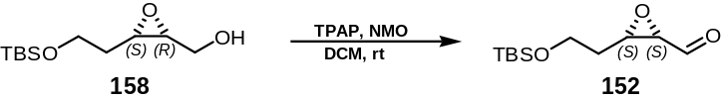

TPAP (MW=351.43, 5 mol%, 0.01 mmol, 3.5 mg) was added to epoxy alcohol 158 (50 mg, 0.2 mmol) and NMO (MW=117.15, 1.5 eq., 0.3 mmol, 37.8 mg) in DCM (5 ml) over 4Å molecular sieves (200 mg) at 0°C. The reaction mixture was stirred at this temperature for 3 h, then filtered through a small pad of Florisil, further eluted with Et₂O (200 ml) and washed with brine (50 ml). The phases were separated and the combined organic layers were dried (MgSO₄), filtered and concentrated in vacuo. Purification by flash column chromatography (eluent PE:Et₂O 10:1) afforded aldehyde 152 (22 mg, 0.095 mmol, 48% unoptimised) as an oil; δ_{H} (400 MHz, CDCl₃): 0.05 (6H, s, Si(CH₃) x 2), 0.86 (9H, s, SiC(CH₃)₃ x 1), 1.84-2.05 (2H, m, 4-H x 2), 3.35-3.44 (2H, m, 2-H x 1, 3-H x 1), 3.81 (2H, t, J 4.8, 5-H x 2), 9.45 (1H, d, J 5.1, 1-H x 1); δ_{C} (100 MHz, CDCl₃): 198.3 (1-C), 59.8 (5-C), 57.6 (2-C), 56.9 (3-C), 31.2 (4-C), 25.9 (SiC(CH₃)₃ x 1), 18.3 (SiC(CH₃)₃), -5.5 (Si(CH₃) x 2); which was used immediately in the next coupling step with the phosphonate 153 due to it’s instability.

Preparation of 6-chloromethyl-2,2-dimethyl-[1,3]dioxin-4-one (167)

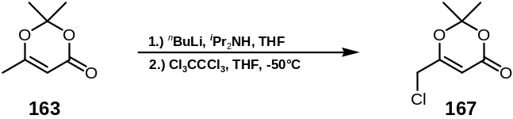

2,2,6-Trimethyl-1,3-dioxin-4-one 163 (24.3 g, 170 mmol, freshly distilled bp=28°C, 0.002 mbar) was added dropwise to a stirring solution of LDA (170 mmol), which was prepared according to Error: Reference source not found (page Error: Reference source not found), at -78°C. A bright yellow suspension formed, which was stirred for 20 min. It was then carefully transferred dropwise, over a period of 30 min, via dry Teflon® tubing to a stirred solution of hexachloroethane (MW=236.74, 59.18 g, 250 mmol), in THF (150 ml), which was precooled to -50°C under dry argon. The red solution thus formed was allowed to warm slowly to -10°C over 2 h, after which the reaction mixture was quenched by addition of ice cold dilute aqueous HCl (1.5M, 500 ml). The acidic solution was shaken to dispel the colour and extracted with Et₂O (3 x 300 ml). The combined Et₂O layers were washed with saturated aqueous NaHCO₃ solution (2 x 300 ml), dried (MgSO₄), filtered and concentrated in vacuo to yield a yellow oil containing crystalline hexachloroethane. This was removed by trituration with hexane (2 x 100 ml). Purification by flash column chromatography (eluent PE:Et₂O 3:1 to 2:1, gradient) afforded pure product 167 (9.85 g, 55.8 mmol, 33%) as an oil; ν_{max} (neat)/cm⁻¹: 3004, 2254, 1725, 1643, 1392, 1378, 1274, 1251, 1202, 1183, 1016, 904, 701; δ_{H} (400 MHz, CDCl₃): 1.68 (6H, s, CH₃ x 2), 4.00 (2H, s, CH₂), 5.51 (1H, s, CH); δ_{C} (100 MHz, CDCl₃): 164.5 (CO), 160.3 (C), 107.5 (C), 95.6 (CH), 40.9 (CH₂Cl), 24.7 (CH₃ x 2); m/z (+EI): 176.0240 ([MNa]⁺, 100%), 178.0211 (32%), 177.0274 (7.8%), 179.0244 (2.5%). Found [M]⁺ 176.0244. [C₇H₉O₃Cl]⁺ requires 176.0240. Data was consistent with those reported in the literature.¹⁵³

Preparation of 2,2-dimethyl-6-(diethylphosphonomethyl)-1,3-dioxin-4-one (153)

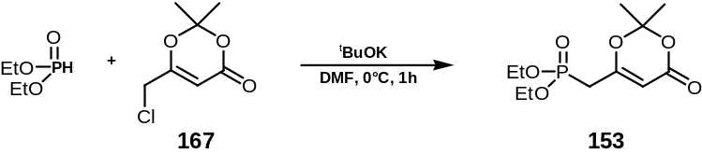

Diethylphosphite (13.81 g, 12.88 ml, 100 mmol, distilled bp=27°C, 0.002 mbar) was added dropwise to a stirring solution of ^{t}BuOK (11.22 g, 100 mmol) in DMF (60 ml), at 0°C. After 30 min, 2,2-dimethyl-6-chloromethyl-1,3-dioxin-4-one 167 (4.00 g, 22.6 mmol) in DMF (20 ml) was added dropwise over 20 min, and the deep purple solution generated was stirred at 0°C for a further 1h. Dropwise addition of concentrated HCl (5 ml) discharged the colour, and the pale brown mixture was filtered through Celite®, eluting with Et₂O (100 ml). The combined organic washings were concentrated in vacuo, keeping the bath temperature below 40°C. Excess DMF and diethyl phosphite were removed by vacuum distillation (0.01 mbar, < 45°C) affording the crude product as a thick brown oil, which was diluted with EtOAc (50 ml) and left at 0°C overnight. The solution was decanted from the crystals thus formed, and reduced in vacuo. Purification by flash column chromatography (eluent Et₂O:EtOAc 1:1 to 1:4, gradient) yielded compound 153 (3.07 g, 11 mmol, 49%) as a pale yellow oil; ν_{max} (neat)/cm⁻¹: 3400 (br), 2984, 2910, 1725, 1633, 1443, 1374, 1252, 1020, 778; δ_{H} (400 MHz, CDCl₃): 1.27 (6H, t, J 7.0, CH₃ x 2), 1.68 (6H, s, CH₃ x 2), 2.70 (2H, d, J 22.4, CH₂), 4.05 (4H, m, CH₂ x 2), 5.31 (1H, d, J 3.7, CH); δ_{C} (100 MHz, CDCl₃): 163.0 (CO), 159.9 (C), 106.9 (C), 95.9 (d, J_{13CP} 8.84, CH), 62.4 (d, J_{13CP} 6.51, CH₂ x 2), 32.1 (d, J_{13CP} 131.0, CH₂), 24.9 (CH₃ x 2), 16.2 (d, J_{13CP} 6.55, CH₃ x 2); m/z (+EI): 301.0809 ([MNa]⁺, 100%), 302.0850 (12.2%), 303.0859 (1.2%). Found [MNa⁺] 301.0809. [C₁₁H₁₉O₆PNa]⁺ requires 301.0817. Data was consistent with those reported in the literature.¹⁵³

Preparation of 6-(2-(3-[2-(tert-butyl-dimethyl-silanyloxy)-ethyl]-oxiranyl)-vinyl)-2,2-dimethyl-[1,3]dioxin-4-one (151)

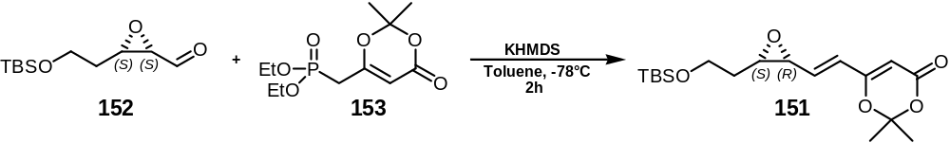

KHMDS [0.5M solution in toluene, MW=199.49, d=0.877] (22 mg, 0.095 mmol, 2.2 eq.) was added to phosphonate ester 153 (53 mg, 0.19 mmol, 2.0 eq.) in toluene (3 ml) at -78°C, and stirring continued for 30 min at that temperature. Epoxy aldehyde 152 (22 mg, 0.095 mmol) was injected via cannula over 1 min, and the reaction mixture was stirred at -25°C for 2 h. The reaction mixture was then poured onto EtOAc (40 ml) and washed with saturated NH₄Cl solution (30 ml). The phases were separated and the aqueous layer re-extracted with EtOAc (20 ml). The combined organic phases were washed with brine (40 ml), dried (MgSO₄), filtered and concentrated in vacuo. Purification by flash column chromatography (eluent PE:Et₂O 5:1 to 1:2, gradient) afforded epoxy alkene 151 (12 mg, 0.034 mmol, 36%) as an oil; ν_{max} (film)/cm⁻¹: 3020, 2979, 2859, 1716, 1654, 1595, 1391, 1276, 1255, 1215, 1108, 1021, 967, 908, 833, 810, 748, 667; δ_{H} (400 MHz, CDCl₃): 0.06 (6H, s, Si(CH₃) x 2), 0.89 (9H, s, SiC(CH₃)₃ x 1), 1.56 (2H, m, CH₂), 1.68 (6H, s, CH₃ x 2), 3.33 (1H, app. q, J 4.4, CH), 3.55 (1H, app. t, J 6.2, CH), 3.77 (2H, t, J 5.9, CH₂), 5.34 (1H, s, =CH), 6.21 (1H, d, J 15.7, =CH), 6.41 (1H, dd, J 15.7, 6.6, =CH); δ_{C} (100 MHz, CDCl₃): 161.7, 161.5, 134.7, 126.2, 106.6, 95.2, 60.1, 57.8, 55.7, 31.0, 25.9 (SiC(CH₃)₃ x 1), 25.1, 24.9, 18.3 (SiC(CH₃)₃), -5.4 (Si(CH₃) x 1), -5.5 (Si(CH₃) x 1); m/z (+EI): 377.1759 (85%), 319.1346 (82%), 316.2163 (100%), 287.1513 (30%), 263.0670 (38%), 243.1133 (28%). Found [MNa]⁺ 377.1759. [C₁₈H₃₀O₅SiNa]⁺ requires 377.1760.

Preparation of methyl-(Z)-5-tert-butyldimethylsilyloxy-2-pentenoate (162)

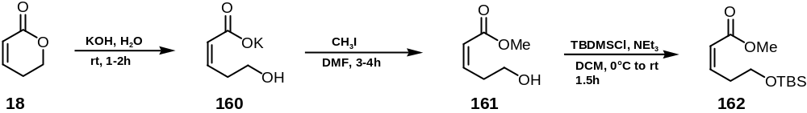

KOH (2.40 g, 42.8 mmol, 1.2 eq.) was added to a solution of commercially available 5,6-dihydro-2-pyrone 18 (MW=98.10, 3.50 g, 35.6 mmol) in H₂O (30 ml). After 2.5 h stirring at rt, the solvent was removed in vacuo, and the resulting residue dried for 24 h over P₂O₅ in a dessiccator. The K-salt 160 was then dissolved in little DMF (20 ml) and MeI (MW=141.94, d=2.280, 5.0 eq., 178 mmol, 25.3 g, 11.1 ml) was added under stirring. After 3 h at rt the mixture was poured onto crushed ice (150 ml) and extracted with Et₂O (3 x 100 ml). The combined organic layers were washed with brine (150 ml) and dried (MgSO₄) to afford, after removal of the solvent, crude product methyl-(Z)-5-hydroxy-2-pentenoate 161, contaminated with small amounts of DMF. This crude product was dissolved in CH₂Cl₂ (30 ml) and subsequently NEt₃ (MW=101.19, d=0.726, 1.2 eq., 25.8 mmol, 2.61 g, 3.6 ml), TBSCl (MW=150.73, 1.2 eq., 25.8 mmol, 3.88 g) and DMAP (MW=122.17, 400 mg) were added at 0°C. The reaction mixture was allowed to warm to rt over 1.5 h, before it was diluted with Et₂O (250 ml), washed very quickly (30 sec.) with 1-N HCl (200 ml), then washed with pH 7 buffer solution (100 ml) (prepared according to Error: Reference source not found (page Error: Reference source not found). The phases were separated and the combined organic phases washed with brine (100 ml), dried (MgSO₄), filtered and concentrated in vacuo. Purification by column chromatography (eluent PE:Et₂O 9:1) afforded the product 162 (3.9 g, 15.9 mmol, 45% over 3 steps) as an oil; ν_{max} (film)/cm⁻¹: 2954, 2929, 2857, 1724, 1645, 1472, 1438, 1407, 1254, 1172, 1098, 1006, 811, 776; δ_{H} (400 MHz, CDCl₃): 0.02 (6H, s, Si(CH₃) x 2), 0.86 (9H, s, SiC(CH₃)₃ x 1), 2.81-2.86 (2H, m, 4-H x 2), 3.67 (3H, s, OCH₃), 3.70 (2H, t, J 6.2, 5-H x 2), 5.82 (1H, d, J 11.3, 2-H x 1), 6.28-6.36 (1H, m, 3-H x 1); δ_{C} (100 MHz, CDCl₃): 166.6 (C=O), 147.2 (=C), 120.3 (=C), 61.9 (CH₂O), 50.9 (OCH₃), 32.5 (CH₂), 25.9 (SiC(CH₃)₃), 18.5 (SiC(CH₃)₃), -5.3 (Si(CH₃) x 2); m/z (+EI): 287.1397 (68%), 269.1458 (5%), 268.1417 (18%), 267.1396 (100%), 243.1183 (21%). Found [MNa]⁺ 267.1396. [C₁₂H₂₄O₃SiNa]⁺ requires 267.1392. Spectral data was identical to that of the compound reported in the literature.¹⁵⁰

Preparation of 5-(tert-butyl-dimethyl-silanyloxy)-pent-2-(Z)-en-1-ol (157) (Method 2)

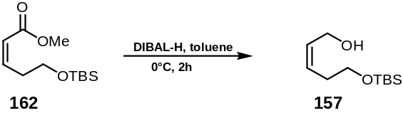

DIBAL-H (1M solution in toluene, MW=142.44, d=0.848, 2.3 eq., 9.4 mmol, 1.34 g, 9.4 ml) was added according to Error: Reference source not found (page Error: Reference source not found) to the ester 162 (1.0 g, 4.1 mmol) in toluene (20 ml). Workup as described and purification by flash column chromatography (eluent PE:Et₂O 5:1) afforded alcohol 157 (0.8 g, 3.7 mmol, 90%). The characterization data were identical to those reported above (10) and to those in the literature.¹⁵⁰

Experimental procedures for chapter 4: novel C-2 connected complexes

Preparation of 2-chloro-3-phenylpropanal (191)

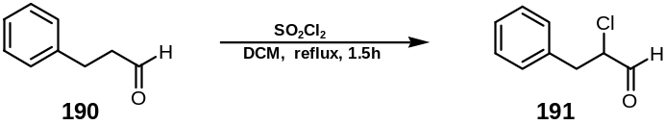

A solution of sulfurylchloride (8.0 ml, 0.1 mol) in DCM (20 ml) was added dropwise to a solution of freshly distilled hydrocinnamaldehyde 190 (13.2 ml, 0.1 mol) in DCM (15 ml) at 0°C and the reaction mixture was then allowed to warm to rt. After 1 h at this temperature, the reaction was heated to reflux for a further 30 min. Distillation under reduced pressure (p=0.5mmHg) afforded the desired mono-chlorinated product. Purification by flash column chromatography (eluent Et₂O:PE 1:3) afforded 2-chloro-3-phenylpropanal 191 (7.6 g, 45%) as a colourless oil.∗ δ_{H} (600 MHz, CDCl₃): 3.10 (1H, dd, J 14.5, 8.3, 3´-H x 1), 3.39 (1H, dd, J 14.5, 5.7, 3-H x 1), 4.40 (1H, ddd, J 2.2, 5.0, 8.0; 2-H x 1), 7.24-7.38 (5H, m, aryl-H x 5), 9.55 (1H, d, J 2.0, 1-H x 1); m/z (EI): Found: [M]⁺ 168.0339. [C₉H₉ClO]⁺ requires 168.0342. Data were consistent with those reported in the literature.¹⁵⁴

Preparation of 2-chloroheptanal (306)

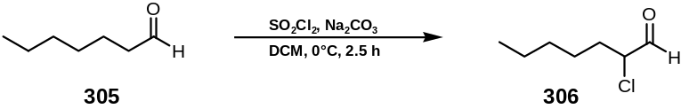

A solution of sulfurylchloride (8.0 ml, 0.1 mmol) in DCM (15 ml) was added dropwise to a solution of freshly distilled heptaldehyde 305 (15.0 ml, 0.1 mmol) in DCM (15 ml) at –10°C and the reaction mixture was allowed to warm to 10-15°C. After 30 min at this temperature the reaction mixture was heated to 50°C and stirred for 2 h. Ice water (100 ml) was then added and the combined phases were extracted with Et₂O (2 x 50 ml) and dried over MgSO₄. Filtration and distillation under reduced pressure (p=0.1mmHg, 25°C) afforded a mixture of desired mono-chlorinated product 306 and (2E)- and (2Z)-hept-2-enal (95:5 – 90:10). Separation by flash column chromatography (eluent Et₂O:PE 1:5) afforded the α-chloro-heptanal 306 (6.1 g, 40%) as a colourless oil. δ_{H} (200 MHz, CDCl₃): 0.85 (3H, t, J 7.1, 7-H x 3), 1.25-1.70 (6H, m, 4-H x 2, 5-H x 2, 6-H x 2), 1.82 – 1.87 (2H, m, 3-H x 2), 4.10 (1H, td, J 8.5, 3.2, 2-H x 1), 9.61 (1H, d, J 2.2, 1-H x 1); m/z (EI): Found: [M]⁺ 148.0641. [C₇H₁₃ClO]⁺ requires 148.0655. Data were consistent with those reported in the literature.^{155,154}

Preparation of 5-chloro-4-hydroxy-3-methylene-6-phenyl-hex-2-one (192)

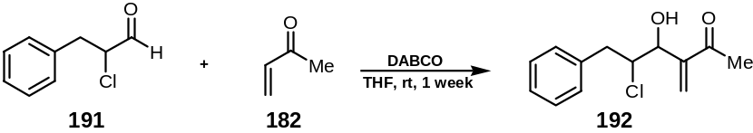

Freshly distilled methylvinylketone 182 (0.31 g, 0.37 ml, 4.4 mmol) was added dropwise to a stirred solution of the α-chlorophenylaldehyde 191 (0.74 g, 4.4 mmol) and DABCO catalyst (0.112 g, 1 mmol) in dry THF (6 ml) at rt. The solution was stirred for one week and then diluted with Et₂O (5 ml). The mixture was then washed with 3N-HCl (2 x 5 ml) and the aqueous layer extracted with Et₂O (2 x 10 ml). The combined organic fractions were washed with Na₂CO₃ solution (10 ml), dried (MgSO₄), filtered and then concentrated in vacuo. Purification was readily achieved by flash column chromatography on silica gel (eluent Et₂O:PE 1:2) and afforded an inseparable mixture of cis and trans diastereoisomeric (ratio 2:1) chloro-hydroxy-phenyl-enones 192 (0.30 g, 29%) as a dark yellow oil; ν_{max} (film)/cm⁻¹: 3446 br (OH), 3062, 3029, 2922, 1672 (C=O), 1604 (C=C), 1496, 1454, 1366, 1299, 1135, 1078, 974, 670; δ_{H} (600 MHz, CDCl₃): 2.35 (3H´, s, 1-H´ x 3), 2.37 (3H, s, 1-H x 3), 2.51 (1H´, d, J 9.0, OH´ x 1), 2.57 (1H´, m , 6-H_{b}´ x 1), 2.90 (1H, dd, J 15.0, 9.5, 6-H_{b} x 1), 3.21 (1H´, m, 6-H_{a}´ x 1), 3.33 (1H, dd, J 15.0, 3.0, 6-H_{a} x 1), 3.36 (1H, d, J 8.0, OH x 1), 4.37 (1H, td, J 11.0, 4.1, 5-H x 1), 4.45 (1H´, td, J 8.0, 2.0, 5-H´ x 1), 4.48 (1H, app. t, J 7.0, 4-H x 1), 4.71 (1H´, app. d, J 9.0, 4-H´ x 1), 6.14 (1H´, s, 3-H_{a}´ x 1), 6.16 (1H, s, 3-H_{a} x 1), 6.25 (1H, s, 3-H_{b} x 1), 6.29 (1H´, s, 3-H_{b}´ x 1), 7.24-7.38 (5H+5H´, m, aryl-H x 5); δ_{C} (50 MHz, CDCl₃): 198.6 (C=O), 198.5, 145.0 (C), 142.7 (C), 137.3 (CH₂), 136.7 (CH₂), 129.1, 128.6, 126.7, 124.0 (aryl-C), 62.5 (CH), 59.0 (CH), 55.2 (CH), 54.9 (CH), 38.5 (CH₂), 32.8 (CH₂), 26.1 (CH₃), 26.0 (CH₃); m/z (+EI) Found: [MNa]⁺ 261.0633. [C₁₃H₁₅O₂ClNa]⁺ requires 261.0658.

Preparation of 5-chloro-4-hydroxy-deca-2-one (197)

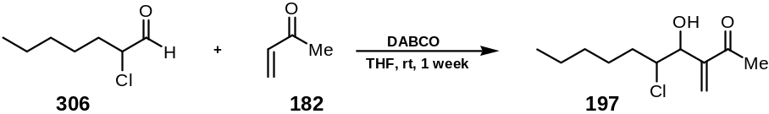

Freshly distilled methylvinylketone 182 (1.4 g, 1.66 ml, 20.0 mmol) was added dropwise to a stirred solution of the α-chloroaldehyde 306 (3.0 g, 20.0 mmol) and DABCO (0.56 g, 5.0 mmol) in dry THF (10 ml) at rt. The solution was stirred at this temperature for one week. The reaction was then diluted by adding Et₂O (100 ml) and the reaction mixture was washed with 3N-HCl (2 x 25 ml). The aqueous layer was extracted with Et₂O (2 x 50 ml). The combined organic fractions were washed with Na₂CO₃ solution (50 ml), dried (MgSO₄), filtered and then concentrated in vacuo. Purification by flash column chromatography (eluent Et₂O:PE 1:2) afforded an inseparable mixture (ratio 3:2) of alkyl-chloro-hydroxy-enones 197 (2.11 g, 48%) as a brown oil; ν_{max} (film)/cm⁻¹: 3464 br (OH), 2956, 2929, 2859, 1711, 1672 (C=O), 1637 (C=C), 1461, 1431, 1365, 1259, 1110, 1078, 1022, 975, 887, 799; δ_{H} (200 MHz, CDCl₃): 0.85 (3H, app. t, J 7.0, 10-H x 3), 1.20-1.88 (8H, m, 9-H x 2, 8-H x 2, 7-H x 2, 6-H x 2), 2.37 (3H, s, 1-H x 3 and 1-H´ x 3), 2.44 (1H, d, J 9.0, OH´ x 1), 3.15 (1H, d, J 7.0, OH x 1), 4.16 (1H, m, 5-H x 1), 4.19 (1H, m, 5-H´ x 1), 4.43 (1H, t, J 7.0, 4-H x 1), 4.68 (1H, m, 4-H´ x 1), 6.11 (1H, s, 3-H_{a}´ x 1), 6.13 (1H, s, 3-H_{a} x 1), 6.23 (1H, s, 3-H_{b} x 1), 6.27 (1H, s, 3-H_{b}´ x 1); δ_{C} (50 MHz, CDCl₃): 200.7 (C=O, 2-C´), 199.4 (C=O, 2-C), 147.6 (C, 3-C´), 145.9 (C, 3-C), 129.1 (=CH₂, 3_{a}-C´), 127.4 (=CH₂, 3_{a}-C), 75.9 (CH, 4-C´), 71.8 (CH, 4-C), 67.2 (CH, 5-C´), 64.9 (CH, 5-C), 35.4 (CH₂, 6-C and 6-C´), 32.5 (CH₂, 7-C and 7-C´), 31.2 (CH₂, 8-C and 8-C´), 25.9 (CH₃, 1-C), 22.4 (CH₂, 9-C and 9-C´), 13.9 (CH₃, 10-C and 10-C´); m/z (+EI) Found: [MNa]⁺ 241.0982. [C₁₁H₁₉O₂ClNa]⁺ requires 241.0971.

Preparation of (4R*,5R*),(4S*,5R*)-epoxy-3-methylene-6-phenyl-hex-2-one (193) (Method 1)

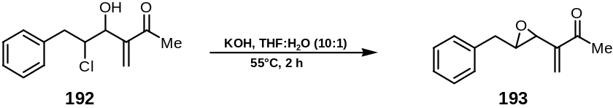

A mixture of cis/trans (2:1) chloro-hydroxy-phenyl-enones 192 (2.88 g, 12.1 mmol) was slowly injected through a gas-tight syringe into 10 ml THF : H₂O (10:1) solution at 55°C, which contained KOH (0.5 g, 8.9 mmol, MW=56.10). The reaction was stirred at this temperature for approximately 2 h and then worked up by the addition of Et₂O (100 ml). The mixture was washed with brine (2 x 20 ml). The aqueous layer was extracted with Et₂O (2 x 30 ml). The combined organic fractions were washed with saturated Na₂CO₃ solution (50 ml), dried (MgSO₄), filtered and then concentrated in vacuo. Purification by flash column chromatography on silica gel (eluent Et₂O:PE 1:1 to 100% Et₂O, gradient) afforded an inseparable mixture (ratio 2:1) of cis and trans epoxy-phenyl-enones 193 (0.75 g, 3.7 mmol, 31%) as a yellow oil; ν_{max} (film)/cm⁻¹: 3029, 2919, 1676 (C=O), 1631 (C=C), 1604, 1496, 1454, 1432, 1372, 1287, 980, 665; δ_{H} (400 MHz, CDCl₃): 2.35 (3H, s, 1-H x 3), 2.39 (3H´, s, 1-H´ x 3), 2.65 (2H´, m, 6-H´ x 2), 2.84 (1H, td, J 6.1, 2.0, 5-H), 2.95 (2H, m, 6-H x 2), 3.48 (1H´, t J 7.0, 5-H´), 3.69 (1H, dd, J 1.0, 0.9, 4-H), 3.94 (1H´, dd, J 3.0, 0.8, 4-H´), 5.92 (1H, s, 3-H_{a}), 6.03 (1H, s, 3-H_{b}), 6.05 (1H´, s, 3-H_{a}´), 6.31 (1H´, s, 3-H_{b}´), 7.24-7.38 (5H+5H´, m, aryl-H x 5); δ_{C} (50 MHz, CDCl₃): 198.6 (C=O, C-2´), 198.5 (C=O, C-2), 145.1 (C, 3-C´), 142.8 (C, 3-C), 137.3, 136.8, 129.1, 128.5 (aryl-C), 126.7 (=CH₂, 3-C_{a}´), 124.1 (=CH₂, 3-C_{a}), 62.55 (CH, 5-C), 59.0 (CH, 5-C´), 55.2 (CH, 4-C´), 54.9 (CH, 4-C), 38.5 (CH₂, 6-C), 32.8 (CH₂, 6-C´), 26.1 (CH₃, 1-C); m/z (+EI) Found: [MNa]⁺ 225.0887. [C₁₃H₁₄O₂Na]⁺ requires 225.0891.

Preparation of (4R*,5R*),(4S*,5R*)-epoxy-3-methylene-deca-2-one (198)

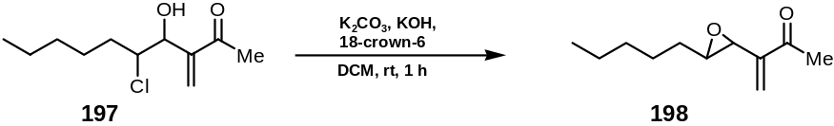

18-Crown-6 (1.21 g, 4.5 mmol), potassium hydroxide (well ground, used as powder, 0.25 g, 4.5 mmol) and K₂CO₃ (0.62 g, 4.5 mmol) were added into a round bottomed flask. The flask was then warmed to 70°C (with a waterbath) and put on a high vacuum line for 30 min – 1 h to evaporate residual water and dry the contents fully. DCM (20 ml) was injected via a syringe, under an argon atmosphere. Alkyl-chloro-hydroxy-enone 197 (0.40 g, 1.8 mmol) in DCM (5 ml) was transferred dropwise via a cannula needle into the base mixture and stirred at rt for approximately 1 h. The reaction mixture was then worked up by addition of Et₂O (250 ml) and was washed with NaHCO₃ solution (2 x 50 ml). The aqueous layer was extracted with Et₂O (2 x 50 ml) and the combined organic fractions washed with Na₂CO₃ solution (50 ml), dried over MgSO₄, filtered and then concentrated in vacuo. Purification by flash column chromatography (eluent Et₂O:PE 1:4) afforded the epoxy-alkyl-enones 198 (0.34 g, 1.8 mmol, 95%) as an inseparable mixture (1:2) of cis and trans diastereoisomers as a bright yellow oil; ν_{max} (film)/cm⁻¹: 2957, 2929, 2858, 1678 (C=O), 1630 (C=C), 1458, 1377, 1288, 1117, 1023, 949, 922; δ_{H} (200 MHz, CDCl₃): 0.88 (3H, t, J 7.0, 10-H x 3), 1.20–1.88 (8H+8H´, m, 9-H, H´ x 2, 8-H, H´ x 2, 7-H, H´ x 2, 6-H, H´ x 2), 2.36 (3H, s, 1-H), 2.37 (3H´, s, 1-H´), 2.60 (1H, td, J 6.0, 2.1, 5-H), 3.18 (1H´, app. q, J 4.6, 5-H´), 3.54 (1H, m, 4-H), 3.83 (1H´, m, 4-H´), 5.90 (1H, s, 3-H_{a}), 5.91 (1H´, s, 3-H_{a}´), 6.02 (1H, s, 3-H_{b}), 6.21 (1H´, s, 3-H_{b}´); δ_{C} (50 MHz, CDCl₃): 145.8 (C=O, 2-C) 125.2 (C, 3-C), 123.8 (=CH₂, 3_{a/b}-C), 62.8 (CH, 4-C), 54.7 (CH, 5-C), 32.0 (CH₂, 6-C), 31.6 (CH₂, 7-C), 31.5 (CH₂, 7-C’), 30.3 (CH₂, 8-C), 25.3 (CH₃, 1-C), 22.5 (CH₂, 9-C), 13.9 (CH₃, 10-C); m/z (+EI) Found: [MNa]⁺ 205.1201. [C₁₁H₁₈O₂Na]⁺ requires 205.1204.

Preparation of (4R*,5R*),(4S*,5R*)-epoxy-3-methylene-6-phenyl-hex-2-one (193) (Method 2)

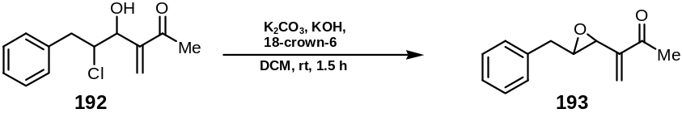

KOH (0.39 g, 7 mmol), K₂CO₃ (0.96 mg , 7 mmol) and 18-crown-6 (3.96 g, 15 mmol) were prepared and dried as previously described (vide supra). After the base mixture was dried, DCM (200 ml) was added. The phenyl-chloro-hydroxy-enone 192 (0.80 g, 3.4 mmol) was dissolved in DCM (50 ml) and transferred slowly via a cannula needle into the base mixture flask. The reaction was stirred at room temperature until completion, taking approximately 1.5 h. The reaction was then worked up by addition of Et₂O (500 ml) and was washed with NH₄Cl solution (2 x 250 ml). The aqueous layer was extracted with Et₂O (2 x 150 ml) and the combined organic fractions were washed with Na₂CO₃ solution (50 ml), dried over MgSO₄, filtered and then concentrated in vacuo. Purification by flash column chromatography (eluent Et₂O:PE 1:3) afforded a mixture (ratio 2:1) of inseparable epoxy-phenyl-enones 193 (0.25 g, 1.25 mmol, 37%) as a yellow oil; ν_{max} (film)/cm⁻¹: 3029, 2919, 1676 (C=O), 1631 (C=C), 1604, 1496, 1454, 1432, 1372, 1287, 980, 665; δ_{H} (400 MHz, CDCl₃): 2.35 (3H, s, 1-H x 3), 2.39 (3H´, s, 1-H´ x 3), 2.65 (2H´, m, 6-H´ x 2), 2.84 (1H, td, J 6.1, 2.0, 5-H), 2.95 (2H, m, 6-H x 2), 3.48 (1H´, t, J 7.0, 5-H´), 3.69 (1H, dd, J 1.0, 0.9, 4-H), 3.94 (1H´, dd, J 3.0, 0.8, 4-H´), 5.92 (1H, s, 3-H_{a}), 6.03 (1H, s, 3-H_{b}), 6.05 (1H´, s, 3-H_{a}´), 6.31 (1H´, s, 3-H_{b}´), 7.24-7.38 (5H+5H´, m, aryl-H x 5); δ_{C} (50 MHz, CDCl₃): 198.6 (C=O, C-2´), 198.5 (C=O, C-2), 145.1 (C, 3-C´), 142.8 (C, 3-C), 137.3, 136.8, 129.1, 128.5 (aryl-C), 126.7 (=CH₂, 3-C_{a}´), 124.1 (=CH₂, 3-C_{a}), 62.6 (CH, 5-C), 59.0 (CH, 5-C´), 55.2 (CH, 4-C´), 54.9 (CH, 4-C), 38.5 (CH₂, 6-C), 32.8 (CH₂, 6-C´), 26.1 (CH₃, 1-C); m/z (+EI) Found: [MNa]⁺ 225.0896. [C₁₃H₁₄O₂Na]⁺ requires 225.0891.

Preparation of [(3-EZ, 5RS)-5-(carbonyloxy-κC)-3-methylene-2-oxo-6-phenyl-(1´,3,4-η)-hex-3-en-1´-yl]-tricarbonyliron (199), [(3-EZ, 5SR)-5-(carbonyloxy-κC)-3-methylene-2-oxo-6-phenyl-(1´,3,4-η)-hex-3-en-1´-yl]-tricarbonyliron (200) and [(1´,3,4,5-η)-3-methylene-2-oxo-6-phenyl-hex-3-en-(1´,5)-diyl]-tricarbonyliron (201)

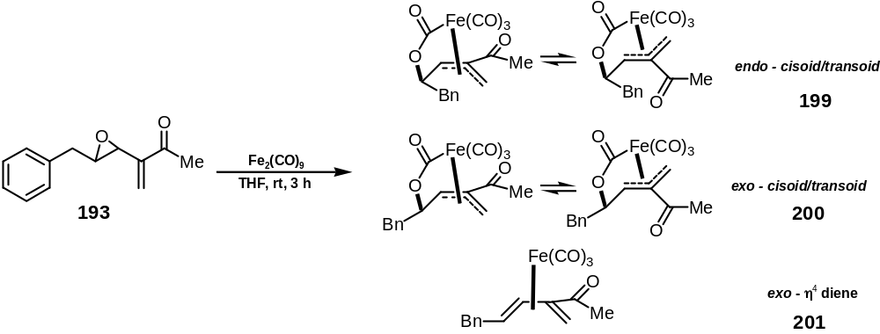

Compounds 199, 200 and 201 were prepared according to Error: Reference source not found (page Error: Reference source not found) with addition of phenyl epoxide 193 (0.25 g, 1.25 mmol) in THF (5 ml) to a suspension of Fe₂(CO)₉ (1.12 g, 3.1 mmol, 2.5 eq.) in THF (20 ml). Purification via flash column chromatography (eluent Et₂O:PE 2:98 to 100:0, gradient) afforded the products as a complex equilibrium (transoid/cisoid species) of a mixture of endo/exo (3:1) complexes and η⁴-diene complex (ratio 3:1:1), overall yield 38%. The data was obtained on the individual complexes after partial separation by flash column chromatography.
Compound 199: ν_{max} (film)/cm⁻¹: 2933, 2360, 2084, 2012, 1745 (C=O), 1673 (C=C), 1496, 1454, 1379, 1205, 965, 922; δ_{H} (600 MHz, CDCl₃): 1.72 (3H, s, 1-H x 3), 1.79 (1H, s, 4-H), 3.05 (1H, m, 6-H_{a}), 3.18 (1H, m, 6-H_{b}), 3.60 (1H, s, 1´-H_{a}), 4.33 (1H, s, 1´-H_{b}), 5.17 (1H, app. t, 5-H), 7.18-7.37 (5H, m, aryl-H x 5); δ_{C} (50 MHz, CDCl₃): 180.3 (CO), 174.8 (CO), 170.4 (CO), 135.9, 129.7, 128.9, 128.8, 128.6, 127.0 (aryl-C), 84.0, 80.0, 65.8, 43.8, 37.8, 24.3, 15.3; m/z (CI): 371 ([MH]⁺, 30%), 242 ([M-(CO⁻)₄O], 100%). Found: [MH]⁺ 371.0248 [C₁₇H₁₅O₆Fe]⁺ requires 371.0218.
Compound 200: ν_{max} (film)/cm⁻¹: 2930, 2350, 2068, 2005, 1997, 1733 (C=O), 1673 (C=C), 1495, 1455, 1372, 1255, 1179, 1096, 1029; δ_{H} (600 MHz, CDCl₃): 2.42 (3H, s, 1-H x 3), 2.43 (1H, s, 4-H), 3.02 (1H, dd, J 13.0, 6.1, 6-H_{a}), 3.20 (1H, dd, J 13.0, 6.1, 6-H_{b}), 3.64 (1H, d, J 20.2, 1´-H_{a}), 3.85 (1H, d, J 20.2, 1´-H_{b}), 5.05 (1H, app. t, J 5.8, 5-H), 7.27-7.40 (5H, m, aryl-H x 5); δ_{C} (50 MHz, CDCl₃): 209.1 (CO), 206.7 (CO), 202.2 (CO), 167.3 (C=O), 139.8, 135.7, 129.2, 128.8, 128.7, 127.2 (aryl-C), 89.5, 80.4, 59.6, 43.6, 32.5, 22.6, 17.4; m/z (CI): 371 ([MH]⁺, 100%), 287 ([M-3CO]⁺, 55%). Found: [MH]⁺ 371.1045. [C₁₇H₁₅O₆Fe]⁺ requires 371.0218.
Compound 201: ν_{max} (film)/cm⁻¹: 3029, 2925, 2096, 2050, 1976, 1683 (C=O), 1602 (C=C), 1495, 1454, 1365, 1250, 748, 700; δ_{H} (600 MHz, CDCl₃): 0.24 (1H, s, 1´-H_{a}), 1.48 (1H, s, 5-H), 2.23 (1H, s, 1´-H_{b}), 2.42 (3H, s, 1-H x 3), 2.97 (1H, dd, J 15.0, 6.0, 6-H_{a} x 1), 3.04 (1H, dd, J 15.0, 6.0, 6-H_{b} x 1), 6.07 (1H, d, J 9.3, 4-H), 7.24-7.36 (5H, m, aryl-H x 5); m/z (CI): 327 ([MH]⁺, 20%), 242 ([M-3CO]⁺, 100%). Found: [MH]⁺ 327.0351. [C₁₆H₁₅O₄Fe]⁺ requires 327.0320.

Preparation of [(3-EZ, 5RS)-5-(carbonyloxy-κC)-3-methylene-2-oxo-(1´,3,4-η)-deca-1´-yl]-tricarbonyliron (202), [(3-EZ, 5SR)-5-(carbonyloxy-κC)-3-methylene-2-oxo-(1´,3,4-η)-deca-1´-yl]-tricarbonyliron (203) and [(1´,3,4,5-η)-3-methylene-2-oxo-deca-3-en-(1´,5)-diyl]-tricarbonyliron (204)

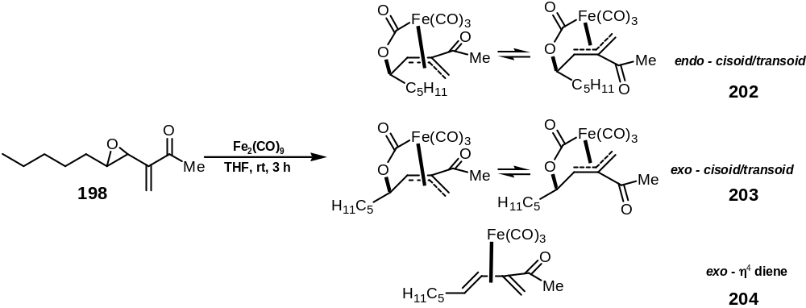

Compounds 202, 203 and 204 were prepared using Error: Reference source not found (page Error: Reference source not found) with addition of alkyl-epoxide 198 (0.34 g, 1.8 mmol) in THF (5 ml) to a suspension of Fe₂(CO)₉ (1.82 g, 5.0 mmol, 2.5 eq.) in THF (25 ml). Purification by flash column chromatography (eluent Et₂0:PE 2:98 to 3:2, gradient) afforded the products as a complex equilibrium (cisoid/transoid species) of a mixture of endo/exo (2:1) complexes and η⁴-diene complex as yellow oils (ratio 2:1:6), in an overall yield of 25%. The data was obtained on the individual complexes after partial separation by flash column chromatography.
Compound 202: ν_{max} (film)/cm⁻¹: 2931, 2859, 2249, 2088, 2018, 1674 (C=O), 1498, 1466, 1418, 1361, 1309, 1234, 1174, 1113, 1018, 915, 864, 732, 654, 612; δ_{H} (600 MHz, CDCl₃): 0.92 (3H, s, 10-H x 3), 1.23–1.90 (8H, m, 9-H x 2, 8-H x 2, 7-H x 2, 6-H x 2), 2.37 (3H, s, 1-H x 3), 3.25 (2H, m, 1´-H_{a/b}), 5.12 (1H, br s, 5-H x 1), 6.78 (1H, br s, 4-H); δ_{H} (600 MHz, C₆D₆): 0.95 (3H, s, 10-H x 3), 1.24–1.57 (8H, m, 9-H x 2, 8-H x 2, 7-H x 2, 6-H x 2), 1.78 (3H, s, 1-H x 3), 3.05 (1H, d, J 19.0, 1´-H_{a}), 3.20 (1H, d, J 19.0, 1´-H_{b}), 4.35 (1H, br s, 5-H), 5.85 (1H, br s, 4-H); δ_{C} (50 MHz, CDCl₃): 210.1, 209.2, 207.1 (3 x CO), 167.6 (C=O), 135.5, 89.7, 79.1, 60.3, 35.1, 31.4, 28.0, 25.1, 24.9, 17.4, 14.0; m/z (CI): 351 ([MH]⁺, 100%), 266 ([M-3CO]⁺, 64%). Found: [MH]⁺ 351.0512. [C₁₅H₁₉O₆Fe]⁺ requires 351.0531.
Compound 203: ν_{max} (film)/cm⁻¹: 2930, 2862, 2068, 1988, 1746, 1677 (C=O), 1468, 1380, 1351, 1293, 1253, 1234, 1177, 1125, 1090, 1024, 621; δ_{H} (600 MHz, CDCl₃): 0.94 (3H, s, 10-H x 3), 1.23–1.89 (8H, m, 9-H x 2, 8-H x 2, 7-H x 2, 6-H x 2), 2.45 (3H, s, 1-H x 3), 2.46 (1H, s, 4-H), 3.80 (2H, m, 1´-H_{a/b}), 4.87 (1H, br. s, 5-H); δ_{H} (600 MHz, C₆D₆): 0.95 (3H, s, 10-H x 3), 1.24–1.80 (8H, m, 9-H x 2, 8-H x 2, 7-H x 2, 6-H x 2), 1.90 (3H, s, 1-H x 3), 2.11 (1H, s, 4-H), 2.82 (1H, d, J 18.0, 1´-H_{a}), 3.40 (1H, d, J 18.0, 1´-H_{b}), 4.19 (1H, br s, 5-H); δ_{C} (50 MHz, CDCl₃): 210.2, 209.3, 207.1 (3 x CO), 167.6 (C=O), 138.8, 89.7, 79.5, 60.4, 31.7, 32.3, 31.4, 24.2, 22.4, 17.4, 13.9; m/z (CI): 351 ([MH]⁺, 100%), 266 ([M-3CO]⁺, 47%). Found: [MH]⁺ 351.0528. [C₁₅H₁₉O₆Fe]⁺ requires 351.0531.
Compound 204: δ_{H} (600 MHz, CDCl₃): 0.89 (3H, s, 10-H x 3), 1.24–1.75 (8H, m, 9-H x 2, 8-H x 2, 7-H x 2, 6-H x 2), 1.78 (3H, s, 1-H x 3), 2.45 (1H, s, 1´-H_{a}), 3.61 (1H, s, 1´-H_{b}), 4.27 (1H, br. s, 4-H), 4.85 (1H, br s, 5-H); δ_{C} (50 MHz, CDCl₃): 206.8 (CO), 205.0 (CO), 203.1 (CO), 127.1 (C=O), 83.5 (CH, 5-C), 82.0 (CH, 4-C), 38.4, 38.3, 32.1, 25.9, 25.9, 25.8, 23.1, 14.7; m/z (CI): 307 ([MH]⁺, 27%), 222 ([M-3CO]⁺, 100%). Found: [MH]⁺ 307.0649. [C₁₄H₁₉O₄Fe]⁺ requires 307.0633.

Experimental procedures for chapter 5: chiral enoate ester complexes

Preparation of (2R*,3R*)-2,3-epoxy-octan-1-ol (232)

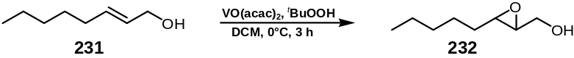

tert-Butyl hydroperoxide (40 ml of a 5M solution in decanes, 200 mmol, 2 eq.) was added via cannula to a solution of (2E)-oct-2-en-1-ol 231 (MW=128.21, d=0.850, 12.8 g, 15.1 ml, 100 mmol) in DCM (200 ml) at 0°C. Vanadium (III) acetylacetonate (MW=265.16, 2.65 g, 10 mmol) was then added in one portion and the mixture was stirred at 0°C for 1.5 h. Na₂SO₃ solution (200 ml) was added and the reaction mixture stirred for 30 min and gradually warmed to room temperature over 1.5 h. The mixture was filtered through a pad of Celite® washing with DCM (3 x 50 ml) and the filtrate poured into brine (200 ml). The layers were separated and the aqueous phase was extracted with ether (3 x 100 ml). The combined organic extracts were washed with brine (100 ml), dried (MgSO₄), filtered and concentrated in vacuo. Purification by flash column chromatography (eluent PE:Et₂O 5:1 to 1:1, gradient) afforded epoxy alcohol 232 (8.8 g, 61 mmol, 61%) as a white solid; ν_{max} (neat)/cm⁻¹: 3245 (OH), 2954, 2931, 2870, 2850, 1460, 1394, 1375, 1327, 1249, 1139, 1062, 1036, 1005, 988, 937, 849, 833, 713; δ_{H} (400 MHz, CDCl₃): 0.88 (3H, t, J 6.9, 8-H x 3), 1.25-1.60 (8H, m, 7-H x 2, 6-H x 2, 5-H x 2, 4-H x 2), 1.80-2.05 (1H, br s, OH), 2.87-2.98 (2H, m, 1-H x 2), 3.56-3.64 (1H, dd, J 12.4, 4.3, 3-H), 3.87-3.91 (1H, dd, J 12.4, 2.5, 2-H); δ_{C} (100 MHz, CDCl₃): 61.7, 58.4, 56.0, 31.5, 31.4, 25.5, 22.5, 13.9; m/z (+EI) Found: [MNa]⁺ 167.1051. C₈H₁₆O₂Na requires MNa, 167.1048. Data were consistent with those reported in the literature.¹⁵⁶

Preparation of (2E,4R*,5R*)-methyl-4,5-epoxy-dec-2-enoate (233)

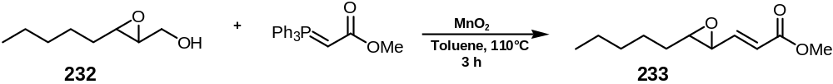

Methyl(triphenylphosphoranylidene)acetate (MW=334.36, 1.2 eq., 11.03 g, 33 mmol) and MnO₂ (MW=86.94, 12 eq., 29.0 g, 330 mmol) was added to a solution of epoxy alcohol 232 (4.0 g, 27.7 mmol) in toluene (200 ml) and the mixture heated under reflux for 3 h. The reaction mixture was filtered through Celite®, washing with DCM (2 x 50 ml), the filtrate concentrated in vacuo and the residue purified by flash column chromatography (eluent PE:Et₂O 8:1 to 1:1, gradient) to afford trans∗ epoxy enoate 233 (4.11 g, 20.7 mmol, 75%) as a pale yellow oil; ν_{max} (film)/cm⁻¹: 2954, 2931, 2859, 1723 (C=O), 1658 (C=C), 1435, 1306, 1272, 1257, 1195, 1178, 1039, 976, 886, 854, 730, 695; δ_{H} (400 MHz, CDCl₃): 0.89 (3H, t, J 6.9, 10-H x 3), 1.24-1.66 (8H, m, 9-H x 2, 8-H x 2, 7-H x 2, 6-H x 2), 2.84 (1H, td, J 5.5, 2.2, 5-H), 3.17 (1H, dd, J 7.3, 2.2, 4-H), 3.70 (3H, s, C(O)OCH₃), 6.10 (1H, d, J 15.7, 2-H), 6.66 (1H, dd, J 15.7, 7.3, 3-H); δ_{C} (100 MHz, CDCl₃): 166.0 (1-C), 145.2 (3-C), 122.9 (2-C), 61.4 (4-C), 56.1 (5-C), 51.5 (C(O)OCH₃), 31.8 (6-C), 31.4 (7-C), 25.4 (8-C), 22.5 (9-C), 13.9 (10-C); m/z (+EI): Found [MNa]⁺ 221.1165. C₁₁H₁₈O₃Na requires 221.1154.

Preparation of (2E,4R*,5R*)-4,5-epoxy-dec-2-en-1-ol (234)

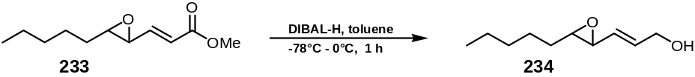

DIBAL-H (31 ml of a 1 M solution in toluene, 2.1 eq., 31 mmol) was gradually added over 10 min to a solution of ester 233 (2.9 g, 14.6 mmol) in toluene (50 ml) at -78°C. The reaction was stirred and allowed to warm up to 0°C over 1 h. H₂O (70 ml) was added and stirring continued for 30 min. Celite® (ca. 4 g) and MgSO₄ (ca. 10 g) were added along with Et₂O (50 ml) and the resulting slurry was stirred for 30 min before being filtered through a pad of Celite®, washing the residue with ether (2 x 50 ml) and EtOAc (3 x 50 ml). The eluate was then concentrated in vacuo and the residue purified by flash column chromatography (eluent Et₂O:PE 3:1) to afford epoxy enol 234 (2.1 g, 12.33 mmol, 84%) as a white solid; ν_{max} (film)/cm⁻¹: 3374 (OH), 2956, 2928, 2858 (C-H), 1458 (C=C), 1378, 1091 (epoxide), 1007, 965 (trans HC=CH), 878 (epoxide); δ_{H} (400 MHz, CDCl₃): 0.96 (3H, t, J 6.9, 10-H x 3), 1.40-1.62 (9H, 9-H x 2, 8-H x 2, 7-H x 2, 6-H x 2, OH), 2.83 (1H, td, J 5.5, 2.1, 5-H), 3.14 (1H, dd, J 8.0, 2.2, 4-H), 4.20 (2H, app. t, J 5.8, 1-H x 2), 5.47 (1H, dd, J 15.3, 7.7, 3-H), 6.05 (1H, dt, J 15.7, 5.5, 2-H); δ_{C} (100 MHz, CDCl₃): 133.9 (3-C), 128.9 (2-C), 62.7 (1-C), 60.6 (4-C), 57.9 (5-C), 31.9 (6-C), 31.5 (7-C), 25.5 (8-C), 22.5 (9-C), 13.9 (10-C); m/z (+EI): Found [MNa]⁺ 193.1197. C₁₀H₁₈O₂Na requires 193.1204.

Preparation of (2E,4R*,5R*)-1-(tert-butyl-dimethyl-silanyloxy)-4,5-epoxy-dec-2-en (235)

TBS protected epoxy alcohol 235 was prepared according to Error: Reference source not found (page Error: Reference source not found) from TBSCl (MW=150.73, 1.1 eq., 11.7 mmol, 1.76 g), imidazole (MW=68.08, 1.2 eq., 12.6 mmol, 864 mg) and epoxy alcohol 234 (10.6 mmol, 1.80 g) in DMF (180 ml). Due to the acid sensitivity of the product, the reaction mixture was poured onto H₂O (600 ml), the layers separated, and the aqueous extracted with Et₂O (3 x 200 ml). The combined organic phases were washed with brine (150 ml), dried (MgSO₄), filtered and concentrated in vacuo and the residue purified by flash column chromatography (eluent Et₂O:PE 8:1 to 6:1, gradient) to afford TBS protected epoxy enol 235 (2.12 g, 8.27 mmol, 78%) as an oil; ν_{max} (film)/cm⁻¹: 2956, 2929, 2857 (C-H), 1462 (C=C), 1379, 1253, 1124 (epoxide), 1104, 1006, 963 (trans HC=CH), 882 (epoxide), 834, 774, 669; δ_{H} (400 MHz, CDCl₃): 0.04 (3H, s, Si(CH₃)), 0.06 (3H, s, Si(CH₃)), 0.80-0.96 (12H, m, 10-H x 3, SiC(CH₃)₃), 1.35-1.58 (8H, 9-H x 2, 8-H x 2, 7-H x 2, 6-H x 2), 2.78 (1H, td, J 5.5, 1.8, 5-H), 3.04 (1H, dd, J 7.7, 1.5, 4-H), 4.14 (2H, m, 1-H x 2), 5.41 (1H, dd, J 15.3, 8.0, 3-H), 5.92 (1H, dt, J 15.4, 4.8, 2-H); δ_{C} (100 MHz, CDCl₃): 134.1 (3-C), 127.4 (2-C), 62.8 (1-C); 60.4 (4-C), 57.9 (5-C), 31.9 (6-C), 31.5 (7-C), 25.8 (SiC(CH₃)₃), 25.5 (8-C), 22.4 (9-C), 18.2 (SiC(CH₃)₃), 13.9 (10-C), -5.2 (Si(CH₃)), -5.3 (Si(CH₃)); m/z (+EI): Found [MNa]⁺ 307.2071. C₁₆H₃₂O₂NaSi requires 307.2069.

Preparation of [(2E,4S*,5R*)-5-(carbonyloxy-κC)-1-(tert-butyl-dimethyl-silanyloxy)-(2,3,4-η)-dec-2-en-4-yl]tricarbonyliron (237) and [(2E,4R*,5R*)-5-(carbonyloxy-κC)-1-(tert-butyl-dimethyl-silanyloxy)-(2,3,4-η)-dec-2-en-4-yl]tricarbonyliron (236)

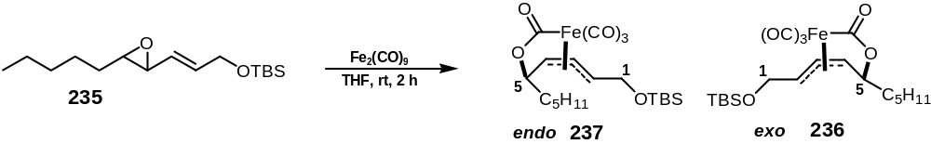

TBS protected epoxy enol 235 (2.1 g, 8.2 mmol) was added according to Error: Reference source not found (page Error: Reference source not found) to a suspension of Fe₂(CO)₉ (MW=363.79, 2.5 eq., 7.54 g, 20.4 mmol) in degassed THF (250 ml) which had been vigorously stirred for 20 min in the dark. After stirring for 2 h, toluene (10 ml) was added, and the mixture was filtered through Celite® washing the residue with Et₂O (3 x 100 ml). The volatiles were removed in vacuo to yield the crude product as a solution in toluene, which was purified immediately by flash column chromatography (eluent PE:Et₂O 98:2 to 50:50, gradient) to yield, in order of elution∗, complexes 237 (1.92 g, 52%) and 236 (0.673 g, 18%) as yellow solids; 237 (major product, endo complex); ν_{max} (neat)/cm⁻¹: 2930 (CH), 2067 (CO), 2018 (CO), 1998 (CO), 1657 (C=O), 1253, 1127, 1007, 835, 781, 659; δ_{H} (400 MHz, CDCl₃): 0.06 (3H, s, Si(CH₃)), 0.08 (3H, s, Si(CH₃)), 0.80-0.97 (12H, m, 10-H x 3, SiC(CH₃)₃), 1.30-1.60 (8H, 9-H x 2, 8-H x 2, 7-H x 2, 6-H x 2), 4.09 (1H, dt, J 11.7, 2.9, 2-H), 4.18 (1H, dd, J 14.2, 2.9, 1-H), 4.25 (1H, td, J 6.9, 5.1, 5-H), 4.41 (1H, dd, J 14.6, 2.2, 1-H), 4.61 (1H, dd, J 8.4, 4.7, 4-H), 4.83 (1H, dd, J 12.1, 8.4, 3-H); δ_{C} (100 MHz, CDCl₃): 209.3 (CO), 206.5 (CO), 205.6 (CO), 204.0 (CO), 86.0 (3-C), 82.2 (2-C), 76.9 (5-C), 76.2 (4-C), 62.2 (1-C), 36.6 (6-C), 31.4 (7-C), 26.5 (8-C), 25.7 (SiC(CH₃)₃) , 22.2 (9-C), 18.3 (SiC(CH₃)₃), 13.7 (10-C), -5.7 (Si(CH₃)), -6.0 (Si(CH₃)); m/z (+EI): 475 ([MNa]⁺, 100%), 447 ([MNa-CO]⁺, 35%). Found: [MNa]⁺, 475.1242. [C₂₀H₃₂O₆FeSiNa]⁺ requires 475.1215; 236 (minor product, exo complex); ν_{max} (neat)/cm⁻¹: 2954 (CH), 2929 (CH), 2857 (CH), 2074 (CO), 2021 (CO), 1998 (CO), 1656 (C=O), 1461, 1324, 1255, 1135, 1038, 976, 832, 774, 655; δ_{H} (400 MHz, CDCl₃): 0.07 (3H, s, Si(CH₃)), 0.08 (3H, s, Si(CH₃)), 0.80-0.96 (12H, m, 10-H x 3, SiC(CH₃)₃), 1.30-1.60 (8H, 9-H x 2, 8-H x 2, 7-H x 2, 6-H x 2), 4.02 (2H, m, 1-H x 2), 4.15 (1H, dt, J 14.6, 2.9, 5-H), 4.39 (1H, dt, J 14.6, 1.8, 2-H), 4.45 (1H, d, J 8.8, 4-H), 5.05 (1H, dd, J 11.3, 7.7, 3-H); δ_{C} (100 MHz, CDCl₃): 209.5 (CO), 206.4 (CO), 205.7 (CO), 204.2 (CO), 87.3 (3-C), 81.4 (2-C), 74.9 (5-C), 74.8 (4-C), 62.1 (1-C), 37.9 (6-C), 31.7 (7-C), 25.7 (SiC(CH₃)₃), 25.1 (8-C), 22.4 (9-C), 18.4 (SiC(CH₃)₃), 13.9 (10-C), -5.6 (Si(CH₃)), -5.7 (Si(CH₃)); m/z (+EI): 475 ([MNa]⁺, 18%), 447 ([MNa-CO]⁺, 16%), 307 ([MNa-Fe(CO)₄], 100%). Found: [MNa]⁺ 475.1216. [C₂₀H₃₂O₆FeSiNa]⁺ requires 475.1215.

Preparation of [(2E,4S*,5R*)-5-(carbonyloxy-κC)-1-hydroxy-(2,3,4-η)-dec-2-en-4-yl]tricarbonyliron (240)

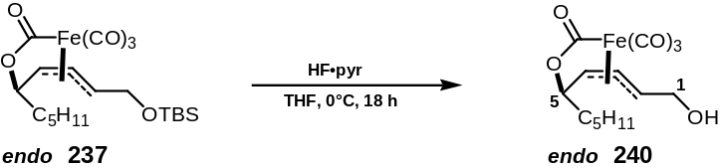

TBS protected endo iron complex 237 (2.0 g, 4.4 mmol) was treated with HF•pyridine solution (2.25 mol/l stock solution prepared according to Error: Reference source not found (page Error: Reference source not found), 25 eq., 110 mmol, 49 ml) in THF (10 ml) at 0°C. The reaction was allowed to warm to rt over 18 h, then poured onto a mixture of NaHCO₃ solution : Et₂O (50 ml : 50 ml), the layers were separated, the aqueous extracted with Et₂O (3 x 100 ml) and the combined organic extracts were poured onto saturated CuSO₄ solution (100 ml). The phases were again separated and the aqueous layer extracted with Et₂O (2 x 100 ml), the combined organic phases were washed with brine (100 ml), dried (MgSO₄), filtered and concentrated in vacuo. Purification by flash column chromatography (eluent Et₂O:PE 2:1 to 3:1, gradient) yielded free alcohol complex 240 (1.26 g, 3.73 mmol, 85%) as a yellow oil; ν_{max} (neat)/cm⁻¹: 3352 (OH), 2958 (CH), 2934 (CH), 2860 (CH), 2079 (CO), 2025 (CO), 2001 (CO), 1620 (C=O), 1459, 1330, 1102, 1030, 729, 660; δ_{H} (400 MHz, CDCl₃): 0.80-0.91 (3H, t, J 6.5, 10-H x 3), 1.25-1.60 (8H, 9-H x 2, 8-H x 2, 7-H x 2, 6-H x 2), 3.10 (1H, br s, OH), 4.05 (1H, dt, J 9.1, 2.9, 2-H), 4.09 (1H, d, J 4.7, 1-H), 4.22 (1H, td, J 6.5, 4.4, 5-H), 4.31 (1H, ddd, J 15.0, 10.9, 4.0, 1-H), 4.63 (1H, dd, J 8.0, 4.7, 4-H), 4.85 (1H, dd, J 11.7, 8.4, 3-H); δ_{C} (100 MHz, CDCl₃): 209.1 (CO), 207.8 (CO), 206.2 (CO), 203.6 (CO), 87.6 (3-C), 81.9 (2-C), 77.9 (5-C), 76.5 (4-C), 62.0 (1-C), 36.7 (6-C), 31.5 (7-C), 26.6 (8-C), 22.4 (9-C), 13.9 (10-C); m/z (+EI): 361 ([MNa]⁺, 100%), 333 ([MNa-CO]⁺, 28%), 277 ([MNa-3CO]⁺, 81%). Found: [MNa]⁺ 361.0367. [C₁₄H₁₈O₆FeNa]⁺ requires 361.0350.

Preparation of [(2E,4R*,5R*)-5-(carbonyloxy-κC)-1-hydroxy-(2,3,4-η)-dec-2-en-4-yl]tricarbonyliron (238)

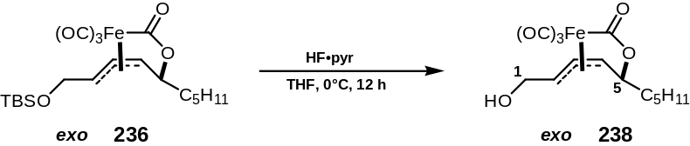

TBS protected exo iron complex 236 (1.25 g, 2.7 mmol) was treated∗ with HF•pyridine solution (2.25 mol/l stock solution prepared according to Error: Reference source not found (page Error: Reference source not found), 15 eq., 110 mmol, 49 ml) in THF (10 ml) at 0°C. The reaction was allowed to warm to rt over 12 h, then poured onto a mixture of NaHCO₃ solution : Et₂O (50 ml : 50 ml), the layers were separated, the aqueous phase extracted with EtOAc (3 x 50 ml) and the combined organic extracts were poured onto saturated CuSO₄ solution (100 ml). The phases were again separated and the aqueous layer extracted with EtOAc (3 x 50 ml), the combined organic phases were washed with brine (100 ml), dried (MgSO₄), filtered and concentrated in vacuo. Purification by flash column chromatography (eluent Et₂O:PE 1:1, 2:1, 3:1, gradient) yielded free alcohol exo complex 238 (0.66 g, 1.95 mmol, 72%) as a yellow oil; ν_{max} (neat)/cm⁻¹: 3286 (OH), 2954 (CH), 2928 (CH), 2855 (CH), 2071 (CO), 1995 (CO), 1649 (C=O), 1467, 1348, 1120, 1047, 993, 670; δ_{H} (400 MHz, CDCl₃): 0.80-0.95 (3H, t, J 6.6, 10-H x 3), 1.25-1.60 (8H, 9-H x 2, 8-H x 2, 7-H x 2, 6-H x 2), 2.80 (1H, br s, OH), 3.98 (1H, dt, J 11.7, 3.3, 2-H), 4.05 (1H, ddd, J 14.6, 6.5, 5.1, 1-H), 4.08 (1H, t, J 4.4, 5-H), 4.31 (1H, dt, J 13.9, 3.3, 1-H), 4.45 (1H, d, J 8.0, 4-H), 5.03 (1H, dd, J 11.7, 8.0, 3-H); δ_{C} (100 MHz, CDCl₃): 209.1 (CO), 207.9 (CO), 206.2 (CO), 203.8 (CO), 89.1 (3-C), 80.6 (2-C), 75.8 (5-C), 74.9 (4-C), 61.8 (1-C), 37.8 (6-C), 31.4 (7-C), 25.1 (8-C), 22.4 (9-C), 13.9 (10-C); m/z (+EI): 361 ([MNa]⁺, 100%), 333 ([MNa-CO]⁺, 13%), 277 ([MNa-3CO]⁺, 7%). Found: [MNa]⁺ 361.0367. [C₁₄H₁₈O₆FeNa]⁺ requires 361.0350.

Preparation of [(2E,4E,6S*,7R*)-7-(carbonyloxy-κC)-2-methoxyoxycarbonyl-(4,5,6-η)-dodeca-2,4-dien-6-yl]tricarbonyliron (241)

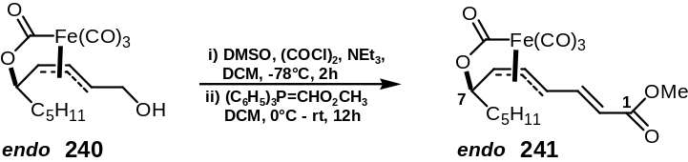

A solution of DMSO (MW=78.13, d=1.101, 2.5 eq., 440 μl, 6.25 mmol) in DCM (2 ml) was added to a solution of oxalyl chloride (MW=126.93, d=1.455, 1.3 eq., 280 μl, 3.25 mmol) in DCM (10 ml) at –78°C and the mixture stirred at –78°C for 5 min. A solution of alcohol complex 240 (840 mg, 2.5 mmol) in DCM (10 ml) was gradually added over 5 min and stirring continued for 30 min. NEt₃ (MW=101.19, d=0.726, 5.0 eq., 1.74 ml, 12.5 mmol) was added and the mixture allowed to warm to -10°C over 1 h. After 1.5 h, methyl(triphenylphosphoranylidene)acetate (MW=334.36, 5.0 eq., 12.5 mmol, 4.2 g) was added and the mixture allowed to warm to rt overnight. The reaction mixture was poured into brine (50 ml) and extracted with DCM (3 x 50 ml). The combined organic phases were then dried (MgSO₄), filtered and concentrated in vacuo and the residue was purified by flash column chromatography (eluent PE:Et₂O 1:1) to afford enoate complex 241 (760 mg, 1.93 mmol, 78%) as a yellow solid; ν_{max} (neat)/cm⁻¹: 2951, 2872, 2850, 2073, 2030, 1994, 1704, 1671, 1627, 1431, 1335, 1247, 1169, 1038, 969, 732, 650; δ_{H} (400 MHz, CDCl₃): 0.86 (3H, t, J 6.5, 12-H x 3), 1.20-1.67 (8H, 11-H x 2, 10-H x 2, 9-H x 2, 8-H x 2), 3.75 (3H, s, C(O)OCH₃), 4.28 (1H, td, J 5.8, 5.7, 7-H), 4.51 (1H, app. t, J 11.3, 4-H), 4.72 (1H, dd, J 8.0, 4.7, 6-H), 4.93 (1H, dd, J 11.7, 8.0, 5-H), 6.25 (1H, d, J 15.4, 2-H), 6.88 (1H, dd, J 15.4, 10.6, 3-H); δ_{C} (100 MHz, CDCl₃): 208.1 (CO), 204.3 (CO), 203.3 (CO), 202.6 (CO), 166.5 (1-C), 145.6 (3-C), 122.0 (2-C), 93.2 (5-C), 79.2 (6-C), 77.2 (7-C), 75.4 (4-C), 51.8 (C(O)OCH₃), 36.7 (8-C), 31.4 (9-C), 26.6 (10-C), 22.4 (11-C), 13.9 (12-C); m/z (+EI): 415 ([MNa]⁺, 100%), 387 ([MNa-CO]⁺, 47%), 303 ([MNa-4CO]⁺, 76%). Found: [MNa]⁺ 415.0469. [C₁₇H₂₀O₇FeNa]⁺ requires 415.0456.

Preparation of [(2E,4E,6R*,7R*)-7-(carbonyloxy-κC)-2-methoxyoxycarbonyl-(4,5,6-η)-dodeca-2,4-dien-6-yl]tricarbonyliron (239)

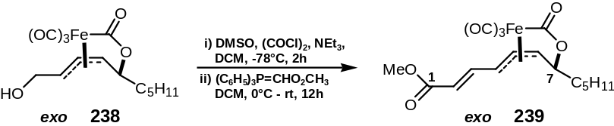

A solution of DMSO (MW=78.13, d=1.101, 2.5 eq., 170 μl, 2.43 mmol) in DCM (1 ml) was added to a solution of oxalyl chloride (MW=126.93, d=1.455, 1.3 eq., 110 μl, 1.26 mmol) in DCM (10 ml) at –78°C and the mixture stirred at –78°C for 5 min. A solution of alcohol complex 238 (330 mg, 0.97 mmol) in DCM (10 ml) was gradually added over 5 min, and stirring continued for 20 min. NEt₃ (MW=101.19, d=0.726, 5.0 eq., 0.67 ml, 4.85 mmol) was added and the mixture allowed to warm to -10°C over 1 h. After 1.5 h, methyl(triphenylphosphoranylidene)acetate (MW=334.36, 5.0 eq., 4.85 mmol, 1.62 g) was added and the mixture allowed to warm to rt overnight. The reaction mixture was poured into brine (50 ml) and extracted with DCM (3 x 50 ml). The combined organic phases were then dried (MgSO₄), filtered and concentrated in vacuo. The residue was purified by flash column chromatography (eluent PE:Et₂O 1:1) to afford enoate complex 239 (320 mg, 0.82 mmol, 85%) as a yellow solid; ν_{max} (neat)/cm⁻¹: 2953, 2930, 2861, 2068, 2020, 1997, 1717, 1706, 1655, 1434, 1348, 1222, 1165, 1012, 718; δ_{H} (400 MHz, CDCl₃): 0.85 (3H, t, J 6.5, 12-H x 3), 1.22-1.65 (8H, 11-H x 2, 10-H x 2, 9-H x 2, 8-H x 2), 3.75 (3H, s, C(O)OCH₃), 4.07 (1H, t, J 6.5, 7-H), 4.41 (1H, app. t, J 11.0, 4-H), 4.56 (1H, d, J 7.7, 6-H), 5.11 (1H, dd, J 11.7, 7.7, 5-H), 6.24 (1H, d, J 15.4, 2-H), 6.88 (1H, dd, J 15.4, 11.0, 3-H); δ_{C} (100 MHz, CDCl₃): 208.4 (CO), 204.3 (CO), 202.9 (CO), 202.8 (CO), 166.5 (1-C), 145.0 (3-C), 122.2 (2-C), 94.3 (5-C), 78.2 (6-C), 74.8 (7-C), 74.7 (4-C), 51.8 (C(O)OCH₃), 37.9 (8-C), 31.3 (9-C), 25.1 (10-C), 22.4 (11-C), 13.9 (12-C); m/z (+EI): 415 ([MNa]⁺, 100%), 387 ([MNa-CO]⁺, 45%), 303 ([MNa-4CO]⁺, 37%). Found: [MNa]⁺ 415.0461. [C₁₇H₂₀O₇FeNa]⁺ requires 415.0456.

Preparation of [(4E,2R*,3S*,6S*,7R*)-7-(carbonyloxy-κC)-2,3-dihydroxy-2-methoxyoxycarbonyl-(4,5,6-η)-dodeca-4-en-6-yl]tricarbonyliron (245)

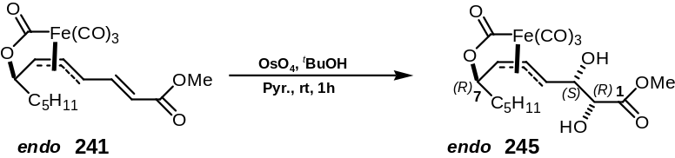

OsO₄ (MW=254.20, 1.2 eq., 135 μmol, 1.72 ml of a 2.5 w/w % solution in tert-butanol) was added to a stirred solution of enoate complex 241 (44 mg, 112 μmol) in pyridine (250 μl). After 1 h, excess Na₂S₂O₅ (ca. 1 g) and H₂O (4 ml) were added and the mixture stirred vigorously for 1 h. The phases were separated and the aqueous phase extracted with DCM (3 x 20 ml). The combined organic fractions were washed with saturated CuSO₄ solution (2 x 20 ml) and brine (20 ml), dried (MgSO₄), filtered and concentrated in vacuo. The crude product was purified by flash column chromatography (eluent Et₂O:PE 3:1) to yield diol complex 245 (27 mg, 56%) as a white solid; ν_{max} (neat)/cm⁻¹: 3550 (OH), 2933 (CH), 2870, 2085 (CO), 1993 (CO), 1738 (C=O), 1650, 1441, 1265, 1109, 1000, 666; δ_{H} (400 MHz, CDCl₃): 0.85 (3H, t, J 6.6, 12-H x 3), 1.19-1.68 (8H, 11-H x 2, 10-H x 2, 9-H x 2, 8-H x 2), 2.63 (1H, s, 3-OH), 3.18 (1H, s, 2-OH), 3.88 (3H, s, C(O)OCH₃), 4.20 (1H, app. q, J 7.3, 4-H), 4.26 (1H, td, J 6.2, 5.1, 7-H), 4.32 (1H, m, 2-H), 4.50 (1H, m, 3-H), 4.71 (1H, dd, J 8.4, 4.7, 6-H), 4.92 (1H, dd, J 11.7, 8.0, 5-H); δ_{C} (100 MHz, CDCl₃): 209.1 (CO), 206.1 (CO), 205.9 (CO), 203.4 (CO), 172.4 (1-C), 87.2 (5-C), 78.7 (4-C), 76.9 (6-C), 76.6 (7-C), 73.7 (2-C), 71.3 (3-C), 53.3 (C(O)OCH₃), 36.5 (8-C), 31.5 (9-C), 26.4 (10-C), 22.4 (11-C), 13.9 (12-C); m/z (+EI): 449 ([MNa]⁺, 50%), 365 ([MNa-3CO]⁺, 100%). Found: [MNa]⁺ 449.0519. [C₁₇H₂₂O₉FeNa]⁺ requires 449.0511.

Preparation of [(4E,2S*,3R*,6R*,7R*)-7-(carbonyloxy-κC)-2,3-dihydroxy-2-methoxyoxycarbonyl-(4,5,6-η)-dodeca-4-en-6-yl]tricarbonyliron (246)

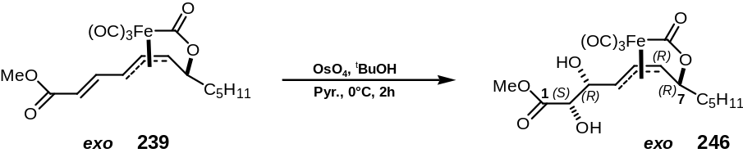

OsO₄ (MW=254.20, 2.4 ml of a 2.5 w/w % solution in tert-butanol, 1.5 eq., 0.26 mmol) was added to a stirred solution of enoate complex 239 (67 mg, 0.17 mmol) in pyridine (1 ml) at 0°C. After 2 h, excess Na₂S₂O₅ (ca. 1 g) and H₂O (2 ml) were added and the mixture stirred vigorously for 3 h. The phases were separated and the aqueous phase extracted with DCM (3 x 20 ml). The combined organic fractions were washed with saturated CuSO₄ solution (2 x 20 ml) and brine (20 ml), dried (MgSO₄), filtered and concentrated in vacuo. The crude product was purified by flash column chromatography (eluent Et₂O:PE 5:1) to yield diol complex 246 (37 mg, 51%) as a white solid; ν_{max} (neat)/cm⁻¹: 3398 (OH) 2928 (CH), 2860, 2077 (CO), 1997 (CO), 1740 (C=O), 1626, 1438, 1278, 1125, 1093, 995, 655; δ_{H} (400 MHz, CDCl₃): 0.88 (3H, t, J 6.9, 12-H x 3), 1.23-1.72 (8H, 11-H x 2, 10-H x 2, 9-H x 2, 8-H x 2), 2.97 (1H, d, J 6.9, 3-OH), 3.35 (1H, d, J, 4.7, 2-OH), 3.80 (1H, dd, J 12.0, 2.9, 4-H), 3.87 (3H, s, C(O)OCH₃), 4.04 (1H, t, J 6.9, 7-H), 4.32 (1H, m, 2-H), 4.52 (1H, d, J 8.0, 6-H), 4.55 (1H, m, 3-H), 5.09 (1H, dd, J 11.7, 7.6, 5-H); δ_{C} (100 MHz, CDCl₃): 209.2 (CO), 206.3 (CO), 206.1 (CO), 203.4 (CO), 172.5 (C=O), 88.7 (5-C), 78.4 (4-C), 76.4 (6-C), 75.1 (7-C), 73.4 (2-C), 71.1 (3-C), 53.2 (C(O)OCH₃), 37.9 (8-C), 31.4 (9-C), 25.1 (10-C), 22.4 (11-C), 13.9 (12-C); m/z (+EI): 449 ([MNa]⁺, 35%), 365 ([MNa-3CO]⁺, 30%). Found: [MNa]⁺ 449.0513. [C₁₇H₂₂O₉FeNa]⁺ requires 449.0511.

Experimental procedures for chapter 6: (-)-gloeosporone

Preparation of (2R,3R)-2,3-epoxyoctan-1-ol (232)

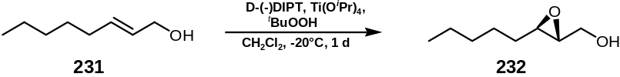

(2E)-Octen-1-ol 231 (15.4 g, 0.12 mol) was treated with diisopropyl D-tartrate (1.2 eq., 0.144 mol, 33.7 g, 30.5 ml), titanium (IV) isopropoxide (1.0 eq., 0.12 mol, 34.1 g, 35.4 ml), activated, powdered 4Å molecular sieves (ca.4 g) and tert-butyl hydroperoxide (5-6M in decanes, 2.5 eq., 0.3 mol, 55 ml) in DCM (200 ml) according to Error: Reference source not found (page Error: Reference source not found) to provide epoxy alcohol 232 as a white solid after purification by flash column chromatography (eluent Et₂O:PE 1:2 to 3:2, gradient) (11.4 g, 81%, 83% e.e.). Two recrystallisations from PE at 0°C yielded enantiomerically enriched epoxy alcohol 271 as white needles (8.1 g, 47%, 95% e.e.); mp 37-38°C (from PE) [Lit.¹⁵⁶ 38-39°C (from PE)]; [α]_{D}²⁵ +37.3 (c 1.00 CHCl₃) [Lit.¹⁵⁶ for enantiomer [α]_{D}²⁴ -42.7 (c 4.7 in CHCl₃)]; Data was consistent with those reported in the literature.¹⁵⁶ The enantiopurity was determined by formation of the ester from (S)-(+)-α-methoxyphenylacetic acid and examination of the ¹H NMR (600 MHz) spectrum.

Preparation of (2S,3R)-2,3-epoxyoctanal (290)

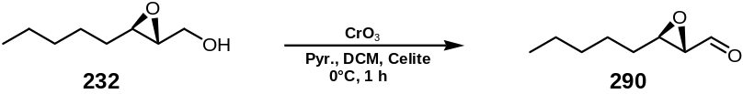

Chromium(VI)oxide (24.9 g, 250 mmol) was added to a solution of pyridine (41 ml, 510 mmol) in DCM (400 ml). After stirring this suspension for 15 min, Celite® (30 g) was added and the resultant slurry was stirred vigorously for a further 5 min before cooling down to 0°C. A solution of epoxy alcohol 232 (3.70 g, 26.4 mmol) was then added via cannula. After warming to rt and stirring for 45 min, NaHSO₄ (60 g) and Et₂O (400 ml) were added and the mixture was stirred vigorously for 15 min before being filtered through a sandwich of silica/MgSO₄/silica, washing with Et₂O (1500 ml). Concentration of the filtrate in vacuo followed by flash column chromatography (eluent PE:Et₂O 30:1 to 10:1, gradient) provided∗ epoxyaldehyde 290 (1.65 g, 11.6 mmol, 44%) as a colourless oil; ν_{max} (film)/cm⁻¹: 2957, 2929, 2860, 2733, 1729 (C=O), 1466, 1436, 1379, 1151, 1050, 976; δ_{H} (400 MHz, CDCl₃): 0.90 (3H, t, J 7.1, 8-H x 3), 1.30-1.62 (8H, m, 4-H x 2, 5-H x 2, 6-H x 2, 7-H x 2), 3.12 (1H, dd, J 6.2, 2.0, 2-H), 3.21 (1H, td, J 5.3, 2.0, 3-H), 9.01 (1H, d, J 6.1, 1-H); δ_{C} (100 MHz, CDCl₃): 198.5 (C=O), 59.2 (CH), 56.8 (CH), 31.4 (CH₂), 31.2 (CH₂), 25.4 (CH₂), 22.5 (CH₂), 13.9 (CH₃); m/z (+EI): 142 (M⁺, 25%), 113 (M-CHO, 52%), 83 (72%), 71 (Me(CH₂)₄, 100%), 69 (55%), 55 (90%). Found: [M]⁺ 142.0988. C₈H₁₄O₂ requires 156.0993. [α]_{D}²⁵ -116.3 (c 1.00 in CHCl₃); Data was consistent with those reported in the literature.¹⁷

Preparation of (3E,5R,6R)-5,6-epoxy-2-oxoundec-3-ene (291)

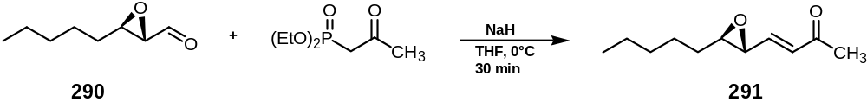

Diethyl (2-oxopropyl)phosphonate (1.2 eq., 13.9 mmol, 2.7 g, 2.67 ml, d=1.010) was added dropwise to a stirred solution of NaH (MW 24.0, 0.51 g of a 60% dispersion in mineral oil, prewashed with hexane (10 ml), 1.1 eq., 12.7 mmol) in THF (110 ml) at rt over 5 min before cooling to 0°C. A solution of (2S,3R)-2,3-epoxyoctanal 290 (1.65 g, 11.6 mmol) in THF (10 ml) was subsequently added dropwise over 10 min. After 30 min the reaction mixture was poured into brine (50 ml) and the layers were separated. The aqueous phase was extracted with Et₂O (3 x 100 ml) and the combined organic extracts were washed with brine (50 ml), and then dried (MgSO₄). Concentration in vacuo followed by flash column chromatography of the residue (eluent Et₂O:PE 1:19 to 1:9, gradient) afforded epoxy enone 291 (1.60 g, 8.8 mmol, 76%) as a colourless oil; ν_{max} (film)/cm⁻¹: 2956, 2929, 2858, 1698, 1679 (C=O), 1628 (C=C), 1466, 1432, 1360, 1299, 1257, 1180, 1146, 976, 883, 827, 726; δ_{H} (400 MHz, CDCl₃): 0.88 (3H, t, J 7.2, 11-H x 3), 1.21-1.62 (8H, m, 7-H x 2, 8-H x 2, 9-H x 2, 10-H x 2), 2.24 (3H, s, 1-H x 3), 2.89 (1H, td, J 5.3, 2.0, 6-H), 3.20 (1H, dd, J 6.7, 2.1, 5-H), 6.32 (1H, d, J 16.8, 3-H), 6.46 (1H, dd, J 16.8, 6.7, 4-H); δ_{C} (100 MHz, CDCl₃): 197.3 (C=O), 143.5 (CH), 132.4 (CH), 61.5 (CH), 56.4 (CH), 31.7 (CH₂), 31.4 (CH₂), 27.2 (CH₃), 25.4 (CH₂), 22.5 (CH₂), 13.9 (CH₃); m/z (+EI): Found: [M]⁺ 182.1308. C₁₁H₁₈O₂ requires M, 182.1307. [α]_{D}²⁵ +23.8 (c 1.00 in CHCl₃) [optical rotation reported in Lit.²³ [α]_{D}²⁷ +27.1 (c 1.0 in CHCl₃)]; Data was consistent with those reported in the literature.²³

Preparation of [(3E,5S,6R)-6-(carbonyloxy-κC)-2-oxo-(3,4,5-η)-undec-3-en-5-yl]tricarbonyliron (25) and [(3E,5R,6R)-6-(carbonyloxy-κC)-2-oxo-(3,4,5-η)-undec-3-en-5-yl]tricarbonyliron (26)

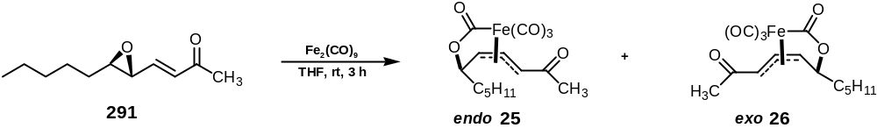

Treatment of epoxy enone 291 (1.60 g, 8.8 mmol) with Fe₂(CO)₉ (MW 363.79, 2.2 eq., 19.4 mmol, 7.04 g) according to Error: Reference source not found (page Error: Reference source not found) afforded after purification with flash column chromatography (eluent PE:Et₂O 1:1) endo complex 25 (1.58 g, 4.5 mmol, 51%) as an orange-brown solid; ν_{max} (film)/cm⁻¹: 3057, 2957, 2932, 2861, 2086 (CO), 2016 (CO), 1681 (C=O), 1499, 1467, 1362, 1310, 1267, 1234, 1174, 1114, 1019, 738, 703, 655, 613; δ_{H} (400 MHz, CDCl₃): 0.88 (3H, t, J 6.5, 11-H x 3), 1.20-1.64 (8H, m, 7-H x 2, 8-H x 2, 9-H x 2, 10-H x 2), 2.43 (3H, s, 1-H x 3), 3.85 (1H, d, J 10.9, 3-H), 4.34 (1H, td, J 6.4, 4.8, 6-H), 5.03 (1H, dd, J 8.8, 4.8, 5-H), 5.55 (1H, dd, J 10.9, 8.8, 4-H); δ_{C} (100 MHz, CDCl₃): 207.8 (CO), 204.9 (CO), 202.4 (CO), 201.6 (CO), 199.7 (CO), 92.0 (CH), 84.6 (CH), 77.3 (CH), 65.8 (CH), 36.7 (CH₂), 31.5 (CH₂), 30.2 (CH_{3 ,}1-C), 26.5 (CH₂), 22.5 (CH₂), 13.9 (CH_{3 ,}11-C); m/z (CI): Found: [MH]⁺ 351.0556. C₁₅H₁₉FeO₆ requires MH, 351.0531; [α]_{D}²⁵ -419.3 (c 1.00 in CHCl₃) [optical rotation reported in Lit.²³ [α]_{D}²⁶ -482.6 (c 1.00 in CHCl₃)]; Data was consistent with those reported in the literature;²³ and then exo complex 26 (0.39 g, 1.1 mmol, 13%) as an orange-brown solid; ν_{max} (film)/cm⁻¹: 2957, 2930, 2861, 2089 (CO), 2021 (CO), 1666 (C=O), 1496, 1467, 1420, 1361, 1315, 1227, 1175, 1114, 1069, 1046, 1004, 913, 734, 648; δ_{H} (400 MHz, CDCl₃): 0.89 (3H, t, J 7.2, 11-H x 3), 1.21-1.69 (8H, m, 7-H x 2, 8-H x 2, 9-H x 2, 10-H x 2), 2.30 (3H, s, 1-H x 3), 3.74 (1H, d, J 11.2, 3-H), 4.05 (1H, t, J 5.9, 6-H), 4.86 (1H, d, J 8.3, 5-H), 5.73 (1H, dd, J 11.2, 8.3, 4-H); δ_{C} (100 MHz, CDCl₃): 208.0 (CO), 204.9 (CO), 202.2 (CO), 201.3 (CO), 199.7 (CO), 93.6 (CH), 83.5 (CH), 74.4 (CH), 64.8 (CH), 38.0 (CH₂), 31.3 (CH₂), 30.1 (CH₃ , 1-C), 25.1 (CH₂), 22.5 (CH₂), 13.9 (CH₃ , 11-C); m/z (CI): Found: [MH]⁺ 351.0567. C₁₅H₁₉FeO₆ requires MH, 351.0531; [α]_{D}²⁵ +411.8 (c 1.00 in CHCl₃) [optical rotation reported in Lit.²³ [α]_{D}²⁶ +410.4 (c 1.00 in CHCl₃)]; Data was consistent with those reported in the literature.²³

Preparation of [(3E,5S,6R)-6-(carbonyloxy-κC)-2-trimethylsilanyloxy-(3,4,5-η)-undec-1,3-dien-5-yl]tricarbonyliron (279)

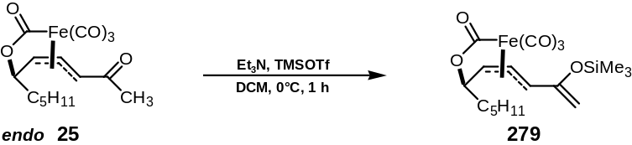

Triethylamine (MW=101.19, d=0.726, 1.2 eq., 5.4 mmol, 0.55 g, 0.75 ml) and trimethylsilyl trifluoromethanesulfonate (MW=222.26, d=1.228, 1.1 eq., 4.95 mmol, 1.10 g, 0.89 ml) were added sequentially to a cooled (0°C) solution of the endo ketone complex 25 (MW=350.14, 1.58 g, 4.5 mmol) in DCM (20 ml) and the reaction mixture was stirred at 0°C for 1 h. The reaction mixture was then poured onto H₂O (100 ml) , the layers separated and the aqueous fraction extracted with Et₂O (50 ml). The organic fractions were washed with brine (100 ml) and dried (MgSO₄). Concentration of the filtrate in vacuo followed by rapid flash column chromatography (Florisil, eluent PE:Et₂O 5:1 to 1:1, gradient) afforded the silyl enol ether complex 279 (1.62 g, MW=422.33, 3.8 mmol, 84%) as a pale yellow solid; ν_{max} (film)/cm⁻¹: 2922, 2853, 2077 (CO), 2011 (CO), 2002 (CO), 1685 (C=O), 1654 (C=C), 1605, 1462; δ_{H} (400 MHz, CDCl₃): 0.25 (9H, s, Si(CH₃)₃), 0.89 (3H, t, J 6.0, 11-H), 1.19-1.68 (8H, m, 7-H x 2, 8-H x 2, 9-H x 2, 10-H x 2), 4.27 (1H, app. q, J 6.4, 6-H), 4.33-4.43 (2H, m, 1-H x 1, 3-H), 4.57-4.68 (2H, m, 1-H x 1, 5-H), 5.00 (1H, dd, J 11.9, 8.5, 4-H); δ_{C} (100 MHz, CDCl₃): 209.2 (CO), 206.2 (CO), 205.5 (CO), 204.3 (CO), 153.8 (quat. C), 94.3 (CH₂), 85.6 (CH), 79.4 (CH), 77.4 (CH), 76.2 (CH), 36.8 (CH₂), 31.6 (CH₂), 26.7 (CH₂), 22.5 (CH₂), 14.0 (CH₃), -0.3 (Si(CH₃)₃); m/z (CI): Found: [MH]⁺ 423.0944. C₁₈H₂₇FeO₆Si requires MH, 423.0926; [α]_{D}²⁵ -287.9 (c 1.00 in CHCl₃); Data was consistent with those for the racemic complex reported in the literature.^{23,62}

Preparation of benzyloxy-1-propanol (295)

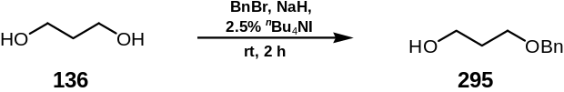

Commercially available propane-1,3-diol 136 (MW=76.1, d=1.053, 25 mmol, 1.9 g) was dissolved in THF (70 ml) and then treated with prewashed (in hexanes) NaH (MW=24.0, 1.0 eq., 25 mmol, 0.6 g, 60% dispersion in oil). The reaction mixture was stirred for 30 min, and then ^{n}Bu₄NI (MW=369.38, 2.5 mol%, 0.625 mmol, 0.23 g) as catalyst was added. Benzylbromide (MW=171.04, d=1.438, 1.0 eq., 25 mmol, 4.27 g, 2.97 ml) was injected via syringe and the reaction mixture stirred for 1 h at rt and then refluxed for a further 2 h at 110°C. After cooling to rt, the reaction mixture was poured onto NH₄Cl solution (200 ml) and H₂O (100 ml), the phases separated, the aqueous phase extracted with Et₂O (2 x 50 ml). The combined organic phases were washed with brine (100 ml), dried (MgSO₄), filtered and concentrated in vacuo to yield a crude mixture of mono- and dibenzylated compounds. Purification by flash column chromatography (eluent PE:Et₂O 10:1 to 1:10, gradient) afforded monobenzylated product 295 (2.8 g, 18.3 mmol, 73%) as an oil; δ_{H} (400 MHz, CDCl₃): 1.85 (2H, q, J 6.1), 2.30-2.40 (1H, br s, OH), 3.67 (2H, t, J 6.1), 3.80 (2H, t, J 6.1), 4.53 (2H, s), 7.30 (5H, m); δ_{C} (100 MHz, CDCl₃): 138.1, 128.4, 127.7, 127.6, 73.2, 69.2, 61.7, 32.2; Data was consistent with those reported in the literature.¹⁵⁷

Preparation of 3-benzyloxy-1-propionaldehyde (294)

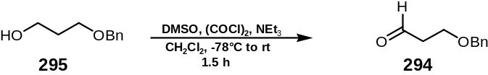

Compound 294 was prepared according to Error: Reference source not found (page Error: Reference source not found) from mono-benzylated propane-1,3-diol 295 (2.8 g, 18.3 mmol), DMSO (MW=78.13, d=1.101, 2.5 eq., 45.9 mmol, 3.6 g, 3.26 ml), oxalylchloride (MW=126.93, d=1.455, 1.2 eq., 21.9 mmol, 2.78 g, 1.91 ml) and NEt₃ (MW=101.19, d=0.726, 5.0 eq., 91.5 mmol, 9.25 g, 12.7 ml). The reaction was quenched by addition of NH₄Cl solution (20 ml), the aqueous phase was extracted with DCM (2 x 50 ml). The combined organic phases were washed with saturated NaHCO₃ (2 x 10 ml), brine (10 ml), dried (MgSO₄) and concentrated in vacuo. Purification by distillation (T=120°C, water pump pressure p=20mmHg) yielded pure, colourless aldehyde 294 (2.1 g, 12.8 mmol, 69%); δ_{H} (400 MHz, CDCl₃): 2.60-2.70 (2H, m), 3.80-3.90 (2H, t, J 6.1), 4.51 (2H, s), 7.20-7.40 (5H, m), 9.77 (1H, t, J 1.8); δ_{C} (100 MHz, CDCl₃): 201.0, 137.9, 128.4, 127.7, 127.6, 127.6, 73.2, 63.8, 43.8; Data was consistent with those reported in the literature.¹⁵⁸

Preparation of [(8E,6R,7S,12S)-14-benzyloxy-6-(carbonyloxy-κC)-12-hydroxy-10-oxo-(7,8,9-η)-tetradec-8-en-7-yl]tricarbonyliron (287)

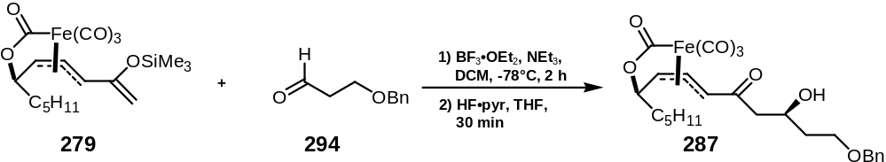

Mukaiyama aldol adduct 287 was synthesized according to Error: Reference source not found (page Error: Reference source not found) from TMS enol ether 279 (560 mg, 1.33 mmol), 3-benzyloxy-1-propionaldehyde 294 (3.0 eq., 4.0 mmol, 650 mg), BF₃•OEt₂ (MW=141.93, d=1.120, 1.1 eq., 1.46 mmol, 207 mg, 185 μl). The reaction mixture was worked up after 4 h as described and the crude mixture of silylated and non-silylated products was then deprotected with HF•pyridine (5 ml of 2.25M stock solution). Purification by flash column chromatography (eluent PE:Et₂O 2:1 to 1:2, gradient) afforded the β-hydroxy ketone 287 (425 mg, 0.83 mmol, 63%) as a yellow gum; ν_{max} (film)/cm⁻¹: 3492, 2931, 2861, 2248, 2087, 2005, 1735, 1668, 1497, 1454, 1364, 1309, 1242, 1205, 1017, 910, 821, 730, 698, 650; δ_{H} (600 MHz, CDCl₃): 0.86 (3H, t, J 6.8, 1-H x 3), 1.24-1.60 (8H, m, 2-H x 2, 3-H x 2, 4-H x 2, 5-H x 2), 1.83 (2H, m, 13-H x 2), 2.85 (2H, d, J 4.9, 11-H x 2), 3.27 (1H, d, J 3.3, OH), 3.70 (2H, m, 14-H x 2), 3.87 (1H, d, J 10.9, 9-H), 4.34 (1H, td, J 6.4, 4.4, 6-H), 4.38 (1H, m, 12-H), 4.52 (2H, s, CH₂C₆H₅), 5.02 (1H, dd, J 8.8, 4.4, 7-H), 5.56 (1H, dd, J 10.9, 8.2, 8-H), 7.22-7.40 (5H, m, CH₂C₆H₅); δ_{C} (150 MHz, CDCl₃): 207.8 (CO), 204.5 (CO), 203.6 (CO), 202.3 (CO), 199.6 (CO), 137.9 (Ph ipso), 128.4 (Ph meta x 2), 127.6 (Ph para), 127.6 (Ph ortho x 2), 92.0 (8-C), 84.6 (7-C), 76.8 (6-C), 73.2 (CH₂C₆H₅), 67.9 (14-C), 66.6 (12-C), 65.8 (9-C), 49.9 (11-C), 36.6 (5-C), 36.1 (13-C), 31.4 (4-C), 26.4 (3-C), 22.4 (2-C), 13.8 (1-C); m/z (ES): Found: [MNa]⁺ 537.1188. C₂₅H₃₀FeNaO₈ requires MNa, 537.1188; [α]_{D}²⁵ -297.6 (c 1.00 in CHCl₃).∗

Preparation of [(8E,6R,7S,12S)-14-benzyloxy-12-(tert-butyl-dimethyl-silanyloxy)-6-(carbonyloxy-κC)-10-oxo-(7,8,9-η)-tetradec-8-en-7-yl]tricarbonyliron (297)

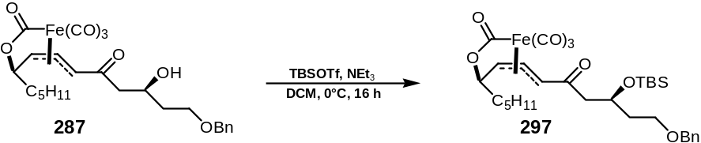

TBSOTf (MW=264.34, d=1.151, 1.1 eq., 0.91 mmol, 0.241 g, 0.209 ml) was added dropwise to a solution of the β-hydroxy ketone 287 (425 mg, 0.83 mmol) and NEt₃ (MW=101.19, d=0.726, 1.25 eq., 1.04 mmol, 104 mg, 0.144 ml) in DCM (5 ml) at 0°C. After 6 h the reaction mixture was purified directly by flash column chromatography (eluent PE:Et₂O 5:1 to 1:1) to afford the mono TBS protected iron lactone complex 297 (522 mg, 0.83 mmol, 100%) as a yellow oil; ν_{max} (neat)/cm⁻¹: 2929, 2857, 2087, 2010, 1671 (C=O), 1497, 1462, 1361, 1322, 1252, 1017, 910, 835, 776, 731, 697; δ_{H} (600 MHz, CDCl₃): 0.05 (3H, s, Si(CH₃)), 0.07 (3H, s, Si(CH₃)), 0.85 (9H, s, SiC(CH₃)₃), 0.89 (3H, t, J 7.1, 1-H x 3), 1.26-1.62 (8H, m, 2-H x 2, 3-H x 2, 4-H x 2, 5-H x 2), 1.86 (2H, app. q, J 6.5, 13-H x 2), 2.82 (1H, dd, J 15.9, 6.0, 11-H), 2.98 (1H, dd, J 15.9, 4.9, 11-H’), 3.56 (2H, m, 14-H x 2), 3.86 (1H, d, J 10.9, 9-H), 4.32 (1H, td, J 7.1, 4.9, 6-H), 4.42 (1H, m, 12-H), 4.49 (2H, m, CH₂C₆H₅), 5.01 (1H, dd, J 8.8, 4.9, 7-H), 5.52 (1H, dd, J 10.9, 8.8, 8-H), 7.20-7.38 (5H, m, CH₂C₆H₅); δ_{C} (150 MHz, CDCl₃): 207.9 (CO), 204.8 (CO), 202.2 (CO), 202.0 (CO), 199.8 (CO), 138.3 (Ph ipso), 128.3 (Ph meta x 2), 127.6 (Ph para), 127.5 (Ph ortho x 2), 91.8 (8-C), 84.4 (7-C), 76.7 (6-C), 72.9 (CH₂C₆H₅), 66.3 (14-C), 66.2 (9-C); 65.9 (12-C), 50.6 (11-C), 37.1 (13-C), 36.7 (5-C), 31.4 (4-C), 26.5 (3-C), 25.8 (SiC(CH₃)₃), 22.4 (2-C), 17.9 (SiC(CH₃)₃), 13.9 (1-C), -4.5 (Si(CH₃)), -4.8 (Si(CH₃)); m/z (ES): Found: [MNa]⁺ 651.2054. C₃₁H₄₄FeNaO₈Si requires MNa, 651.2053; [α]_{D}²⁵ -247.2 (c 1.00 in CHCl₃).

Preparation of [(8E,6R,7S,10S,12S)-14-benzyloxy-12-(tert-butyl-dimethyl-silanyloxy)-6-(carbonyloxy-κC)-10-hydroxy-(7,8,9-η)-tetradec-8-en-7-yl]tricarbonyliron (298)

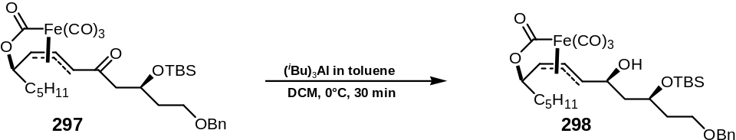

^{i}Bu₃Al (1M solution in toluene, d=0.848, 2.0 eq., 1.34 mmol, 1.34 ml) was added according to Error: Reference source not found (page Error: Reference source not found) to a solution of the TBS protected Mukaiyama aldol adduct 297 (423 mg, 0.67 mmol) in DCM (5 ml) at 0°C. Workup as described followed by flash column chromatography (eluent PE:Et₂O 5:1 to 3:1, gradient) afforded the secondary alcohol iron lactone complex 298 (353 mg, 0.56 mmol, 83%) as a yellow oil; ν_{max} (neat)/cm⁻¹: 3419 (br, OH), 2929, 2857, 2077, 2000, 1667, 1636, 1462, 1360, 1252, 1004, 835, 775, 657; δ_{H} (400 MHz, CDCl₃): 0.05 (3H, s, Si(CH₃)), 0.08 (3H, s, Si(CH₃)), 0.85 (9H, s, SiC(CH₃)₃), 0.89 (3H, t, J 7.1, 1-H x 3), 1.30-1.64 (8H, m, 2-H x 2, 3-H x 2, 4-H x 2, 5-H x 2), 1.80 (2H, m, 11-H x 2), 1.86 (2H, m, 13-H x 2), 3.52 (2H, t, J 5.8, 14-H x 2), 3.70 (1H, s, OH), 3.94 (1H, d, J 9.5, 9-H), 4.16 (1H, m, 12-H), 4.25 (1H, td, J 6.9, 5.1, 6-H), 4.45 (1H, m, 10-H), 4.49 (2H, d, J 3.3, CH₂C₆H₅), 4.60 (1H, dd, J 8.4, 4.4, 7-H), 4.85 (1H, dd, J 12.1, 8.4, 8-H), 7.22-7.35 (5H, m, CH₂C₆H₅); δ_{C} (100 MHz, CDCl₃): 209.7 (CO), 207.1 (CO), 206.2 (CO), 203.3 (CO), 138.0 (Ph ipso), 128.4 (Ph meta x 2), 127.7 (Ph para), 127.6 (Ph ortho x 2), 88.2 (8-C), 87.0 (7-C), 77.3 (6-C), 75.9 (10-C), 73.1 (CH₂C₆H₅), 71.1 (14-C), 69.6 (9-C), 66.2 (12-C), 45.3 (11-C), 37.8 (13-C), 36.7 (5-C), 31.5 (4-C), 26.6 (3-C), 25.7 (SiC(CH₃)₃), 22.4 (2-C), 17.8 (SiC(CH₃)₃), 13.9 (1-C), -4.0 (Si(CH₃)), -4.7 (Si(CH₃)); m/z (CI) Found: [MH]⁺ 631.2380. C₃₁H₄₇FeO₈Si requires MH, 631.2390; [α]_{D}²⁵ -62.4 (c 1.00 in CHCl₃).

Preparation of [(8E,6R,7S,10S,12S)-10-acetoxy-14-benzyloxy-12-(tert-butyl-dimethyl-silanyloxy)-6-(carbonyloxy-κC)-(7,8,9-η)-tetradec-8-en-7-yl]tricarbonyliron (289)

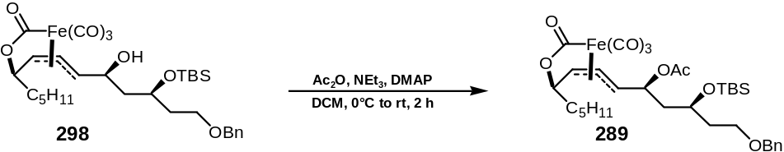

Acetic anhydride (MW=102.09, d=1.082, 1.1 eq., 0.57 mmol, 58.3 mg, 53.8 μl) was added according to Error: Reference source not found (page Error: Reference source not found) to a solution of the alcohol 298 (330 mg, 0.52 mmol), NEt₃ (MW=101.19, d=0.726, 1.3 eq., 0.68 mmol, 68.8 mg, 94.8 μl) and DMAP (MW=122.17, 0.1 eq., 0.052 mmol, 6.3 mg) in DCM (5 ml) at 0°C. Workup as described without further purification yielded the acetate complex 289 (340 mg, 0.51 mmol, 98%) as a colourless oil; ν_{max} (neat)/cm⁻¹: 2929, 2857, 2077, 2000, 1740 (C=O), 1667 (C=O), 1463, 1370, 1224, 1098, 1005, 835, 774, 734, 697, 655; δ_{H} (400 MHz, CDCl₃): 0.05 (3H, s, Si(CH₃)), 0.08 (3H, s, Si(CH₃)), 0.86 (9H, s, SiC(CH₃)₃), 0.89 (3H, t, J 7.1, 1-H x 3), 1.20-1.66 (8H, m, 2-H x 2, 3-H x 2, 4-H x 2, 5-H x 2), 1.80 (2H, app. q, J 5.8, 11-H x 2), 2.03 (3H, s, COCH₃), 2.10 (2H, m, 13-H x 2), 3.58 (2H, m, 14-H x 2), 3.90 (1H, dd, J 6.5, 5.1, 9-H), 3.96 (1H, m, 12-H), 4.20 (1H, td, J 6.9, 5.1, 6-H), 4.47 (1H, m, 10-H), 4.49 (2H, d, J 3.3, CH₂C₆H₅), 4.60 (1H, dd, J 8.4, 4.4, 7-H), 5.45 (1H, dd, J 12.1, 8.4, 8-H), 7.23-7.37 (5H, m, CH₂C₆H₅); δ_{C} (100 MHz, CDCl₃): 208.8, 206.4, 204.1, 202.9, 170.0, 138.4, 128.3, 127.7, 127.6, 127.5, 89.0, 81.7, 73.0, 71.7, 66.6, 66.3, 44.7, 36.5, 36.3, 31.5, 26.5, 25.8 (SiC(CH₃)₃), 22.4, 20.6, 17.9 (SiC(CH₃)₃), 13.9, -4.5 (Si(CH₃)), -4.6 (Si(CH₃)); m/z (ES): Found: [MH]⁺ 673.2477. C₃₃H₄₉FeO₉Si requires MH, 673.2495; [α]_{D}²⁵ -139.7 (c 1.00 in CHCl₃).

Preparation of (7E,9E,6R,12R)-14-benzyloxy-12-(tert-butyl-dimethyl-silanyloxy)-6-hydroxy-tetradeca-7,9-diene (299), (7E,9Z,6R,12R)-14-benzyloxy-12-(tert-butyl-dimethyl-silanyloxy)-6-hydroxy-tetradeca-7,9-diene (300) and (7Z,9E,6R,12R)-14-benzyloxy-12-(tert-butyl-dimethyl-silanyloxy)-6-hydroxy-tetradeca-7,9-diene (301)

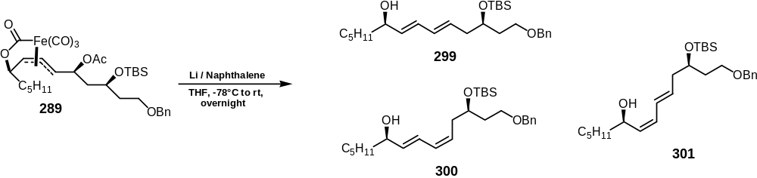

Dienes 299, 300 and 301 were prepared according to Error: Reference source not found (page Error: Reference source not found) from iron lactone complex 289 (55 mg, 0.08 mmol, MW=672.66) in THF (1 ml) and lithium naphthalenide (5 eq., 0.41 mmol, 0.41 ml, 1M solution in THF, prepared according to Error: Reference source not found (page Error: Reference source not found)). Workup as described followed by flash column chromatography (eluent PE:Et₂O 5:1 to 1:1, gradient) afforded an inseparable mixture of dienes 299, 300 and 301 (0.5: 0.2:0.3) as an oil (36 mg, 0.08 mmol, 98%); ν_{max} (neat)/cm⁻¹: 3358 (OH), 2927, 2855, 2079, 1973, 1455, 1361, 1252, 1092, 1043, 989, 835, 774, 734, 697; δ_{H} (400 MHz, CDCl₃): 0.05 (3H, s, Si(CH₃)), 0.08 (3H, s, Si(CH₃)), 0.84 (9H, s, SiC(CH₃)₃), 0.89 (3H, t, J 7.1, 1-H x 3), 1.21-1.63 (8H, m, 2-H x 2, 3-H x 2, 4-H x 2, 5-H x 2), 1.75 (2H, m, 11-H x 2), 2.26 (2H, m, 13-H x 2), 3.54 (1H, s, OH), 3.58 (1H, m, 12-H), 3.91 (0.5H, m, 6-H x 0.5), 4.12 (0.5H, m, 6-H x 0.5), 4.49 (2H, app. q, J 11.7, CH₂C₆H₅), 5.29 (0.3H, m, 7-H x 0.3), 5.49 (0.2H, m, 10-H x 0.2), 5.58 (0.5H, dd, J 15.0, 6.9, 7-H x 0.5), 5.69 (1H, m, 7-H x 0.2, 10-H x 0.8), 6.04 (1H, m, 8-H x 0.3, 9-H x 0.7), 6.17 (0.5H, dd, J 15.3 10.2, 8-H x 0.5), 6.32 (0.3H, dd, J 15.0 10.9, 9-H x 0.3), 6.44 (0.2H, dd, J 15.0 10.9, 8-H x 0.2), 7.24-7.38 (5H, m, CH₂C₆H₅); δ_{C} (100 MHz, CDCl₃): 138.5, 134.3, 131.9, 130.6, 128,3, 127.7, 127.4, 125.8, 72.9, 72.7, 69.2, 67.0, 41.2, 41.0, 37.4, 37.3, 36.9, 31.8, 25.8 (SiC(CH₃)₃), 25.1, 24.9, 22.6, 18.1 (SiC(CH₃)₃), 14.0, -4.3 (Si(CH₃)), -4.7 (Si(CH₃)); m/z (ES) Found: [MH]⁺ 447.3267. C₂₇H₄₇O₃Si requires MH, 447.3294.

Preparation of (3R,9R)-3-(tert-butyl-dimethyl-silanyloxy)-tetradecane-1,9-diol (288)

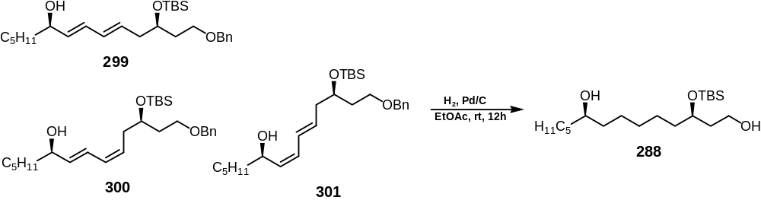

Alkene 288 was prepared according to Error: Reference source not found (page Error: Reference source not found) from diene mixture 299, 300 and 301 (120 mg, 0.27 mmol, MW=446.74), Pd/C (1 eq., 10 wt.%, 0.27 mmol, 283 mg) under H₂ atmosphere in EtOAc (5 ml). After 12 h, workup as described followed by flash column chromatography (eluent PE:Et₂O 2:1 to 1:1, gradient) afforded alkene 288 as an oil (81 mg, 0.22 mmol, 83%); ν_{max} (neat)/cm⁻¹: 3394 (OH), 2928, 2856, 2370, 2358, 2299, 1462, 1254, 1059, 835, 773, 734, 661; δ_{H} (400 MHz, CDCl₃): 0.07 (3H, s, Si(CH₃)), 0.09 (3H, s, Si(CH₃)), 0.89 (9H, s, SiC(CH₃)₃), 0.89 (3H, t, J 7.1, 14-H x 3), 1.25-1.52 (18H, m, 4-H x 2, 5-H x 2, 6-H x 2, 7-H x 2, 8-H x 2, 10-H x 2, 11-H x 2, 12-H x 2, 13-H x 2), 1.65 (1H, m, 2-H), 1.81 (1H, m, 2-H’), 2.40 (2H, s, 1-OH, 9-OH), 3.58 (1H, m, 9-H), 3.70 (1H, m, 1-H), 3.83 (1H, m, 1-H’), 3.91 (1H, m, 3-H); δ_{C} (100 MHz, CDCl₃): 71.9, 71.8, 60.3, 37.7, 37.4, 37.3, 36.7, 31.9, 29.8, 25.8 (SiC(CH₃)₃), 25.5, 25.3, 25.3, 25.2, 22.6, 17.9 (SiC(CH₃)₃), 14.0, -4.4 (Si(CH₃)), -4.7 (Si(CH₃)); m/z (+ES) Found: [MNa]⁺ 383.2966. C₂₀H₄₄O₃SiNa requires MNa, 383.2957.

Preparation of (3R,9R)-3-(tert-butyl-dimethyl-silanyloxy)-9-hydroxy-tetradecanal (302)

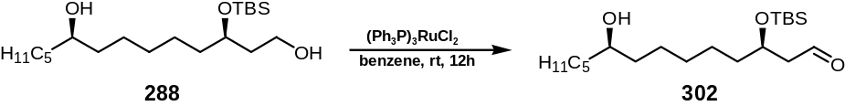

A solution of diol 288 (70 mg, 0.19 mmol, MW=360.65) in benzene (3 ml) was added via cannula to a stirred solution of tris(triphenylphosphine)ruthenium dichloride (1 eq., 0.19 mmol, 186 mg, MW=958.85) in benzene (5 ml). The reaction mixture was stirred at rt for 12 h, then filtered through a pad of Florisil®. The residue was washed with Et₂O (3 x 50 ml). Concentration of the filtrate in vacuo followed by flash column chromatography (PE:Et₂O 1:1) afforded aldehyde 302 (53 mg, 0.15 mmol, 78%) as an oil; ν_{max} (neat)/cm⁻¹: 3432 (OH), 2928, 2857, 1725 (C=O), 1463, 1434, 1361, 1255, 1094, 1005, 938, 806, 744, 693; δ_{H} (400 MHz, CDCl₃): 0.07 (3H, s, Si(CH₃)), 0.09 (3H, s, Si(CH₃)), 0.89 (9H, s, SiC(CH₃)₃), 0.89 (3H, t, J 7.1, 14-H x 3), 1.19-1.61 (18H, m, 4-H x 2, 5-H x 2, 6-H x 2, 7-H x 2, 8-H x 2, 10-H x 2, 11-H x 2, 12-H x 2, 13-H x 2), 2.05 (1H, s, 9-OH), 2.51 (2H, m, 2-H x 2), 3.58 (1H, m, 9-H), 4.17 (1H, quint., J 5.5, 3-H), 9.81 (1H, t, J 2.2, 1-H); δ_{C} (100 MHz, CDCl₃): 202.3 (C=O), 71.9, 68.2, 50.8, 37.7, 37.4, 37.3, 34.2, 31.8, 30.3, 29.6, 25.7 (SiC(CH₃)₃), 25.5, 25.3, 25.1, 22.6, 18.0 (SiC(CH₃)₃), 14.0, -4.5 (Si(CH₃)), -4.7 (Si(CH₃)); m/z (+ES) Found: [MNa]⁺ 381.2803. C₂₀H₄₂O₃SiNa requires MNa, 381.2801; [α]_{D}²⁵ -2.6 (c 0.75 in CHCl₃).

Preparation of (3R,9R)-3-(tert-butyl-dimethyl-silanyloxy)-tetradecanal-9-yl pent-4’-enoate (303)

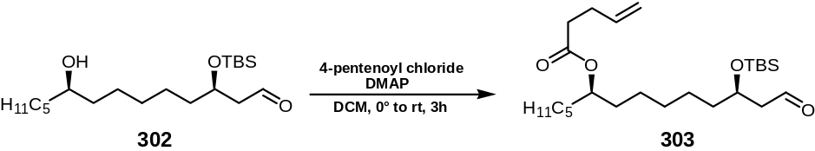

4-Pentenoyl chloride (2 eq., 14.5 mg, 13.5 μl, MW=118.56, d=1.074) was added to aldehyde 302 (22 mg, 0.061 mmol, MW=358.63) and DMAP (3 eq., 0.18 mmol, 22.3 mg, MW=122.17) in DCM (2 ml) at 0°C. The reaction mixture was stirred and allowed to warm to rt over 3 h, then filtered through a pad of Florisil®. The residue was washed with Et₂O (3 x 10 ml). Concentration of the filtrate in vacuo followed by flash column chromatography (PE:Et₂O 9:1 to 2:1) afforded ester 303 (5.3 mg, 0.012 mmol, 30% conversion, 65% yield) as an oil∗; δ_{H} (400 MHz, CDCl₃): 0.07 (3H, s, Si(CH₃)), 0.09 (3H, s, Si(CH₃)), 0.89-0.94 (12H, s, SiC(CH₃)₃, 14-H x 3), 1.23-1.69 (18H, m, 4-H x 2, 5-H x 2, 6-H x 2, 7-H x 2, 8-H x 2, 10-H x 2, 11-H x 2, 12-H x 2, 13-H x 2), 2.30 (4H, m, 2’-H x 2, 3’-H x 2), 2.43 (2H, m, 2-H x 2), 4.08 (1H, app. t, J 5.5, 9-H), 4.79 (1H, quint., J 5.2, 3-H), 4.95 (2H, app. q, 5’-H x 2), 5.75 (1H, m, 4’-H), 9.78 (1H, t, J 2.2, 1-H.

Preparation of (4R,10R)-4-(tert-butyl-dimethyl-silanyloxy)-pentadec-1-en-10-yl pent-4’-enoate (262)

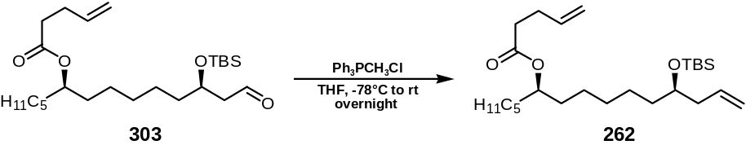

Methyltriphenylphosphonium chloride∗ (0.2 mmol, 63 mg, MW=312.78) was deprotonated by stirring with ^{n}BuLi (1M in THF, 0.19 mmol, 190 μl) in THF (2 ml) at rt for 30 min. The pre-cooled (-78°C) ylid (3.0 eq., 37.4 μmol, 11.7 mg) was then added to aldehyde 303 (5.3 mg, 12 μmol, MW=440.74) in THF (1 ml) at -78°C. The reaction mixture was stirred and allowed to warm to rt overnight, then filtered through a pad of Florisil®. The residue was washed with Et₂O (3 x 5 ml). Concentration of the filtrate in vacuo followed by flash column chromatography (PE:Et₂O 40:2 to 40:3) afforded diene 262 (4.2 mg, 9.6 μmol, 77%) as an oil; ν_{max} (neat)/cm⁻¹: 2928, 2858, 1735 (C=O), 1255, 1093, 835, 822; δ_{H} (400 MHz, CDCl₃): 0.07 (3H, s, Si(CH₃)), 0.09 (3H, s, Si(CH₃)), 0.79-0.89 (12H, s, SiC(CH₃)₃, 15-H x 3), 1.21-1.50 (18H, m, 5-H x 2, 6-H x 2, 7-H x 2, 8-H x 2, 9-H x 2, 11-H x 2, 12-H x 2, 13-H x 2, 14-H x 2), 2.15 (2H, t, J 6.8, 3-H x 2), 2.29-2.35 (4H, m, 2’-H x 2, 3’-H x 2), 3.61 (1H, quint., J 5.5, 4-H), 4.80 (1H, quint., J 6.1, 10-H), 4.98-5.11 (4H, m, 1-H x 2, 5’-H x 2), 5.65-5.80 (2H, m, 2-H, 4’-H); δ_{C} (100 MHz, CDCl₃): 172.9 (C=O), 136.8 (C=C), 135.4 (C=C), 116.6 (C=C), 115.4 (C=C), 74.3, 71.9, 41.9, 36.7, 34.0, 33.8, 31.7, 29.7, 29.6, 29.0, 25.9 (SiC(CH₃)₃), 25.3, 25.2, 24.9, 22.5, 18.1 (SiC(CH₃)₃), 14.0, 13.9, 1.0, -4.4 (Si(CH₃)), -4.5 (Si(CH₃)); m/z (+ES) Found: [MNa]⁺ 461.3431. C₂₆H₅₀O₃SiNa requires MNa, 461.3427; [α]_{D}²⁵ +10.5 (c 0.1 in CHCl₃). Data was consistent with those reported in the literature.¹²⁷

 The yellow oil could not be stored for more than a few days, even in the fridge, since polymerisation occurs, forming a yellow solid.
 very minor traces of the cis epoxy enoate could be identified in the NMR spectrum.
 very little of suspected η⁴-diene complex eluted off at first, which was discarded.
 when deprotecting the exo complex, less equivalents of HF•pyr are required, and also the reaction time is much shorter. This is presumably due to less steric crowding, since the C₅H₁₁ alkyl chain points away.
 Two further side products, presumably the esters from overoxidation, eluded before the main product.
 The minor diastereoisomer was not isolated due to its low abundance. However, analysis of the 400 MHz ¹H nmr spectrum of the crude reaction mixture after silyl deprotection allowed an estimation of the d.e. of the aldol products, specifically by integration of the 9-H resonance; δ_{H} (400 MHz) 3.87 (0.98H, d), 3.83 (0.02H, d). Calculated d.e. = 96%
 Due to the instability of the aldehyde it was used immediately in the following reaction. IR, ¹³C NMR data, MS and OR data were not obtained on this unstable aldehyde.
 Methyltriphenylphosphonium chloride was dried prior to use by dissolving it in little toluene and concentration in vacuo (2 x) and leaving it on a high vacuum pump overnight.

