# Multi-omics Boot Camp

## Analysis of Omics Data for Research Studies

### Day 1: Wednesday Jan 18,2023

8:45 – 9:00 PT

*11:45 – 12:00 ET*

*Login to Zoom*

9:00 – 9:45 PT

*12:00 – 12:45 ET*

**Welcome and Introduction** David Conti, PhD

9:45 – 10:00 PT

*12:45 – 1:00 ET*

*Break / One-on-one questions*

10:00 – 11:00 PT

*1:00 – 2:00 ET*

Session 1. Introduction to Observational Studies and Omic Data (Lecture)

David Conti, PhD

*TA: Yinqi Zhao*

11:00 – 11:15 PT

*2:00 – 2:15 ET*

*Break / One-on-one questions*

11:15 – 12:00 PT

*2:15 – 3:00 ET*

Session 2. Polygenic Analyses and Summary Statistics (Lecture)

Nicholas Mancuso PhD

*TA: Zeyun Lu*

12:00 – 1:00 PT

*3:00 – 4:00 ET*

*Networking Meal Break*

1:00 – 1:45 PT

*4:00 – 4:45 ET*

**Session 3. Polygenic Analyses and Summary Statistics (Lab)** Nicholas Mancuso, PhD

*TA: Zeyun Lu*

1:45 – 2:00 PT

*4:45 – 5:00 ET*

*Break / One-on-one questions*

2:00 – 3:00 PT

*5:00 – 6:00 ET*

**Session 4.** **Advanced Polygenic analysis and Summary**

**Statistics (Lecture/Lab**) Nicholas Mancuso, PhD

*TA: Zeyun Lu*

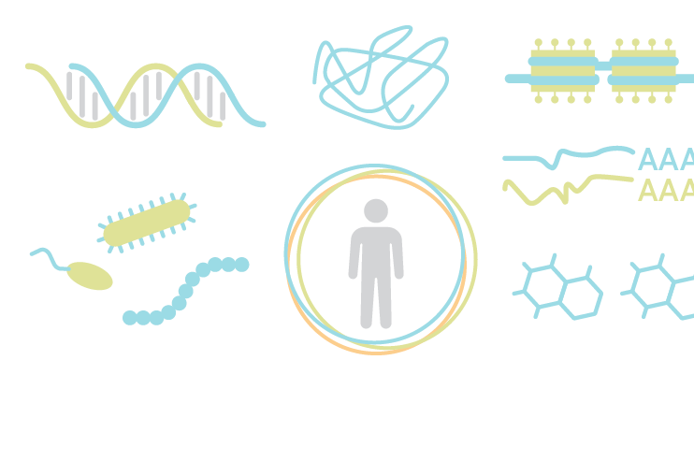3:00 – 3:15 PT

*6:00 – 6:15 ET*

Questions and Day 1 Wrap Up

# Multi-omics Boot Camp

## Analysis of Omics Data for Research Studies

### Day 2: Thursday Jan 19, 2023

8:45 – 9:00 PT

*11:45 – 12:00 ET*

*Login to Zoom*

9:00 – 9:45 PT

***12:00 – 12:45***

Session 5. Interaction (Lecture)William Gauderman, PhD

*TA: Yingi Zhao*

9:45 – 10:00 PT

*12:45 – 1:00 ET*

*Break / One-on-one questions*

10:00 – 10:45 PT

*1:00 – 1:45 ET*

**Session 6. Interaction (Lab)** WIlliam Gauderman, PhD

*TA: Yingi Zhao*

10:45 – 11:00 PT

*1:45 – 2:00 ET*

*Break / One-on-one questions*

11:00 - 12:00 PT

*2:00 – 3:00 ET*

Session 7. Advanced Interactions (Lecture/Lab)Juan Pablo Lewinger, PHD

*TA: Yingi Zhao*

12:00 – 1:00 PT

*3:00 – 4:00 ET*

*Networking Meal Break*

1:00 – 1:45 PT

*4:00 – 4:45 ET*

**Session 8. Clustering (Lecture)** Kimberly Siegmund, PhD

*TA: Yinqi Zhao*

1:45 – 2:00 PT

*4:45 – 5:00 ET*

*Break / One-on-one questions*

2:00 – 3:00 PT

*5:00 – 6:00 ET*

**Session 9. Clustering (Lab)** Kimberly Siegmund, PhD

*TA: Yinqi Zhao*

3:00 – 3:15 PT

*6:00 – 6:15 ET*

Questions and Day 2 Wrap Up

# Multi-omics Boot Camp

## Analysis of Omics Data for Research Studies

### Day 3: Friday Jan 20, 2023

8:45 – 9:00 PT

*11:30 – 12:00 ET*

*Login to Zoom*

9:00 – 10:00 PT

*12:00 – 1:00 ET*

**Session 10. Advanced Clustering (Lecture/Lab)** Kimberly Siegmund, PhD

*TA: Yinqi Zhao*

10:00 – 10:15 PT

*1:00 – 1:15 ET*

*Break / One-on-one questions*

10:15 – 11:00 PT

*1:15 – 2:00 ET*

**Session 11. Mediation/Latent Variable (Lecture)** David Conti, PhD

*TA: Yinqi Zhao*

11:00 – 11:15 PT

*2:00 – 2:15 ET*

*Break / One-on-one questions*

11:15 – 12:00 PT

*2:15 – 3:00 ET*

**Session 12. Mediation/Latent Variable (Lab)** David Conti, PhD

*TA: Yinqi Zhao*

12:00 – 1:00 PT

*3:00 – 4:00 ET*

*Networking Meal Break*

1:00 – 2:00 PT

*4:00 – 5:00 ET*

**Session 13. Advanced Mediation/Latent Variable (Lecture/Lab)** David Conti, PhD

*TA: Yinqi Zhao*

2:00 – 2:15 PT

*5:00 – 5:15 ET*

*Break / One-on-one questions*

2:15 – 3:00 PT

*5:15 – 6:00 ET*

Session 14. Bringing it all Together: Multi-omic Analysis in Real Data

Jesse Goodrich, PhD

3:00 – 3:15 PT

*6:00 – 6:15 ET*

**Questions and wrap-up** All Instructors