Logical Resources for All Address-Spaces

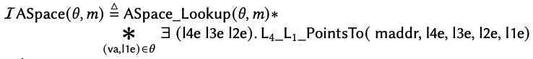

***I***ASpace :

N

Virtual PointsTos:

1

Logical Resources for Address-Space Abstraction