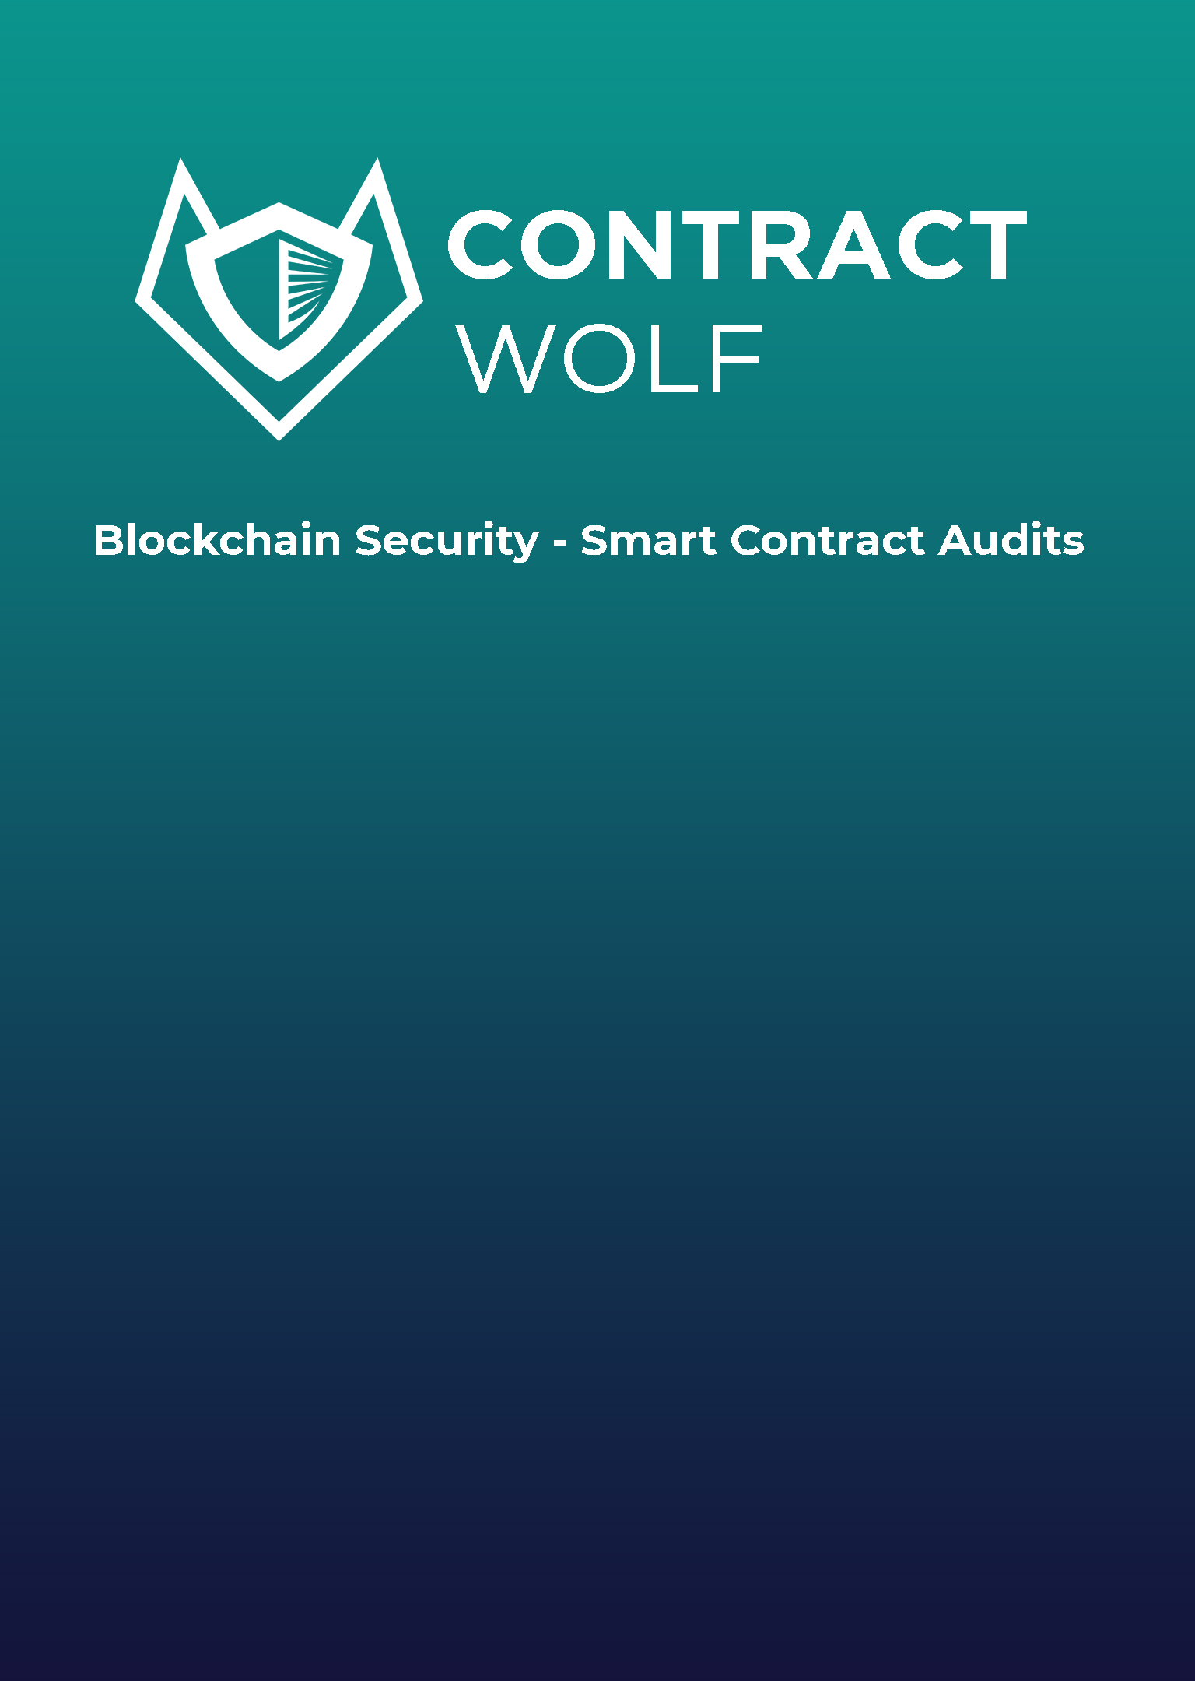

**Security Assessment**

March 29, 2022

**Disclaimer 3**

**Description 5**

**Engagement 5**

**Project Engagement 5**

**Logo 6**

**Contract Link 6**

**Risk Level Classification 7**

**Methodology 8**

**Used Code from other Frameworks / Smart Contracts (Imports) 9**

**Description 10**

**Scope of Work 12**

**Inheritance Graph 13**

**Verify Claim 14**

**Overall Checkup 18**

**Write Functions of Contract 19**

**SWC Attack 20**

**Audit Result 24**

**Audit Comments 25**

**Disclaimer  
ContractWolf.io** audits and reports should not be considered as a form of project's "advertisement" and does not cover any interaction and assessment from "project's contract" to "external contracts" such as Pancakeswap or similar.

**ContractWolf** does not provide any warranty on its released reports.

**ContractWolf** should not be used as a decision to invest into an audited project and is not affiliated nor partners to its audited contract projects.

**ContractWolf** provides transparent report to all its "clients" and to its "clients participants" and will not claim any guarantee of bug-free code within it’s **SMART CONTRACT**.

**ContractWolf** presence is to analyze, audit and assess the client's smart contract's code.

Each company or projects should be liable to its security flaws and functionalities.

**Network**

Binance Smart Chain (BEP20)

**Website**

http://www.apextokenbusd.com/

**Telegram**

https://t.me/Apextokenbusd

**Twitter**

https://twitter.com/ApexToken1

**Description**

With #APEXTOKEN provide will be earning unlimited passive income! Apex Token has a reflection reward of 12%. 12% rewards are applied to all buy and sell transactions.

**ContractWolf Engagements**

29th of March 2022, **Apex Token** engaged and agrees to audit their smart contract's code by **ContractWolf**. The goal of this engagement was to identify if there is a possibility of security flaws in the implementation of the contract or system.

**ContractWolf** will be focusing on contract issues and functionalities along with the projects claims from smart contract to their website, whitepaper and repository which has been provided by **Apex Token.**

**Logo**

Contract link:

https://bscscan.com/address/0x523852811CB7B2F289C396110e57Ce4895b6b8c9#code

**Risk Level Classification**

Risk Level represents the classification or the probability that a certain function or threat that can exploit vulnerability and have an impact within the system or contract.  
Risk Level is computed based on CVSS Version 3.0

**Auditing Approach**

Every line of code along with its functionalities will undergo manual review to check its security issues, quality, and contract scope of inheritance.The manual review will be done by our team that will document any issues that there were discovered.

**Methodology**

The auditing process follows a routine series of steps:

1. Code review that includes the following:

* Review of the specifications, sources, and instructions provided to ContractWolf to make sure we understand the size, scope, and functionality of the smart contract.
* Manual review of code, our team will have a process of reading the code line-by-line with the intention of identifying potential vulnerabilities and security flaws.

2. Testing and automated analysis that includes:

* Testing the smart contract functions with common test cases and scenarios, to ensure that it returns the expected results.

3. Best practices review, the team will review the contract with the aim to improve efficiency, effectiveness, clarifications, maintainability, security, and control within the smart contract.

4. Recommendations to help the project take steps to secure the smart contract.

**Used Code from other Frameworks/Smart Contracts (Direct Imports)**

Imported Packages

* IERC20Extended
* SafeMath
* IUniswapV2Factory
* IUniswapV2Router01
* IUniswapV2Router02
* IDividendDistributor
* DividendDistributor
* Clones
* Auth
* BaseToken

**Description**

Optimization enabled: Yes  
Version: v0.8.4

Decimal: 9

Symbol: $APX

**Capabilities**

**Components**

|  |  |  |  |  |
| --- | --- | --- | --- | --- |
| **Version** | **Contracts** | **Libraries** | **Interfaces** | **Abstract** |
| **1.0** | **2** | **2** | **5** | **2** |

**Exposed Functions**

|  |  |  |
| --- | --- | --- |
| **Version** | **Public** | **Private** |
| **1.0** | **12** | **0** |

|  |  |  |
| --- | --- | --- |
| **Version** | **External** | **Internal** |
| **1.0** | **71** | **36** |

**State Variables**

|  |  |  |
| --- | --- | --- |
| **Version** | **Total** | **Public** |
| **1.0** | **53** | **45** |

**Capabilities**

|  |  |  |  |  |  |
| --- | --- | --- | --- | --- | --- |
| **Version** | **Solidity Versions Observed** | **Experimental**  **Features** | **Can Receive Funds** | **Uses Assembly** | **Has Destroyable Contracts** |
| **1.0** | **^0.8.4** |  | **Yes** | **Yes (3asm blocks)** | **No** |

**Scope of Work**

**Apex Token’s** team provided us with the files that needs to be tested (Github, Bscscan, Etherscan, files, etc.). The scope of the audit is the main contract.

**Inheritance Graph**

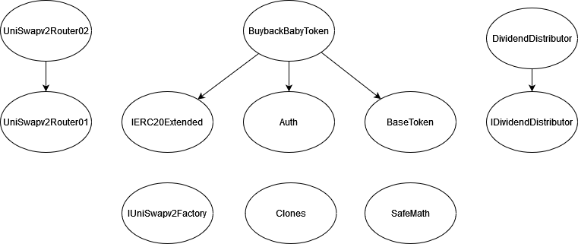

**Verify Claims**

**Correct implementation of Token Standard**

|  |  |
| --- | --- |
| **Tested** | **Verified** |
| **✓** | **✘** |

|  |  |  |  |  |
| --- | --- | --- | --- | --- |
| **Function** | **Description** | **Exist** | **Tested** | **Verified** |
| TotalSupply | Information about the total coin or token supply | **✓** | **✓** | **✓** |
| BalanceOf | Details on the account balance from a specified address | **✓** | **✓** | **✓** |
| Transfer | An action that transfers a specified amount of coin or token to a specified address | **✓** | **✓** | **✓** |
| TransferFrom | An action that transfers a specified amount of coin or token from a specified address | **✓** | **✓** | **✓** |
| Approve | Provides permission to withdraw specified number of coin or token from a specified address | **✓** | **✓** | **✓** |

**Optional implementation**

|  |  |  |  |  |
| --- | --- | --- | --- | --- |
| **Function** | **Description** | **Exist** | **Tested** | **Verified** |
| renounceOwnership | Owner renounce ownership for more trust | **–** | **–** | **–** |

**Deployer cannot mint after initial deployment**

|  |  |  |  |  |
| --- | --- | --- | --- | --- |
| **Statement** | **Exist** | **Tested** | **Verified** | **File** |
| Deployer cannot mint | **–** | **–** | **–** | Main |

Max / Total supply: 100,000,000,000

**Deployer cannot block user**

|  |  |  |  |
| --- | --- | --- | --- |
| **Statement** | **Exist** | **Tested** | **Verified** |
| Deployer cannot block user | **✓** | **✓** | **✓** |

**Deployer cannot burn**

|  |  |  |  |
| --- | --- | --- | --- |
| **Statement** | **Exist** | **Tested** | **Verified** |
| Deployer cannot burn | **–** | **–** | **–** |

**Deployer cannot pause contract**

|  |  |  |  |
| --- | --- | --- | --- |
| **Statement** | **Exist** | **Tested** | **Verified** |
| Deployer cannot pause | **✓** | **✓** | **✓** |

**Overall Checkup (Smart Contract Security)**

|  |  |
| --- | --- |
| **Tested** | **Verified** |
| **✓** | **✓** |

Legend

|  |  |
| --- | --- |
| **Attribute** | **Symbol** |
| Verified / Checked | **✓** |
| Partly Verified | **✘** |
| Unverified / Not checked | 🏴 |
| Not Available | **­–** |

**Write Functions of Contract  
**

**SWC Attacks**

|  |  |  |  |
| --- | --- | --- | --- |
| **ID** | **Title** | **Relationships** | **Status** |
| [SWC-136](https://swcregistry.io/docs/SWC-136) | Unencrypted Private Data  On-Chain | [CWE-767: Access to Critical Private Variable via Public Method](https://cwe.mitre.org/data/definitions/767.html) | **PASSED** |
| [SWC-135](https://swcregistry.io/docs/SWC-135) | Code With No Effects | [CWE-1164: Irrelevant Code](https://cwe.mitre.org/data/definitions/1164.html) | **PASSED** |
| [SWC-134](https://swcregistry.io/docs/SWC-134) | Message call with hardcoded gas amount | [CWE-655: Improper Initialization](https://cwe.mitre.org/data/definitions/665.html) | **PASSED** |
| [SWC-133](https://swcregistry.io/docs/SWC-133) | Hash Collisions with Multiple Variable Length Arguments | [CWE-294: Authentication Bypass by Capture-replay](https://cwe.mitre.org/data/definitions/294.html) | **PASSED** |
| [SWC-132](https://swcregistry.io/docs/SWC-132) | Unexpected Ether balance | CWE-667:  Improper Locking | **PASSED** |
| [SWC-131](https://smartcontractsecurity.github.io/SWC-registry/docs/SWC-131) | Presence of unused variables | [CWE-1164: Irrelevant Code](https://cwe.mitre.org/data/definitions/1164.html) | **PASSED** |
| [SWC-130](https://smartcontractsecurity.github.io/SWC-registry/docs/SWC-130) | Right-To Left Override control character (U+202E) | [CWE-451: User Interface (UI)](http://cwe.mitre.org/data/definitions/451.html)  [Misrepresentation of Critical](http://cwe.mitre.org/data/definitions/451.html)  [Information](http://cwe.mitre.org/data/definitions/451.html) | **PASSED** |
| [SWC-129](https://smartcontractsecurity.github.io/SWC-registry/docs/SWC-129) | Typographical Error | [CWE-480: Use of Incorrect Operator](https://cwe.mitre.org/data/definitions/480.html) | **PASSED** |
| [SWC-128](https://smartcontractsecurity.github.io/SWC-registry/docs/SWC-128) | DoS With Block Gas Limit | [CWE-400: Uncontrolled Resource Consumption](https://cwe.mitre.org/data/definitions/400.html) | **PASSED** |
| [SWC-127](https://smartcontractsecurity.github.io/SWC-registry/docs/SWC-127) | Arbitrary Jump with Function Type Variable | [CWE-695: Use of Low-Level Functionality](https://cwe.mitre.org/data/definitions/695.html) | **PASSED** |
| [SWC-126](https://smartcontractsecurity.github.io/SWC-registry/docs/SWC-128) | Insufficient Gas Griefing | CWE-691: Insufficient Control Flow Management | **PASSED** |
| [SWC-125](https://smartcontractsecurity.github.io/SWC-registry/docs/SWC-125) | Incorrect Inheritance Order | [CWE-696: Incorrect Behavior Order](https://cwe.mitre.org/data/definitions/696.html) | **PASSED** |
| [SWC-124](https://smartcontractsecurity.github.io/SWC-registry/docs/SWC-124) | Write to  Arbitrary  Storage Location | [CWE-123: Write-what-where Condition](https://cwe.mitre.org/data/definitions/123.html) | **PASSED** |
| [SWC-123](https://smartcontractsecurity.github.io/SWC-registry/docs/SWC-123) | Requirement Violation | [CWE-573: Improper Following of Specification by Caller](https://cwe.mitre.org/data/definitions/573.html) | **PASSED** |
| [SWC-122](https://smartcontractsecurity.github.io/SWC-registry/docs/SWC-122) | Lack of Proper Signature Verification | [CWE-345: Insufficient](https://cwe.mitre.org/data/definitions/345.html)  [Verification of Data](https://cwe.mitre.org/data/definitions/345.html)  [Authenticity](https://cwe.mitre.org/data/definitions/345.html) | **PASSED** |
| [SWC-121](https://smartcontractsecurity.github.io/SWC-registry/docs/SWC-121) | Missing Protection against Signature  Replay Attacks | CWE-347: Improper Verification of Cryptographic Signature | **PASSED** |
| [SWC-120](https://smartcontractsecurity.github.io/SWC-registry/docs/SWC-120) | Weak Sources of Randomness from Chain Attributes | [CWE-330: Use of Insufficiently](https://cwe.mitre.org/data/definitions/330.html)  [Random Values](https://cwe.mitre.org/data/definitions/330.html) | **PASSED** |
| [SWC-119](https://smartcontractsecurity.github.io/SWC-registry/docs/SWC-119) | Shadowing State Variables | [CWE-710: Improper Adherence to Coding Standards](http://cwe.mitre.org/data/definitions/710.html) | **PASSED** |
| [SWC-118](https://smartcontractsecurity.github.io/SWC-registry/docs/SWC-118) | Incorrect  Constructor  Name | [CWE-665: Improper](http://cwe.mitre.org/data/definitions/665.html)  I[nitialization](http://cwe.mitre.org/data/definitions/665.html) | **PASSED** |
| [SWC-117](https://smartcontractsecurity.github.io/SWC-registry/docs/SWC-117) | Signature Malleability | [CWE-347: Improper Verification of Cryptographic Signature](https://cwe.mitre.org/data/definitions/347.html) | **PASSED** |
| [SWC-116](https://smartcontractsecurity.github.io/SWC-registry/docs/SWC-116) | Timestamp Dependence | [CWE-829: Inclusion of](https://cwe.mitre.org/data/definitions/829.html)  [Functionality from Untrusted](https://cwe.mitre.org/data/definitions/829.html) [Control Sphere](https://cwe.mitre.org/data/definitions/829.html) | **PASSED** |
| [SWC-115](https://smartcontractsecurity.github.io/SWC-registry/docs/SWC-115) | Authorization through tx.origin | [CWE-477: Use of Obsolete Function](https://cwe.mitre.org/data/definitions/477.html) | **PASSED** |
| [SWC-114](https://smartcontractsecurity.github.io/SWC-registry/docs/SWC-114) | Transaction  Order  Dependence | [CWE-362: Concurrent Execution using Shared Resource with Improper Synchronization ('Race Condition')](https://cwe.mitre.org/data/definitions/362.html) | **PASSED** |
| [SWC-113](https://smartcontractsecurity.github.io/SWC-registry/docs/SWC-113) | DoS with Failed Call | [CWE-703: Improper Check or Handling of Exceptional Conditions](https://cwe.mitre.org/data/definitions/703.html) | **PASSED** |
| [SWC-112](https://smartcontractsecurity.github.io/SWC-registry/docs/SWC-112) | Delegate call to  Untrusted  Callee | [CWE-829: Inclusion of](https://cwe.mitre.org/data/definitions/829.html)  [Functionality from Untrusted](https://cwe.mitre.org/data/definitions/829.html)  [Control Sphere](https://cwe.mitre.org/data/definitions/829.html) | **PASSED** |
| [SWC-111](https://smartcontractsecurity.github.io/SWC-registry/docs/SWC-110) | Use of Deprecated Solidity Functions | CWE-477: Use of Obsolete Function | **PASSED** |
| [SWC-110](https://smartcontractsecurity.github.io/SWC-registry/docs/SWC-110) | Assert Violation | [CWE-670: Always-Incorrect Control Flow Implementation](https://cwe.mitre.org/data/definitions/670.html) | **PASSED** |
| [SWC-109](https://smartcontractsecurity.github.io/SWC-registry/docs/SWC-109) | Uninitialized  Storage Pointer | [CWE-824: Access of Uninitialized Pointer](https://cwe.mitre.org/data/definitions/824.html) | **PASSED** |
| [SWC-108](https://smartcontractsecurity.github.io/SWC-registry/docs/SWC-108) | State Variable  Default  Visibility | [CWE-710: Improper Adherence to Coding Standards](https://cwe.mitre.org/data/definitions/710.html) | **NOT PASSED** |
| [SWC-107](https://smartcontractsecurity.github.io/SWC-registry/docs/SWC-107) | Reentrancy | [CWE-841: Improper](https://cwe.mitre.org/data/definitions/841.html)  [Enforcement of Behavioral](https://cwe.mitre.org/data/definitions/841.html)  [Workflow](https://cwe.mitre.org/data/definitions/841.html) | **NOT PASSED** |
| [SWC-106](https://smartcontractsecurity.github.io/SWC-registry/docs/SWC-106) | Unprotected SELFDESTRUCT Instruction | [CWE-284: Improper Access Control](https://cwe.mitre.org/data/definitions/284.html) | **PASSED** |
| [SWC-105](https://smartcontractsecurity.github.io/SWC-registry/docs/SWC-105) | Unprotected  Ether  Withdrawal | [CWE-284: Improper Access Control](https://cwe.mitre.org/data/definitions/284.html) | **PASSED** |
| [SWC-104](https://smartcontractsecurity.github.io/SWC-registry/docs/SWC-104) | Unchecked Call Return Value | [CWE-252: Unchecked Return Value](https://cwe.mitre.org/data/definitions/252.html) | **PASSED** |
| [SWC-103](https://smartcontractsecurity.github.io/SWC-registry/docs/SWC-103) | Floating Pragma | [CWE-664: Improper Control of a Resource Through its Lifetime](https://cwe.mitre.org/data/definitions/664.html) | **PASSED** |
| [SWC-102](https://smartcontractsecurity.github.io/SWC-registry/docs/SWC-102) | Outdated Compiler Version | [CWE-937: Using Components with Known Vulnerabilities](http://cwe.mitre.org/data/definitions/937.html) | **PASSED** |
| [SWC-101](https://smartcontractsecurity.github.io/SWC-registry/docs/SWC-101) | Integer Overflow and Underflow | [CWE-682: Incorrect Calculation](https://cwe.mitre.org/data/definitions/682.html) | **PASSED** |
| [SWC-100](https://smartcontractsecurity.github.io/SWC-registry/docs/SWC-100) | Function Default Visibility | [CWE-710: Improper Adherence to Coding Standards](https://cwe.mitre.org/data/definitions/710.html) | **PASSED** |

**AUDIT PASSED**

**Medium Issues**

|  |  |
| --- | --- |
| Reentrancy vulnerabilities | L: 1159 |
| Unchecked token transfer | L: 849 |

**Low Issues**

|  |  |
| --- | --- |
| Proper importing of npm packages | - |
| State variable visibility is not set | L: 728, 730, 1008 |

**Audit Comments**

* Deployer can transfer ownership
* Deployer can set update fees/rates not greater than 25%
* Deployer cannot set transaction limit
* Deployer cannot pause/lock contract
* Deployer cannot renounce ownership
* Deployer cannot burn
* Deployer cannot mint after initial deployment

