

**Security Assessment**

January 17, 2022

**Disclaimer 3**

**Description 5**

**Engagement 5**

**Project Engagement 5**

**Logo 6**

**Contract Link 6**

**Risk Level Classification 7**

**Methodology 8**

**Used Code from other Frameworks / Smart Contracts (Imports) 9**

**Description 10**

**Scope of Work 11**

**Inheritance Graph 12**

**Verify Claim 13**

**Overall Checkup 16**

**Write Functions of Contract 17**

**SWC Attack 18**

**Audit Result 22**

**Audit Comments 23**

**Disclaimer  
ContractWolf.io** audits and reports should not be considered as a form of project's "advertisement" and does not cover any interaction and assessment from "project's contract" to "external contracts" such as Pancakeswap or similar.

**ContractWolf** does not provide any warranty on its released reports.

**ContractWolf** should not be used as a decision to invest into an audited project and is not affiliated nor partners to its audited contract projects.

**ContractWolf** provides transparent report to all its "clients" and to its "clients participants" and will not claim any guarantee of bug-free code within it’s **SMART CONTRACT**.

**ContractWolf** presence is to analyze, audit and assess the client's smart contract's code.

Each company or projects should be liable to its security flaws and functionalities.

**Network**

AVAX Network

**Website**

https://heroesofnft.com/

**Twitter**

https://twitter.com/heroesofnft

**Telegram**

https://t.me/heroesofNFTofficial

**Other channels**

https://blog.heroesofnft.com/

https://discord.com/invite/ngvATGZ6QE

**Description**

**Heroes of NFT** is an online card game where you can attend tournaments and defeat your opponents to rise to victory. Its unique story structure allows you to enter a Metaverse in the year 2073 to experience the stories of your heroes and get to know more about the world they live in before you begin to fight.

**ContractWolf Engagement**

17th of January 2022, **Heroes of NFT** engaged and agrees to audit their smart contract's code by ContractWolf. The goal of this engagement was to identify if there is a possibility of security flaws in the implementation of the contract or system.

**ContractWolf** will be focusing on contract issues and functionalities along with the projects claims from smart contract to their website, whitepaper and repository which has been provided by **Heroes of NFT.**

**Logo**

**Contract Link**

https://snowtrace.io/address/0xbd7bd0b4650d324e3ea6f734faa3fc37d80b7d82

**Risk level classification**

Risk Level represents the classification or the probability that a certain function or threat that can exploit vulnerability and have an impact within the system or contract.  
Risk Level is computed based on CVSS Version 3.0

|  |  |  |
| --- | --- | --- |
| **Level** | **Value** | **Vulnerability** |
| **Critical** | 9 - 10 | An exposure that can affect the contract functions in several events that can risk and disrupt the contract |
| **High** | 7 - 8.9 | An exposure that can affect the outcome when using the contract that can serve as an opening in manipulating the contract in an unwanted manner |
| **Medium** | 4 - 6.9 | An opening that could affect the outcome in executing the contract in a specific situation |
| **Low** | 0.1 - 3.9 | An opening but doesn’t have an impact on the functionality of the contract |
| **Informational** | 0 | An opening that consists of information’s but will not risk or affect the contract |

**Auditing Approach**

Every line of code along with its functionalities will undergo manual review to check its security issues, quality, and contract scope of inheritance.The manual review will be done by our team that will document any issues that there were discovered.

**Methodology**

The auditing process follows a routine series of steps:

1. Code review that includes the following:

* Review of the specifications, sources, and instructions provided to ContractWolf to make sure we understand the size, scope, and functionality of the smart contract.
* Manual review of code, our team will have a process of reading the code line-by-line with the intention of identifying potential vulnerabilities and security flaws.

2. Testing and automated analysis that includes:

* Testing the smart contract functions with common test cases and scenarios, to ensure that it returns the expected results.

3. Best practices review, the team will review the contract with the aim to improve efficiency, effectiveness, clarifications, maintainability, security, and control within the smart contract.

4. Recommendations to help the project take steps to secure the smart contract.

**Description**

Optimization enabled: Yes  
Version : ^0.8.3

Decimal : --(ERC721)

Symbol : HRO

**Capabilities**

**Components**

|  |  |  |  |  |
| --- | --- | --- | --- | --- |
| **Version** | **Contracts** | **Libraries** | **Interfaces** | **Abstract** |
| **1.0** | **1** | **4** | **2** | **4** |

**Exposed Functions**

|  |  |  |
| --- | --- | --- |
| **Version** | **Public** | **Private** |
| **1.0** | **35** | **12** |

|  |  |  |
| --- | --- | --- |
| **Version** | **External** | **Internal** |
| **1.0** | **18** | **41** |

**Capabilities**

|  |  |  |  |  |  |
| --- | --- | --- | --- | --- | --- |
| **Version** | **Solidity Versions Observed** | **Experimental**  **Features** | **Can Receive Funds** | **Uses Assembly** | **Has Destroyable Contracts** |
| **1.0** | **^0.8.3** |  | **Yes** | **Yes (2asm blocks)** | **No** |

**Scope of Work**

**Heroes Of NFT**’s team provided us with the files that needs to be tested (Github, Bscscan, Etherscan, files, etc.). The scope of the audit is the main contract.

We will verify the following claims:

1. Correct implementation of Token standard.
2. Deployer cannot mint any new tokens.
3. Deployer cannot burn or lock user funds.
4. Deployer cannot pause the contract.
5. Overall checkup. (Smart Contract Security)

**Inheritance Graph**

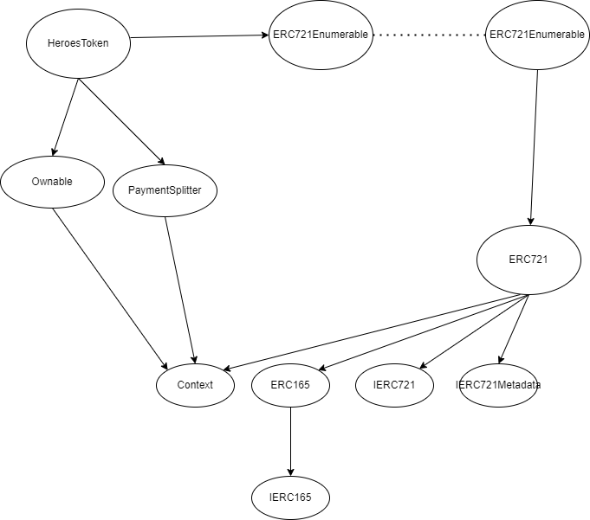

**Verify Claims**

**Correct implementation of Token Standard**

|  |  |
| --- | --- |
| **Tested** | **Verified** |
| **✓** | **✘** |

|  |  |  |  |  |
| --- | --- | --- | --- | --- |
| **Function** | **Description** | **Exist** | **Tested** | **Verified** |
| TotalSupply | Information about the total coin or token supply | **✓** | **✓** | **✘** |
| BalanceOf | Details on the account balance from a specified address | **✓** | **✓** | **✓** |
| Transfer | An action that transfers a specified amount of coin or token to a specified address | **✓** | **✓** | **✓** |
| TransferFrom | An action that transfers a specified amount of coin or token from a specified address | **✓** | **✓** | **✓** |
| Approve | Provides permission to withdraw specified number of coin or token from a specified address | **✓** | **✓** | **✓** |

**Optional implementation**

|  |  |  |  |  |
| --- | --- | --- | --- | --- |
| **Function** | **Description** | **Exist** | **Tested** | **Verified** |
| renounceOwnership | Owner renounce ownership for more trust | **✓** | **✓** | **✘** |

**Deployer cannot mint any new tokens**

|  |  |  |  |  |
| --- | --- | --- | --- | --- |
| **Statement** | **Exist** | **Tested** | **Verified** | **File** |
| Deployer can mint | **✓** | **✓** | **✓** | Main |
| Deployer can generate NFT | **✓** | **✓** | **✓** | Main |

Max / Total supply: --

**Deployer cannot burn or lock user funds**

|  |  |  |  |
| --- | --- | --- | --- |
| **Statement** | **Exist** | **Tested** | **Verified** |
| Deployer cannot pause | **✓** | **✓** | **✓** |

**Deployer cannot pause contract**

|  |  |  |  |
| --- | --- | --- | --- |
| **Statement** | **Exist** | **Tested** | **Verified** |
| Deployer cannot pause | **✓** | **✓** | **✓** |

**Overall Checkup (Smart Contract Security)**

|  |  |
| --- | --- |
| **Tested** | **Verified** |
| **✓** | **✓** |

Legend

|  |  |
| --- | --- |
| **Attribute** | **Symbol** |
| Verified / Checked | **✓** |
| Partly Verified | **✘** |
| Unverified / Not checked | 🏴 |
| Not Available | **­–** |

**Write Functions of Contract  
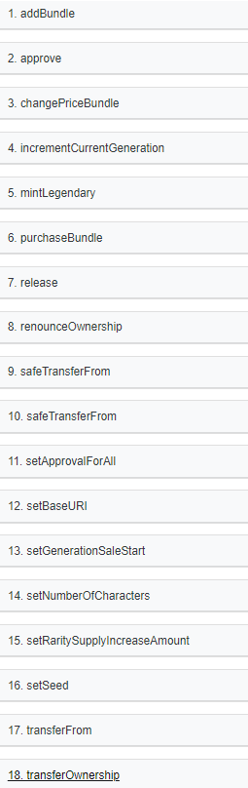**

**SWC Attacks**

|  |  |  |  |
| --- | --- | --- | --- |
| **ID** | **Title** | **Relationships** | **Status** |
| [SWC-136](https://swcregistry.io/docs/SWC-136) | Unencrypted Private Data  On-Chain | [CWE-767: Access to Critical Private Variable via Public Method](https://cwe.mitre.org/data/definitions/767.html) | **PASSED** |
| [SWC-135](https://swcregistry.io/docs/SWC-135) | Code With No Effects | [CWE-1164: Irrelevant Code](https://cwe.mitre.org/data/definitions/1164.html) | **PASSED** |
| [SWC-134](https://swcregistry.io/docs/SWC-134) | Message call with hardcoded gas amount | [CWE-655: Improper Initialization](https://cwe.mitre.org/data/definitions/665.html) | **PASSED** |
| [SWC-133](https://swcregistry.io/docs/SWC-133) | Hash Collisions with Multiple Variable Length Arguments | [CWE-294: Authentication Bypass by Capture-replay](https://cwe.mitre.org/data/definitions/294.html) | **PASSED** |
| [SWC-132](https://swcregistry.io/docs/SWC-132) | Unexpected Ether balance | CWE-667: Improper Locking | **PASSED** |
| [SWC-131](https://smartcontractsecurity.github.io/SWC-registry/docs/SWC-131) | Presence of unused variables | [CWE-1164: Irrelevant Code](https://cwe.mitre.org/data/definitions/1164.html) | **PASSED** |
| [SWC-130](https://smartcontractsecurity.github.io/SWC-registry/docs/SWC-130) | Right-To Left Override control character (U+202E) | [CWE-451: User Interface (UI)](http://cwe.mitre.org/data/definitions/451.html)  [Misrepresentation of Critical](http://cwe.mitre.org/data/definitions/451.html)  [Information](http://cwe.mitre.org/data/definitions/451.html) | **PASSED** |
| [SWC-129](https://smartcontractsecurity.github.io/SWC-registry/docs/SWC-129) | Typographical Error | [CWE-480: Use of Incorrect Operator](https://cwe.mitre.org/data/definitions/480.html) | **PASSED** |
| [SWC-128](https://smartcontractsecurity.github.io/SWC-registry/docs/SWC-128) | DoS With Block Gas Limit | [CWE-400: Uncontrolled Resource Consumption](https://cwe.mitre.org/data/definitions/400.html) | **PASSED** |
| [SWC-127](https://smartcontractsecurity.github.io/SWC-registry/docs/SWC-127) | Arbitrary Jump with Function Type Variable | [CWE-695: Use of Low-Level Functionality](https://cwe.mitre.org/data/definitions/695.html) | **PASSED** |
| [SWC-125](https://smartcontractsecurity.github.io/SWC-registry/docs/SWC-125) | Incorrect Inheritance Order | [CWE-696: Incorrect Behavior Order](https://cwe.mitre.org/data/definitions/696.html) | **PASSED** |
| [SWC-124](https://smartcontractsecurity.github.io/SWC-registry/docs/SWC-124) | Write to  Arbitrary  Storage  Location | [CWE-123: Write-what-where Condition](https://cwe.mitre.org/data/definitions/123.html) | **PASSED** |
| [SWC-123](https://smartcontractsecurity.github.io/SWC-registry/docs/SWC-123) | Requirement Violation | [CWE-573: Improper Following of Specification by Caller](https://cwe.mitre.org/data/definitions/573.html) | **PASSED** |
| [SWC-122](https://smartcontractsecurity.github.io/SWC-registry/docs/SWC-122) | Lack of Proper Signature Verification | [CWE-345: Insufficient](https://cwe.mitre.org/data/definitions/345.html)  [Verification of Data](https://cwe.mitre.org/data/definitions/345.html)  [Authenticity](https://cwe.mitre.org/data/definitions/345.html) | **PASSED** |
| [SWC-121](https://smartcontractsecurity.github.io/SWC-registry/docs/SWC-121) | Missing Protection against Signature  Replay Attacks | CWE-347: Improper Verification of Cryptographic Signature | **PASSED** |
| [SWC-120](https://smartcontractsecurity.github.io/SWC-registry/docs/SWC-120) | Weak Sources of Randomness from Chain Attributes | [CWE-330: Use of Insufficiently](https://cwe.mitre.org/data/definitions/330.html)  [Random Values](https://cwe.mitre.org/data/definitions/330.html) | **PASSED** |
| [SWC-119](https://smartcontractsecurity.github.io/SWC-registry/docs/SWC-119) | Shadowing State Variables | [CWE-710: Improper Adherence to Coding Standards](http://cwe.mitre.org/data/definitions/710.html) | **PASSED** |
| [SWC-118](https://smartcontractsecurity.github.io/SWC-registry/docs/SWC-118) | Incorrect  Constructor  Name | [CWE-665: Improper](http://cwe.mitre.org/data/definitions/665.html)  I[nitialization](http://cwe.mitre.org/data/definitions/665.html) | **PASSED** |
| [SWC-117](https://smartcontractsecurity.github.io/SWC-registry/docs/SWC-117) | Signature Malleability | [CWE-347: Improper Verification of Cryptographic Signature](https://cwe.mitre.org/data/definitions/347.html) | **PASSED** |
| [SWC-116](https://smartcontractsecurity.github.io/SWC-registry/docs/SWC-116) | Timestamp Dependence | [CWE-829: Inclusion of](https://cwe.mitre.org/data/definitions/829.html)  [Functionality from Untrusted](https://cwe.mitre.org/data/definitions/829.html)  [Control Sphere](https://cwe.mitre.org/data/definitions/829.html) | **PASSED** |
| [SWC-115](https://smartcontractsecurity.github.io/SWC-registry/docs/SWC-115) | Authorization through tx.origin | [CWE-477: Use of Obsolete Function](https://cwe.mitre.org/data/definitions/477.html) | **PASSED** |
| [SWC-114](https://smartcontractsecurity.github.io/SWC-registry/docs/SWC-114) | Transaction  Order  Dependence | [CWE-362: Concurrent Execution using Shared Resource with Improper Synchronization ('Race Condition')](https://cwe.mitre.org/data/definitions/362.html) | **PASSED** |
| [SWC-113](https://smartcontractsecurity.github.io/SWC-registry/docs/SWC-113) | DoS with Failed Call | [CWE-703: Improper Check or Handling of Exceptional Conditions](https://cwe.mitre.org/data/definitions/703.html) | **PASSED** |
| [SWC-112](https://smartcontractsecurity.github.io/SWC-registry/docs/SWC-112) | Delegate call to  Untrusted  Callee | [CWE-829: Inclusion of](https://cwe.mitre.org/data/definitions/829.html)  [Functionality from Untrusted](https://cwe.mitre.org/data/definitions/829.html)  [Control Sphere](https://cwe.mitre.org/data/definitions/829.html) | **PASSED** |
| [SWC-111](https://smartcontractsecurity.github.io/SWC-registry/docs/SWC-111) | Use of Deprecated Solidity  Functions | [CWE-477: Use of Obsolete Function](https://cwe.mitre.org/data/definitions/477.html) | **PASSED** |
| [SWC-110](https://smartcontractsecurity.github.io/SWC-registry/docs/SWC-110) | Assert Violation | [CWE-670: Always-Incorrect Control Flow Implementation](https://cwe.mitre.org/data/definitions/670.html) | **PASSED** |
| [SWC-109](https://smartcontractsecurity.github.io/SWC-registry/docs/SWC-109) | Uninitialized  Storage Pointer | [CWE-824: Access of Uninitialized Pointer](https://cwe.mitre.org/data/definitions/824.html) | **PASSED** |
| [SWC-108](https://smartcontractsecurity.github.io/SWC-registry/docs/SWC-108) | State Variable  Default  Visibility | [CWE-710: Improper Adherence to Coding Standards](https://cwe.mitre.org/data/definitions/710.html) | **PASSED** |
| [SWC-107](https://smartcontractsecurity.github.io/SWC-registry/docs/SWC-107) | Reentrancy | [CWE-841: Improper](https://cwe.mitre.org/data/definitions/841.html)  [Enforcement of Behavioral](https://cwe.mitre.org/data/definitions/841.html)  [Workflow](https://cwe.mitre.org/data/definitions/841.html) | **PASSED** |
| [SWC-106](https://smartcontractsecurity.github.io/SWC-registry/docs/SWC-106) | Unprotected SELFDESTRUCT Instruction | [CWE-284: Improper Access Control](https://cwe.mitre.org/data/definitions/284.html) | **PASSED** |
| [SWC-105](https://smartcontractsecurity.github.io/SWC-registry/docs/SWC-105) | Unprotected  Ether  Withdrawal | [CWE-284: Improper Access Control](https://cwe.mitre.org/data/definitions/284.html) | **PASSED** |
| [SWC-104](https://smartcontractsecurity.github.io/SWC-registry/docs/SWC-104) | Unchecked Call Return Value | [CWE-252: Unchecked Return Value](https://cwe.mitre.org/data/definitions/252.html) | **PASSED** |
| [SWC-103](https://smartcontractsecurity.github.io/SWC-registry/docs/SWC-103) | Floating Pragma | [CWE-664: Improper Control of a Resource Through its Lifetime](https://cwe.mitre.org/data/definitions/664.html) | **PASSED** |
| [SWC-102](https://smartcontractsecurity.github.io/SWC-registry/docs/SWC-102) | Outdated Compiler Version | [CWE-937: Using Components with Known Vulnerabilities](http://cwe.mitre.org/data/definitions/937.html) | **PASSED** |
| [SWC-101](https://smartcontractsecurity.github.io/SWC-registry/docs/SWC-101) | Integer Overflow and Underflow | [CWE-682: Incorrect Calculation](https://cwe.mitre.org/data/definitions/682.html) | **PASSED** |
| [SWC-100](https://smartcontractsecurity.github.io/SWC-registry/docs/SWC-100) | Function Default Visibility | [CWE-710: Improper Adherence to Coding Standards](https://cwe.mitre.org/data/definitions/710.html) | **PASSED** |

**AUDIT PASSED**

**Critical Issues**

No critical issues found

**High Issues**

No high issues found

**Medium Issues**

No medium issues found

**Low Issues**

No medium issues found

**Informational Issues**

No informational issues found

**Function Issues**

No informational issues found

**Audit Comments**

Deployer can mint NFT  
Deployer can Increase the supply limit of NFT  
Deployer cannot pause the contract

For more information please check contract HeroesToken

https://snowtrace.io/address/0xbd7bd0b4650d324e3ea6f734faa3fc37d80b7d82#code