Synoptic Display Studio: Widget-Properties

Stefan Hofer, Sven Wende, Alexander Will, Kai Meyer

C1 WPS GmbH
Vogt-Kölln-Straße 30
D-22527 Hamburg
[sven.wende|alexander.will|stefan.hofer|kai.meyer]@c1-wps.de

Introduction
This document describes the properties and their editors used by the SDS-widgets. Every SDS-widget defines in his model a set of properties, which describes the characteristics of the widget. The properties have a specific type and with that a custom editor. Currently the available Types are:
- BooleanProperty
- ColorProperty
- DoubleProperty
- FontProperty
- IntegerProperty
- OptionProperty
- PointListProperty
- StringProperty
- ParameterStringProperty
- DoubleArrayProperty
- StringMapProperty
- ResourceProperty
- ActionDataProperty
The following sections describe these properties and introduce their editors.

ActionData-Property

The ActionData holds an unbound number of org.csstudio.sds.model.properties.actions.WidgetAction. These WidgetActions are used when a ActionButton is pressed or released, for the menu of an MenuButton and within the submenu “Actions” of the context menu of a widget. Every WidgetAction has a type, a name and a map of org.csstudio.sds.model.WidgetProperty. The WidgetProperties are the same as used for the SDS-Widgets.
The currently available types of the WidgetActions, which are defined in org.csstudio.sds.model.properties.ActionType, are:
- OPEN_SHELL: Opens the specified display in a new shell
- OPEN_VIEW: Opens the specified display in a view
- COMMIT_VALUE: Sends a value
Which properties a WidgetAction contains, is in the corresponding subclass of WidgetAction defined. The OPEN_SHELL- and the OPEN-VIEW-actions have a property for a short description, a path to the display, which should be opened, and a map of new aliases for the display. The COMMIT_VALUE-action contains a property for the value to send, and also a property for the description. The value can be every data, which can be represented as String (e.g. plain text and numbers). To send the specified value properly an output channel must be configured in the “Dynamics Wizard”, which can be reached by clicking with the right mouse button on the “Action Data”-property of the current widget and choosing the “Configure Dynamic Aspects”-entry. If the entered channel is valid the value of the COMMIT_VALUE-action is send to this channel.
To add a WidgetProperty to an existing WidgetAction, another property must be created and registered within the createProperties()-method of the concrete class.

For a new type of a WidgetAction, a corresponding entry in the enum ActionType must be made. The only task of the needed org.csstudio.sds.model.properties.actions.WidgetActionFactory is to create a specific WidgetAction. To execute the new WidgetAction, a new org.csstudio.sds.ui.internal.widgetactionhandler.IWidgetActionHandler must be implemented and registered in the createHandler()-method of the class org.csstudio.sds.ui.internal.widgetactionhandler. WidgetActionHandlerService.

ActionDataCellEditor
The screenshot below shows the org.csstudio.sds.ui.internal.properties.ActionDataCellEditor.

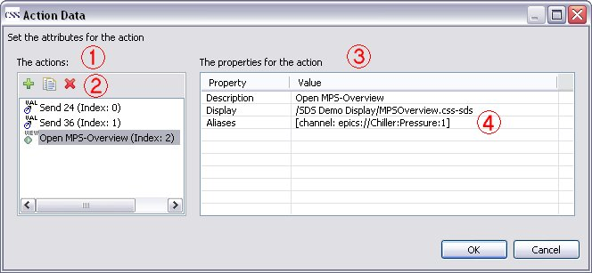
The marked points are:
- The list of the defined WidgetActions. Every Action has an icon, a representing text and in round brackets the index of the WidgetAction.
- The Toolbar to add, copy or remove a WidgetAction.
- The table for the properties of the selected WidgetAction. The first column contains the name of the properties, while the second column shows the currently configured values of the properties.
- If a click on a row occurs, an editor appears for the specific property.

Option-Property
Option-Properties allow the user to pick one of several possibilities. The available options depend on the usage of the property, for example to choose a cursor, the style of a line or a border. The model of a widget, which holds an Option-Property, configures the property with a fixed list of describing names. The current selection is not provided as the name, but as the index within the list. Which effect the index has, is defined in the editpart or the figure itself.
To provide easier access to the names and their indices, some enums are held in the org.csstudio.sds.model.optionEnums-package. These enums contain the displayed name and the index.
A new option can be added by extending the corresponding list in the model with a new name. If an enum is used, it has to be enhanced.

OptionCellEditor
The editor, which is used for the Option-Property, is a simple org.eclipse.jface.viewers.ComboBoxCellEditor. So for example the editor for the style of the border looks like this:
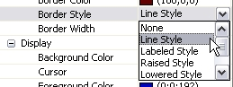

ParameterString-Property
A ParameterString-property holds a text, which can be enriched with links to other properties except itself. The contained text can be also formatted with line breaks and empty spaces. To create a link to another property you have to enter “${propertyName}$”, where propertyName must be replaced by the displayed name in the “Widget Properties”-view of the SDS.
For example: To provide a tooltip, which displays the name plus the current x- and y values of the figure, the tooltip text can look like this:
${Name}$
X: ${X-Coordinate}$
Y: ${Y-Coordinate}$
CAUTION: If a widget contains two or more ParameterString-properties, it is possible to create a cycle, which never will be resolved. To prevent this case, it is necessary, that the ParameterString-properties doesn’t reference each other.

ParamStringCellEditor
The org.csstudio.sds.ui.internal.properties.ParamStringCellEditor is shown below:
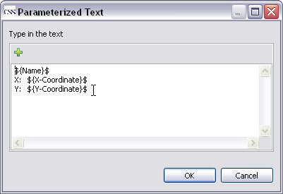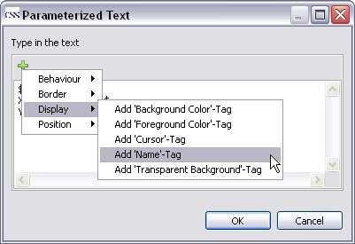
To access the names of the properties in an easier way the editor provides a menu which contains all available properties grouped by their categories.

